REACT

**What is React ?**

**React** is a **JavaScript library** for building **user interfaces** (UIs) on the web. React is a declarative, component based library that allows developers to build reusable UI components and It follows the [Virtual DOM](https://www.geeksforgeeks.org/reactjs-virtual-dom/) (Document Object Model) approach, which optimizes rendering performance by minimizing DOM updates. React is **fast** and works well with other tools and libraries.

***Prerequisite of React***

*For learning React first you have a clear understanding of HTML, CSS and JavaScript. As React is a JavaScript library and uses most of its concept so you really have to understands the major concepts of it.*

* [***HTML***](https://www.geeksforgeeks.org/html-tutorial/)***and***[***CSS***](https://www.geeksforgeeks.org/css-tutorial/)
* [***JavaScript***](https://www.geeksforgeeks.org/javascript/)***and ES6***
* [***JSX (Javascript XML)***](https://www.geeksforgeeks.org/reactjs-jsx-introduction/)***& Babel***
* [***Node***](https://www.geeksforgeeks.org/nodejs/)***+Npm***
* [***Git***](https://www.geeksforgeeks.org/ultimate-guide-git-github/)***and CLI (Command Line Interface).***

**History of React**

* React was invented by Facebook developers who found the traditional DOM slow. By implementing a virtual DOM, React addressed this issue and gained popularity rapidly.
* The current stable version of ReactJS is 18.2.0, released on June 14, 2022. The library continues to evolve, introducing new features with each update.

**How does React work?**

React operates by creating an in-memory virtual DOM rather than directly manipulating the browser’s DOM. It performs necessary manipulations within this virtual representation before applying changes to the actual browser DOM. React is efficient, altering only what requires modification.

**Features of React**

React is one of the most demanding JavaScript librarys because it is equipped with a ton of features which makes it faster and production-ready. Below are the few features of React.

**1. Component-Based Architecture**

React provides the feature to break down the UI into smaller, self-contained components. Each component can have its own **state and props**.

**2. JSX (JavaScript Syntax Extension)**

JSX is a syntax extension for JavaScript that allows developers to write HTML-like code within their JavaScript files. It makes React components more readable and expressive.

const name="GeekforGeeks";

const ele = <h1>Welcome to {name}</h1>;

**3. Virtual DOM**

React maintains a lightweight representation of the actual DOM in memory. When changes occur, React efficiently updates only the necessary parts of the DOM.



**4. One-way Data Binding**

[One-way data binding](https://www.geeksforgeeks.org/reactjs-data-binding/), the name itself says that it is a one-direction flow. The data in react flows only in one direction i.e. the data is transferred from top to bottom i.e. from parent components to child components. The properties(props) in the child component cannot return the data to its parent component but it can have communication with the parent components to modify the states according to the provided inputs.



**5. Performance**

As we discussed earlier, react uses virtual DOM and updates only the modified parts. So , this makes the DOM to run faster. DOM executes in memory so we can create separate components which makes the DOM run faster.

**6. Components**

React divides the web page into multiple [components](https://www.geeksforgeeks.org/reactjs-components/) as it is component-based. Each component is a part of the UI design which has its own logic and design as shown in the below image. So the component logic which is written in JavaScript makes it easy and run faster and can be reusable.



**7. Single-Page Applications (SPAs)**

React is recommended in creating SPAs, allowing smooth content updates without page reloads. Its focus on reusable components makes it ideal for real-time applications.

**ReactJS Lifecycle**

Every React Component has a lifecycle of its own, lifecycle of a component can be defined as the series of methods that are invoked in different stages of the component’s existence. React automatically calls these methods at different points in a component’s life cycle. Understanding these phases helps manage state, perform side effects, and optimize components effectively.

**1. Initialization**

This is the stage where the component is constructed with the given Props and default state. This is done in the constructor of a Component Class.

**2. Mounting Phase**

* **Constructor**: The constructor method initializes the component. It’s where you set up initial state and bind event handlers.
* **render():**This method returns the JSX representation of the component. It’s called during initial rendering and subsequent updates.
* **componentDidMount():** After the component is inserted into the DOM, this method is invoked. Use it for side effects like data fetching or setting timers.

**3. Updating Phase**

* **componentDidUpdate(prevProps, prevState)**: Called after the component updates due to new props or state changes. Handle side effects here.
* **shouldComponentUpdate(nextProps, nextState):** Determines if the component should re-render. Optimize performance by customizing this method.
* **render():** Again, the render() method reflects changes in state or props during updates.

**4. Unmounting Phase**

* **componentWillUnmount()**: Invoked just before the component is removed from the DOM. Clean up resources (e.g., event listeners, timers).

**Top 30 Global Companies That Use React JS**

So what companies use React JS? Some of the big names include Facebook, Instagram, Tesla, PayPal, Netflix, Walmart and Uber.

* [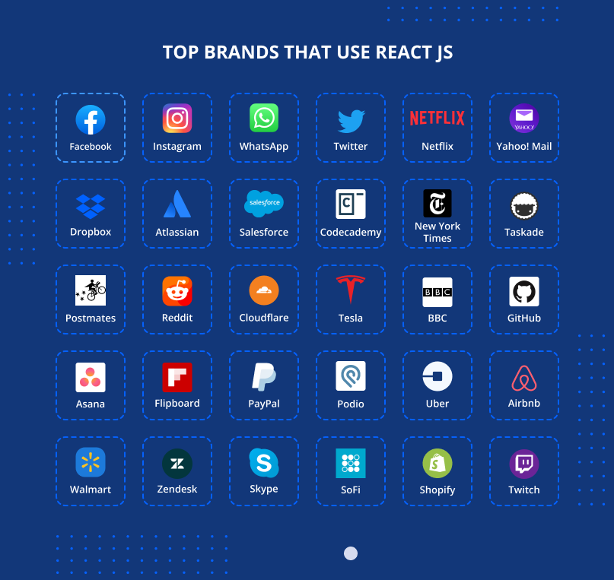](https://d2i2xyh28mr8fx.cloudfront.net/wp-content/uploads/2023/04/11144304/Top-companies-that-use-ReactJS.png)

There’s too many companies using React JS to list them all here, so instead we’re going to cover the top 30 companies who use React JS. We’ll then detail what React components they use and the benefit it has for their web and mobile application development.

**Facebook**

Facebook is a social networking company that connects people with friends, family, and businesses online.

The Facebook web front-end was built with React JS while React Native was used for developing its mobile apps.

The benefit of using React for Facebook is that changes on users’ feeds can load immediately and users can benefit from that immediate response without having to reload the page.

**Instagram**

When people ask which companies use ReactJS, Instagram is often one of the first names mentioned.

Instagram, which is owned by Meta, uses React JS extensively to ensure smooth operation for customers using mobile phones.

Instagram uses React as the basis for their entire app and React functions include key elements such as Google Maps APIs, tags, geolocation and to help improve search engine accuracy, which is vital when you integrate a large internet search engine into a product.

**WhatsApp**

Meta text and video chat service WhatsApp uses React for building the user interface and to improve user experience throughout the app. Known as an easy way to send instant messages, WhatsApp has benefited from React integration in a number of ways.

React allows Meta to reuse code across their platforms and to develop cross-platform apps with the smooth user experience and efficiency of native apps without having to build native apps from the ground up.

**Twitter**

Twitter allows users to share and interact with short, public messages called “tweets.” The platform has become a popular source for breaking news, real-time updates, and public conversations on a wide range of topics.

Twitter is a React JS company and they use it for producing web apps. Their developers also contribute design and patches to React.

The client-side JavaScript application for Twitter is “[developed, built and tested](https://blog.twitter.com/engineering/en_us/topics/open-source/2017/how-we-built-twitter-lite)” with various open source libraries, including React.

**Netflix**

When people ask what companies are using React JS, Netflix is a common name that comes up.

Netflix uses React for their Gibbon platform, which is used for low-performance TV devices. They chose React because of its rapid start-up speed, modularity and runtime performance.

* [](https://d2i2xyh28mr8fx.cloudfront.net/wp-content/uploads/2023/04/11144234/Netflix-about-ReactJS.png)

**Yahoo! Mail**

The Yahoo! mail client uses React and since using it as part of their own digital product, Yahoo! developers have found it to be easy to work with and a shortcut to intuitive website design.

The Yahoo! team uses React to improve their debugging tools, create reusable components and to reduce developer learning curve.

* [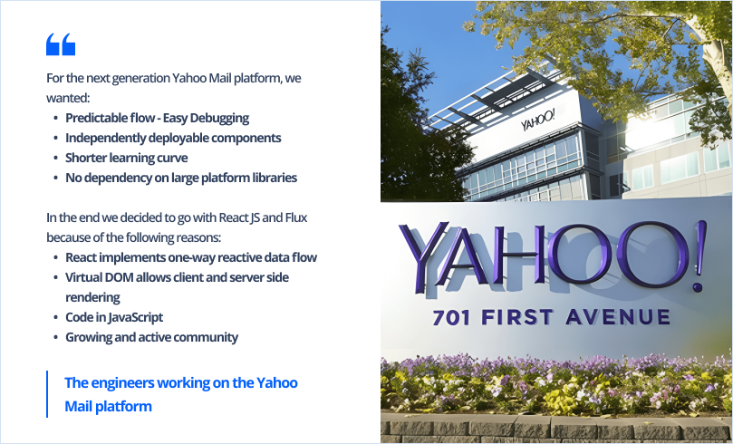](https://d2i2xyh28mr8fx.cloudfront.net/wp-content/uploads/2023/04/11144316/Yahoo-about-ReactJS.png)

**Dropbox**

If you want to know who uses React JS in the tech world, Dropbox is one such example. The file hosting service is a longtime React JS user.

Key React functions at Dropbox include reducing file sizes and reloading speeds, resulting in a more user-friendly interface. The React JS library is also used for Dropbox backup and cloud storage solutions.

**Atlassian**

Australian corporation Atlassian stated on their developer blog that they use React due to its good tooling and ability to deploy across web, mobile and desktop, therefore “allowing developers to reuse libraries between platforms.” Such versatility helps increase developer productivity.

**Salesforce**

Salesforce is a cloud-based software company that provides customer relationship management (CRM) and other business applications.

* [](https://d2i2xyh28mr8fx.cloudfront.net/wp-content/uploads/2023/04/11144247/Salesforce-about-ReactJS.png)

Salesforce developer Stephen James, who leads their front end development, stated on the company blog that they use React because it allows developers to reuse components, thereby resulting “in less time spent on development and an increase in longstanding efficiency.”

**Codecademy**

React companies include software education site Codecademy. React is found on many web applications and an example of this is on Codecademy, where it is used for the menu, header and navigation.

The development team created these elements with React because it makes SEO easy, is flexible and is known to be reliable, thus ensuring customer satisfaction.

* [](https://d2i2xyh28mr8fx.cloudfront.net/wp-content/uploads/2023/04/11144222/Codeacademy-about-ReactJS.png)

**New York Times**

React JS is used by companies in the media sphere and the New York Times is one of the more prominent examples.

The New York Times uses React to help create[fast-loading pages and render HTML for accessible viewing.](https://softwareengineeringdaily.com/2018/10/22/react-and-graphql-at-the-nytimes/)

The company uses React for the above because development teams can collaborate faster through reusable front-end components, reducing work duplication. React also speeds up mobile app development because the components can be reused across different devices.

* [](https://d2i2xyh28mr8fx.cloudfront.net/wp-content/uploads/2023/04/11144255/The-New-York-Times-about-ReactJS.png)

**Taskade**

Task management platform Taskade was made with React. The business idea for Taskade is to “build a second brain for your team” and they benefited from the efficiency of React.

Taskade used ReactJS to build its web and mobile applications, including its task lists, task boards, and team collaboration features. The company used ReactJS components to create a modular and flexible UI architecture, which allowed developers to build new features and enhance the user experience more quickly and efficiently.

**Postmates**

Food delivery service Postmates engages React front end developers to build their client-side technology, which they revealed in an interview with their development team.

* [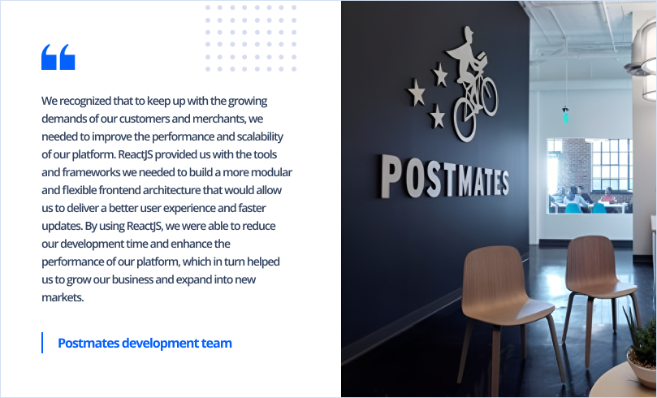](https://d2i2xyh28mr8fx.cloudfront.net/wp-content/uploads/2023/04/11144238/Postmates-about-ReactJS.png)

**Reddit**

Reddit is a social news aggregation and discussion website where users can post content, vote on it, and comment on other users’ posts. The platform covers a wide range of topics, including news, entertainment, technology, and more.

Social network giant Reddit began using React in recent years, riding the wave for the technology that has been enjoying so much popularity recently. They also use a range of other JS tools in their tech stack.

Chris Slowe, discussed the decision to use ReactJS, saying:

* [](https://d2i2xyh28mr8fx.cloudfront.net/wp-content/uploads/2023/04/11145653/Reddit-about-ReactJS.png)

**Cloudflare**

Cloudflare is a cloud-based platform that provides a range of services to improve the performance, security, and reliability of websites and applications. The company’s services include content delivery network (CDN), DDoS protection, DNS management, and web application firewall (WAF).

John Graham-Cumming, discussed the benefits of using ReactJS, saying:

* [](https://d2i2xyh28mr8fx.cloudfront.net/wp-content/uploads/2023/04/11144217/Cloudflare-about-ReactJS.png)

**Tesla**

Tesla uses React to help customers along on their web journey.

Tesla has used ReactJS for various applications, including its official website and web apps. In a tweet by Elon Musk on July 26, 2019, he mentioned that Tesla’s website was upgraded to React, which allowed for faster load times and improved user experience.

**BBC**

The BBC, also known as the British Broadcasting Corporation, is a public service broadcaster in the United Kingdom. The company provides a wide range of news, entertainment, and educational programming through various mediums, including television, radio, and online platforms.

The BBC runs React throughout their entire design system, as the BBC website is a large-scale, open source React build.

**GitHub**

GitHub is a web-based hosting platform for version control using Git. It is mostly used for computer code.

GitHub decided to implement ReactJS to solve several problems with their existing front-end architecture. According to a blog post by GitHub’s engineering team, they found that their existing codebase was difficult to maintain and update, and that they were having trouble scaling their front-end development efforts.

* [](https://d2i2xyh28mr8fx.cloudfront.net/wp-content/uploads/2023/04/11144225/Github-about-ReactJS.png)

**Asana**

Work management platform Asana rewrote their UI entirely using React, and also built their mobile app with React Native.

Asana uses React to improve client-side performance and its virtual document object model (VDOM) was used to improve the user interface, including the animations.

**Flipboard**

Flipboard is a personalized news and content aggregation application available on various platforms, including iOS and Android. The app collects news and content from different sources and presents them in a magazine-style layout.

The developers of social app Flipboard have declared they’re fans of React, and have been using React for the Flipboard web app since 2015. They enjoy working with it due to the efficient and lightweight React VDOM.

**PayPal**

PayPal is an American online payment system that allows individuals and businesses to make and receive payments electronically. The company operates as a payment processor for online vendors, auction sites, and other commercial users, for which it charges a fee in exchange for benefits such as fraud protection and payment security.

PayPal used ReactJS to redesign its user interface and streamline its checkout process.

PayPal has a huge range of technologies to power their diverse services, and they used React to build their front-end, along with Node.js/kraken framework with JavaScript programming.

**Podio**

Podio is a cloud-based collaboration platform that allows teams to manage their workflows, projects, and communications in one place.

The development team at project management tool Podio uses React for a number of purposes in their technology stack. Additionally, the team used server-side rendering to improve the initial load time of the application, resulting in a faster and more responsive user experience.

**Uber**

Uber is a transportation network company that operates a mobile app connecting passengers with drivers of vehicles for hire. The company’s platform allows users to request rides, track their ride in real-time, and make payments through the app.

The company initially built the web Restaurant Dashboard with React JS. Following internal React analyses, they subsequently used React Native to build the tablet version of the Restaurant Dashboard as a React/Flux application.

Uber noted that React Native gave their team more options, as it “fuses web and mobile development, allowing us to write features either natively or in JavaScript.”

**Airbnb**

Airbnb is an online marketplace that enables people to find and book unique accommodations around the world. The company has a large team of over 60 developers who use ReactJS extensively to build and optimize their platform.

According to Gabriel Lew, Engineering Lead at Airbnb, React has been an incredible foundation for the company to build their platform. The team finds React very intuitive, easy to use, and modular, allowing them to build on top of it and modify it for various use cases. React’s flexibility has enabled Airbnb to re-purpose React code for different functions and has helped the company to streamline their search engines and communication protocols.

**Walmart**

Walmart is a multinational retail corporation that operates a chain of hypermarkets, discount department stores, and grocery stores.

In an interview with Forbes, Walmart’s Chief Technology Officer, Jeremy King, explained that the company had a problem with website speed, which was affecting its online business. As a solution, Walmart turned to ReactJS, which proved to be an effective choice for improving website performance. According to King, Walmart’s React applications are typically two to three times faster than their non-React applications.

**Zendesk**

Zendesk is a software development organization that provides a SaaS-based suite of tools to help businesses manage their customer service support, issue tracking, and help desk management.

To improve their suite of tools, Zendesk has utilized ReactJS to build various components. These components are part of their Garden design system, which offers React components and utilities to provide users with visuals, localization, and keyboard navigation options.

**Skype**

Skype is a telecommunications application that allows users to make voice and video calls, send instant messages, and share files with other Skype users over the internet.

Skype used ReactJS to redesign its web application, with a focus on improving performance and user experience. The company’s engineers developed a custom solution that utilized React’s server-side rendering capabilities and component-based architecture.

* [](https://d2i2xyh28mr8fx.cloudfront.net/wp-content/uploads/2023/04/11144230/Microsoft-about-ReactJS.png)

**SoFi**

SoFi (Social Finance) is a finance company that provides personal finance products and services, including loans, investments, and insurance.

SoFi senior software engineer Josh Hinkle outlined how the personal finance company uses React, stating the following about the SoFi Lending bundle stack:

* [](https://d2i2xyh28mr8fx.cloudfront.net/wp-content/uploads/2023/04/11144251/SoFi-about-ReactJS.png)

**Shopify**

Shopify is an e-commerce platform that allows businesses to create online stores and sell their products and services.

Shopify developed Hydrogen as their next business idea over a period of over 12 months. Hydrogen is a React framework for creating custom Shopify storefronts.

Shopify Senior Staff Developer Josh Larsen stated that Shopify wanted web frameworks to solve the problems that merchants faced when building custom storefronts and decided that[building Hydrogen with React was the best solution](https://shopify.engineering/how-we-built-hydrogen#:~:text=We've%20been%20building%20Hydrogen,a%20terrific%20experience%20for%20developers.).

**Twitch**

Twitch is a live streaming platform that allows users to watch and broadcast video game content, esports competitions, and other creative content.

The company decided to use ReactJS to solve the problem of scaling their front-end development.

* [](https://d2i2xyh28mr8fx.cloudfront.net/wp-content/uploads/2023/04/11144308/Twitch-about-ReactJS.png)

To address these issues, the Twitch team chose ReactJS.

**Why Big Companies Are Using React Native in 2023**

We’ve addressed many of the big players above, such as Meta, Netflix and Walmart. Now we’ll break down the top seven reasons why such industry leaders are using React in 2023.

* [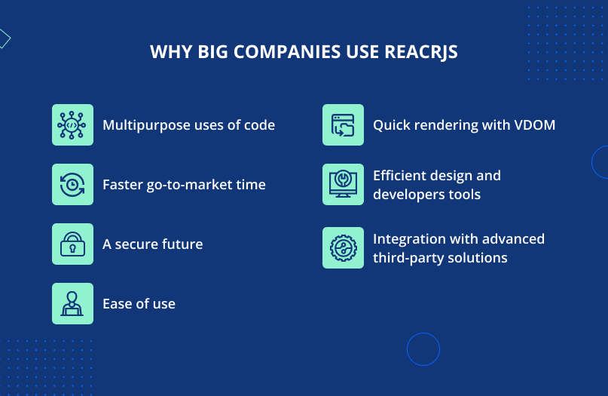](https://d2i2xyh28mr8fx.cloudfront.net/wp-content/uploads/2023/04/11151129/Why-big-companies-use-ReactJS.png)

**Multipurpose uses of code**

React enabling the reuse of code is the biggest recurring theme in the case studies above.

At Meta developers reuse code across multiple platforms such as Facebook, Instagram and WhatsApp. Developers at Yahoo!, Atlassian, Salesforce and the New York Times also noted this advantage.

**Ease of use**

React is easy to use and developers love to work with it. Above we reported on how Yahoo! developers found that the library is easy to work with, which increases productivity.

**Faster go-to-market time**

When developers are able to extensively reuse code, this results in a faster time to market.

The New York Times found that React reduced work duplication, which helps them launch products faster.

**A secure future**

React is maintained and supported by Meta as well as a dedicated community. With such business and community support behind it, React is not going away any time soon.

**Quick rendering with VDOM**

The React VDOM allows it to reduce computation requirements with re-rendering a user interface.

Above we explored how longtime React user Flipboard found the VDOM to be efficient and lightweight.

**Efficient design and developer tools**

React has a large set of development tools available, which help improve developer productivity by assisting with rapid debugging, accurate reporting of changes and ease of installation.

**Integration with advanced third-party solutions**

There are various third-party solutions available for React, and these expand and improve the functionality of React.

**Conclusion**

There’s a huge range of benefits to developing with React, which is why so many top companies are investing in it.

Some of the benefits of React include ease of use, reuse of components, rapid time to market, support from Meta, efficient resource use and powerful developer tools.