1. In the below elements which of them are values or an expression? eg:- values can be integer or string and expressions will be mathematical operators.

*

'hello'

-87.8

-

/

6

***Ans:***

* : **Expression**

'hello' : **String**

-87.8 : **Float**

- : **Expression**

/ : **Expression**

* : **Expression**

6 : **integer**

2. What is the difference between string and variable?

***Ans:***

String is a literal text string, i.e. 'xxxxxx'

Variable is something that stores data - it can store a string, int, float, class, etc.

A Variable is a store of information, and a String is a type of information. String is usually words, enclosed with "" Eg String x ="Vijay" X is the Variable, and we declared it as a String, use the single = to assign the text to it.

3. Describe three different data types.

***Ans:***

1. **Integers** – This value is represented by int class. It contains positive or negative whole numbers (without fraction or decimal). For example – 5,6,7
2. **Complex Numbers** – Complex number is represented by complex class. It is specified as (real part) + (imaginary part)j. For example – (10+6j)
3. **String** - A string is a collection of one or more characters put in a single quote, double-quote or triple quote. It is represented by str class. For example – “vijay”, “kumar”.

4. What is an expression made up of? What do all expressions do?

***Ans:***

An expression is a combination of values, variables, operators, and calls to functions. Expressions need to be evaluated. If we print an expression, the interpreter evaluates the expression and displays the result.

5. This assignment statements, like spam = 10. What is the difference between an expression and a statement?

***Ans:***

An expression is a combination of values, variables, and operators. If you type an expression on the command line, the interpreter evaluates it and displays the result.

If we assign, spam = 10, and run the cell, when we type spam and run, it shows 10

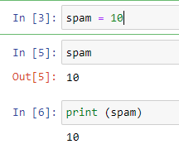

**Statement** is an instruction that the Python interpreter can execute. Statement are  while statements, for statements, if statements, and import statements.

6. After running the following code, what does the variable bacon contain?

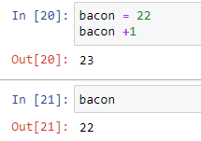bacon = 22

bacon + 1

***Ans:*** bacon contain 22

7. What should the values of the following two terms be?

'spam' + 'spamspam'

'spam' * 3

***Ans:***'spamspamspam'

8. Why is eggs a valid variable name while 100 is invalid?

***Ans:*** Because variable names cannot begin with a number

9. What three functions can be used to get the integer, floating-point number, or string version of a value?

***Ans:*** int(), float(), str()

10. Why does this expression cause an error? How can you fix it?

'I have eaten ' + 99 + ' burritos.'

***Ans:***  'I have eaten' and 'burritos' are strings, and 99 is integer, string + int will not work, need same type of data forms to work.

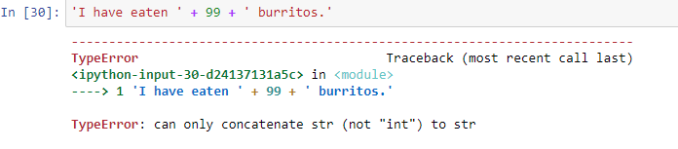

To fix the error and print 'I have eaten’ + “99” + ‘burritos.', 99 needs '' around it to treat it as a string.

