1.What are the two values of the Boolean data type? How do you write them?

**Ans:** Two Values of Boolean data type is True & False. We can write as True and False.

2. What are the three different types of Boolean operators?

**Ans :** or, and, not

3. Make a list of each Boolean operator's truth tables (i.e. every possible combination of Boolean values for the operator and what it evaluate ).

**Ans** : True or True : True.  
 True or False : True.  
 False or True : True.  
 False or False : False.  
 - Not True is False and not False is True

4. What are the values of the following expressions?

(5 > 4) and (3 == 5)

not (5 > 4)

(5 > 4) or (3 == 5)

not ((5 > 4) or (3 == 5))

(True and True) and (True == False)

(not False) or (not True)

**Ans:** (5 > 4) and (3 == 5) : False

not (5 > 4) : False

(5 > 4) or (3 == 5) : True

not ((5 > 4) or (3 == 5)) : False

(True and True) and (True == False) : False

(not False) or (not True) : True

5. What are the six comparison operators?

**Ans** : ==, !=, <, >, <=, and >=.

6. How do you tell the difference between the equal to and assignment operators? Describe a condition and when you would use one.

**Ans:** == is the equal to operator that compares two values and evaluates to a Boolean, while = is the assignment operator that stores a value in a variable.

Condition is an expression used in a flow control statement that evaluates to a Boolean value.

7. Identify the three blocks in this code:

spam = 0

if spam == 10:

print('eggs')

if spam > 5:

print('bacon')

else:

print('ham')

print('spam')

print('spam')

Ans:The three blocks are everything inside the if statement and the lines print('bacon') and print('ham').

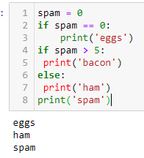

8. Write code that prints Hello if 1 is stored in spam, prints Howdy if 2 is stored in spam, and prints Greetings! if anything else is stored in spam.

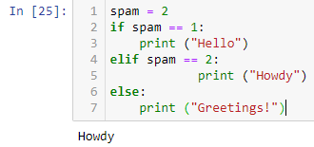spam = 2

if spam == 1:

print ("Hello")

elif spam == 2:

print ("Howdy")

else:

print ("Greetings!")

9.If your programme is stuck in an endless loop, what keys you’ll press?

**Ans:** CTRL-C

10. How can you tell the difference between break and continue?

**Ans:** The break statement will move the execution outside and just after a loop.

The continue statement will move the execution to the start of the loop.

11. In a for loop, what is the difference between range(10), range(0, 10), and range(0, 10, 1)?

**Ans:** All are the same thing. The range(10) call ranges from 0 up to (but not including) 10, range(0, 10) explicitly tells the loop to start at 0, and range(0, 10, 1) explicitly tells the loop to increase the variable by 1 on each iteration.

12. Write a short program that prints the numbers 1 to 10 using a for loop. Then write an equivalent program that prints the numbers 1 to 10 using a while loop.

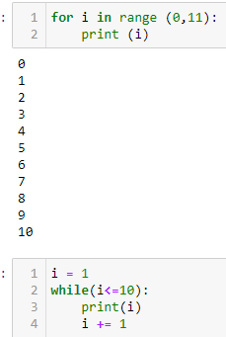**Ans:**

#With For Loop:

for i in range (0,11):

print (i)

#With While Loop:

i = 1

while(i<=10):

print(i)

i += 1

13. If you had a function named bacon() inside a module named spam, how would you call it after importing spam?

**Ans**: It can be called with spam.bacon()