
TARGET BRAZIL E-COMMERCE
Customer, Order & Operational Analytics
Detailed Analysis Report

Prepared By
Vijay Kumar

Executive Summary
This case study evaluates the Target Brazil e-commerce dataset across data quality, demand patterns, customer and geographic behaviour, order economics, logistics, payment behaviour and customer experience. The project then extends the core SQL analysis into customer-level analytics using RFM segmentation, customer value concentration, high-value customer pathways and a recent high-value customer profile.
The analytical objective is to demonstrate an end-to-end workflow: understand the data model, validate data quality, control analytical grain, answer business questions with SQL, communicate findings through Looker Studio, and translate evidence into practical business implications.
Project scope | Tools | Observation period
E-commerce customer, order, logistics, payment and experience analysis | SQL • BigQuery • Looker Studio • Business Analysis | Sep 2016 – Oct 2018

Area | Key finding
Customer base | 93,358 active customers had at least one delivered order; 97.00% were one-time customers and 3.00% were repeat customers.
Observed customer value | R$15.42M of observed value was generated across active customers from completed purchases.
Value concentration | 48.85% of customers account for 80% of observed customer value; the dataset does not follow a simple 80/20 concentration pattern.
RFM | 97% of active customers are F1, while higher-frequency RFM cells show substantially higher average observed customer value.
High-value pathways | High-value one-time customers average R$390.63 per order; high-value repeat customers average 2.16 orders/customer at R$194.91 per order.
Recent high-value profile | 5,515 recent high-value one-time customers represent R$2.20M observed value and average R$399.30 order value.
Geography | SP, RJ and MG account for 61.24% of the recent high-value one-time segment.
Basket structure | 80.82% of recent high-value one-time customers place single-item orders, supporting a high-ticket rather than high-basket pattern.
Customer experience | The recent high-value segment has a 4.19 average review score; 93.82% of its observed deliveries were completed before the estimated date.

Executive Priorities
- Treat repeat purchase development as a distinct customer-value opportunity because most customers are one-time buyers, while higher-frequency customers generate materially higher value per customer.
- Use RFM and observed customer value to identify customer groups for targeted analysis without interpreting one-time behaviour as confirmed churn.
- Prioritize analysis of high-value one-time customers because they represent a meaningful observed-value pool and provide a clear opportunity to study pathways into repeat purchasing.
- Use SP, RJ and MG as important geographic concentrations for customer and category analysis within the recent high-value segment.
- Protect the analytical grain of orders, order items, payments and reviews to avoid double counting when combining tables.
- Use logistics, payment and review findings as supporting evidence rather than assuming that observed relationships establish causality.

1. Business Context & Objective
The Target Brazil e-commerce case uses a relational marketplace dataset containing customer, order, order-item, payment, product, seller, review and geolocation information. The project is designed as a portfolio-grade business analysis rather than a collection of isolated SQL queries.

Business Questions
- Is the underlying data complete and structurally reliable enough for analysis?
- How does order demand evolve over time and across time-of-day periods?
- Where is customer demand geographically concentrated?
- How does order value and freight burden vary by customer state?
- How long do orders take to reach customers, and how accurate are estimated delivery dates?
- Which payment methods and installment patterns are observed?
- What does customer review behaviour indicate about customer experience?
- Who are the highest-value customer groups, how frequently do they purchase, and how is observed value concentrated?
- How do high-value one-time and repeat customers differ in purchase pathways?

Analytical Model & Grain
Instead of relying solely on the ER diagram provided with the dataset, we created a new, detailed ER diagram that includes all major tables, columns, primary keys (PKs), foreign keys (FKs), data types, and relationships.
The purpose of creating this detailed ER diagram was to understand the complete data schema, table relationships, and analytical grain before writing SQL queries. This helped us identify one-to-many relationships, understand how tables connect, and reduce the risk of double counting when combining transactional data.
The orders table represents the core transactional grain, while order_items, payments, and order_reviews can contain multiple records associated with a single order. For customer-level analysis, customer_unique_id is used to identify the underlying customer across potentially multiple customer_id records.
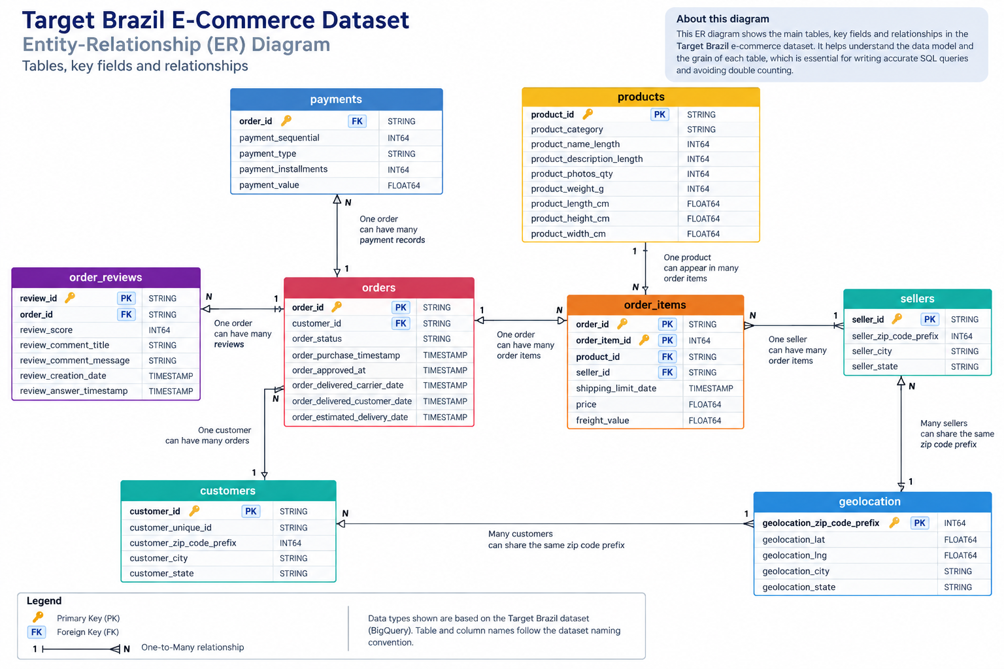
Grain control
Payments and order_items are aggregated to order level before being joined to customer-level or order-level metrics. This reduces the risk of multiplying values when one order has multiple payment or item records.

Core Metric Definitions
Metric | Definition
Active customer | Customer with ≥1 delivered order.
Observed customer value | Total payment value from completed/delivered orders attributed to an active customer during the observation period.
Purchase frequency | Count of completed/delivered orders associated with the customer.
RFM | Recency, Frequency and Monetary scoring based on completed purchases.
High-value customer | M4 customer in the RFM framework; current dashboard threshold is observed customer value > ₹182.40.
Recent customer | R4 customer; last purchase within 163 days of the 17 Oct 2018 observation date.
One-time customer | Customer with exactly one completed order.

2. Data Quality & Integrity
The first analytical phase profiles the eight source tables and audits missing values in the orders table. The purpose is to understand table scale, identify null patterns and establish which fields can safely support downstream analysis.
Table | Rows
customers | 99,441
geolocation | 1,000,163
order_items | 112,650
order_reviews | 99,224
orders | 99,441
payments | 103,886
products | 32,951
sellers | 3,095

SQL Output:
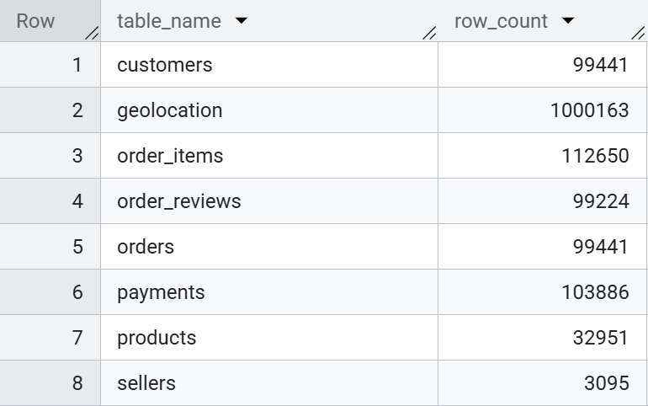

Missing-value audit
The orders table contains expected missingness in lifecycle timestamps. The supplied analysis identifies 160 null order-approved timestamps, 1,783 null carrier-delivery timestamps and 2,965 null customer-delivery timestamps. These nulls must be interpreted in the context of order status rather than automatically treated as data errors.
Analytical implication
Delivery-duration metrics should be calculated only where delivered orders have valid delivered-customer and estimated-delivery timestamps. Incomplete lifecycle records should not be silently converted into zero-duration or late-delivery observations.

3. Demand, Growth & Seasonality
The demand analysis examines monthly order volume, seasonality and time-of-day purchasing behaviour. The dataset spans September 2016 through October 2018, with the final observation date used for customer analysis set to 17 October 2018.

Monthly order trend
Monthly order counts provide the baseline view of demand evolution. November 2016 is absent from the observed monthly sequence, which should be treated as an observed gap rather than filled without evidence.
SQL Output (Sample Data):
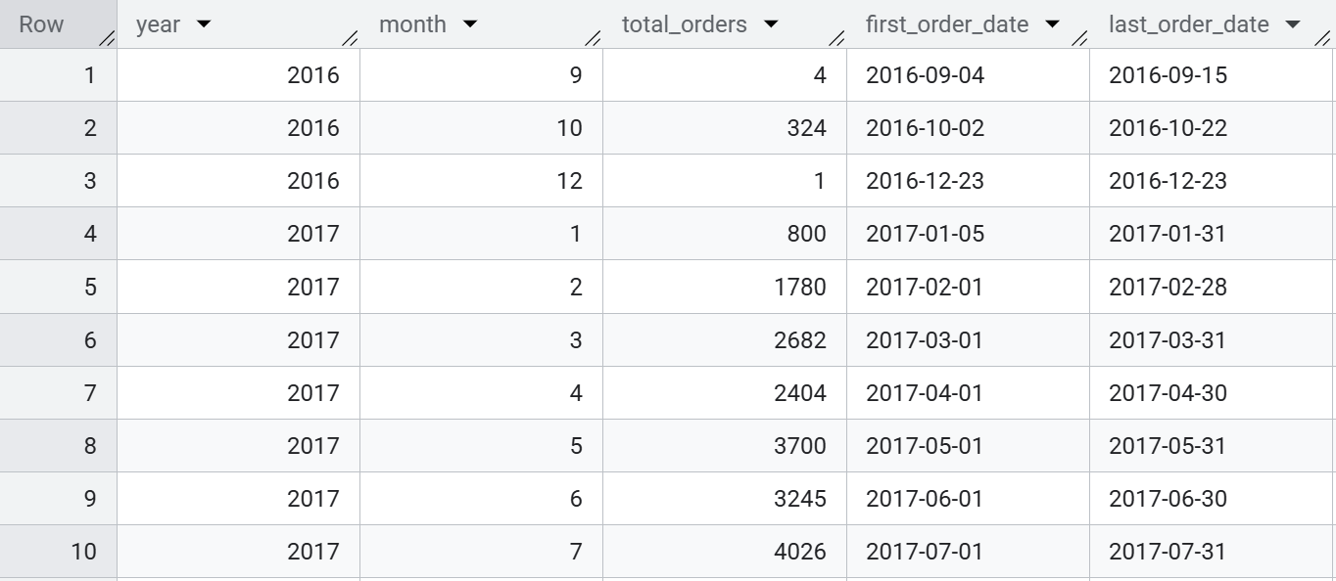
Business interpretation
The dataset shows rapid growth in order activity during the early observation period, rising from 324 orders in October 2016 to 4,026 orders by July 2017. While the overall trajectory indicates strong expansion in observed demand, the unusually low volumes in the initial months—including a missing November 2016 record and only one order in December—make early-period month-to-month comparisons less representative.

Order time-of-day
Using the defined time buckets, the largest share of orders occurs in the Afternoon period. Across all orders, 38,135 orders fall in Afternoon, followed by Night (28,331), Morning (27,733) and Dawn (5,242). For delivered orders, Afternoon remains the largest group with 36,965 orders.
Time bucket | All orders | Delivered orders
Afternoon (13:00–18:59) | 38,135 | 36,965
Night (19:00–23:59) | 28,331 | 27,522
Morning (07:00–12:59) | 27,733 | 26,919
Dawn (00:00–06:59) | 5,242 | 5,072

SQL Output:
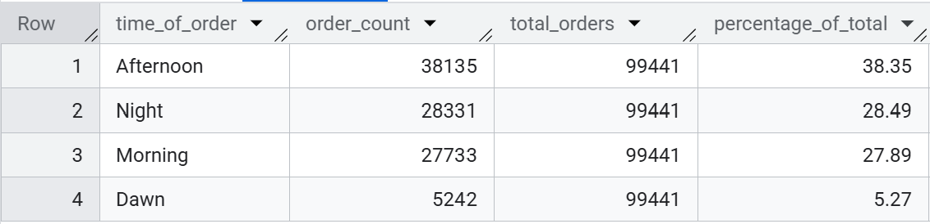

Business interpretation
Afternoon demand is the largest observed order window. This is useful for operational and campaign timing, but the analysis is descriptive and does not by itself establish that changing campaign timing would cause higher sales.

4. Customer & Geographic Demand
Customer geography is analysed using the customer table, with customer_state and customer_city providing the geographic dimension. The analysis examines concentration, state-level fulfilment and the distribution of demand.

Customer concentration
São Paulo is the dominant customer state, representing approximately 41.98% of customers in the supplied state-level analysis. Rio de Janeiro and Minas Gerais follow, creating a clear concentration of customer demand in a small group of states.
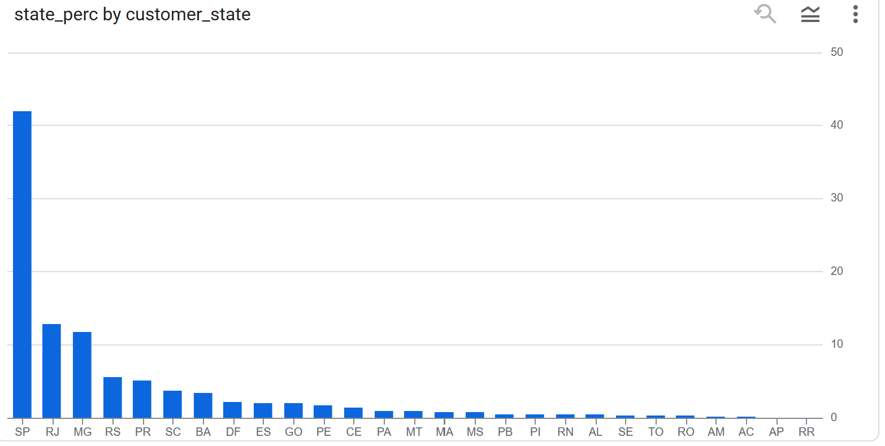

State-level fulfilment
Delivery rate is calculated as delivered orders divided by total orders for each customer state. This provides a consistent state-level view of fulfilment performance and can be compared with order value and freight burden.
SQL Output (Sample Data):
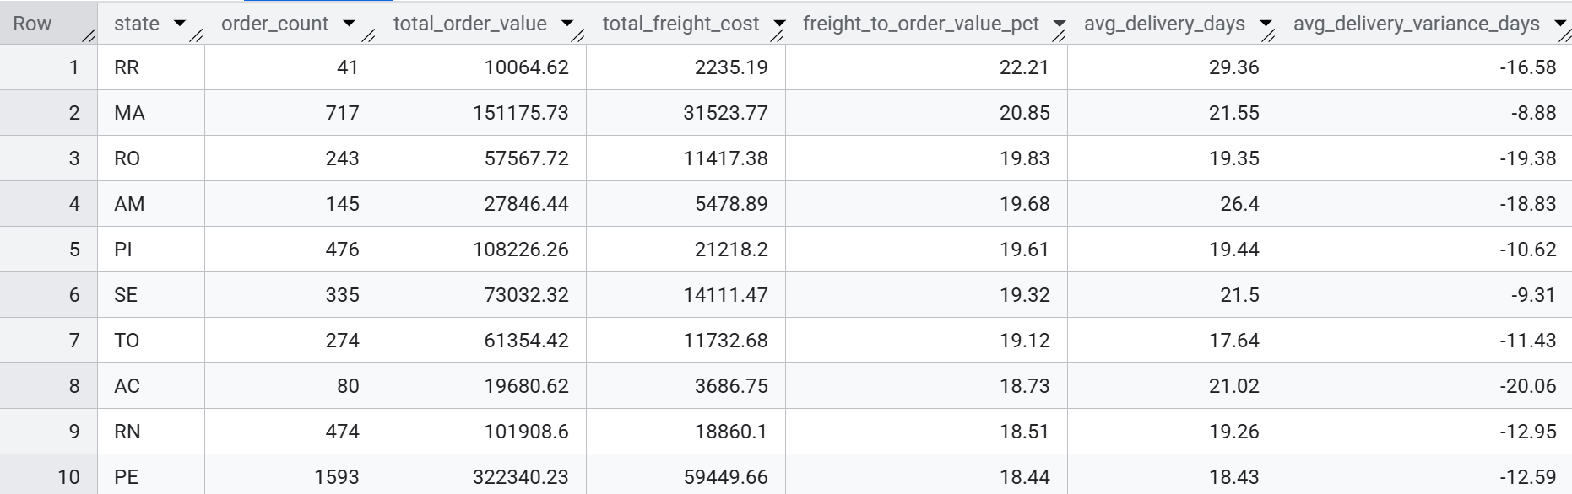
Business interpretation
Geographic concentration can guide where to investigate customer acquisition, category mix, logistics performance and service economics. State-level comparisons should be read alongside order volume because small states can produce volatile rates.

5. Order Value & Unit Economics
The order-value phase combines payments, orders and customers to calculate total payment value and average order value (AOV) by state. Freight burden is then evaluated as freight cost relative to order value.

Order value
State-level payment value and AOV are useful complementary measures: total payment value identifies where monetary demand is concentrated, while AOV shows whether a state reaches that value through many smaller orders or fewer higher-value orders.
SQL Output (Sample Data):
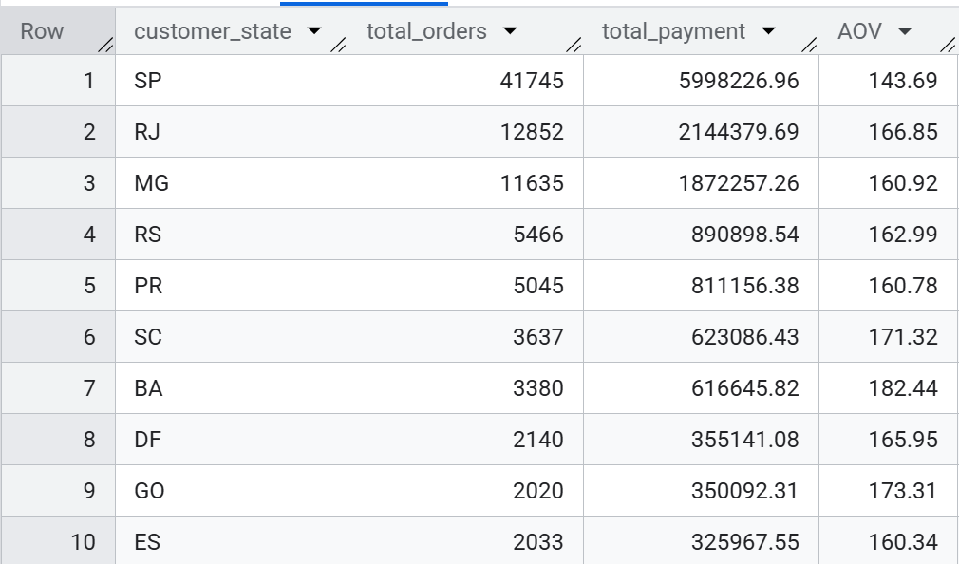

Freight cost burden
Freight burden is calculated as total freight cost divided by total order value. This avoids treating absolute freight cost as a standalone indicator because states with larger order volumes will naturally accumulate more freight.
SQL Output (Sample Data):
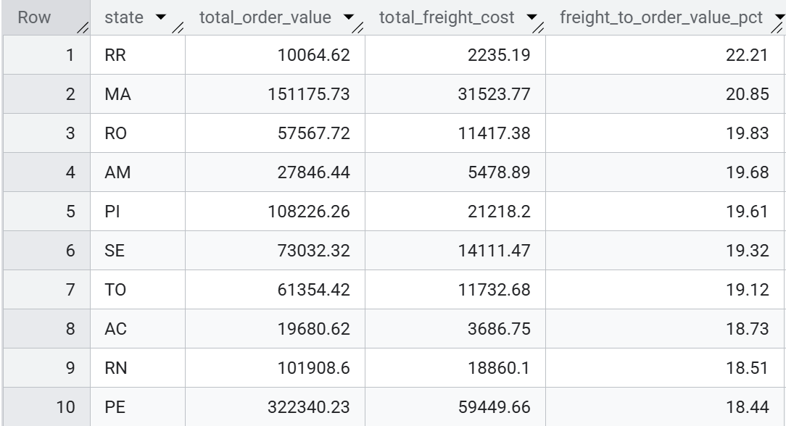
Analytical caution
Freight-to-order-value percentage is a burden indicator, not a profitability measure. A complete margin analysis would require additional cost information beyond freight.

6. Logistics & Delivery
The logistics analysis measures delivery duration from purchase to customer delivery, compares actual delivery against the estimated date, and evaluates state-level relationships between freight burden and delivery time.

Delivery duration
Delivery duration is calculated only for delivered orders with a valid delivered-customer timestamp. The same logic is then applied at state level to compare average delivery duration.
SQL Output (Sample Data):
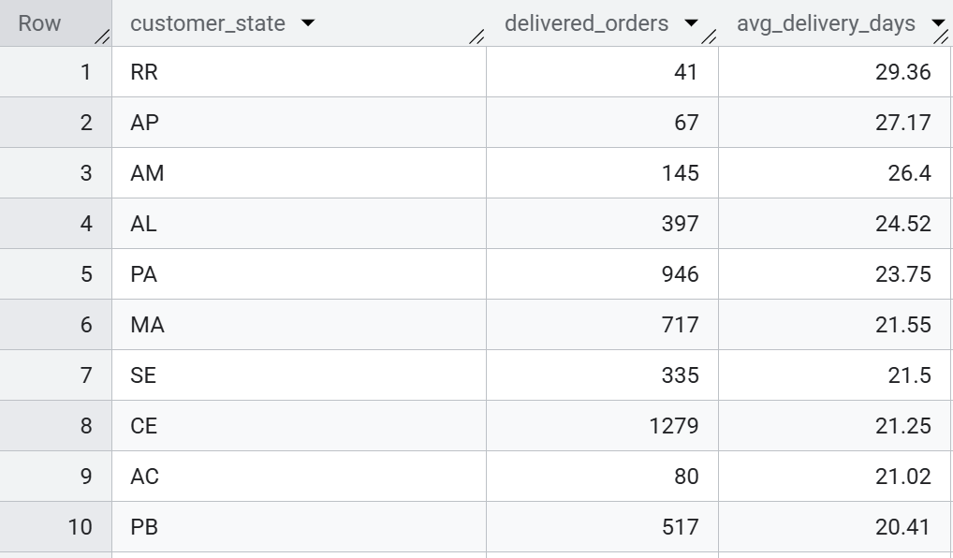

Actual vs estimated delivery
Delivery variance is defined as actual delivered date minus estimated delivery date. Negative values indicate delivery before the estimate, zero indicates delivery on the estimated date, and positive values indicate delivery after the estimate.
SQL Output:

Freight vs delivery time
The analysis calculates a state-level correlation between average freight per order and average delivery days. The resulting coefficient should be interpreted as an association across state averages, not as evidence that freight cost causes delivery delay.
SQL Output:
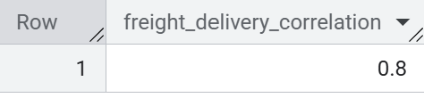

Business interpretation
Overall delivery performance is strong, with 91.78% of delivered orders arriving ahead of the estimated date and orders arriving 11.16 days early on average. However, the strong state-level correlation (r = 0.80) between freight cost and delivery time suggests that geographically expensive-to-serve markets also tend to experience longer delivery durations, highlighting an opportunity for deeper regional logistics analysis.

7. Payment Behaviour
Payment analysis examines payment methods over time and installment behaviour for credit-card transactions. The purpose is to understand how customers complete transactions and whether payment terms vary in a meaningful way.

Payment methods
The monthly payment analysis groups payment value and order count by payment type. This provides a view of payment-method adoption and how payment value changes over the observation period.
SQL Output (Sample Data):
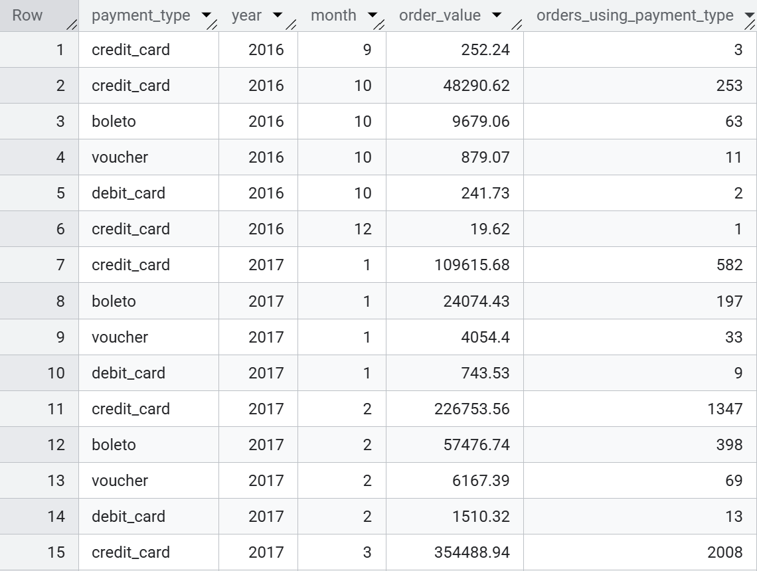
Business interpretation

Credit card is the primary payment method in the observed transactions, accounting for the largest payment value and order volume across the displayed periods. Boleto follows as the second-most-used method, while debit card and voucher remain relatively small contributors. The growth in credit-card transaction volume also broadly follows the overall increase in order activity, making credit card the dominant transaction channel in the observed dataset.

Installment behaviour
Credit-card transactions are grouped into single-term, short-term, medium-term, long-term and very-long-term installment bands. The analysis uses both order counts and payment value to avoid relying on frequency alone.
Installment Term Classification
To understand how customers use credit-card/payment installments, payment_installments was grouped into business-friendly term categories:
Classification logic:
- Single term: 1 installment
- Short term: 2–3 installments
- Medium term: 4–6 installments
- Long term: 7–12 installments
- Very long term: 13–24 installments
- Zero installment: 0 installments
Note: The analysis uses the payment_installments field from the payments table and groups transactions into practical installment bands to make payment behaviour easier to interpret.
SQL Output:
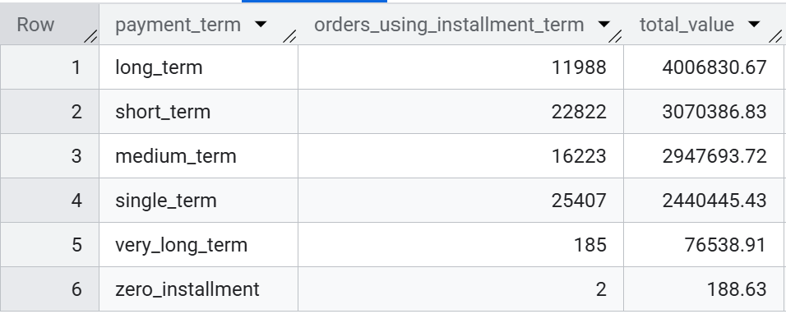
Business interpretation
Shorter payment terms dominate transaction volume, with 62.94% of orders using 1–3 installments. However, long-term payments (7–12 installments) account for only 15.64% of orders while contributing 31.95% of payment value, indicating that longer installment plans are associated with higher-value transactions.

Recent high-value profile
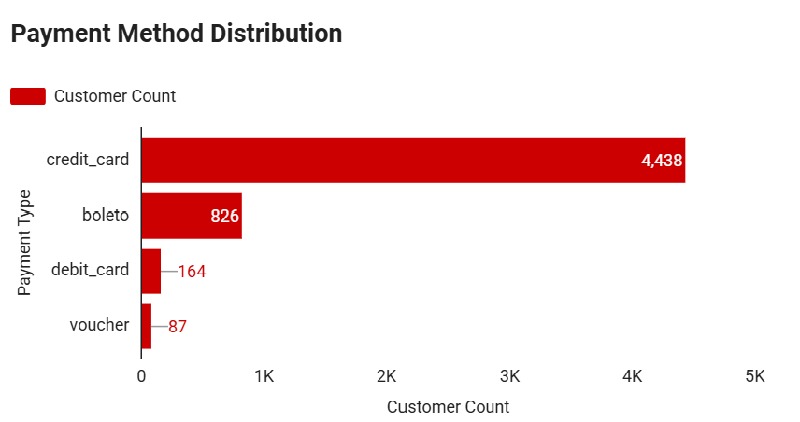
Within the recent high-value one-time segment, credit card is the dominant observed payment method, followed by boleto. This is a segment-specific observation and should not be generalized to the entire customer base.

8. Customer Experience
Customer experience is evaluated using review scores and the relationship between delivery performance and review categories.

Review score distribution
Review scores are summarized by count and share of all reviews. The distribution provides a descriptive measure of observed customer satisfaction.
SQL Output:
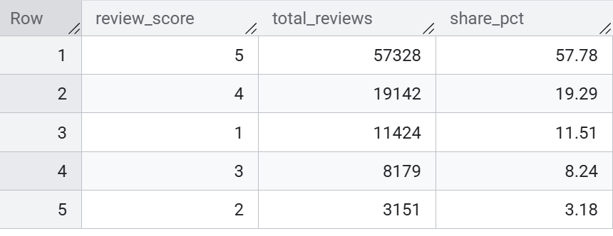

Delivery performance vs review score
Reviews are grouped into bad (1–2), good (3–4) and excellent (5), then compared across early, on-time and late delivery categories. This allows the analysis to test whether review composition differs by delivery outcome.
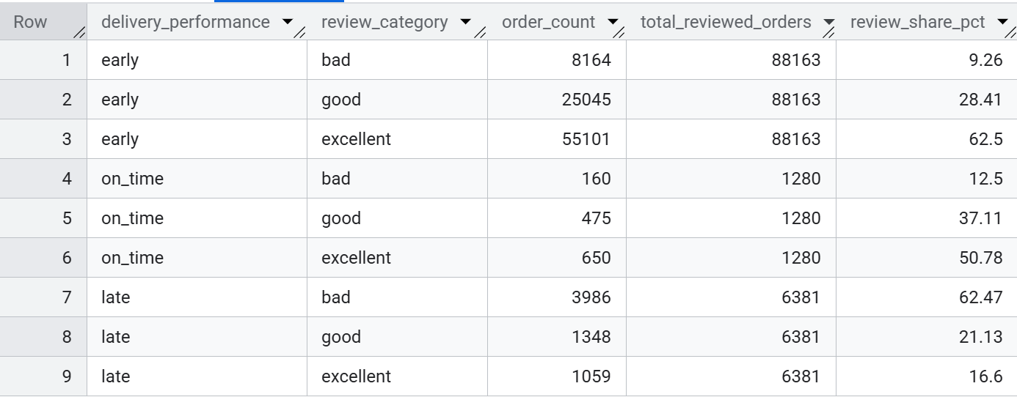
Business interpretation
57.78% of all reviews are rated 5 stars, and another 19.29% are rated 4 stars, meaning 77.07% of reviews are positive (4–5). However, review outcomes differ substantially by delivery performance: 62.50% of early deliveries receive excellent ratings, compared with only 16.60% of late deliveries.

9. Customer Analytics & RFM
The customer analytics layer moves from order-level reporting to customer-level behaviour. A customer-order base is constructed at one row per customer-order, payment values are aggregated to order level, and completed purchases are used for active-customer analysis.

Customer behaviour
Metric | Result
Active customers | 93,358
One-time customers | 90,557 (97.00%)
Repeat customers | 2,801 (3.00%)
Completed-order observed value | R$15,422,461.77
Average observed customer value | R$165.20
Median observed customer value | R$107.78

Customer value concentration
Customer value concentration shows that 48.85% of customers account for 80% of observed customer value. This is materially different from a simple 80/20 assumption and demonstrates why concentration should be calculated from the actual customer distribution.
Key finding
The customer base is broad and predominantly one-time, while observed value is meaningfully concentrated among a smaller share of customers.
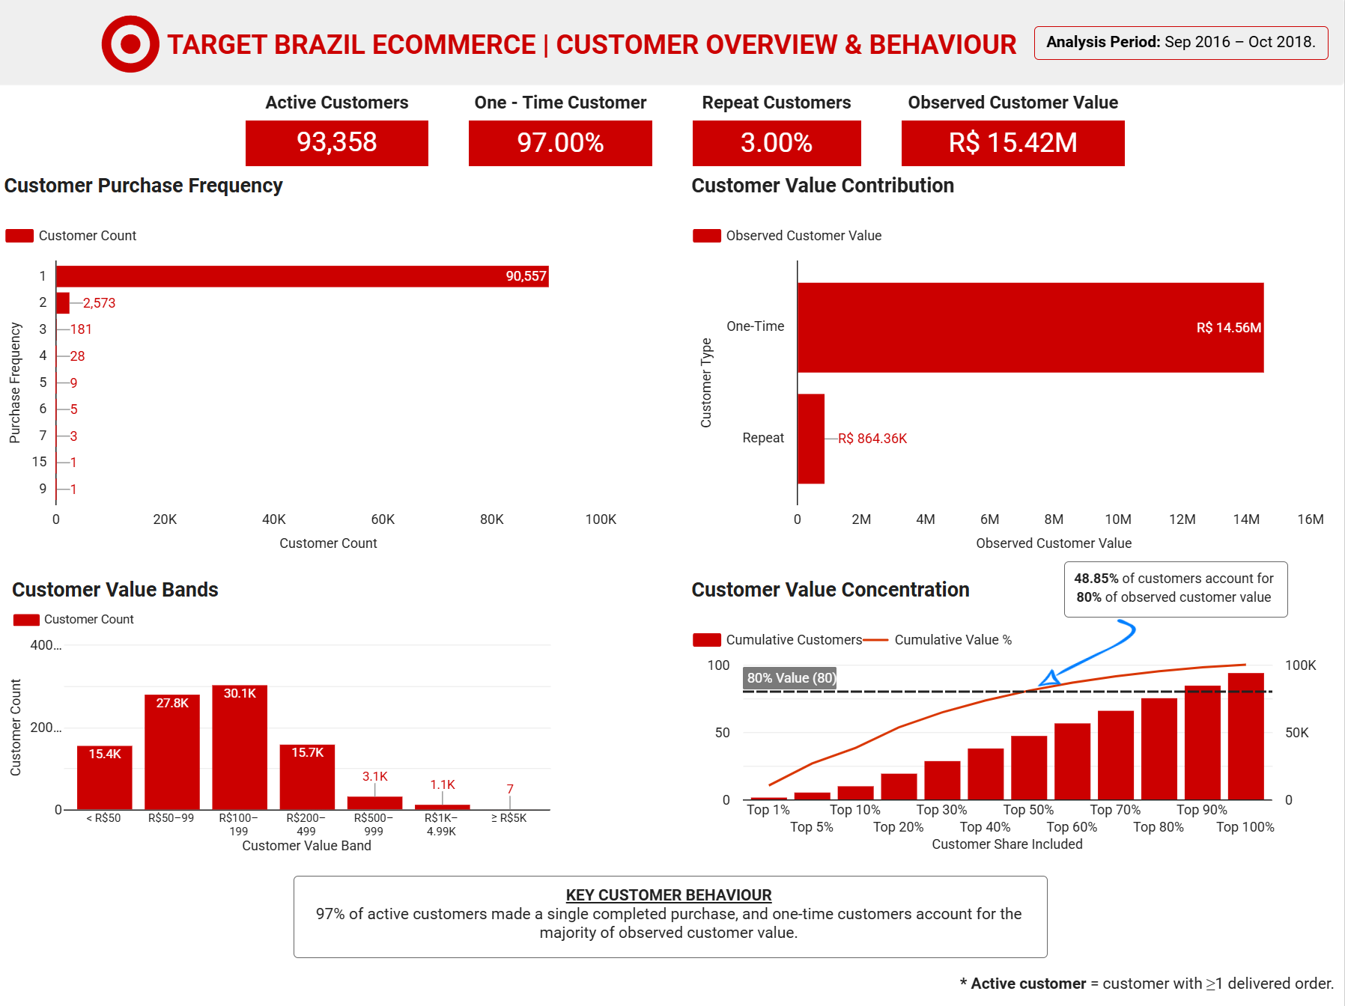

RFM segmentation
RFM segmentation combines Recency, Frequency and Monetary value. The dashboard uses R4 for the most recent customers, R1 for the least recent, F4 for the highest frequency and F1 for one-time customers. The RFM matrix shows that 97% of active customers are F1.
RFM component | Dashboard interpretation
Recency | R4 = most recent; R1 = least recent.
Frequency | F4 = highest frequency; F1 = exactly one completed order.
Monetary | M4 = highest observed customer-value band; current high-value threshold is > ₹182.40.

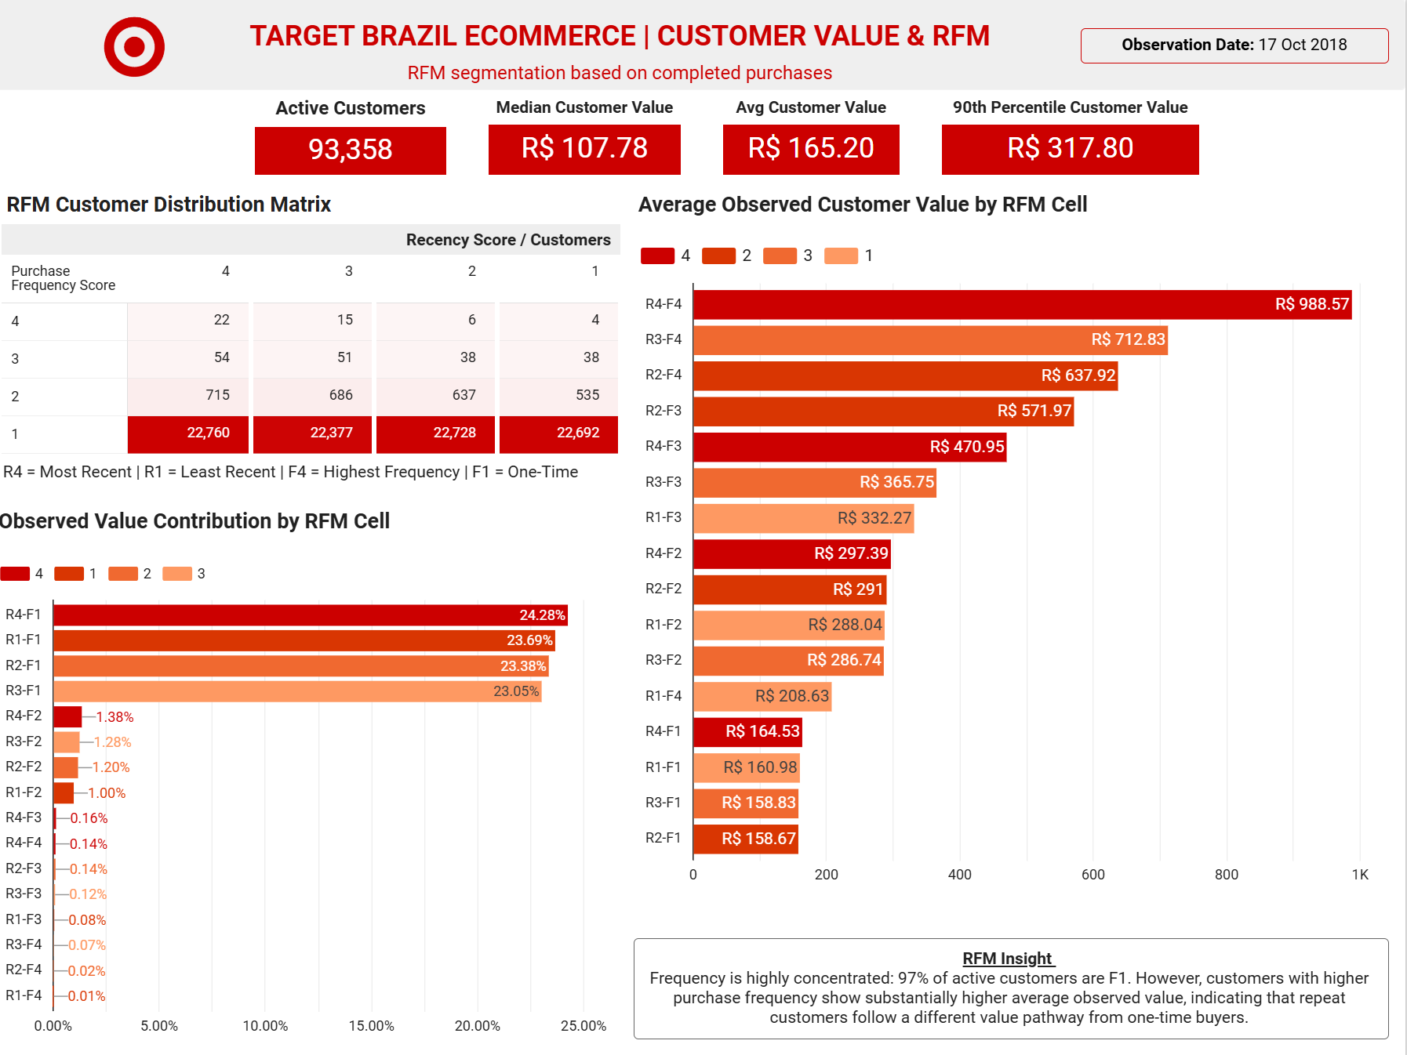
RFM insight
Although F1 customers dominate the population, higher-frequency customers show substantially higher average observed value. This indicates a distinct value pathway associated with repeat purchasing.

10. High-Value Customer Pathways
The high-value pathway analysis compares one-time and repeat customers within the high-value monetary segment. This separates two different ways customers can generate observed value: one high-ticket purchase versus multiple lower-value purchases.
Metric | High-value one-time | High-value repeat
Customers | 21,586 | 1,771
Average observed customer value | R$390.63 | R$415.46
Average orders per customer | 1.00 | 2.16
Average order value | R$390.63 | R$194.91
Average items per order | 1.32 | 1.29

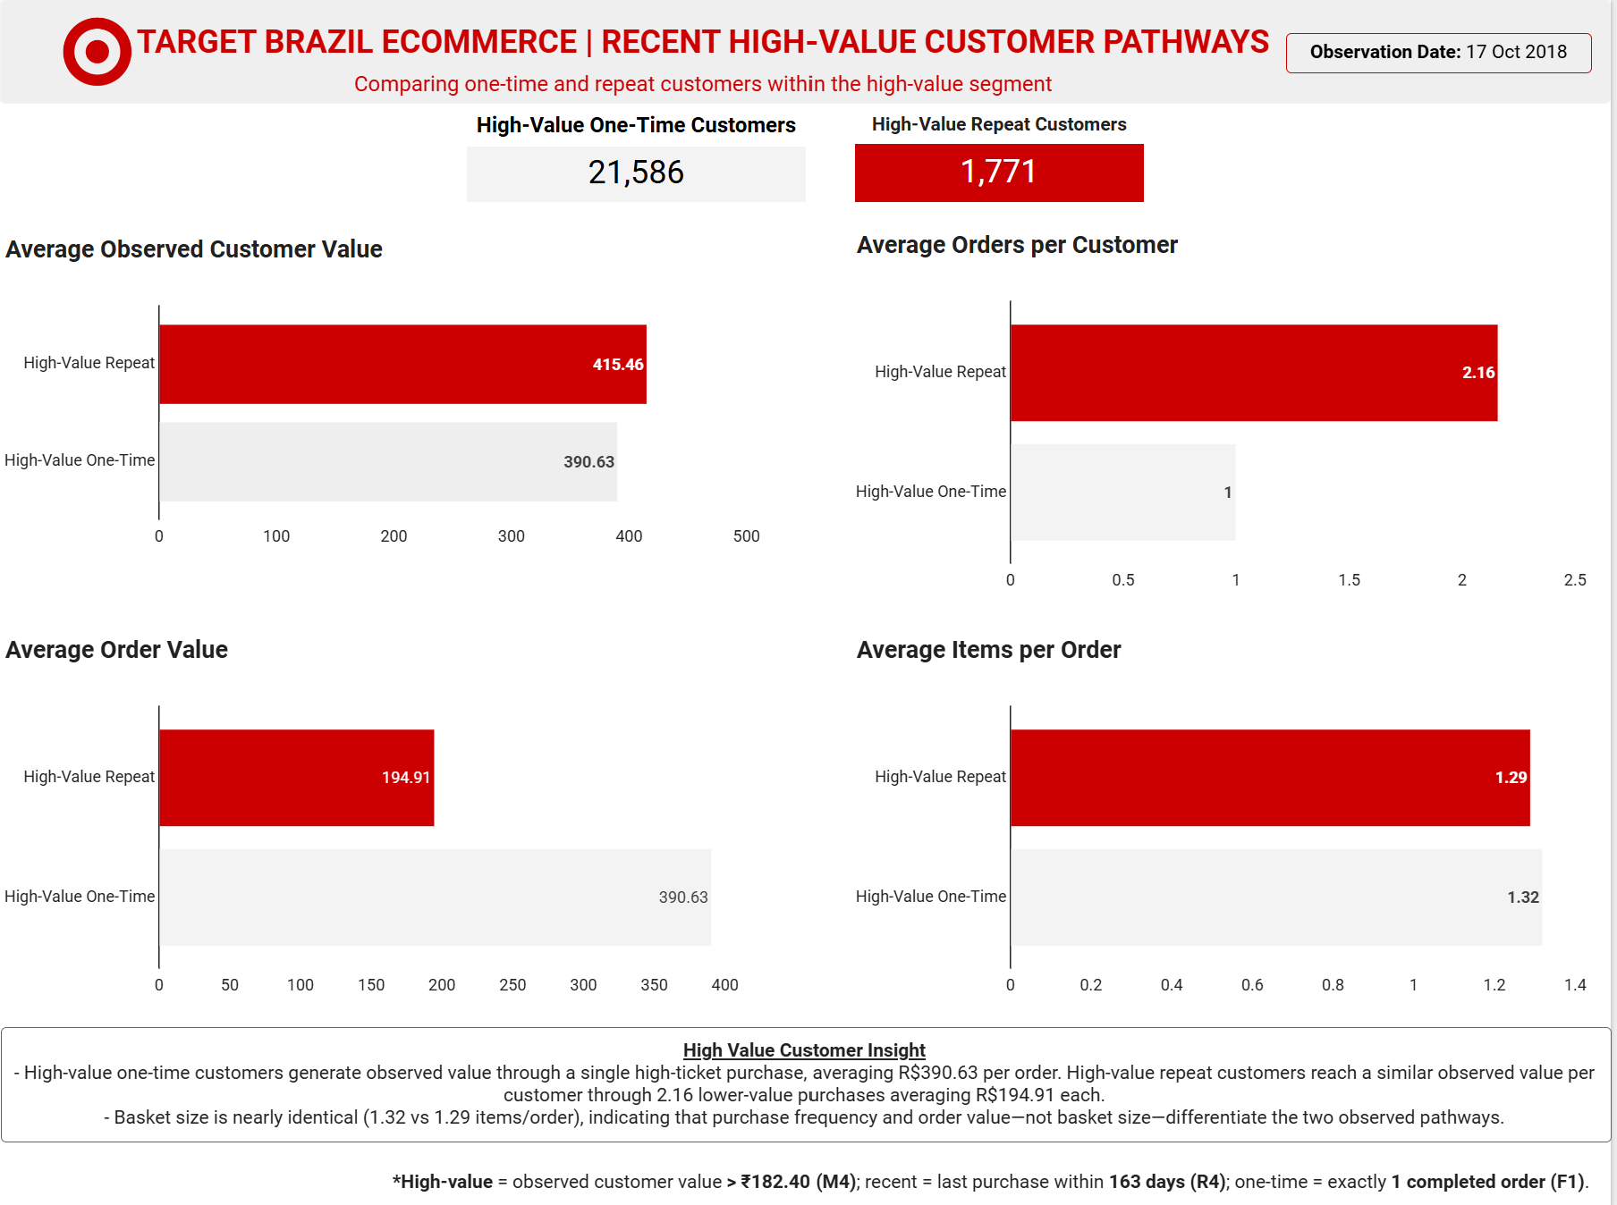

Business insight
- High-value one-time customers generate observed value through a single high-ticket purchase.
- High-value repeat customers reach a similar observed value per customer through approximately 2.16 purchases with lower average order value.
- Basket size is nearly identical between the groups (1.32 vs 1.29 items/order), so purchase frequency and order value—not basket depth—differentiate the observed pathways.
Definition
High-value = M4 observed customer value > ₹182.40; recent = R4, last purchase within 163 days of 17 Oct 2018; one-time = exactly one completed order.

11. Recent High-Value Customer Profile
The recent high-value profile focuses on customers who are recent, one-time purchasers with high observed customer value. The purpose is to understand where these customers are concentrated and what their purchase pattern looks like.
Metric | Result
Recent high-value one-time customers | 5,515
Observed customer value | R$2.20M
Average order value | R$399.30
Average review score | 4.19
SP + RJ + MG share | 61.24%
Single-item orders | 80.82%
Average delivery time | 10.51 days
Delivered before estimated date | 93.82%
Positive reviews (4–5) | 79.87%
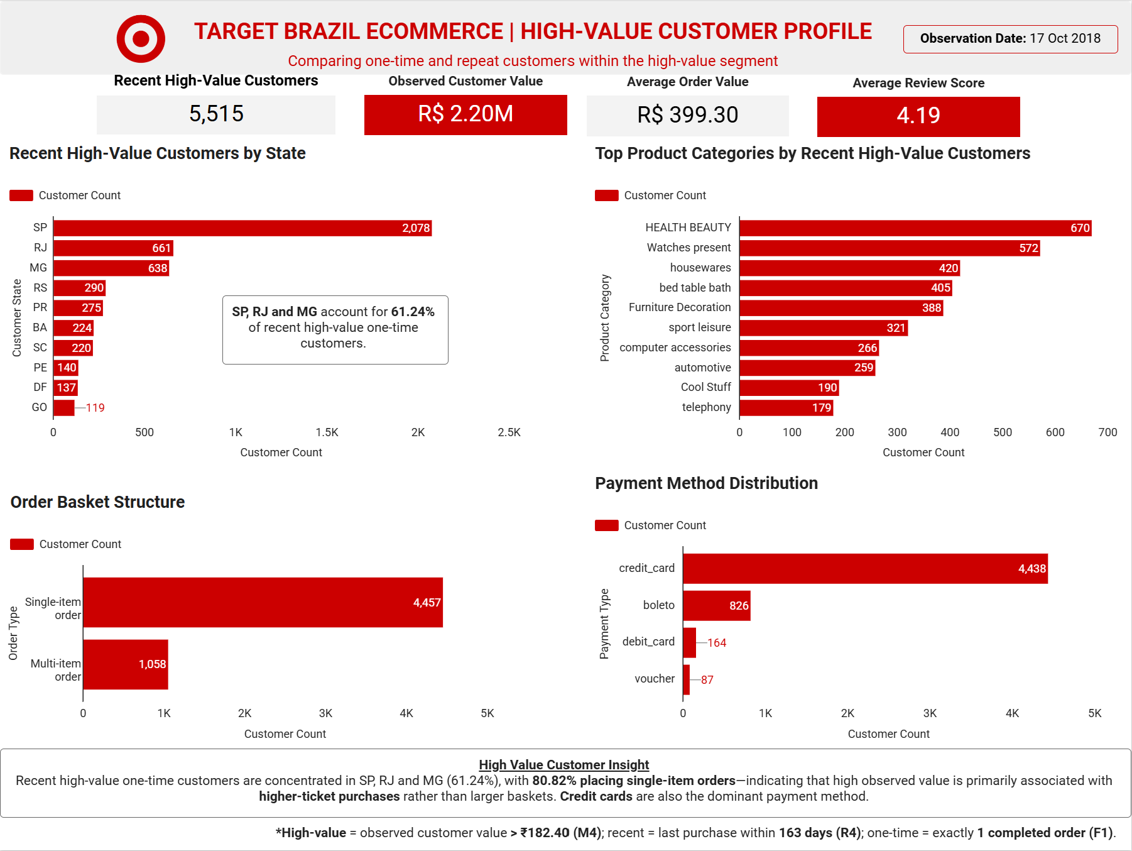

Geographic profile
São Paulo, Rio de Janeiro and Minas Gerais together account for 61.24% of recent high-value one-time customers. São Paulo alone contributes 2,078 customers, followed by Rio de Janeiro at 661 and Minas Gerais at 638.

Product and basket profile
Health Beauty and Watches present the largest observed customer counts among the top product categories for this segment. The basket structure is dominated by single-item orders: 4,457 single-item versus 1,058 multi-item observations in the supplied profile analysis.
Key insight
The recent high-value one-time segment is geographically concentrated and primarily characterized by higher-ticket, single-item purchases rather than deep baskets.

13. Executive Recommendations
The recommendations below translate the observed evidence into areas for further commercial and operational investigation. They are framed as analytical priorities rather than claims of causality.
- Prioritize repeat-purchase analysis. With 97% of active customers making only one completed purchase, repeat behaviour is the clearest customer-value differentiation in the observed dataset.
- Use RFM to structure customer targeting. RFM can separate recent, infrequent and high-value groups without relying on unsupported churn labels.
- Investigate high-value one-time customers as a conversion opportunity. The segment contains 5,515 recent customers and R$2.20M of observed value, with high average order value.
- Focus geographic analysis on SP, RJ and MG. These states represent 61.24% of the recent high-value one-time segment and can be used as priority markets for category and customer analysis.
- Evaluate high-ticket purchase pathways. The high-value one-time segment averages R$390.63 per order, while repeat high-value customers reach similar customer value through more frequent, lower-value orders.
- Use logistics and review analysis as supporting diagnostics. The recent high-value segment shows generally positive observed delivery and review outcomes, so the available evidence does not support assuming poor service explains non-repeat behaviour.
- Use payment and installment analysis to understand transaction mechanics, but avoid treating payment method alone as a driver of customer value without additional controlled analysis.
- Preserve order-level analytical grain. Aggregate payments and order items before joining them to customer or order-level metrics to prevent double counting.

14. Data Limitations & Analytical Caveats
- The dataset ends on 17 Oct 2018. Recent customers have a shorter opportunity window for repeat purchase, which limits direct churn interpretation.
- One-time customer behaviour is not equivalent to churn.
- Observed customer value is historical transaction value, not predicted Customer Lifetime Value and not profit.
- Payment value may contain multiple payment records per order; payment data must be aggregated before order-level joins.
- Order items can contain multiple records per order; item-level joins can multiply order-level measures if grain is not controlled.
- Review records may not be one-to-one with orders; review joins should use distinct order logic where appropriate.
- Geolocation is a reference dataset and should not replace customer master geography when the objective is customer-state analysis.
- State-level correlations describe association across state aggregates and should not be interpreted as individual-level causal relationships.
- The high-value threshold is a scoring convention within the RFM framework and should not be interpreted as a universal definition of a valuable customer.
- Category counts in the recent high-value profile are customer-level views and should be interpreted according to the specific aggregation logic used in the SQL.

Analytical definitions
Term | Project definition
Observation date | 17 Oct 2018
Active customer | At least one delivered order
Observed customer value | Sum of payment value from completed/delivered orders
One-time customer | Exactly one completed order
Repeat customer | More than one completed order
High-value / M4 | Highest monetary score; current dashboard uses > ₹182.40
Recent / R4 | Last purchase within 163 days of observation date

15. Portfolio Deliverables
- GitHub: SQL scripts organized by analytical phase.
- BigQuery: source tables, analytical views and customer-level derived datasets.
- Looker Studio: four-page customer analytics dashboard covering overview, RFM, high-value pathways and recent high-value profile.
- ER Diagram: relational model showing tables, primary keys, foreign keys and one-to-many relationships.
- Detailed Analysis Report: business-facing findings, interpretation, limitations and recommendations.
- README: project context, business questions, data model, tools, dashboard link, key insights and repository structure.

Appendix — Analytical Question Map
Phase | Questions | Coverage
Phase 1 – Data Quality & Integrity | Q1–Q2 | Table profiling, null audit and missing-value investigation
Phase 2 – Demand, Growth & Seasonality | Q3–Q5 | Monthly order trend, seasonality and time-of-day demand
Phase 3 – Customer & Geographic Demand | Q6–Q7 | State/city concentration and state-level fulfilment
Phase 4 – Order Value & Unit Economics | Q8–Q10 | State-level payment value, AOV and freight burden
Phase 5 – Logistics & Delivery | Q11–Q14 | Delivery duration, ETA accuracy, state logistics and freight/delivery association
Phase 6 – Payment Behaviour | Q15–Q16 | Payment methods, monthly payment trends and installment behaviour
Phase 7 – Customer Experience | Q17–Q18 | Review distribution and delivery performance vs review score
Customer Analytics Extension | Derived analysis | Customer value, RFM, concentration, high-value pathways, recent high-value profile and retention

Conclusion
The Target Brazil e-commerce project demonstrates an end-to-end customer and operational analytics workflow in which SQL is the analytical engine, BigQuery provides the scalable data layer, Looker Studio is the communication layer, and business interpretation is the final deliverable. The strongest portfolio story is the ability to move from a relational data model and data-quality checks to customer behaviour, RFM segmentation, value concentration, high-value pathways and evidence-based business priorities.
The project intentionally separates observed behaviour from assumptions about future behaviour. In particular, one-time customers are not labelled as churned because the dataset has a fixed observation end date. This methodological discipline strengthens the credibility of the analysis and provides a clear foundation for future retention or predictive modelling.

