How to get started with this project

: This project showcases the implementation of user friendly chatbot, here we have considered a business case of a Massage parlour, this massage parlour has a website where they showcase their products and users can book online consulting or appointment with this massage parlour, **the chatbot should be giving answers based on the content of the website**

Language of the chatbot:

: Here we are considering the Spanish language as our first choice of language and the bot designed would be giving answers in Spanish unless we specify it to give answers in English

Let’s discuss the implementation of the chatbot from scratch:

Now as we know that, we want to design a simple user friendly chatbot which should be able to answer any questions related to the business of the massage parlour, the pricing, massage recommendation as per the budget, and other things which can be answered smartly

We would be now explaining the flowchart below

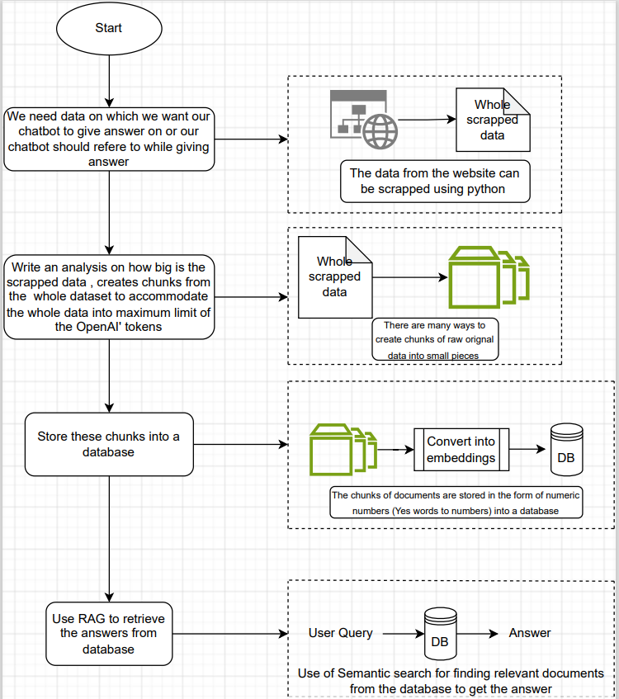

Flowchart for Chatbot implementation – A separate file representing this flow is available in pdf format

I highly recommend you to please follow this explanation with Jupyter notebook provided for better understanding

Step 1: