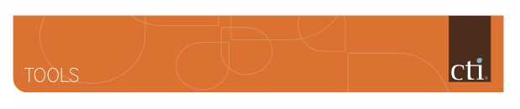



# The Wheel of Life

The Wheel of Life provides a unique model for clients. The wheel shows clients what balance in their life looks like. Coaches use this tool with clients in the discovery session, sample sessions and to get a sense of fulfillment in the client’s life.

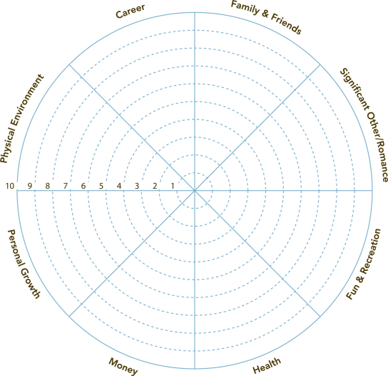Using the Wheel of Life in a coaching session:

1. Briefly explain the wheel and what it signifies to your client.

The wheel of life is a tool coaches use to get a snapshot of how satisfied a client is in their life. There are eight areas on the wheel. You may want to change the categories to reflect the areas of your life.

For example: The client may choose to break the category of friends and family into two separate categories. The client may wish to add a category.

1. Ask the client to rate their level of satisfaction in each of the areas.

* “I am going to ask you to rate your level of satisfaction in eight areas of your life.

Zero means not satisfied and 10 means highly satisfied.”

1. After the client has rated each of the areas. Ask them to connect the lines to form an inner wheel. This gives the client an overview of balance in their life.

* “Remember, this is not about getting 10s ! It’s about a smoother ride.”
* “If this wheel were a tire on your car, how bumpy would the ride be?”

Listen to the client’s response and then move to step 4.

1. Ask the client, What area would you like coaching on? Or what area are you ready to make a change in?

Once an area is selected, continue to ask powerful questions to move the client forward.

1. Wrap up the coaching session by making a request, or by giving the client a homework assignment.
2. Be sure to hold the client accountable. What will you do? When? How will I know?