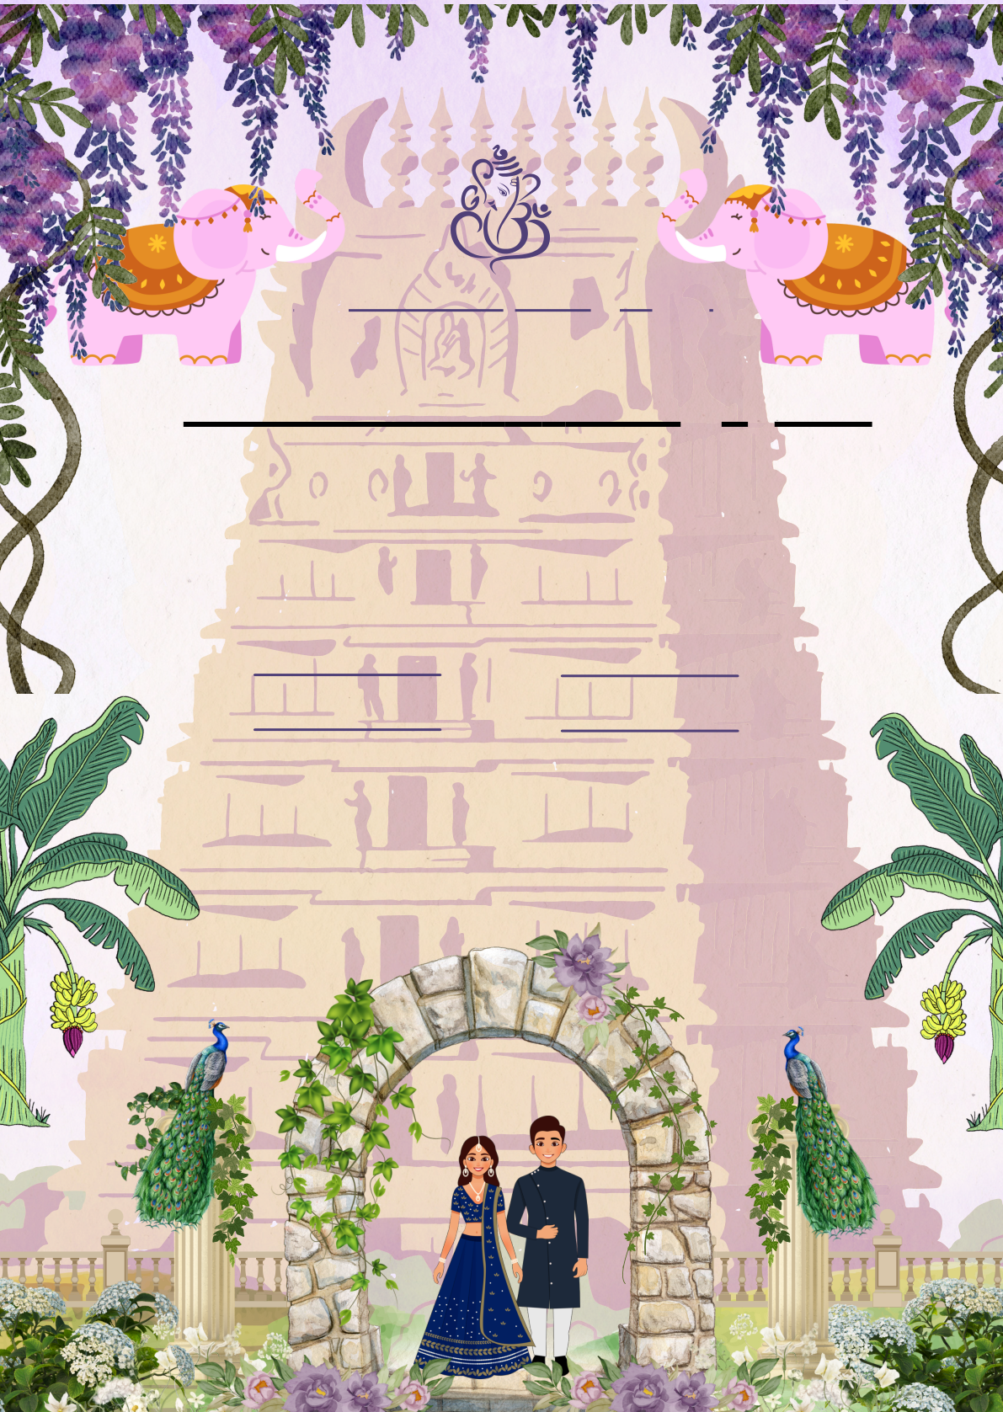
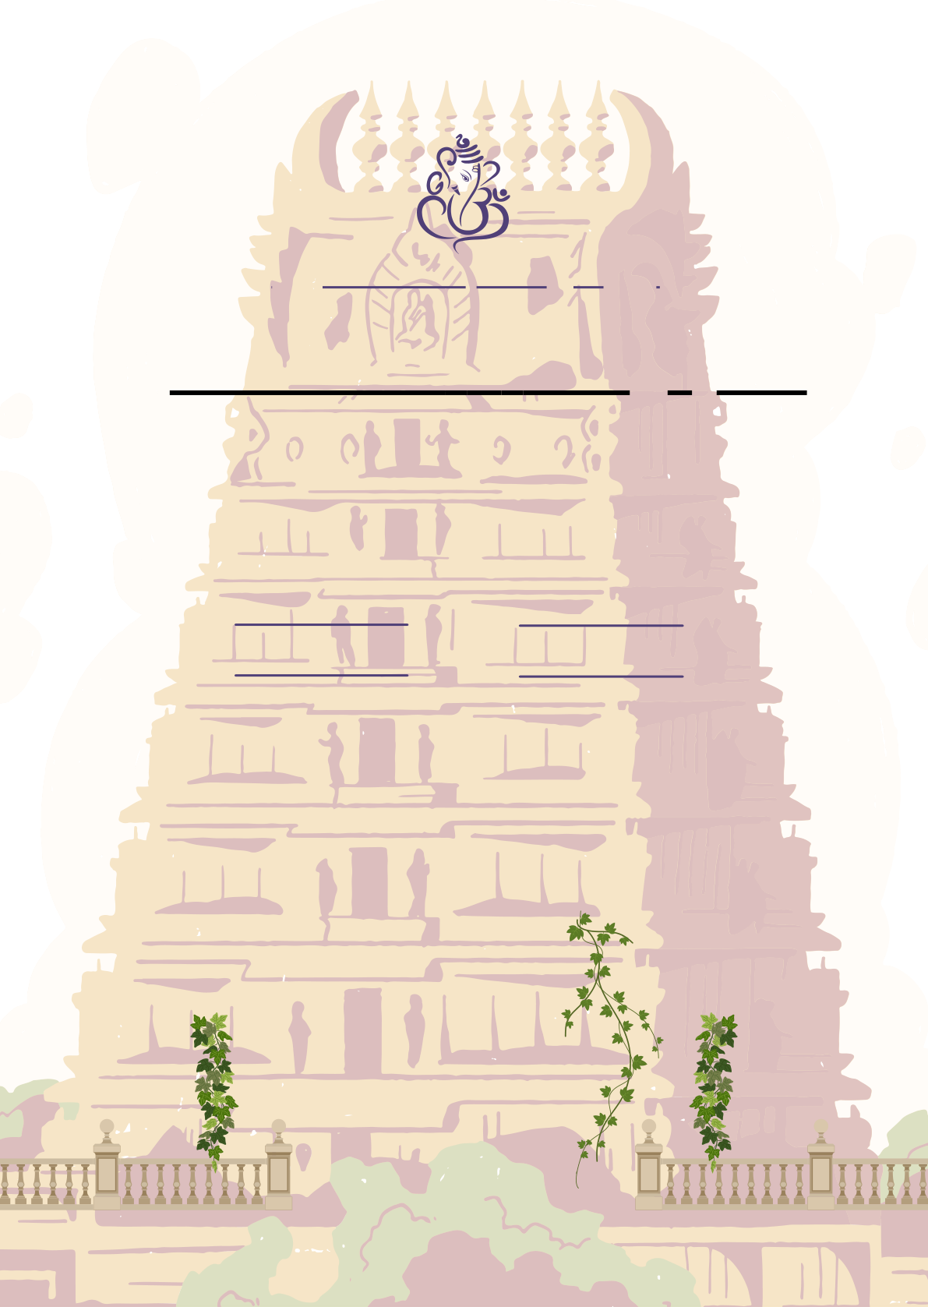
்ரீ
R.Keerthana & B.V.Jayanth
D/O S/O
Mr. R.Ravi Mr. K.Venkatesh
Mrs. R.Gayathiri Mrs. C.Bhagavathi
Grand child of Grand child of
(late)Grandfather Rajamanikam Grandfather Mr. Chidambaram
Mrs. Grandmother Thulasi Grandmother Mrs. Jaya
November
Sunday30 At 6 am
2025
Sri Madheswara Thirumana Mandapam.
Paramathi,Namakkal,Tamil Nadu 637207
are inviting for their wedding
ceremony

