Question-Bank: Mixed Questions
Topic: Maths
Sub-topic: Equations
Marks: 2,-1

Direction: This is the direction for the question 1-4
Passage:
India has a unified legal profession governed by the Advocates Act of 1961. The entry to the
profession is perhaps less rigorous than it ought to be. The standard qualification for the entry is
graduation in law rather than any practical training.

At present there are about 500 law colleges of
varied quality. The nature of legal education is relevant not merely for professional competence. It
also determines how far a lawyer cultivates his professional obligation to his client, to Courts and to
the society at large. The present relaxed entry to the profession has led to a prolific number of
lawyers approaching 500,000, a distinction exceeded only by the United States.

1. The magnificent constitution that we have framed was later kidnapped and purloined by the
lawyers. The underlined word means
(a) derogated.
(b) stolen.
(c) maligned.
(d) ignored
(e) insulted

2. Which of the following cannot be inferred from the passage ?
(a) A majority of the Indian political leaders are lawyers.
(b) Very few junior lawyers practice in different states.
(c) It is not difficult to join the legal profession.
(d) civil litigation is very limited in India
(e) none of the above.
Ans: b

3. The costs are calculated on such a nominal basis as to be almost derisory. The underlined
word maybe replaced with
(a) ridiculous
(b) negligible
(c) biased
(d) deflationary
(e) irrelevant
Ans: c

4. Mansfield suggests that It is better not to give reasons for a judgment. By this he means
(a) no two persons normally reason in the same way.
(b) all arbitrators make correct decisions but their logic is often erroneous.
(c) two persons in argument will never see the decision of an arbitrator in the same light.
(d) giving reasons leads to move debates on the decision
(e) none of the above
Ans: d

Topic: Maths
Sub-topic: Equations
Marks: 2,-1

Q5. What is the author's attitude towards departmental societies.
(a) thus feel that they are working in an executive capacity.
(b) are too independent of the corporation to submit willingly to
(c) become estranged from the owners with whom they can no longer
(d) are desirous of improving their skills.
Answer: a,b,c

Sub-topic: General
Direction: This is the direction for this question.
Q6. what is the capital of india?
<img>
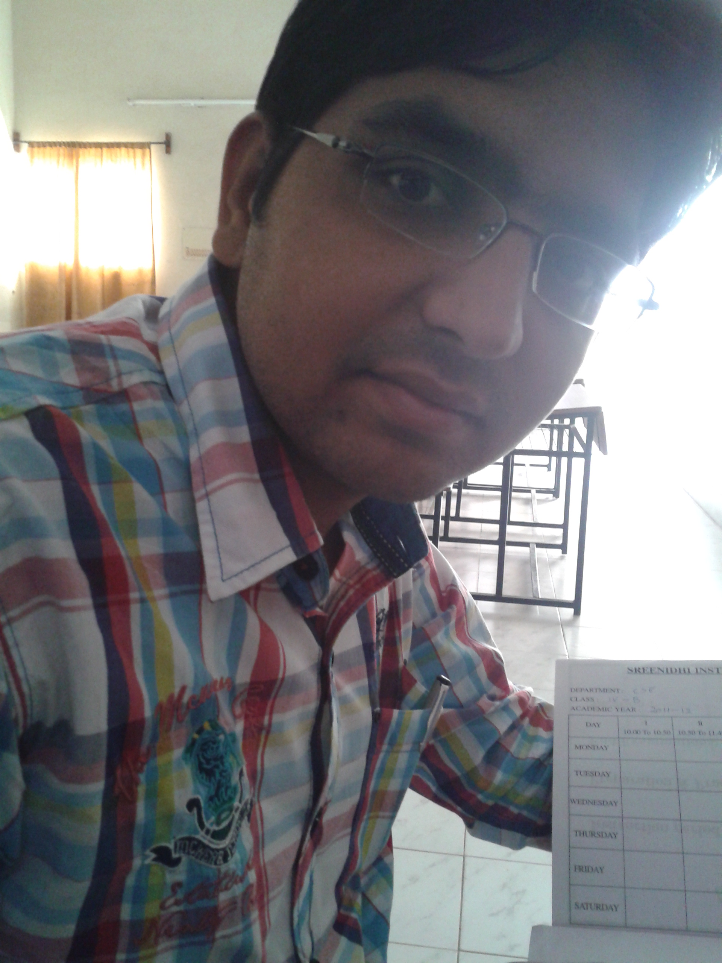
a. Delhi
b. New Delhi
Ans: a,b

Q7. who among this is from pandavas?
(a) Bheem
(b) yudhistir
(c) Arjun
(d) Nakul
(e) Duryodhan
Ans: a,b,c,d

Q8. who is the prime minister among these?
(a) Atal bihari vajpayee
(b) Apj abdul kalam
(c) Manmohan Singh
(d) Pratibha Patil
Ans: a,c

Q9. which of these are states?
(a) Delhi
(b) karnataka
(c) Haryana
(d) Chandigarh
(e) Punjab
Ans: b,c,e

Topic: Algebra
Sub-topic: newly
Tags: easy,3,0

Directions: Each of the following question 10-12 has this as direction
Q10. "Atwiddle " in line most likely means
A. upright
B. alert
C. flaccid
D. quiescent
<img>

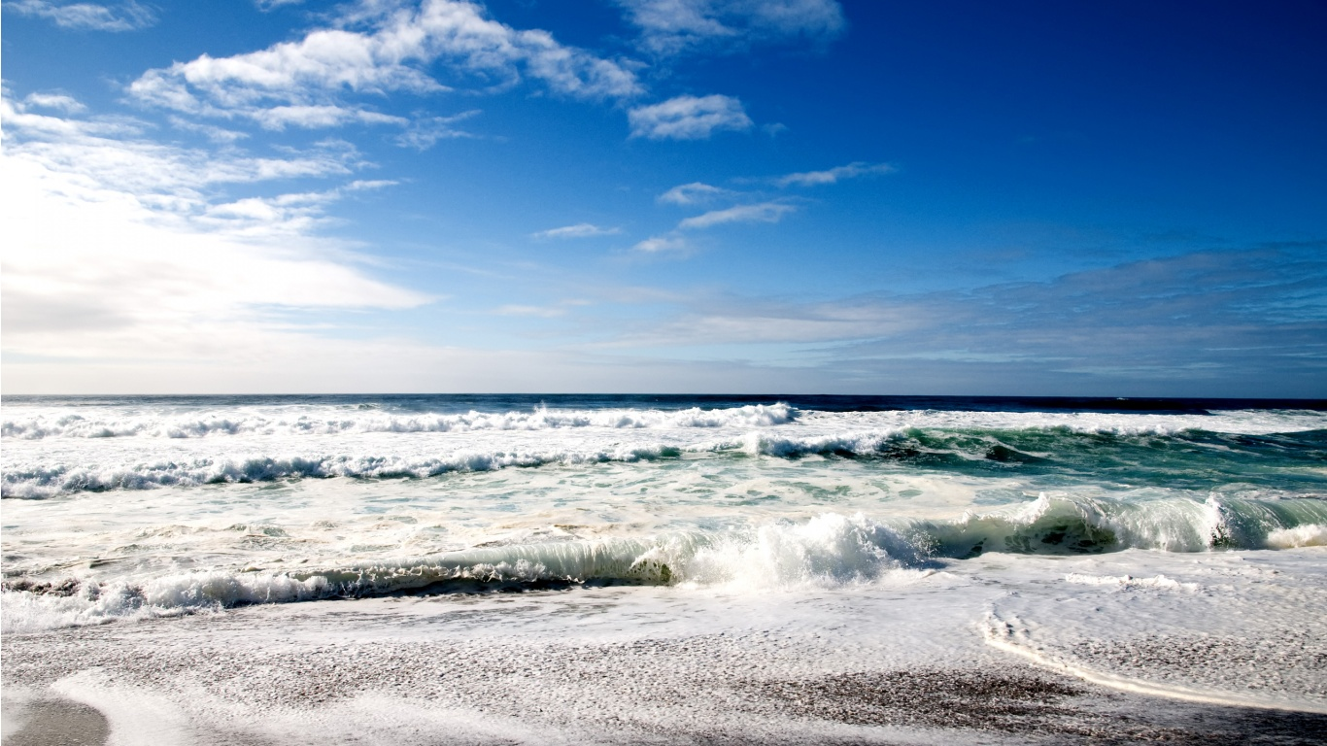
E. inquisitive
Ans: A
Tags: medium,2,0

Q11. Where are You?
(a) Delhi
(b) Hyderabad
(c) Chandigarh
Ans: b

Q12. I, he and you must go to the party.
(a) You, he and I
(b) he, I and you
(c) I, he and you
(d) You, I and he
(e) I, you and he
Ans: a

Q13. She is better than any teacher.
(a) better than any
(b) better any
(c) better than any other
(d) better than any one
(e) good than any
Ans: b

Q14. Only a few apples its left.
(a) it left
(b) its left
(c) is left
(d) are left
(e) its leaving
Ans: d

Direction: This is the direction for india as a question.
Q15. Which city is called as pink city?
Ans: Jaipur

Q16. Where is the problem?
Ans: In the direction.

Direction: This is the direction for 17-20 a question.
Q17. Where is India?
Ans: Asia

Q18. Which lap you are using?
Ans: DEll

Q19. What is the capital of india?
Ans: New Delhi

Q20. what is the formula of water____?
Ans: H2O

Q21. who is the father of computer____?
Ans: Charles Babbage

Q22. _____ is the first prime minister of india?
Ans: Jawahar Lal Nehru

Q23. what you want to have _____?
Ans: Cold Drink.

