A [survey paper](http://59.108.48.12/lcwm/wanxj/files/summ_survey_draft.pdf) by Jin-ge Yao et. al. in summarizes various works that were published in the field of text summarization in the last 5-6 years. Taking help of this work we have chosen the papers which present the results for the datasets listed below and also keeping in mind the conferences in which they were published.

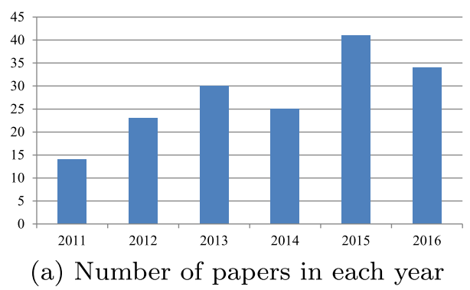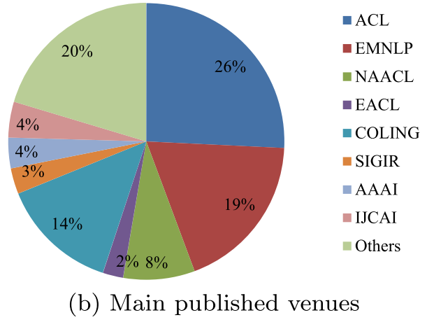

## Conferences

* ACL
* EMNLP
* NAACL
* EACL
* COLING
* SIGIR
* AAAI
* IJCAI

## Datasets

* Text Analytics Conferences (TAC)
* Document Understanding Conference (DUC)
* Gigaword
* CNN
* LCSTS