PRE-ARB AI AGENT
Design Approach, Architecture & Workflow
Enterprise Architecture • Architecture Review Board Automation

Vijaykumar Dixit - 06-March-2026

1. Executive Summary
The Pre-ARB AI Agent is an intelligent automation layer that accelerates and standardises the Architecture Review Board (ARB) process. It captures intake data, validates solution architecture artifacts against the enterprise knowledge base, assesses Non-Functional Requirements (NFRs), and produces a structured pre-ARB dossier — all before the ARB panel convenes.

Problem Addressed  Long turnaround, unstructured reviews, missing evidence, open-ended outcomes | Agent Outcome  Structured pre-ARB report with ADRs, RAG scores, decisions and traceable actions | Human in the Loop  SA provides artifacts; EA validates, accepts or overrides agent decisions before full ARB

2. Problem Statement & Motivation
Current ARB reviews face several structural challenges that this agent directly addresses:

Current ARB Constraints
- Long turnaround from EARR/PTX ticket to approval — SLAs on SA and EA not enforced
- Scheduling of ARB is slow; no standard pre-ARB or informal readiness checks
- ARB panel is too large, diluting focus and accountability
- Reviews are MNE/application-scoped, missing end-to-end platform and cross-cutting impact
- No standard agenda; reviews devolve into unstructured panelist Q&A
- FINDINGS issued rather than Architecture Decision Records (ADRs) with owners and deadlines
- Discussions are open-ended — no clear approve / approve-with-conditions / defer / reject taxonomy

Proposed Solutions Automated by Agent
- Set SLAs for SA and EA and track them automatically via workflow engine
- Automated validations and AI-enabled reviews reduce manual preparation effort
- Focused participant list with roles enforced via workflow gates
- Agent scope covers Business, App, Data, Integration, Infra, Security and DevSecOps views
- Fixed, time-boxed agenda template generated per review
- ADRs generated with owners, target dates and conditional approval tracking
- Decision taxonomy enforced: Approve / Approve with Actions / Defer / Reject

3. Agent Design Overview
The Pre-ARB AI Agent is a multi-step, human-in-the-loop agentic system composed of four primary subsystems:

1  Intake & Ingestion | 2  Knowledge Retrieval | 3  Validation & Scoring | 4  Report Generation
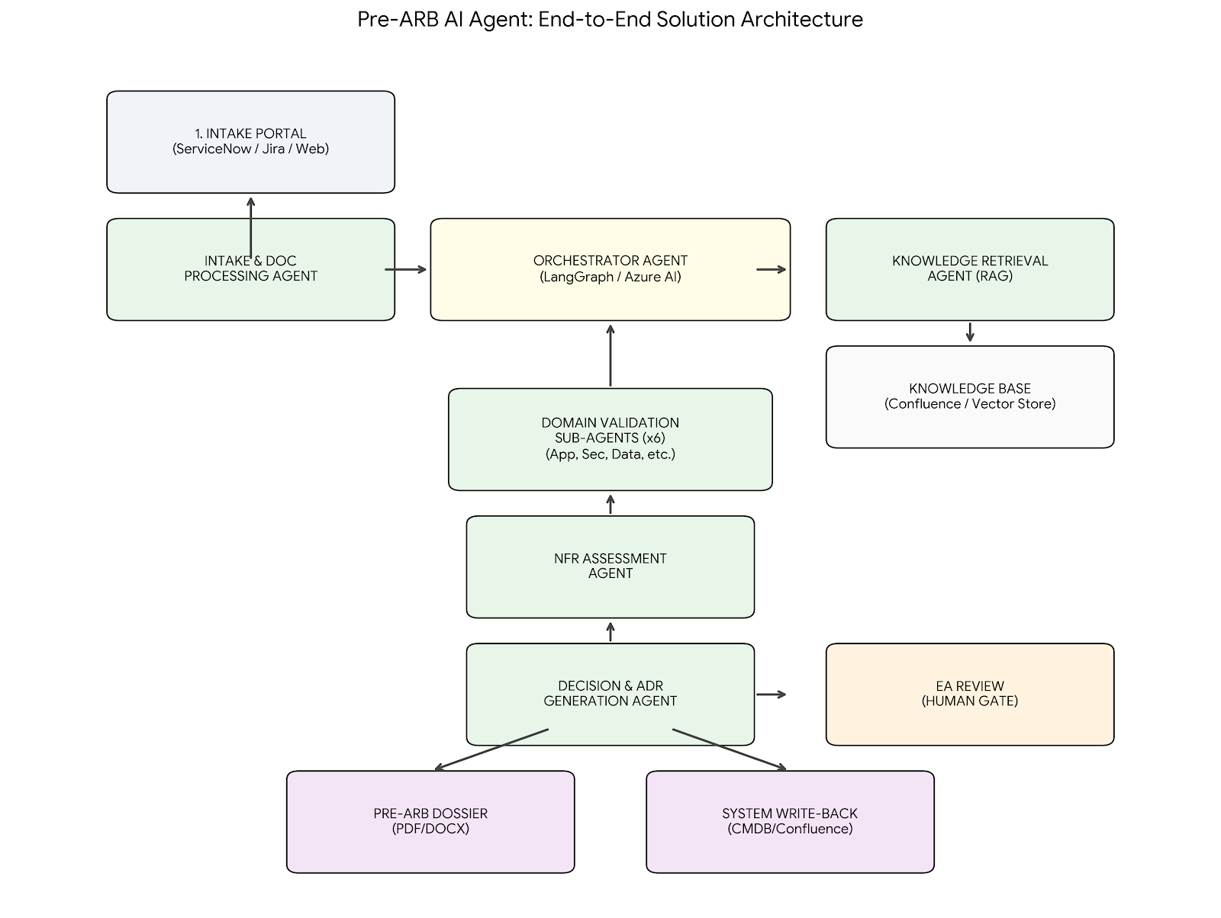

4. Intake Form & Required Inputs
The agent surfaces a structured intake form to the Solution Architect (SA) or LOB/Platform owner. All fields are mandatory before the agent proceeds to analysis. The form is orchestrated via a workflow portal (e.g. ServiceNow, Jira, or a custom web form).

4.1 SOLUTION CONTEXT

Solution / Platform Name | Name of the platform, solution, or service under review
Business Problem Statement | Clearly articulated problem the solution addresses, including goals, constraints, KPIs and success metrics
Business Use Cases | List of use cases and capabilities impacted; domain model overview; service / contract / functions
Growth / Change Plans | YoY growth projections, change in business model or priority, alignment to target architecture / roadmap
Stakeholders & Users | Actors, user groups, geo-regions, multilingual needs, multi-currency requirements, operation times

4.2 ARCHITECTURE ARTIFACTS (UPLOADED BY SA)

Current State Diagram | AS-IS architecture: context, component, sequence and key flow diagrams across all architecture views
Target / North Star Diagram | FSA / North Star with transition states 1..N showing evolution path
Architecture View Diagrams | Separate diagrams for: Application, Integration, Data, Security, Infrastructure, Operations
Integration Catalogue | SR, Provider, Consumer, Pattern/Type/Method, Async/Batch/Sync, Frequency, Data Flows, NFRs per integration
ADRs (existing) | Any previously recorded Architecture Decision Records, waivers or known deviations
SBOM / Dependency List | Software Bill of Materials including library EOS dates, license expiry, planned upgrades

4.3 NFR EVIDENCE PACK

Scalability & Performance | Number of users, YoY growth, concurrent users, TPS/API calls, response time targets (<3 sec), batch/peak load  Performance test results or benchmarks
HA, Resilience & DR | Single points of failure analysis, HA targets (Four 9s / Five 9s), DR/RPO/RTO targets  Failover strategy, self-healing capabilities, error handling approach
Security | Authentication / Authorization scheme, RBAC/IAM model, Key Vault usage, PKI/Encryption  VAPT evidence, endpoint protection, integration security, regulatory compliance
DevSecOps | CI/CD pipeline details, branching strategy, 12-Factor compliance, SAST/DAST results, SW hardening  Identity/secrets management, build/packaging, deployment & release strategy, IaC templates

5. Knowledge Base Architecture
The agent retrieves context from a versioned, indexed knowledge base hosted on Confluence/SharePoint and supplemented by a vector store for semantic retrieval. All sources are tagged with domain, version and effective date.

Governance & Standards | Architecture Patterns | Reference Artifacts
- Architecture principles  - Technology standards & policies  - Security standards (RBAC, VAPT, PKI)  - Data classification policies  - Responsible AI pathway  - Regulatory & compliance framework | - Approved integration patterns (API, Events, Files, MSG)  - Microservices & resilience patterns  - Data mesh / data product patterns  - Cloud & IaC reference patterns  - DevSecOps pipeline blueprints  - HA/DR architecture patterns | - Interface & data catalogs  - CMDB entries  - Data dictionary  - Approved ADR repository  - Previous ARB decisions

Retrieval mechanism: A hybrid RAG (Retrieval-Augmented Generation) approach is used. Structured queries fetch exact policy versions from Confluence via API. Semantic queries use a vector store (e.g. Azure AI Search / Pinecone) to match solution descriptions against patterns and principles. Domain routing ensures each architecture view's checks draw from the correct sub-corpus.

6. High-Level Agent Architecture
The agent is designed as a multi-agent pipeline with specialist sub-agents for each architecture domain, orchestrated by a central Orchestrator Agent. A human-in-the-loop approval gate sits between automated analysis and the final report.
- Summary Diagram
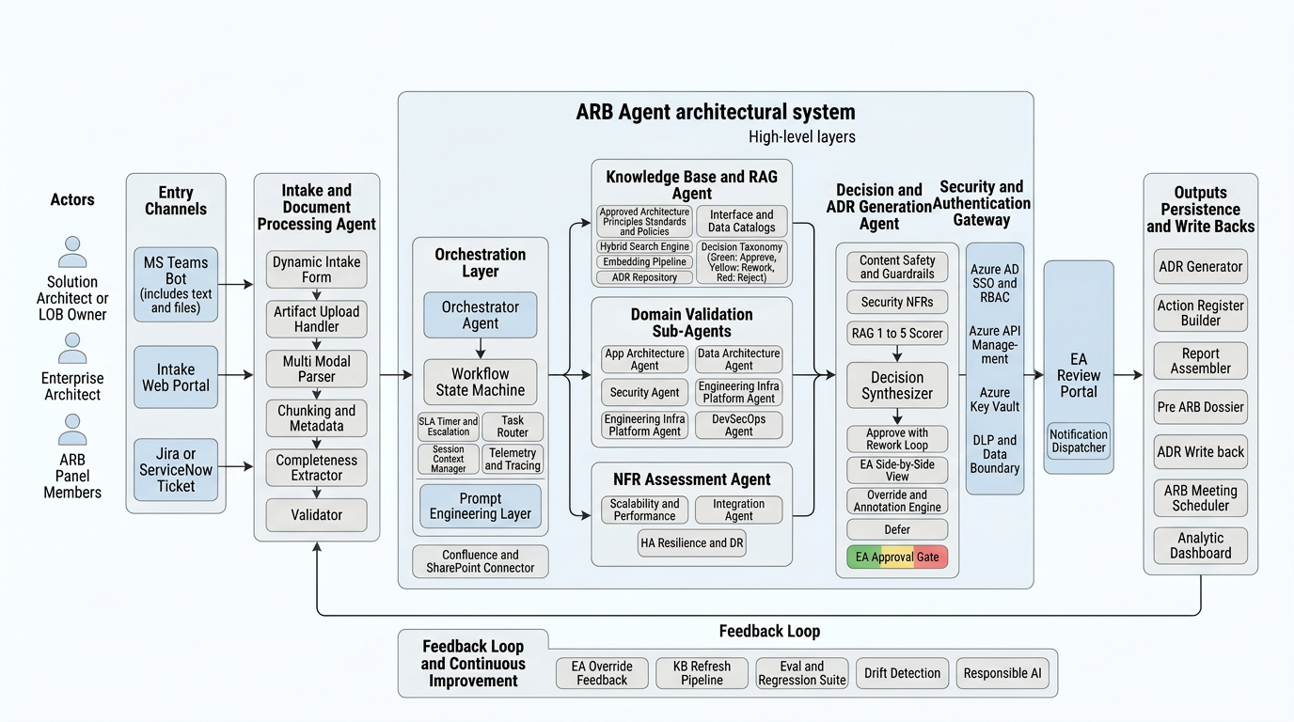
- Detailed Solution Overview Diagram
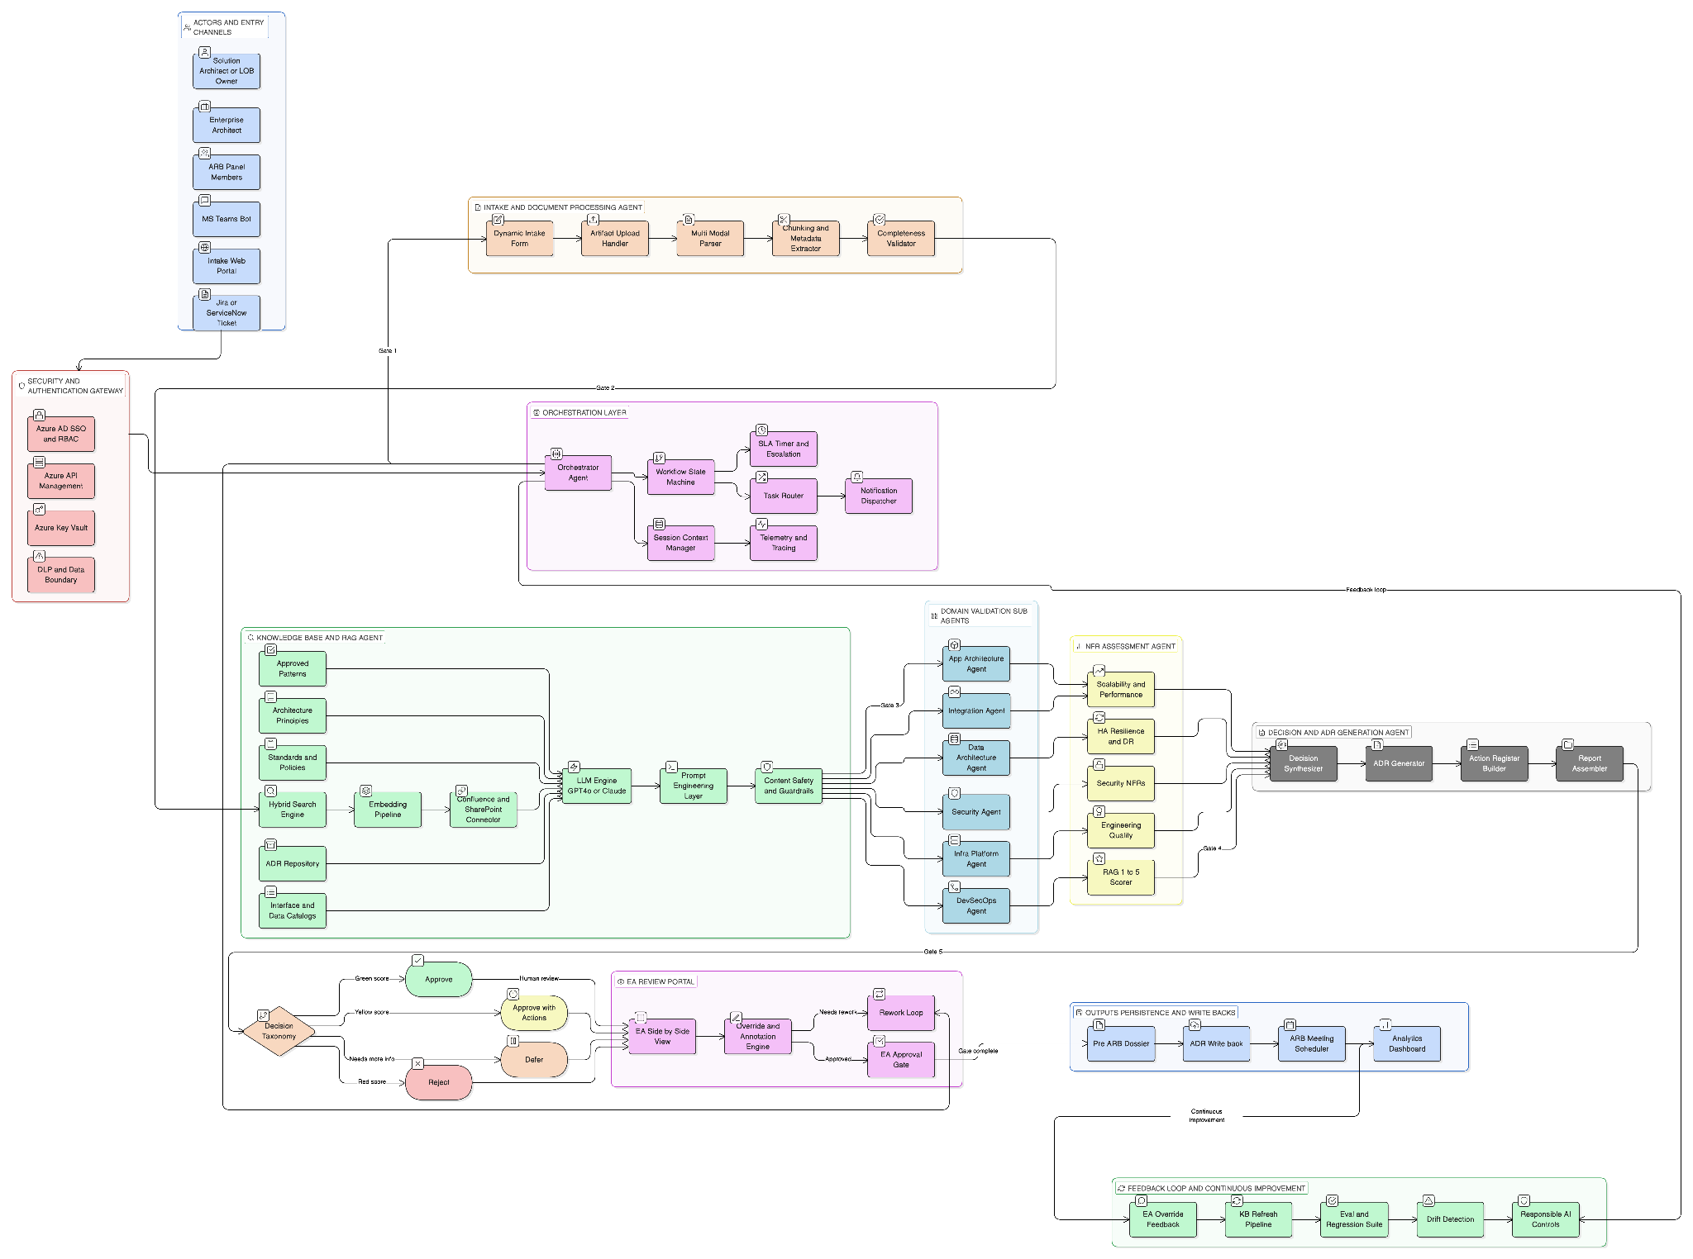

6.1 CORE COMPONENTS

Orchestrator Agent
- Manages overall workflow state machine and task sequencing
- Routes intake artifacts to appropriate domain sub-agents
- Aggregates sub-agent outputs and resolves scoring conflicts
- Enforces SLAs; escalates stalled reviews to EA via notification
- Manages human-in-the-loop checkpoints and approval gates

Intake & Document Processing Agent
- Presents dynamic intake form via chat interface or portal widget
- Validates completeness of all mandatory fields before proceeding
- Parses and chunks architecture diagrams, ADRs and NFR evidence using multi-modal LLM
- Extracts structured metadata (integration catalogue, SBOM, dependency versions)
- Flags missing artifacts and requests clarification from SA via workflow notification

Knowledge Retrieval Agent (RAG)
- Performs hybrid search (keyword + semantic) against the knowledge base
- Retrieves relevant principles, patterns and standards per architecture domain
- Resolves version conflicts — always uses the most recently approved policy
- Caches retrieved knowledge per review session to reduce latency
- Surfaces source citations for every retrieved standard in the final report

Domain Validation Sub-Agents (x6)
- App Architecture Agent: tech choices, versioning, resilience patterns, documentation currency
- Integration Agent: catalogue completeness, API design standards, event schemas, idempotency
- Data Architecture Agent: classification, data lifecycle, model documentation, EoS/EoL tracking
- Security Agent: AuthN/AuthZ, RBAC/IAM, PKI, VAPT, endpoint protection, legal compliance
- Infra/Platform Agent: environment adequacy, platform upgrades, IaC, capacity, EoS/EoL
- DevSecOps Agent: CI/CD gates, SAST/DAST, SW quality metrics, deployment strategy

NFR Assessment Agent
- Evaluates Scalability & Performance evidence against SLO baselines
- Validates HA/DR targets against platform-mandated four-nines or five-nines standards
- Cross-checks security NFRs with regulatory and internal security policy thresholds
- Generates RAG scores (1-5) per NFR category with evidence citations
- Identifies gaps and proposes mitigating conditions for amber-rated NFRs

Decision & ADR Generation Agent
- Synthesises domain agent outputs into a unified decision recommendation
- Applies decision taxonomy: Approve / Approve with Actions / Defer / Reject
- Generates structured ADRs with: context, decision, rationale, consequences, owner, target date
- Groups decisions by category and maps to architecture view
- Produces action register with accountable owners and SLA-bound target dates

6.2 TECHNOLOGY STACK (REFERENCE)

LLM / Foundation Model | GPT-4o / Claude 3.5 Sonnet — multi-modal for diagram parsing; structured output mode for JSON ADRs
Orchestration Framework | LangGraph or Azure AI Agent Service — manages stateful multi-agent workflow with human-in-the-loop nodes
Vector Store / RAG | Azure AI Search or Pinecone — hybrid dense+sparse retrieval with metadata filtering by domain and version
Document Ingestion | Azure Document Intelligence + custom chunking pipeline for Confluence, PDF, PPTX, and Visio diagrams
Workflow & Notifications | ServiceNow or Jira workflow engine — manages SLA timers, escalations and approval gates
Frontend / Intake Portal | React web form embedded in ServiceNow portal or standalone; conversational intake via Teams bot
Output / Report | Generated DOCX/PDF pre-ARB dossier; structured JSON ADR payload for CMDB / Confluence write-back
Security & Auth | Azure AD SSO, RBAC per role (SA, EA, ARB member); all data in-tenant, no external data exfiltration

7. End-to-End Workflow
The workflow is a state machine with eight stages. Human checkpoints (★) are mandatory gates that pause the agent until an authorised actor provides input or approval.
1 | Initiation & Intake (★ SA)  SA or LOB owner creates a review request via the intake portal. The Intake Agent presents the structured form covering solution context, architecture artifacts upload, and NFR evidence. Form validation ensures all mandatory sections are complete before advancing. SLA clock starts. Estimated time: 1–2 days.

2 | Artifact Ingestion & Parsing  The Document Processing Agent ingests all uploaded files (diagrams, ADRs, SBOM, catalogue). Multi-modal parsing extracts structured data. Missing or low-quality artifacts trigger an automated clarification request back to SA (workflow notification). Estimated time: 1–4 hours.

3 | Knowledge Base Retrieval  The RAG Agent performs domain-scoped retrieval for each architecture view. Relevant principles, approved patterns and policies are fetched and versioned. All retrieved context is cached for the session and passed to validation agents. Estimated time: minutes (automated).

4 | Domain Validation & Scoring  Six domain sub-agents run in parallel, each validating their view against retrieved standards. Each produces a RAG/1-5 score, a list of compliant areas, gaps and risks. Security and DR checks require Green for approval; others allow Amber with actions. Estimated time: 30–60 minutes (automated).

5 | NFR Assessment  The NFR Agent cross-validates the SA-provided NFR evidence against platform SLOs and industry benchmarks. It generates per-category RAG scores and identifies gaps requiring mitigating actions or conditional approval. Estimated time: 15–30 minutes (automated).

6 | Draft ADR & Decision Generation  The Decision Agent synthesises all domain and NFR outputs. It generates draft ADRs (one per significant decision), assigns decision type (Approve/Approve with Actions/Defer/Reject), proposes owners and target dates, and assembles the pre-ARB dossier. Estimated time: 15–30 minutes (automated).

7 | EA Review & Human Approval (★ EA)  The pre-ARB dossier is routed to the assigned Enterprise Architect for review. The EA can: accept agent decisions, override with rationale, add annotations, assign additional actions, or send back to SA for rework. EA approval finalises the pre-ARB report. Estimated time: 1 day (SLA enforced).

8 | Pre-ARB Report Published & ARB Scheduled  The finalised pre-ARB dossier (DOCX/PDF + structured JSON ADRs) is published to the ARB portal and Confluence. The ARB meeting is scheduled using the standard 90–120 min time-boxed agenda template. The agent monitors conditional approvals post-ARB and sends reminders to action owners. Estimated time: Same day.

8. Quality Scoring Model
The agent uses a dual-axis scoring model for each architecture view and NFR category, consistent with the ARB quality scoring framework.

🟢 GREEN (4–5) | 🟡 AMBER (2–3) | 🔴 RED (1) — Security / DR | ⬜ WAIVER (Conditional)
Meets all standards, patterns and NFRs | Partially meets standards | Fails mandatory security or DR standard | Known deviation with documented  rationale
Documentation complete and current | Gaps identified with mitigation plan | Blocking issue — must be resolved pre-approval | Time-bound waiver with  expiry date
Minor actions tracked — no blockers | Actions with owners and dates required | Triggers automatic Defer or Reject recommendation | EA approval required;  tracked in ADR
Eligible for full approval | Approve with conditions (except Security/DR) | Re-review required after remediation | No open-ended or  unbounded waivers permitted

Scoring dimensions: Each architecture view (Apps, Integration, Data, Security, Infra) receives an independent RAG/1-5 score. NFR categories (Scalability, HA, Security, DevSecOps, Eng. Excellence) receive separate scores. An aggregate platform readiness score is computed. The agent will never approve on promises — all Amber and Red scores require verifiable evidence.

9. Pre-ARB Dossier Structure
The agent generates a structured dossier delivered as both a human-readable document (DOCX/PDF) and a machine-readable JSON payload for CMDB write-back. The structure mirrors the ARB review areas and decision taxonomy.

Section 1 — Executive Summary
Solution name, platform, presenting team, review date, aggregate RAG score, and recommended decision (Approve / Approve with Actions / Defer / Reject).
Section 2 — Business Architecture Assessment
Alignment to business strategy, use case coverage, domain model review, business NFR evaluation, Economics / TCO summary.
Section 3 — Application Architecture Assessment
Technology choices vs. standards, SBOM and dependency health, resilience patterns, versioning and backward compatibility, documentation currency score.
Section 4 — Integration Architecture Assessment
Integration catalogue review, API design standard compliance, event schema registry alignment, reliability and rate-limiting controls, idempotency validation.
Section 5 — Data Architecture Assessment
Data classification and ownership review, data lifecycle compliance, data model documentation score, EoS/EoL technology flags.
Section 6 — Security Architecture Assessment
AuthN/AuthZ model review, RBAC/IAM adequacy, PKI/encryption compliance, VAPT evidence review, regulatory and legal compliance check.
Section 7 — Infra & Platform Architecture Assessment
Environment and runtime adequacy, platform upgrade alignment, capacity and bandwidth analysis, IaC / automation maturity.
Section 8 — Engineering & DevSecOps Assessment
CI/CD pipeline quality gates, SAST/DAST results, code review coverage, performance and automation test evidence, SW quality metrics.
Section 9 — NFR Scorecard
RAG 1-5 score per NFR category with evidence citations. Gaps, risks and proposed mitigating conditions. Platform SLO alignment summary.
Section 10 — Architecture Decision Records (ADRs)
One ADR per significant decision: context, options considered, decision, rationale, consequences, owner, target date, status (Open/Conditional/Closed).
Section 11 — Action Register
All actions from Amber conditions and pending checks: owner, target date, verification method and check-back mechanism.
Section 12 — Cross-Platform Impact Analysis
Consuming platform impacts, shared interface changes, migration plan summary, transition state dependencies.

10. Governance & Human-in-the-Loop Design
Human oversight is embedded at three mandatory checkpoints. The agent cannot advance past each gate without explicit human action. All overrides are logged with rationale for auditability.

Gate | Actor | Agent Action | Human Action
Gate 1 — Intake Completion | Solution Architect (SA) | Validates form completeness, flags missing artifacts, sends clarification requests | Completes intake form and uploads all required artifacts before agent proceeds
Gate 2 — EA Pre-ARB Approval | Enterprise Architect (EA) | Delivers draft pre-ARB dossier with ADRs and scores; pauses workflow | Reviews, annotates, overrides (with rationale), sends back for rework, or approves to publish
Gate 3 — Post-ARB Action Tracking | Action Owner + EA | Monitors conditional approval actions; sends reminders on approaching deadlines | Confirms completion of actions; EA validates evidence before closing conditional ADR

Governance principles applied: Quorum and voting rules for the full ARB remain unchanged. The agent dossier is an advisory input — final decisions rest with the ARB panel. All agent decisions, retrievals and overrides are stored in an immutable audit log. ADRs are written back to Confluence and CMDB. Lessons learned from each review are fed back to the knowledge base to continuously improve future validations.

11. Implementation Roadmap

Phase 1 — Foundation (0-3 mo) | Phase 2 — Domain Agents (3-6 mo) | Phase 3 — ADR & Report (6-9 mo) | Phase 4 — Optimise (9-12 mo)
Define intake form schema | Build App & Integration agents | Decision taxonomy engine | Feedback loop & KB refresh
Build knowledge base corpus | Build Data & Security agents | ADR generation module | SLA analytics dashboard
Implement RAG pipeline | Build Infra & DevSecOps agents | Pre-ARB dossier generation | Waiver tracking automation
Develop intake + doc parsing agent | NFR Assessment agent | CMDB / Confluence write-back | AI-assisted ARB agenda generation
Pilot with 2-3 ARB reviews | EA review portal (HITL gate) | Full-scale pilot rollout | Continuous improvement cycle

12. Next Steps
- Adopt this design as the foundational blueprint and socialise with Enterprise Architecture and ARB stakeholders
- Stand up the knowledge base corpus on Confluence / vector store with initial principles, patterns and policy documents
- Define and agree the intake form schema with the ARB panel and Solution Architecture community
- Identify two or three upcoming ARB reviews to serve as a pilot for the Intake and RAG components
- Establish CI/CD quality gates and NFR test suites aligned to platform SLOs for agent validation benchmarks
- Configure human-in-the-loop workflow in ServiceNow / Jira with SLA timers for SA and EA stages
- Leverage other enterprise resources: Responsible AI pathway, and internal architecture documentation
- Define evaluation metrics: pre-ARB dossier accuracy, EA override rate, time-to-review reduction, ADR closure rate

End of document

