# HackXplore - Project Write-Up

**Project Name: HackXplore**

**Description:**

HackXplore is an innovative platform designed to connect hackathon enthusiasts by simplifying event discovery and participation. It helps users find hackathons near their locality or in specific locations and allows users to post about hackathons to reach a wider audience. The platform aims to build a tech community that promotes knowledge sharing, innovation, and collaboration.

**Technology Stack:**

* Frontend: Java Vaadin Dependency for creating interactive user interfaces.
* Backend: Pure Java for core logic and Spring Boot Framework for robust application development.
* Database: PostgreSQL/MySQL for managing hackathon data with JDBC for connectivity.
* Development Environment: IntelliJ IDEA, Eclipse, or Spring Tool Suite.
* Servelet: Apache Tomcat for hosting the web application.

**Current Features:**

1. *Hackathon Discovery:*

* Users can search for hackathons based on their locality or specific filters.
* Real-time updates ensure users stay informed about upcoming events.

2. *Hackathon Posting:*

* Organizers can post details about their hackathons to attract participants.
* Posts include event descriptions, dates, locations, and registration links.

**Architecture Diagram:**

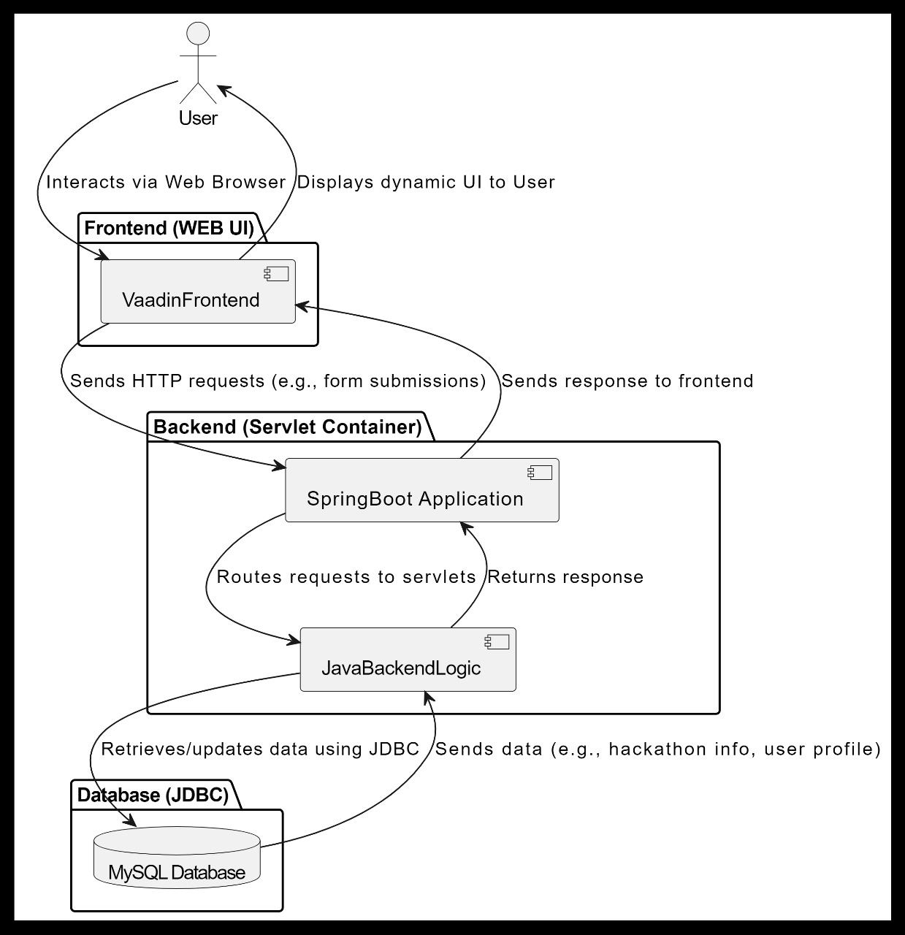

**Future Updates:**

1. *Team Collaboration:*

- Users can post their professional profiles to find and join teams.

2. *Event Hosting:*

- Tools for creating and managing hackathons with customizable features.

3*. User Profiles:*

* Integration with LinkedIn or other social platforms for professional networking.

**Applications:**

* Enables users to discover and participate in hackathons effortlessly.
* Provides a platform for organizers to share and promote their events.
* Fosters a tech-savvy community focused on innovation and collaboration.

**Challenges:**

1. *Scalability:*

- Ensuring smooth performance with growing user activity.

2*. Security:*

- Protecting sensitive event and user data.

3. *User Engagement:*

- Creating features that encourage active participation and retention.