**Visualizations & Insights (WeRateDogs)**

There is plenty of information available in these three datasets. When combined together a lot of insights could be drawn from them. The first item that we are going to look at is the source for the tweets. From the chart below, we can see tweets came from iPhone, Web Client and Tweet Deck. iPhone seems to be the major source of the tweets. It shows people highly prefer their phones for connecting socially. Tweet deck is the least used.

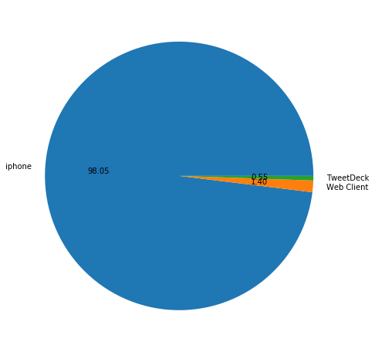

Here is the image of the dog (named Atticus) that got the highest rating, but a prediction of his breed couldn’t be made because of all the fun stuff he is wearing.

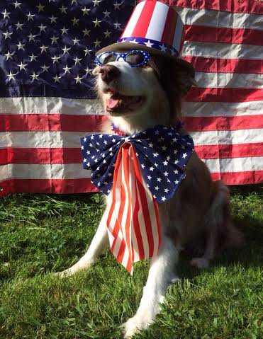

Here is most favorited/retweeted dog and it is a Labrador Retriever.



On an average **Soft-Coated Wheaten Terrier** dog breeds gets high rating when compared to other dog breeds. Although not preferred **@weratedogs** also rated some other animals/things and quite surprisingly their ratings on an average is higher than dog ratings. This high average can be attributed to above dog Atticus who is not identified as dog by prediction engine. Below chart represents top 5 dog breeds with high average rating.

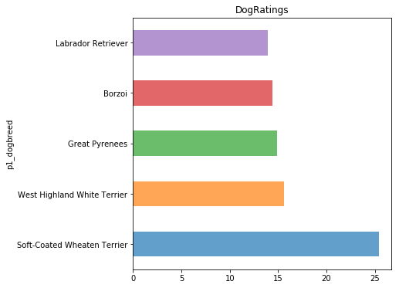

When I looked at the confidence with which the dog breeds were matched, it is surprising to see such high efficiency. Any breed that was predicted with .95% or more were correct. Below are the image of dogs predicted with 99.9% confidence.

|  |
| --- |
|  |

Instead of going by the hour, I wanted to look the tweets by the time of the day. While looking at the times at which tweets were made, it is hard not to notice majority of them were made at late nights. It appears people prefer to connect socially during late nights the most.

