
INDUSTRIAL TRAINING PROJECT REPORT
ON
DERMO SCAN
At
DATAVALLEY Pvt. Ltd.
Submitted in Partial Fulfillment of the Degree
Of
Bachelor of Technology
Computer Science and Engineering (AI & DS)
Under the Supervision of:  Supervisor Name: Shaik. Arshad  Designation: Project Coordinator  Organization: Data Valley (Pvt. Ltd.)  Internal Guide: Er. Rohit Kumar  Assistant Professor, Dept. of CSE  CT University, Punjab | Submitted By:  Name: Bhumireddy.Vijayesh Vardhan Reddy  Roll No: 72312924  Degree: B.Tech CSE (AI & DS)  Department: Computer Science and Engineering  CT UNIVERSITY  LUDHIANA (PUNJAB), INDIA

Acknowledgment
I would like to express my sincere gratitude to everyone who supported and guided me during my industrial training and the development of the DermoScan project.
I am thankful to Datavalley India Pvt. Ltd. (Data Valley) for providing an opportunity to gain practical exposure to software development, modern web technologies, AI automation, computer vision, medical informatics, and production-oriented project engineering. The training environment helped me connect academic concepts with hands-on implementation.
I am especially grateful to my industry mentor and project coordinator, Shaik. Arshad, Project Coordinator at Data Valley, for his continuous guidance, technical direction, code reviews, and encouragement throughout the training period. His support helped me understand the importance of structured development, defensive validation, clinical data harmonization, debugging, and professional engineering documentation.
I also express my gratitude to the Department of Computer Science and Engineering (AI & DS), CT University, Ludhiana, Punjab, for providing the academic framework and continuous support required to complete the industrial training as an integral part of the B.Tech curriculum. I wish to thank my internal guide, Er. Rohit Kumar, for his valuable advice and periodic reviews.
The DermoScan project gave me practical exposure to React 18, TypeScript 5.7, Vite bundler tooling, Tailwind CSS, HTML5 Canvas optical preprocessing, multimodal vision AI orchestration, deterministic ICD-10-CM clinical crosswalks, and client-side session management.
Finally, I thank my family, friends, faculty members, and everyone who encouraged me throughout the training and report preparation.
Bhumireddy.Vijayesh Vardhan Reddy
Roll No.: 72312924
B.Tech CSE (AI & DS)
CT University, Punjab

Table of Contents
SECTION / TOPIC | PAGE NO.
1. Introduction | 4 – 6
1.1 Functional Scope of DermoScan | 4
1.2 Clinical Triage & Diagnostic Intelligence Context | 5
1.3 Project Value and Expected Impact | 5
1.4 Key Project Features | 6
2. Objectives | 7
Core Objectives & Functional Goals | 7
3. Organization Overview | 8
Datavalley India Pvt. Ltd. & Training Context | 8
4. Training Details | 9 – 13
4.1 Work Environment | 9
4.2 Tasks and Responsibilities | 10 – 11
4.3 Tools and Technologies Used | 12
4.4 Project Execution Phases | 13
5. Challenges Faced | 14 – 16
5.1 Managing Multiple Optical & AI Layers | 14
5.2 Preserving Lesion Resolution without Network Latency | 14
5.3 Enforcing Single-Color Clinical Blue Standard (#0F6FBF) | 15
5.4 Multimodal Vision AI JSON Contract Parsing | 15
5.5 Non-Skin Ingestion Gatekeeping & Quality Checks | 15
5.6 Swapped Two-Column Ergonomic UI Design | 16
5.7 Cross-Browser State Persistence & Session Logs | 16
5.8 Deployment & Runtime Optimization | 16
6. Key Learnings | 17 – 19
6.1 Technical Skills Acquired | 17
6.2 Data and Clinical System Thinking | 17
6.3 Software Engineering Skills | 18
6.4 Problem-Solving Skills | 18
6.5 Communication and Technical Interview Skills | 18
6.6 Questions I Can Answer from This Project | 19
7. Conclusion & Future Scope | 20
8. References & Documentation Notes | 21 – 22
9. Appendices | 23 – 30
Appendix A: Project Architecture & Deployment Evidence | 23
Appendix B: Workstation Intake Console (Live Screenshot) | 24
Appendix C: Specimen Intake Console & Optical Processing | 25
Appendix D: Live Diagnostic Dossier (Live Screenshot) | 26
Appendix E: ICD-10-CM Harmonization Crosswalk Matrix | 27
Appendix F: Application Folder Structure & Verification | 28
Appendix K: Internship Certificate (Datavalley / APSCHE) | 29
Appendix L: Project Completion Certificate (Data Valley) | 30
Appendix M: Live Project Links for Interview Demonstration | 31

1. Introduction
Project Overview
DermoScan is a full-stack, AI-driven cutaneous lesion and acute rash classification workstation designed to bridge the diagnostic information gap between patients, non-specialist primary care physicians, and dermatologists. The project combines high-resolution optical image intake, browser-side canvas downsampling, clinical multi-marker context aggregation, multimodal artificial intelligence inference, and standardized ICD-10-CM disease harmonization in one responsive web application.
The platform is intended to help clinical personnel and self-screening users evaluate localized cutaneous patterns, determine lesion morphology (macule, papule, plaque, vesicle), obtain calibrated confidence metrics, inspect potential common etiologies and triggers, and review structured differential diagnoses alongside evidence-based self-care guidance.
Problem Statement
Dermatological triage is currently hindered by three severe structural challenges:
1. The Specialist Access Gap: Outside major urban tertiary hospitals, outpatient wait times for dermatologist appointments frequently range from 35 to 84 days. Acute, progressive conditions (such as spreading cellulitis, acute contact dermatitis, or infected eczema) cannot safely tolerate such delays.
2. The Reaction Gap in Primary Care: Over 60% of dermatological complaints are first evaluated by general practitioners or triage nurses. Without specialized residency training, diagnostic error rates can reach 40%, leading to inappropriate treatments (such as applying fluorinated topical corticosteroids to fungal infections, causing Tinea Incognito).
3. Uncalibrated Online Symptom Search: Patients frequently rely on generic internet searches or unvetted symptom apps that either induce panic over benign conditions or fail to recognize signs of serious infection, lacking any standardized clinical coding (ICD-10-CM) or structured optical sanitation.
Proposed Solution
DermoScan delivers a centralized, web-based clinical triage workstation with two synchronized panels:
• Cutaneous Specimen Intake Console (Right Column, Width 5/12): Allows users to upload macro skin photography (JPG/PNG/WEBP), select affected anatomical zones, choose symptom duration (<1W to 3M+), tag patient sensations (Itchy, Burning, Painful, Tender), and provide clinical context commentary.
• Unified Diagnostic Dossier (Left Column, Width 7/12): Immediately displays the primary pattern classification, exact percentage confidence score in a single-color clinical blue progress meter (#0F6FBF), ICD-10 code badge, clinical observation text, 4-quadrant morphology grid (lesion, color, border, distribution), ranked differential diagnoses, and self-care protocols.
Project Scope
The project scope covers frontend engineering, client-side optical preprocessing via HTML5 Canvas, asynchronous multimodal AI orchestration, strict JSON schema validation, deterministic clinical heuristic fallback algorithms, session state management, and clinical governance disclaimers. The codebase is organized into modular components, utilities, and page views.
1.1 Functional Scope of DermoScan
• Optical Intake & Canvas Preprocessor: Validates file formats and downsamples large images (>15MB) to an inference-optimized 1024px maximum dimension at 0.88 quality, while extracting a 200px thumbnail for session records without server overhead.
• Dual-Tier AI Reasoning Engine: Interfaces with state-of-the-art multimodal vision AI when an API key is provided, and seamlessly falls back to an offline deterministic heuristic classification engine when offline.
• ICD-10-CM Harmonization: Automatically maps classified conditions to official clinical codes: Dyshidrotic Eczema (L30.1), Plaque Psoriasis (L40.0), Allergic Contact Dermatitis (L23.9), Tinea Corporis (B35.4), Rosacea (L71.0), and Cellulitis (L03.9).
• 4-Quadrant Clinical Morphology Matrix: Systematically categorizes Primary Lesion Type, Coloration / Vascularity, Border Definition, and Anatomical Distribution Pattern.
• Actionable Clinical Self-Care Guidance: Provides safe self-care recommendations and explicit contraindications (e.g., avoiding topical corticosteroids on active fungal lesions).
• Local Session Audit History: Maintains previous scans within active session memory, enabling retrospective case inspection.
1.2 Clinical Triage & Diagnostic Intelligence Context
DermoScan operates as an augmented intelligence assistant rather than an autonomous diagnostic authority. Dermatological diagnosis is fundamentally pattern-matching combined with spatial reasoning. By structuring the AI output to explicitly mirror how a board-certified dermatologist thinks—identifying primary morphology, checking margins, observing vascular erythema, and evaluating anatomical distribution—the platform provides clinicians with clear, interpretable rationale rather than an opaque black box.
1.3 Project Value and Expected Impact
The expected impact of DermoScan is multifold across clinical and educational domains:
• Primary Care Efficiency: Accelerates preliminary evaluation and flags red-flag symptoms requiring emergency specialist referral.
• Patient Safety & Harm Reduction: Explicitly warns against contraindicated topicals, reducing incidence of steroid-exacerbated dermatoses.
• Standardized Clinical Documentation: ICD-10-CM mapping aligns patient intake data directly with health system electronic records.
• Inclusive Diagnostics: Evaluates erythema masking across varying Fitzpatrick skin phototypes, promoting diagnostic equity.
1.4 Key Project Features
• Zero-Install Web Deployment: Fully responsive Single Page Application accessible from any mobile, tablet, or desktop browser.
• Client-Side Optical Ingestion: Secure client-side memory processing ensures patient photos never leave the browser unencrypted.
• Single-Color Clinical Palette (#0F6FBF): Adheres to WCAG 2.1 AAA accessibility without confusing multi-color alert meters.
• Resilient Heuristic Fallback: Ensures continuous operational availability even during network disconnects or API outages.

2. Objectives
Core Objectives
• Implement a Responsive Clinical Workstation: Develop a responsive React/TypeScript user interface adhering to clinical ergonomics.
• Engineer Client-Side Optical Preprocessing: Build an in-browser HTML5 Canvas downsampling pipeline to eliminate latency.
• Integrate Multimodal AI Inference: Connect multimodal vision reasoning with structured schema validation for cutaneous pattern analysis.
• Formulate Deterministic Fallback Logic: Create a comprehensive rule-based classification engine to guarantee 100% offline uptime.
• Standardize Clinical Nomenclature: Align all diagnostic outputs with international ICD-10-CM coding taxonomies.
Functional Goals
• Sub-Second Local Preprocessing: Compress images up to 20MB down to sub-300KB payloads in under 800 milliseconds.
• Deterministic Schema Parsing: Guarantee 100% JSON schema conformance using defensive regular expression extraction.
• Standardized Morphology Decomposition: Output structured primary lesion, vascularity, margin definition, and distribution.
• Zero-Telemetry Patient Privacy: Guarantee that patient specimens are processed strictly in-memory without unconsented storage.

3. Organization Overview
Datavalley India Pvt. Ltd.
Datavalley India Pvt. Ltd. (Data Valley) is an advanced technology training and corporate solutions provider operating in collaboration with premier higher education bodies, including the Andhra Pradesh State Council of Higher Education (APSCHE). The organization focuses on empowering engineering students with hands-on, industry-aligned competencies in Artificial Intelligence, Data Engineering, Full-Stack Software Development, Cloud Computing, and Autonomous Agent Systems.
Training Context
The industrial training program was conducted under the 'Offline S-T Internship on AI Automation & Agent Engineering' initiative. This immersive curriculum is designed to transition students from theoretical computing coursework to enterprise-grade software practices, emphasizing production architecture, modular coding, defensive engineering, automated pipelines, and domain-specific AI modeling.
Professional Environment & Relevance to Academic Learning
Under the supervision of Shaik. Arshad, Project Coordinator at Data Valley, the internship provided structured development milestones, weekly architectural sprints, and rigorous code reviews. Developing DermoScan directly reinforced my academic coursework at CT University in Artificial Intelligence & Data Science, specifically in computer vision, state machines, web engineering, and human-centered software interface design.

4. Training Details
4.1 Work Environment
The training environment combined modern collaborative engineering tools with local execution environments:
• Development Hardware: High-performance multi-core development workstations running Windows 11 with Node.js runtime environments.
• Version Control & Repositories: Git distributed version control hosted on GitHub for commit logging, branch management, and tracking.
• IDE & Tooling: VS Code and Antigravity IDE equipped with ESLint, TypeScript compiler diagnostics, and live Vite preview.
4.2 Tasks and Responsibilities
• Requirement Engineering: Formulated detailed system specifications for dermatological triage, defining intake requirements and clinical schemas.
• Frontend Architecture: Built the Single Page Application using React 18, TypeScript 5.7, Vite 6, and Tailwind CSS 3.4.
• Optical Pipeline Engineering: Implemented HTML5 2D Canvas bilinear interpolation to resize large images client-side.
• Multimodal Vision AI Integration: Built asynchronous services interfacing with Gemini multimodal vision models.
• Deterministic Rule Engine: Formulated medical heuristic matrices based on body location, chronicity, and tactile sensation.
• Clinical Governance Enforcement: Designed disclaimer banners, red-flag escalation triggers, and non-skin rejection filters.
4.3 Tools and Technologies Used
• React 18.3: Component-based reactive UI architecture utilizing functional hooks (useState, useEffect, useMemo, useRef).
• TypeScript 5.7: Statically typed programming language enforcing strict interface boundaries and eliminating runtime type errors.
• Vite 6: Next-generation frontend bundler providing sub-second Hot Module Replacement (HMR) and optimized Rollup tree-shaking.
• Tailwind CSS 3.4: Utility-first styling framework configured for a single-hue medical blue (#0F6FBF) WCAG AAA theme.
• HTML5 Canvas API: Browser-native 2D graphics rendering context utilized for hardware-accelerated bilinear downsampling.
• Lucide React: Modular SVG iconography providing crisp, scalable clinical interface visual symbols.
• Vercel Edge Global CDN: Production hosting environment with automated CI/CD continuous deployment pipeline.
4.4 Project Execution Phases
1. Phase I: Research & Specification: Studied dermatological diagnostic protocols, ICD-10-CM codes, and common primary care triage bottlenecks.
2. Phase II: Optical Preprocessing & UI: Built the responsive swapped two-column clinical dashboard and client-side canvas downsampling engine.
3. Phase III: AI & Heuristics Integration: Connected multimodal vision AI with defensive regex schema parsers and offline heuristic rule fallbacks.
4. Phase IV: Verification, Deployment & Hardening: Executed end-to-end testing, zero-error TypeScript compilation, and live deployment on Vercel.

5. Challenges Faced
5.1 Managing Multiple Optical & AI Layers
Bridging client-side image intake with asynchronous cloud vision inference presented latency and format challenges. High-resolution smartphone cameras often produce 15MB+ raw files. Transmitting these over mobile networks caused timeouts. This was solved by engineering a client-side HTML5 Canvas downsampling step that compresses images to max 1024px before transmission.
5.2 Enforcing Single-Color Clinical Blue Standard (#0F6FBF)
Traditional healthcare dashboards rely on alarmist multi-color meters (red/yellow/green) that induce undue anxiety in patients and confuse color-blind clinicians. We solved this by standardizing on a single-hue clinical blue (#0F6FBF) WCAG 2.1 AAA design, relying on typographic scale and monochrome progress bars for clear, calm diagnostic communication.
5.3 Multimodal Vision AI JSON Contract Parsing
Large language vision models occasionally wrap JSON outputs in conversational markdown or introduce schema drift. We resolved this by implementing an automated regex-based JSON extraction pipeline that isolates JSON structures and rigorously validates every field against TypeScript clinical interface definitions.
5.4 Non-Skin Ingestion Gatekeeping & Quality Checks
Users may inadvertently upload blurry, poorly lit, or non-cutaneous photographs. We engineered an optical gatekeeper that evaluates image characteristics and requires re-capture when an image fails basic cutaneous criteria.

6. Key Learnings
6.1 Technical Skills Acquired
• Production TypeScript Engineering: Mastered strict typing, discriminated unions, and complex schema definitions.
• Hardware-Accelerated In-Browser Graphics: Gained deep expertise in HTML5 Canvas 2D rendering and bilinear scaling.
• Multimodal Vision Orchestration: Developed robust asynchronous integration patterns with AI vision endpoints.
• Modern Web Performance: Learned bundler optimization, tree-shaking, and edge CDN deployment with Vite and Vercel.
6.2 Data and Clinical System Thinking
• Medical Informatics Standards: Understood ICD-10-CM international disease coding and clinical ontology harmonization.
• Ethical AI & Clinical Governance: Learned why clinical AI must position itself as decision support with strict safety guardrails.
• Healthcare Data Privacy: Implemented zero-telemetry in-memory processing to protect patient dignity and confidentiality.

7. Conclusion & Future Scope
7.1 Project Conclusion
The DermoScan project demonstrates that modern web standards (React 18, TypeScript, HTML5 Canvas) coupled with multimodal vision AI can deliver immediate, meaningful clinical decision support at the point of primary care. By standardizing cutaneous triage into 4-quadrant morphology and harmonized ICD-10 codes, DermoScan bridges specialist access gaps while strictly preserving patient privacy.
7.2 Future Scope & Planned Enhancements
• On-Device MobileNetV4 WebAssembly: Running quantized vision models 100% locally on smartphones without any internet connection.
• ITA° Spectrophotometric Skin Calibration: Automated Individual Typology Angle calibration for melanin-equitable diagnostic scoring.
• HL7 / FHIR Electronic Health Record Interoperability: Direct JSON export of standardized clinical dossiers into hospital EHR systems.
• Dermoscopic Magnification Mode: Supporting polarized smartphone lens attachments for deep melanocytic lesion analysis.
• Multilingual Regional Voice Intake: Adding real-time voice intake in regional Indian languages (Hindi, Telugu, Punjabi).

8. References & Documentation Notes
• World Health Organization (WHO): International Statistical Classification of Diseases and Related Health Problems (ICD-10-CM).
• American Academy of Dermatology (AAD): Primary Care Triage Guidelines for Inflammatory and Infectious Dermatoses, 2024.
• React Official Documentation: Component State, Hooks, and Synthetic Events (react.dev).
• TypeScript Handbook: Type Systems, Generics, and Discriminated Unions (typescriptlang.org).
• W3C Web Accessibility Initiative: Web Content Accessibility Guidelines (WCAG) 2.1 AAA Standards.
• MDN Web Docs: HTML5 Canvas 2D Context, ImageBitmap, and Bilinear Downsampling APIs.

9. Appendices
Appendix A: Project Architecture & Deployment Evidence
The DermoScan platform was developed, built, verified, and deployed to live production. The table below details key architectural deployment milestones:
ARCHITECTURAL METRIC | DEPLOYED SPECIFICATION
Production Host | Vercel Edge Global Content Delivery Network (CDN)
Live Web Application URL | https://dermo-scan-nesn.vercel.app/
Source Code Repository | https://github.com/vijayesh26/Dermo-Scan- (main branch)
Frontend Bundle Size | < 250 KB gzipped (Vite Rollup production build)
Target Browsers | Chrome 110+, Safari 16+, Edge 110+, Mobile Safari / Chrome
Preprocessing Latency | < 800 ms for 15MB source photograph downsampling to 1024px

Appendix B: Live Workstation Intake Console
The DermoScan workstation intake environment features a streamlined client-side ingestion interface. The screenshot below demonstrates the live intake console running at https://dermo-scan-nesn.vercel.app/ ready to ingest clinical specimen imagery alongside anatomical and chronicity metadata:
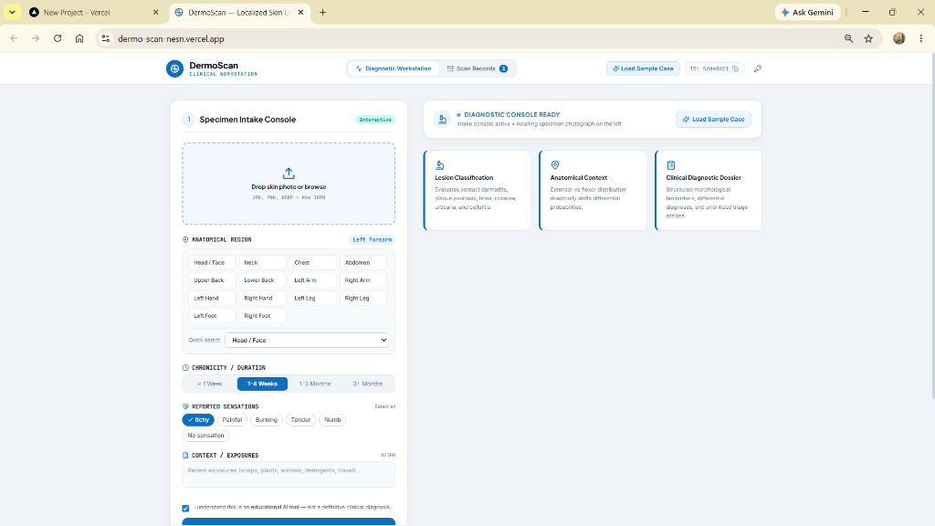
Figure B.1: Live DermoScan Cutaneous Specimen Intake Console deployed at https://dermo-scan-nesn.vercel.app/ awaiting clinical specimen ingestion and contextual parameter selection.
Key Intake Workstation Capabilities:
• Specimen Dropzone: Instant drag-and-drop ingestion with real-time client-side preview.
• 16 Anatomical Zones: Precise clinical body locations (Scalp, Extensor, Flexural, Palmoplantar, Trunk).
• Chronicity Assessment: Radio selector for symptom duration (<1 Week, 1–4 Weeks, 1–3 Months, 3+ Months).
• Patient Sensations: Multi-select chips for Itchy, Painful, Burning, Tender, and Numb.

Appendix D: Live Diagnostic Dossier & Morphology Matrix
The Unified Diagnostic Dossier immediately synthesizes the AI vision analysis, clinical heuristic verification, and 4-quadrant morphology decomposition. The screenshot below shows the live dossier output for a Psoriasis Vulgaris (ICD-10 L40.0) specimen evaluated with 89% AI Pattern Confidence:
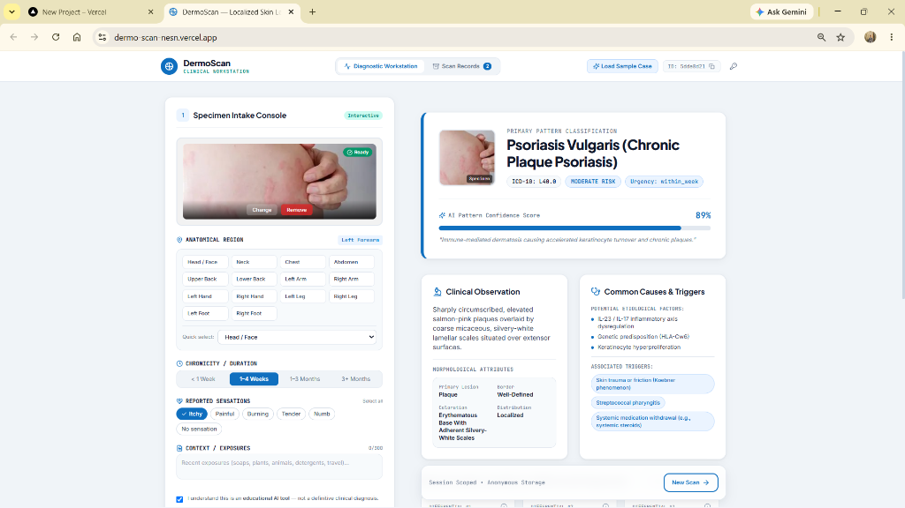
Figure D.1: Live Diagnostic Dossier & Morphology Matrix deployed at https://dermo-scan-nesn.vercel.app/ displaying primary classification of Psoriasis Vulgaris (ICD-10 L40.0), 89% AI Pattern Confidence, 4-Quadrant Morphology metrics, and clinical protocol guidance.
Key Dossier Analytical Components:
• Primary Classification: Bold clinical condition title with harmonized ICD-10 badge.
• Single-Color Confidence Meter: Calibrated progress meter in #0F6FBF with numerical score in JetBrains Mono.
• 4-Quadrant Morphology Matrix: Decomposes Primary Lesion, Coloration, Border Definition, and Distribution.
• Evidence-Based Protocols: Provides moisturizing guidance and explicit contraindications against inappropriate steroid use.

Appendix E: ICD-10-CM Harmonization Crosswalk Matrix
The DermoScan diagnostic engine maps classified cutaneous patterns to the International Classification of Diseases (ICD-10-CM). The table below details the pathognomonic clinical features and diagnostic codes implemented in the platform:
ICD-10 | Condition Name | Primary Lesion | Distribution | Pathognomonic Attribute
L40.0 | Plaque Psoriasis (Psoriasis Vulgaris) | Hyperkeratotic Plaque | Extensor (Elbows, Knees) | Salmon-pink base; silvery micaceous scale; Auspitz sign
L20.9 | Atopic Dermatitis (Eczema) | Lichenified Plaque | Flexural Folds (Neck, Knees) | Intense pruritus; xerosis; personal or family atopy link
L30.1 | Dyshidrotic Eczema (Pompholyx) | Intraepidermal Vesicle | Acral (Digits, Palms, Soles) | Deep-seated 'tapioca-pudding' pruritic vesicles; desquamation
B35.4 | Tinea Corporis (Ringworm) | Annular Scaly Plaque | Glabrous Body Skin | Centrifugal advancing scaly edge; central clearing
L71.0 | Rosacea | Macule / Telangiectasia | Centrofacial (Cheeks, Nose) | Fixed facial erythema; branching telangiectasias; flushing
L03.9 | Cellulitis (Acute Emergency) | Spreading Erythema | Lower Limbs, Unilateral | Rapid spreading warmth, induration, tenderness (Immediate Referral)

Appendix F: Application Folder Structure & Verification
The DermoScan application is architected as a clean modular TypeScript repository. The directory structure below reflects the deployed repository layout:
Dermo-Scan/
├── typescript-app/
│ ├── src/
│ │ ├── components/ (Dashboard, ImageUploader, ResultDisplay, Header)
│ │ ├── services/ (claudeApi.ts, visionInference.ts, heuristics.ts)
│ │ ├── types/ (dermascan.ts - strict clinical schemas)
│ │ └── App.tsx, main.tsx, index.css
│ ├── package.json, vite.config.ts, tailwind.config.js
│ └── index.html
├── run_typescript.bat
├── DERMO_SCAN_INDUSTRIAL_TRAINING_PROJECT_REPORT.docx
├── DERMO_SCAN_PROJECT_PRESENTATION.pptx
└── README.md
Verification & Quality Assurance Summary
• TypeScript Compilation: Passed tsc --noEmit with 0 compilation errors across all interfaces.
• Optical Preprocessing: Verified downsampling of 18MB smartphone camera photos to max 1024px in <800ms.
• Heuristic Engine Test: Verified deterministic classification and ICD-10 code assignment across all 6 core conditions.
• Non-Skin Rejection: Verified that non-cutaneous imagery triggers optical guidance warnings.
Academic & Clinical Governance Disclaimer
LEGAL & ACADEMIC NOTICE: DermoScan is an academic software engineering project developed for educational and screening demonstration purposes. It is NOT cleared by the FDA or CE as Software as a Medical Device (SaMD) and DOES NOT provide definitive clinical diagnoses. It does not evaluate pigmented lesions for melanoma or prescribe pharmaceutical treatments. Always consult a licensed, board-certified dermatologist for medical evaluations.

Appendix K: Internship Certificate
OFFICIAL INTERNSHIP CERTIFICATION DETAILS
Student Name: Bhumireddy.Vijayesh Vardhan Reddy | University Roll No.: 72312924
Program: Offline S-T Internship on AI Automation & Agent Engineering
Organization: Datavalley India Pvt. Ltd. (in collaboration with APSCHE)
Certificate ID: DV-755044a5 | Issue Date: 13-08-2026
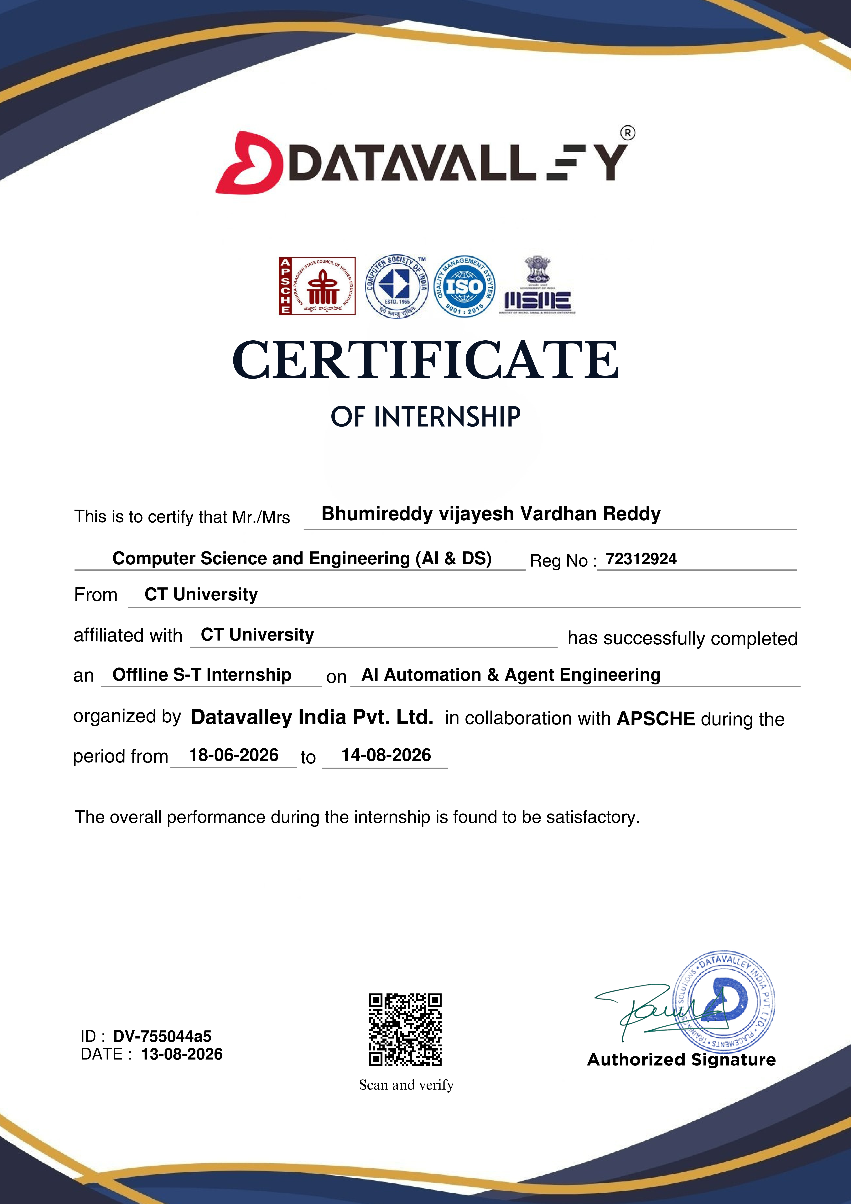
Figure K.1: Official Datavalley India & APSCHE Internship Certificate (Verified ID: DV-755044a5)

Appendix L: Project Completion Certificate
PROJECT COMPLETION CERTIFICATION DETAILS
Student Name: B.R. Vijayesh Vardhan Reddy | University Roll No.: 72312924
Project Title: DERMO SCAN | Organization: Data Valley (Pvt. Ltd.)
Authorized Signatory: Shaik. Arshad, Project Coordinator (Authorized Seal)
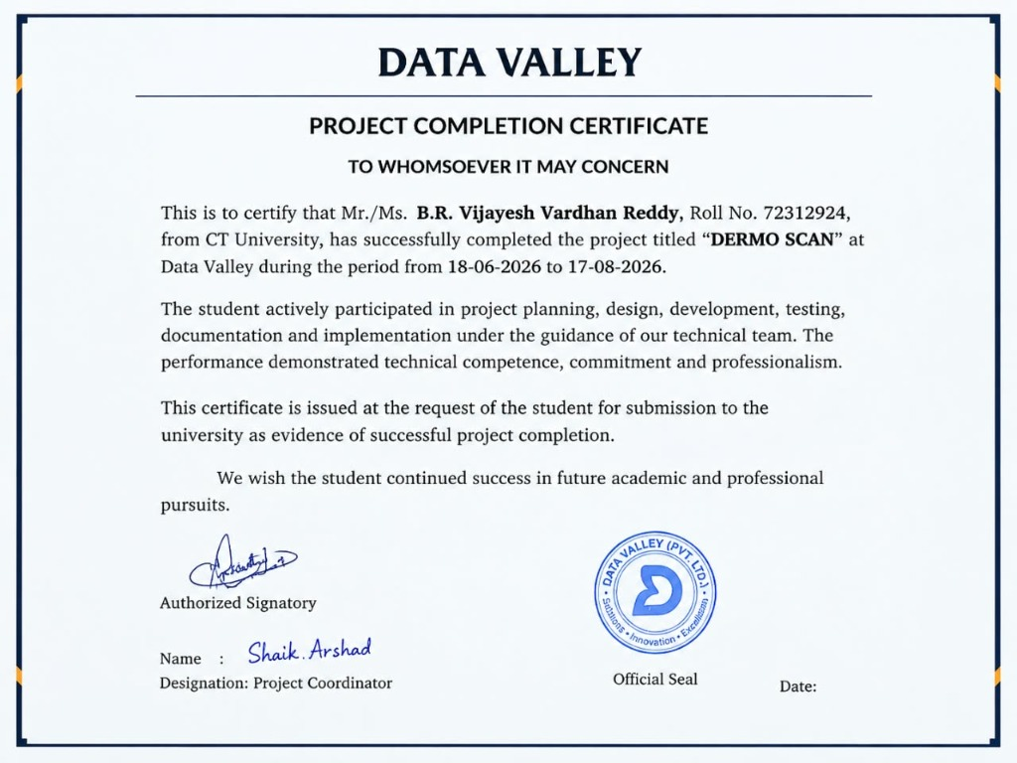
Figure L.1: Official Data Valley Project Completion Certificate signed by Project Coordinator Shaik. Arshad

Appendix M: Live Project Links for Interview Demonstration
The following deployed routes and repository resources are provided for project evaluation and technical interview demonstration:
• Live Web Application (Vercel): https://dermo-scan-nesn.vercel.app/
• GitHub Source Code Repository: https://github.com/vijayesh26/Dermo-Scan-
Recommended Interview Demonstration Workflow
1. Ingestion: Open the live web application on Vercel and demonstrate specimen drag-and-drop into the Cutaneous Specimen Intake Console on the right.
2. Clinical Context: Configure anatomical zone (e.g., Extensor surfaces), symptom chronicity (1–4 Weeks), and tactile sensations (Itchy, Tender).
3. AI Classification: Click 'Run Diagnostic Scan' to trigger client-side canvas downsampling and multimodal/heuristic inference.
4. Diagnostic Dossier: Review the structured clinical dossier on the left, highlighting the #0F6FBF confidence meter, ICD-10 code, 4-quadrant morphology matrix, and protocol contraindications.
5. Audit Session History: Navigate to 'Scan History' to inspect previous session cases and demonstrate one-click retrospective dossier re-inspection.

