**Credentials**

UserType- Admin

Username- root

Password-root

-----------------------------------------------------------------------

UserType- SuperAdmin

Username-superadmin

Password-superadmin

-----------------------------------------------------------------------------------------

Please follow below steps to walkthrough Spring Boot Demo API Application.

Import Project as Existing Maven Project

Run **GithubdemoapiApplication.java** (Entry Point of the Application).

Main URL

<http://localhost:9090/api/>

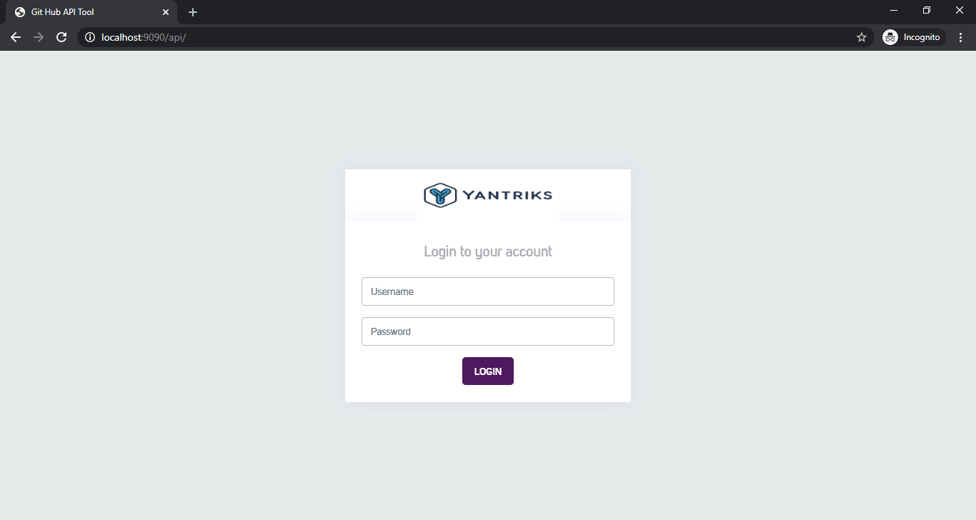

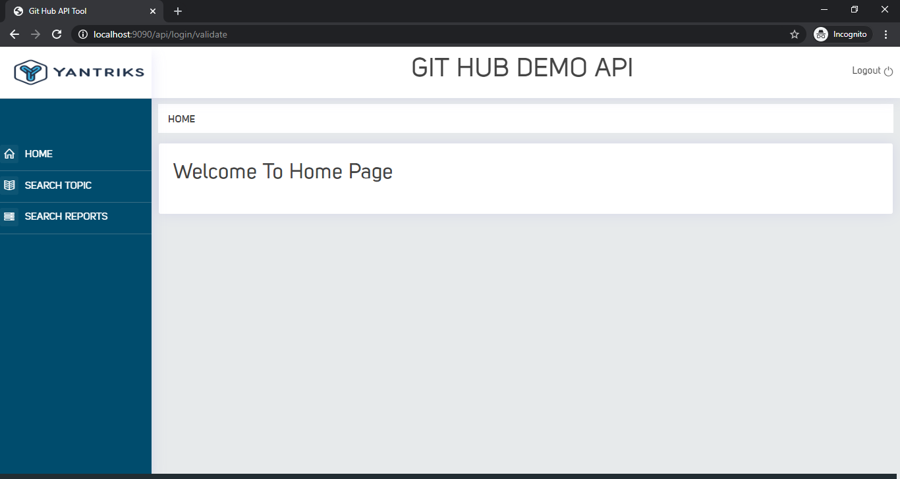

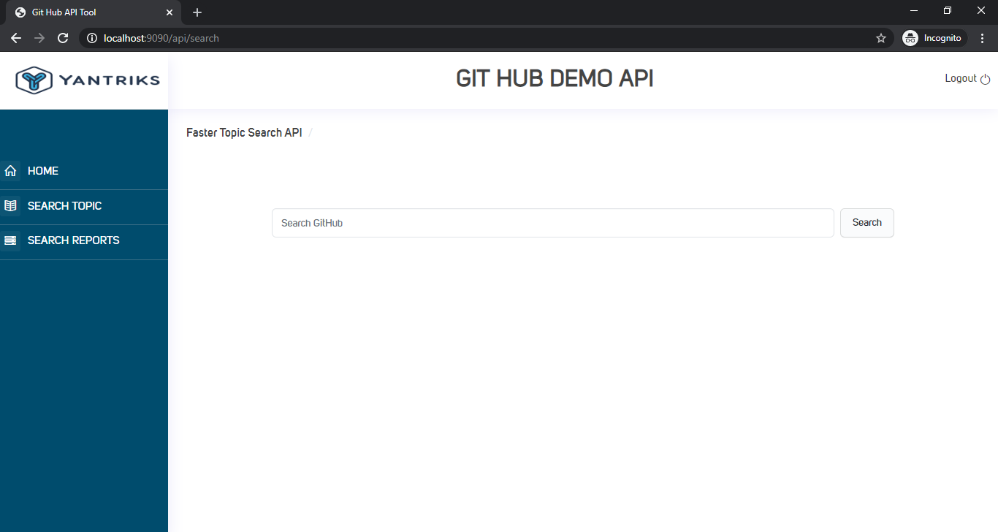

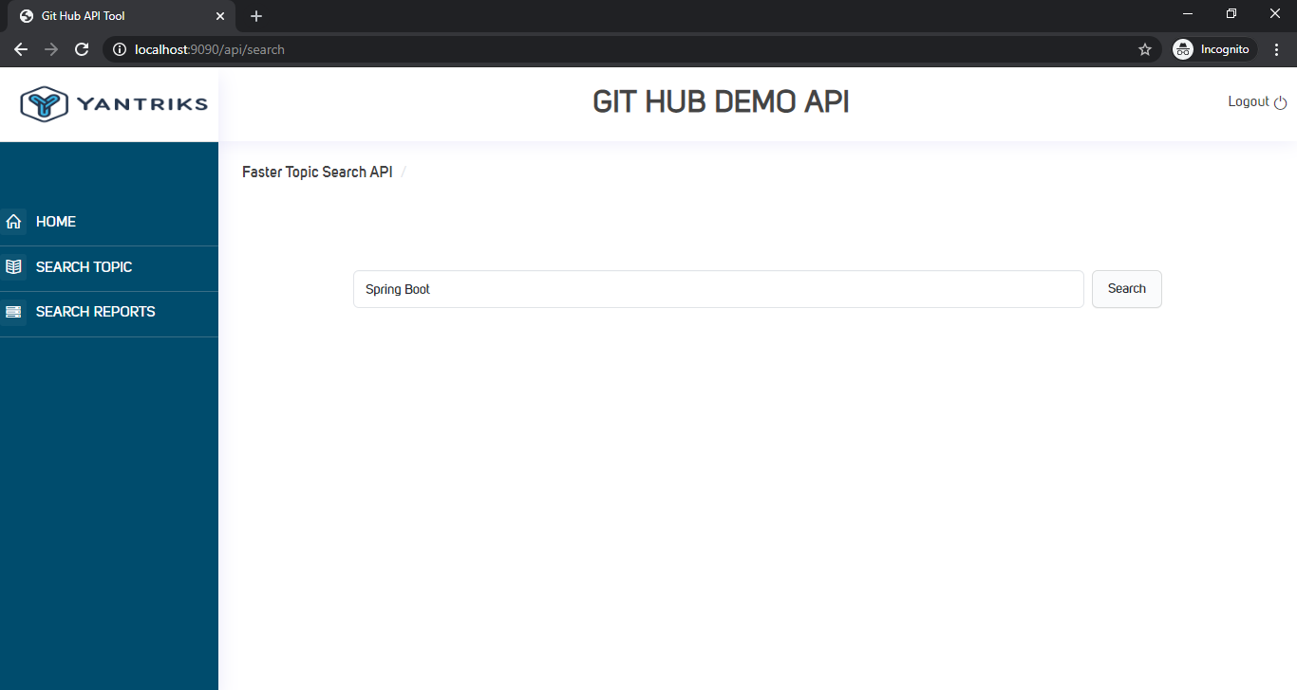

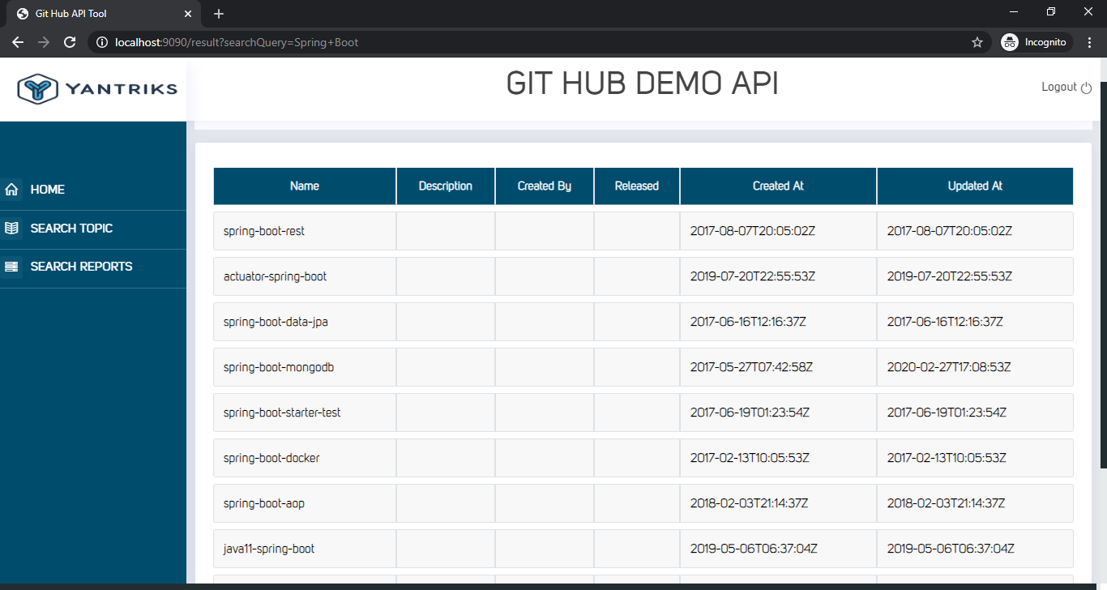

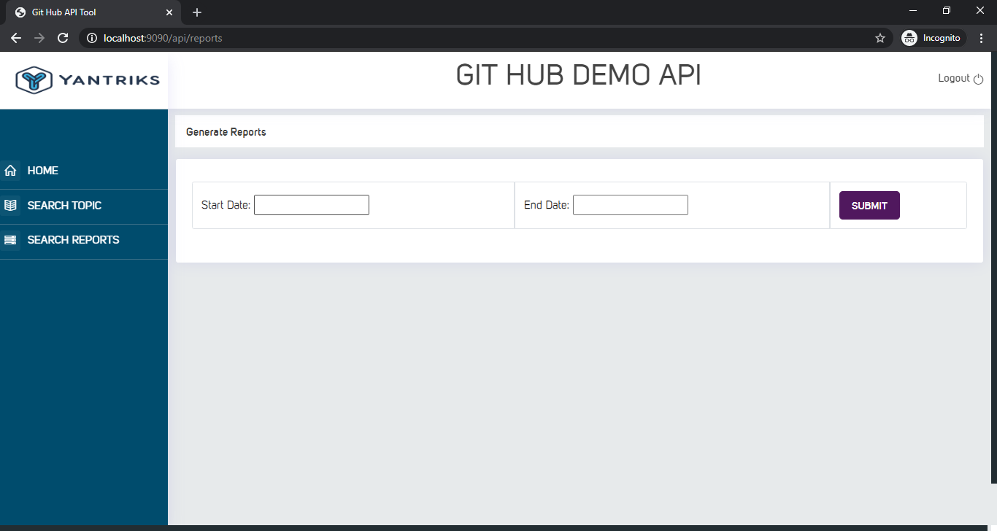

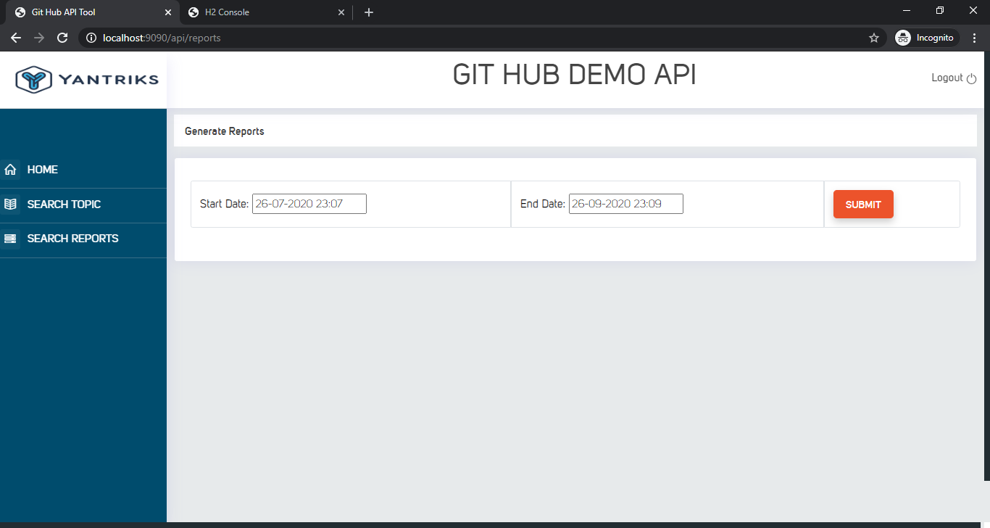

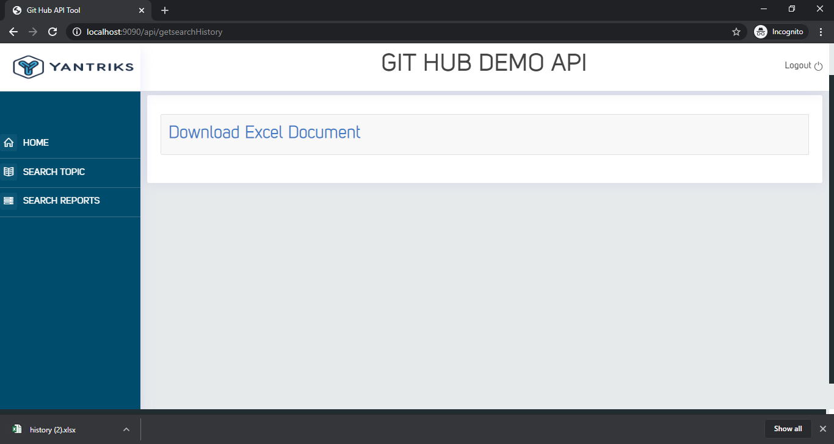

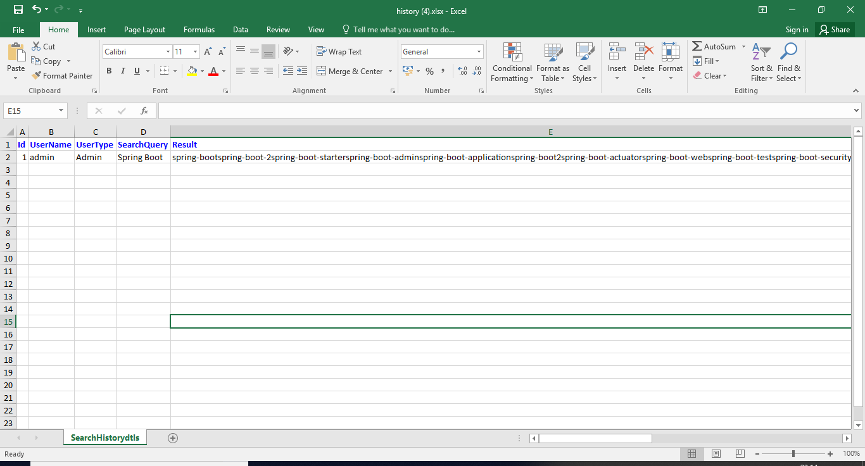

Note :-Only User with type Admin whose search history will be stored.

Run **GithubdemoapiApplicationTests.java file** to Run test cases.

