**1.MAIN SCREEN**

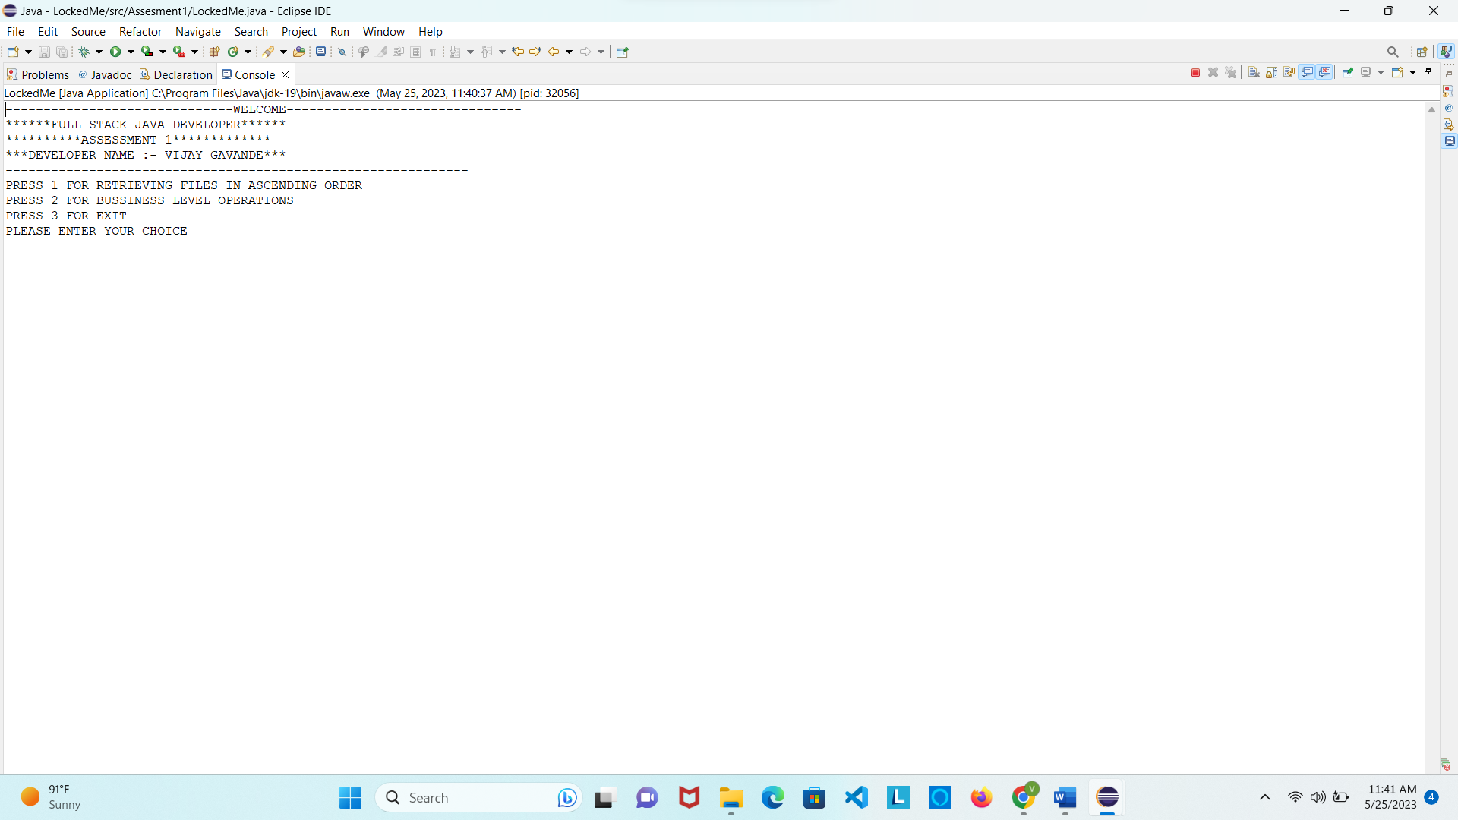

**2.FOR SHOWING FILES IN ASCENDING ORDER**

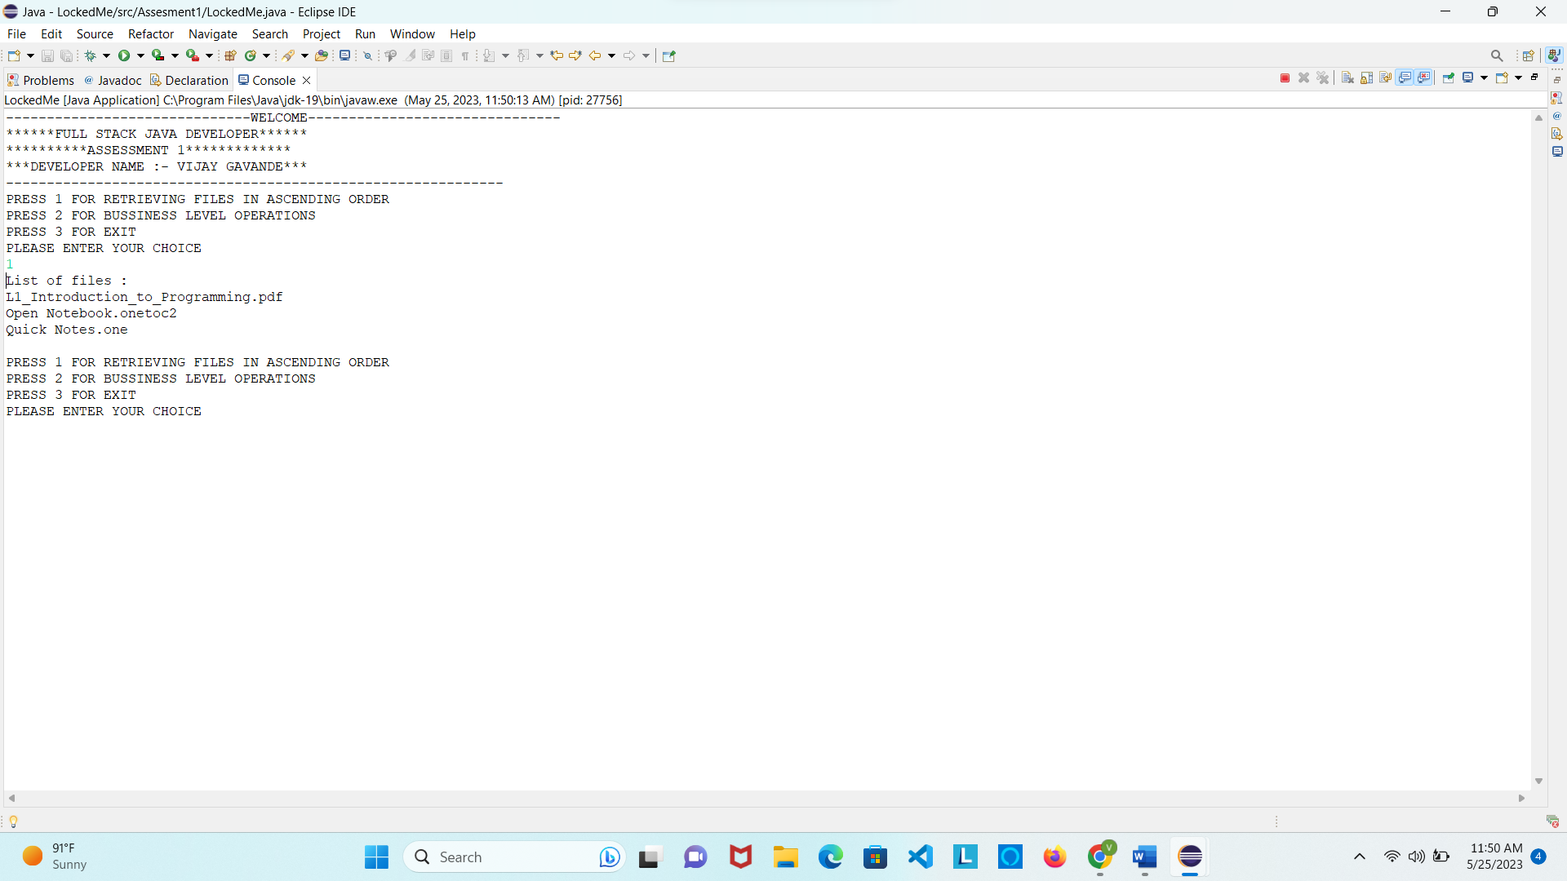

**3. FOR BUSSINESS LEVEL OPERATIONS**

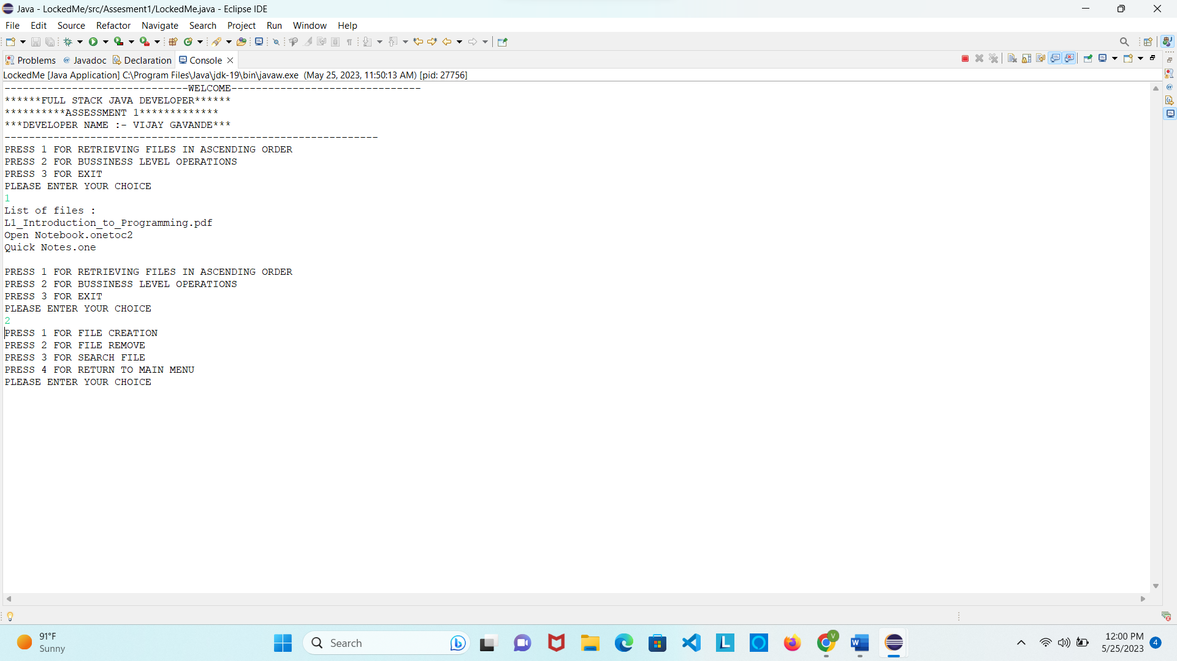

**4. FOR FILE CREATION IN BUSSINESS LEVEL OERATIONS**

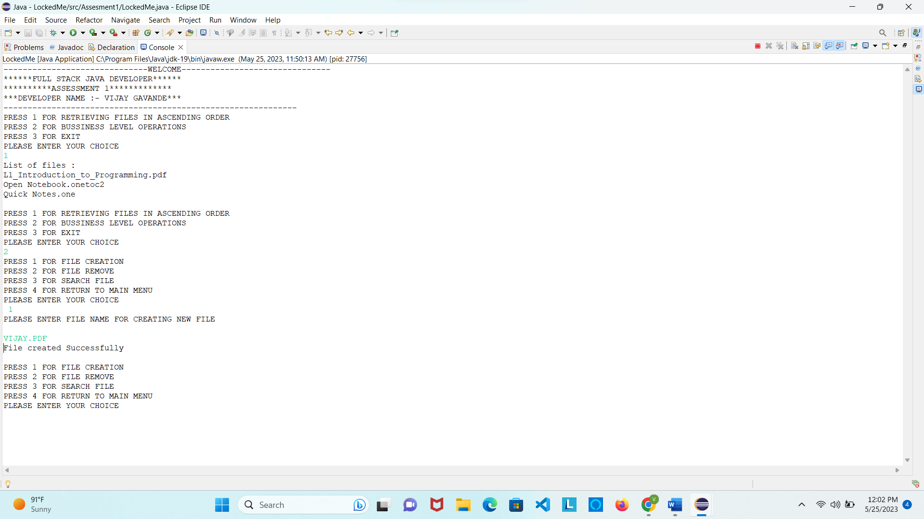

**5. FOR FILE DELETION IN BUSSINESS LEVEL OERATIONS**

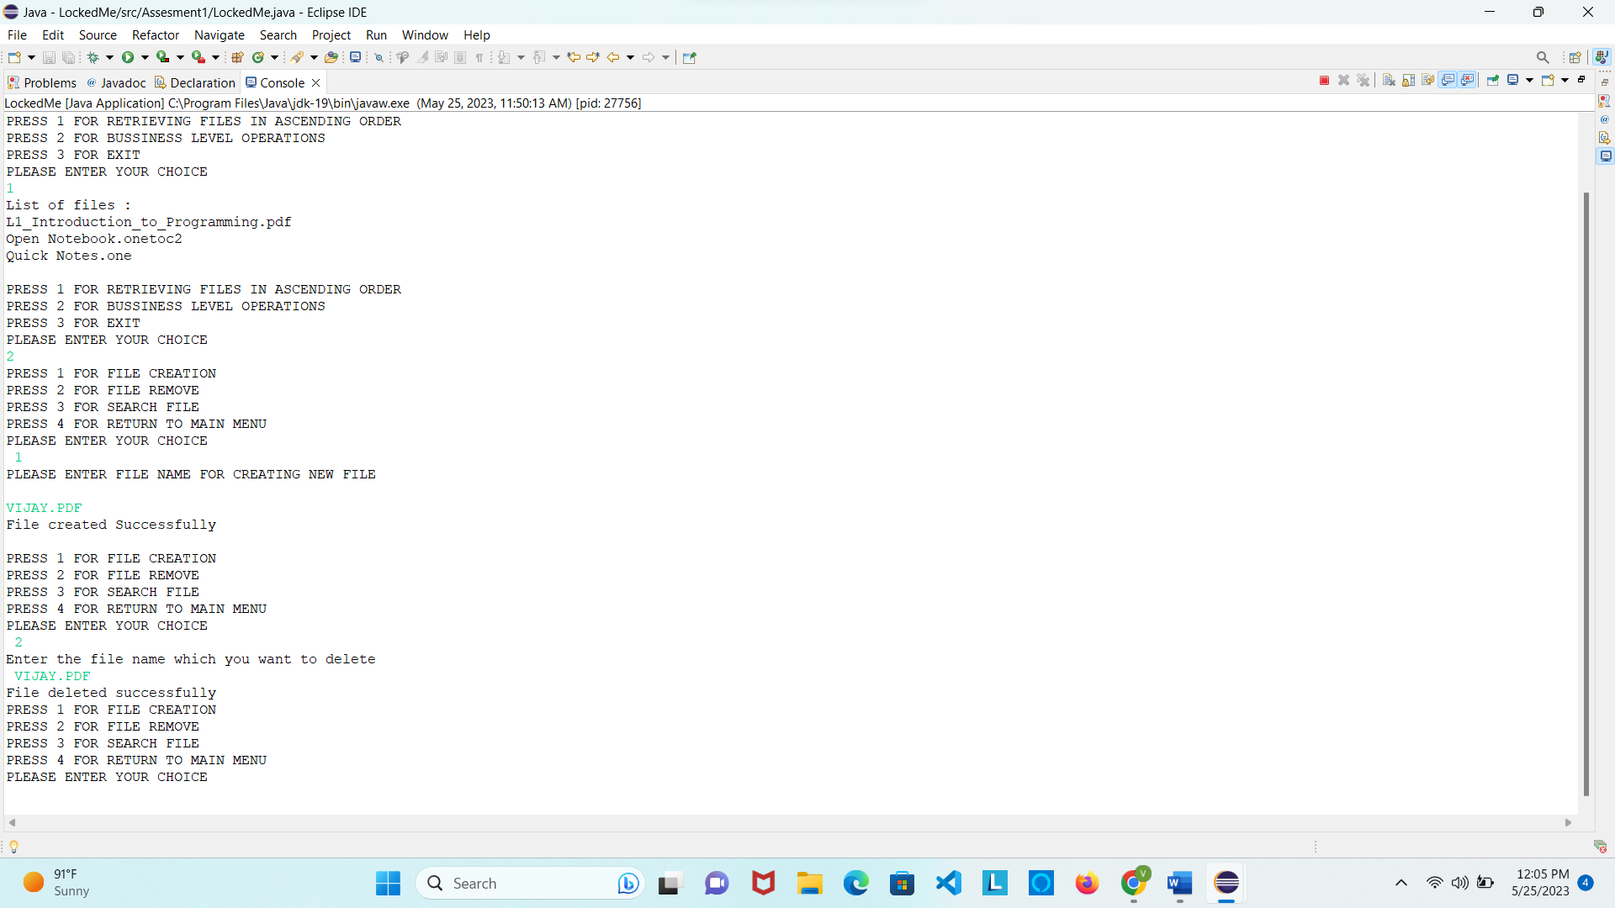

**6. FOR SEARCH FILE IN BUSSINESS LEVEL OERATIONS**

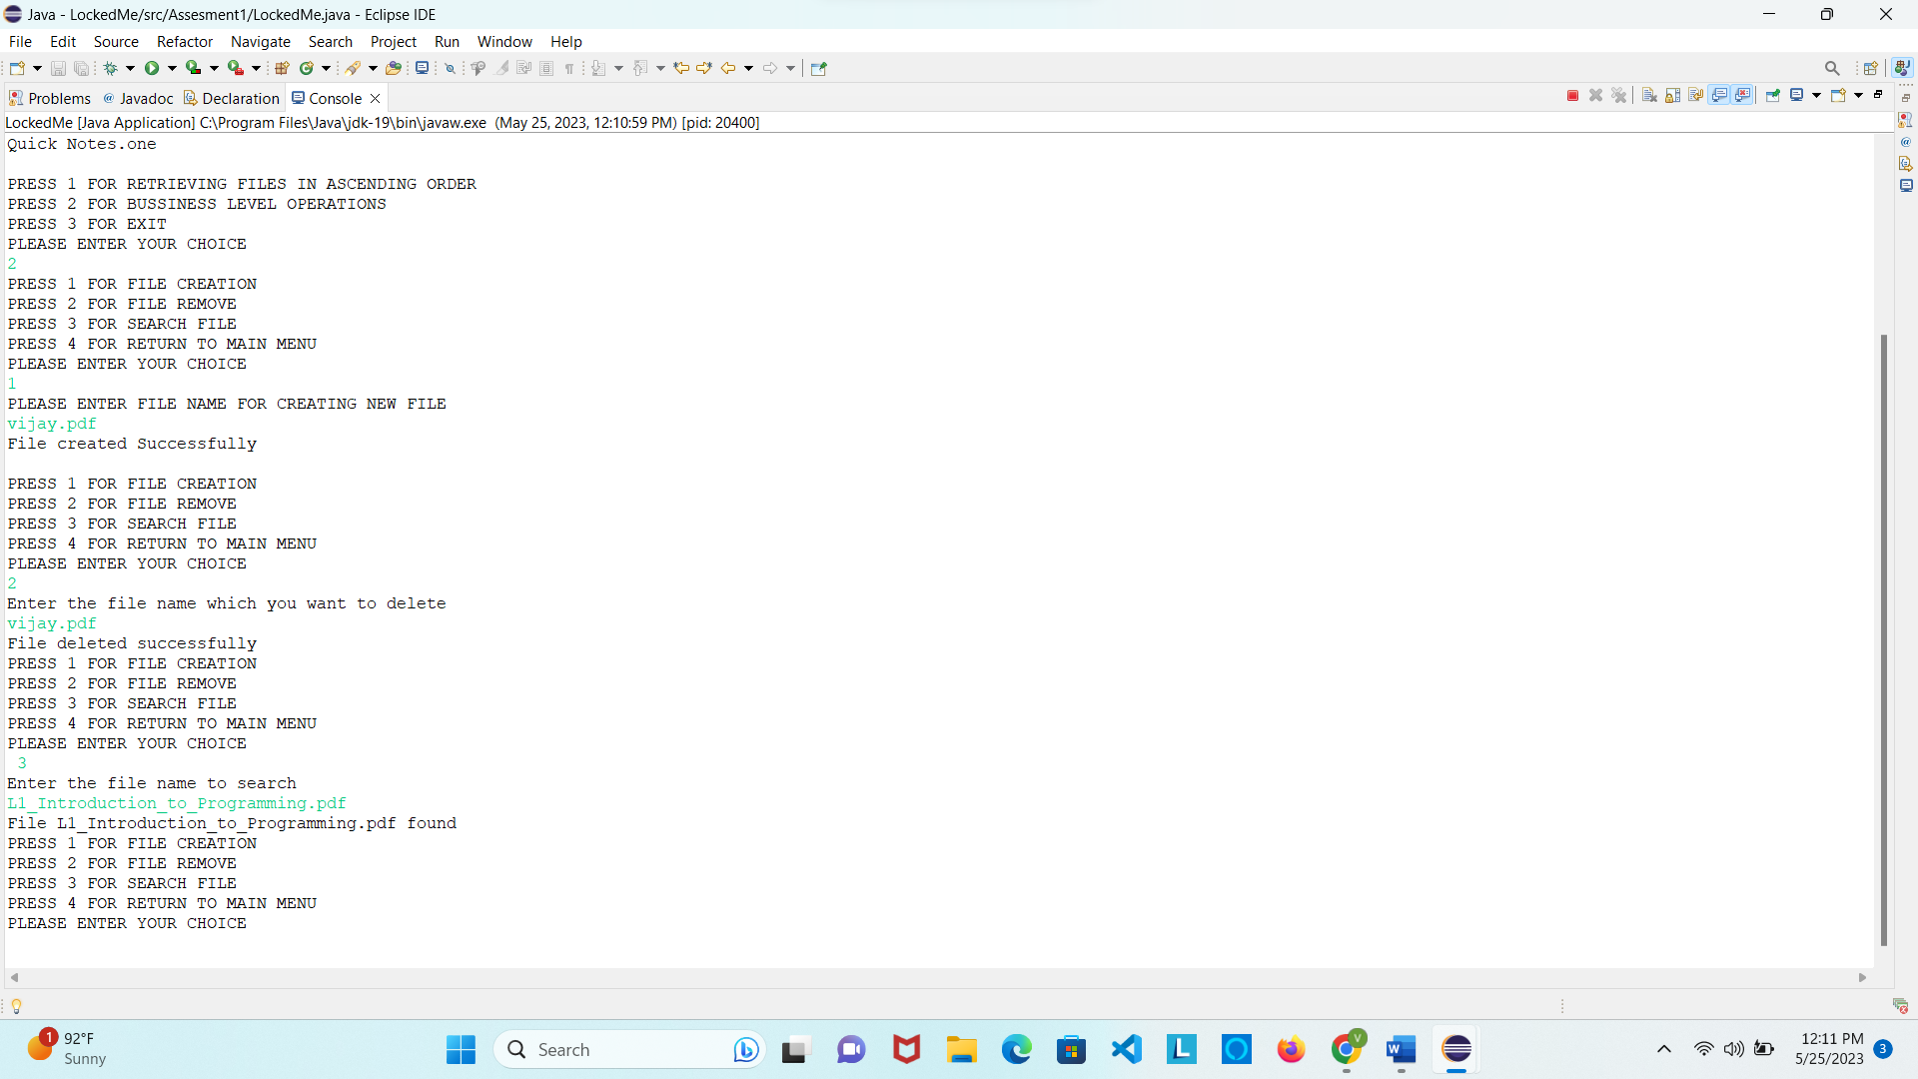

**7. FOR RETURN TO MAIN MENU**

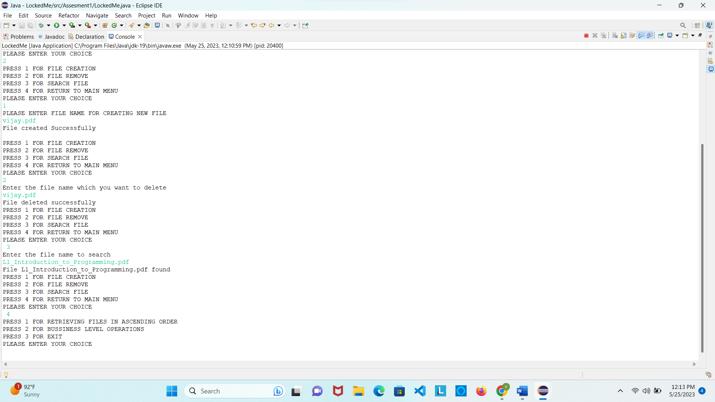

**8.FOR EXIT FROM APPLICATION**

