1/(a) 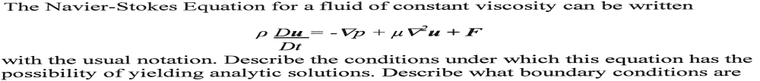
(This question comes from the book “physical fluid dynamics” second edition by D.J.Tritton, page 55-64)
(b)Chaotic flows occur frequently in nature. Discuss in some detail the physical processes which lead to such flows. Discuss the consequences of chaotic in one particular example. Discuss at least one chaotic flow which occurs in nature and described how the observed outcome differs from the non chaotic case. (I have attached the article which is related to answer this question “chaos, strange attractors and weather” ).
(c )
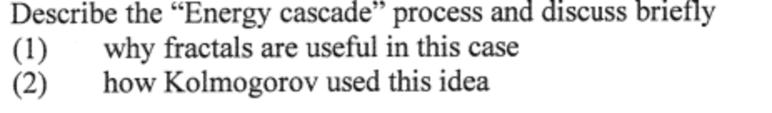
(I have attached the article which is related to answer this question “scale Invariance, Symmetries, Fractals, and Stochastic Simulations of Atmospheric Phenomena”).
(d)
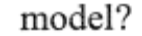(I have attached the article which is related to answer this question “Marine turbines for electrical power generation in New Zealand”
2/(a) Describe how you would attempt to estimate the fluxes of carbon dioxide and methane in a tropical forest. (I have attached the article which is related to answer this question “Extended-Range Atmospheric prediction and the Lorentz model”).
(b)
. (The answer could be in one of the articles which I attached or you can find the answer in the book “physical fluid dynamics” second edition, by D.J.Tritton).

(c )
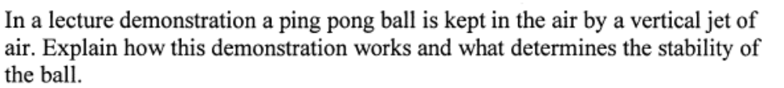
(you can find the answer in the book “physical fluid dynamics” second edition, by D.J.Tritton).
(d )
(use the book and the articles to answer this Q)
3/ (a)
(I have attached the article which is related to answer this question “scale Invariance, Symmetries, Fractals, and Stochastic Simulations of Atmospheric Phenomena”).
(b)
(I have attached the articles which is related to answer this question “scale Invariance, Symmetries, Fractals, and Stochastic Simulations of Atmospheric Phenomena”).
(c )
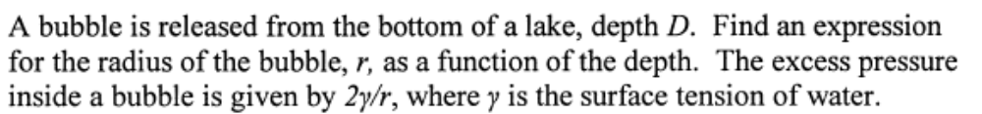
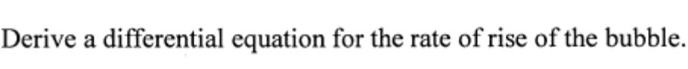

(d ) (i)
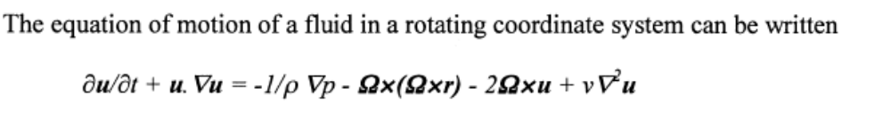
With the usual notation. Identify the physical origin of each term.
(To answer this question read chapter 16 in the book “physical fluid dynamics” second edition, by D.J.Tritton).
(ii)
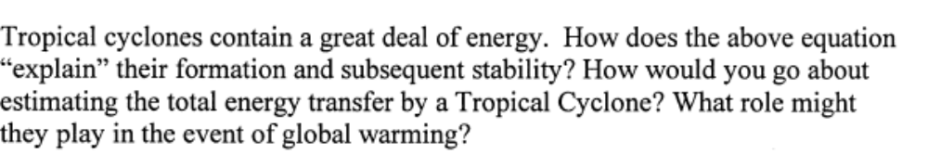
(iii)
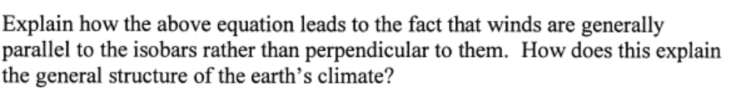
4/(a)
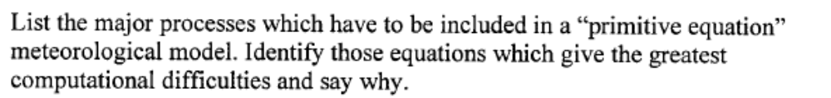
(I have attached the article which is related to answer this question “Formulation of Mesoscale Numerical Models”.
(b)
(c )
(d)
(read the articles which I have attached to answer question 4).

