Solutions:
Question 1
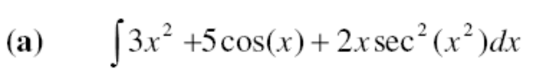
Substitute 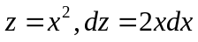
y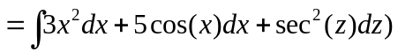
Answer, y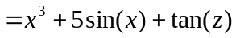
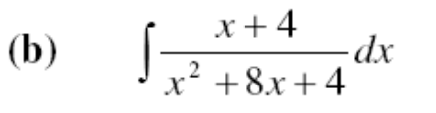
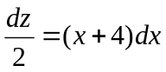Substitute 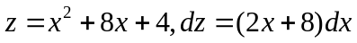

y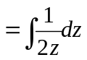
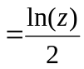
Answer, y 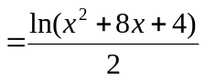
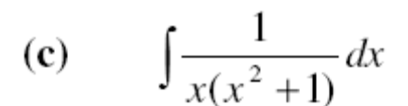
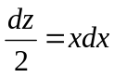Substitute 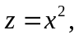

y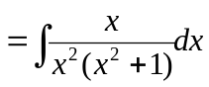
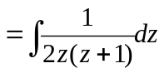
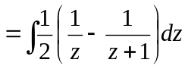
Answer, y 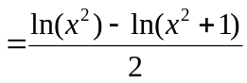

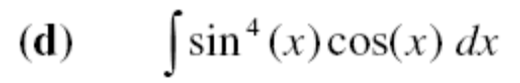
Substitute, 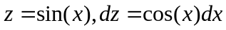
y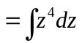
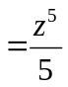
Answer, y 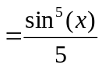
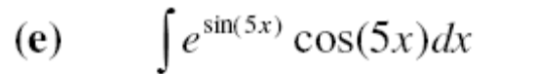
Substitute, 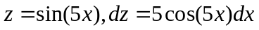
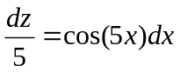

y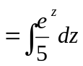
Answer, y 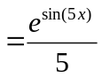

Question 2
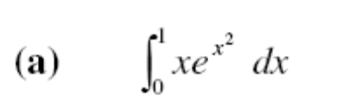
Substitute 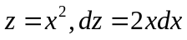

y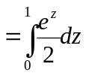
y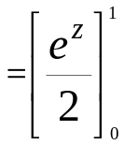
Answer, y =0.8591

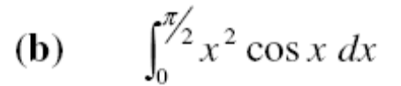
Integrating by parts,
y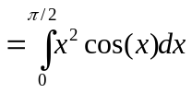
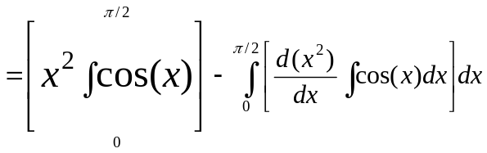
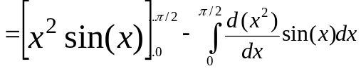

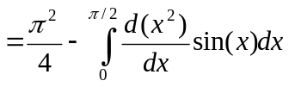
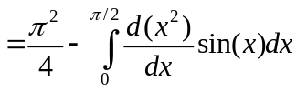
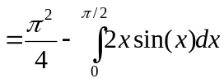
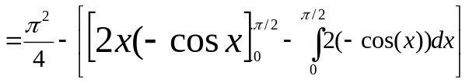
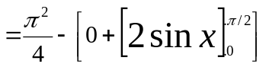
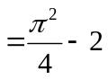
Answer, y 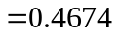

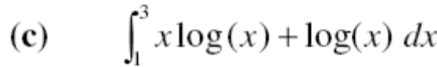
Integrating by parts,
y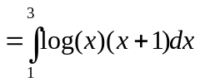
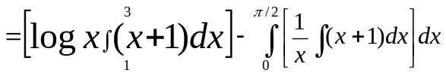
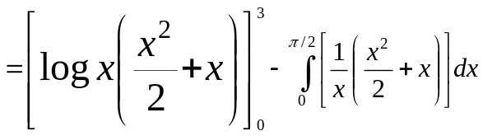
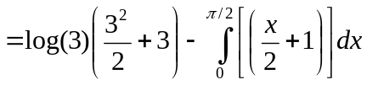
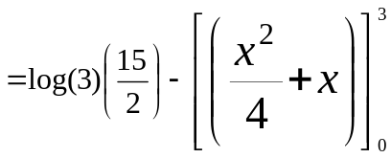
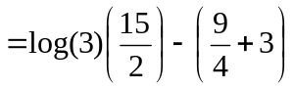
Answer, y 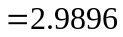

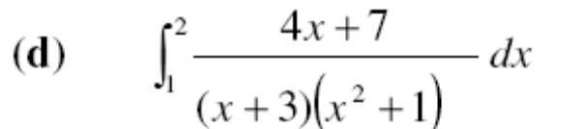
Using partial fraction expansion,
y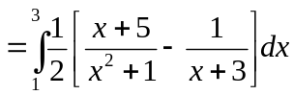
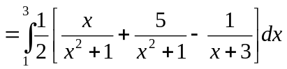
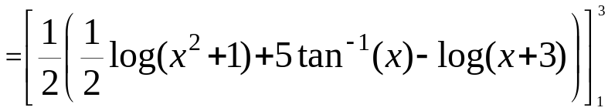
Answer, y 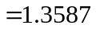

Question 3
- Sketch the (finite) region R which is bounded by the graphs of y = x² and y = 1.
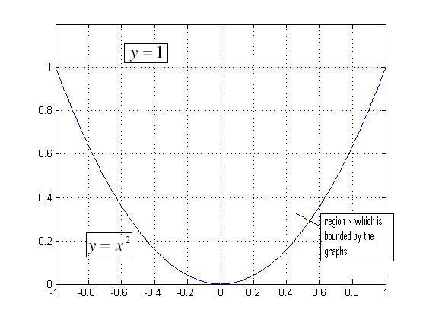
- Calculate the area of the region R.
The area of the region R
= (The area under the curve y=1) – (the area under the curve y = x² )
=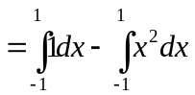
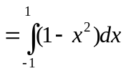
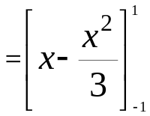
Area=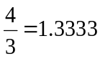
Question 4
(a) Sketch the (finite) region R which is bounded by the graphs of y = x² + 2x −4 and
y = 2x between x = 0 and x = 4 .
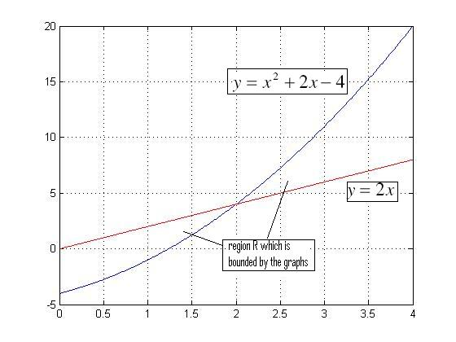

- Calculate the area of the region R.
The curve y = x² + 2x −4 intersects y = 2x at x=2 for x between 0 and 4.

Area of region R=
[(The area under the curve y=2x) – (the area under the curve y = x²+ 2x −4 ) for x between 0 and 2] + [ (the area under the curve y = x²+ 2x −4 ) – (The area under the curve y=2x) for x between 2 and 4]
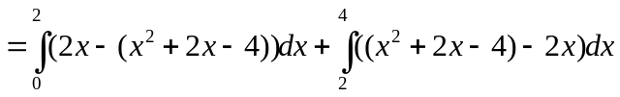
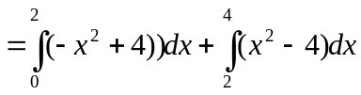
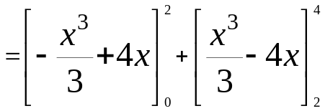
Area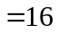

Question 5
A ball, initially at rest, is dropped from a height of 1000 meters. The acceleration due to
gravity is 9.8m/ s² .
- Derive the equation for the velocity of the ball with respect to time t.
Acceleration due to gravity g can be expressed as rate of change of velocity, v with respect to time, or time derivative of velocity
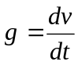
Let the initial velocity at time t=0 be u and final velocity at t=t be v,
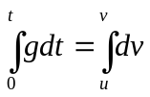
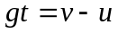
Hence, equation for the velocity of the ball with respect to time t,v
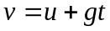
- Derive an equation for the displacement of the ball at time t.
Velocity of the ball v can be expressed as rate of change of displacement, s with respect to time, or time derivative of displacement
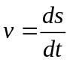
Let the initial displacement at time t=0 be 0 and final displacement at t=t be s,
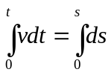
As velocity v is variable, substituting
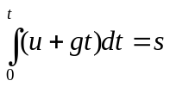
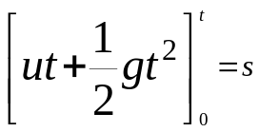
Displacement of the ball at time t,
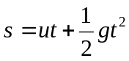

- After how much time will the ball hit the ground?
As ball is initially at rest, so u=0, g=9.8, s=1000.
Substituting the values in , we get
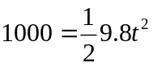
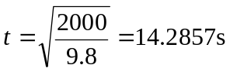
Hence, the ball will hit the ground after 14.2857 seconds.
- What is the velocity with which the ball hits the ground?
Substituting u=0, g=9.8, t=14.2857 in equation
we get,
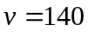
Hence, the velocity with which the ball hits the ground is 140 m/s

