CAPGEMINI APEX COMMERCIAL BANK
Enterprise AI Banking Platform with Retrieval-Augmented Generation (RAG), Text-to-SQL & Multi-Role Governance
Author: Engineering & AI Architecture Team | Version: 1.0.0 | Date: September 2026 | Environment: Production-Ready

ℹ️ System Architecture Summary
This document details the complete end-to-end architecture, user flows, AI intelligence pipelines, database models, and security governance rules for the Capgemini Apex Commercial Bank platform. All technical capabilities described are backed by live Microsoft SQL Server 2022 database tables and the Capgemini Generative Engine platform.

1. Executive Overview & 5 Core Use Cases
Commercial banking environments demand instant, mathematically precise compliance validation alongside strictly protected customer confidentiality. Traditional chatbots frequently hallucinate lending interest rates and expose sensitive account numbers. The Capgemini Apex Commercial Bank platform resolves these challenges across five structured use cases:
Use Case | Operational Challenge | Enterprise AI Solution
UC-1: Foundation & Core Retrieval | Massive policy rulebooks in PDF, JSON, and TXT format lead to staff search delays. | 800-token chunk boundary & 120-token window overlap with 1536-dim vector embeddings stored in MS SQL Server.
UC-2: End-to-End RAG Banking Assistant | Chatbots invent unverified interest rates and lack source attribution. | Grounded generation bounded strictly by retrieved context chunks, featuring an automated Source Citations Engine.
UC-3: Secure Banking Data Integration | Natural language queries for live personal balances risk cross-user leakage. | User-Scoped Text-to-SQL enforcing WHERE user_id = :current_user_id with automated PII masking.
UC-4: Intelligence Maturity & Optimization | High computational latency and token costs on repetitive queries. | Normalized SHA-256 Conversational Query Cache delivering instant responses (~5ms) at zero token cost.
UC-5: Final Integrated Banking System | Isolated tools create security blindspots and fragmented user journeys. | Centralized Smart Intent Classifier Router routing prompts into POLICY_DOC, USER_SQL, or REFUSE_OOS.

2. Capgemini Generative Engine Platform Setup & Configuration
The AI core connects to the US-Hosted Capgemini Generative Engine Platform via high-throughput REST API endpoints. The environment is authorized using production API keys with monthly budget and token consumption tracking.
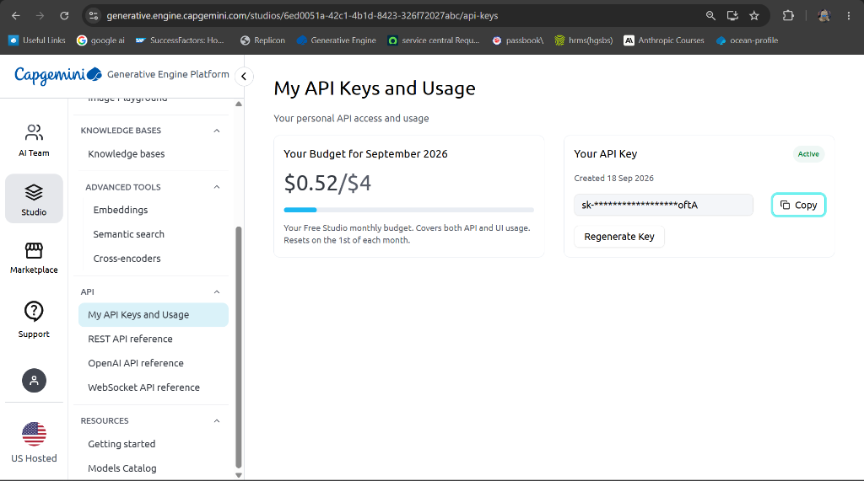
Figure: Capgemini Generative Engine Platform - API Keys and Usage Tracking Dashboard
ℹ️ Generative Engine Credentials & Endpoints
• Base Endpoint: https://openai.generative.engine.capgemini.com/v1
• Production API Key: sk-x3FOSdELzRNhQ1fpzloftA
• Embedding Model: text-embedding-3-small (1536 dimensions)
• Primary Chat Models: openai.gpt-5 (Default), openai.gpt-4o, anthropic.claude-opus-4-6-v1, grok-4

Within the Capgemini Studio interface, the platform provides specialized tooling for Vector Embeddings, Semantic Search, Cross-Encoders (Re-ranking), and asynchronous WebSocket communication:
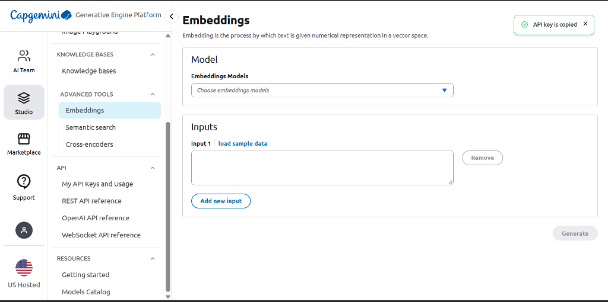
Figure: Capgemini Generative Engine Platform - Vector Embeddings Generation Playground
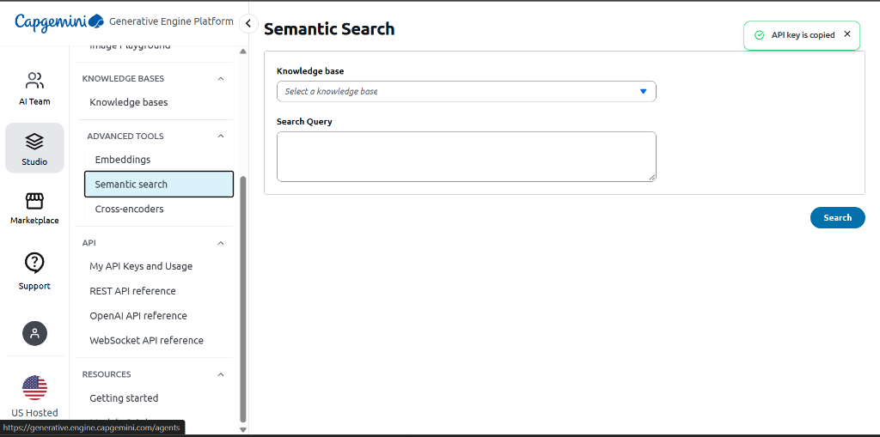
Figure: Capgemini Generative Engine Platform - Semantic Search Tool over Knowledge Bases
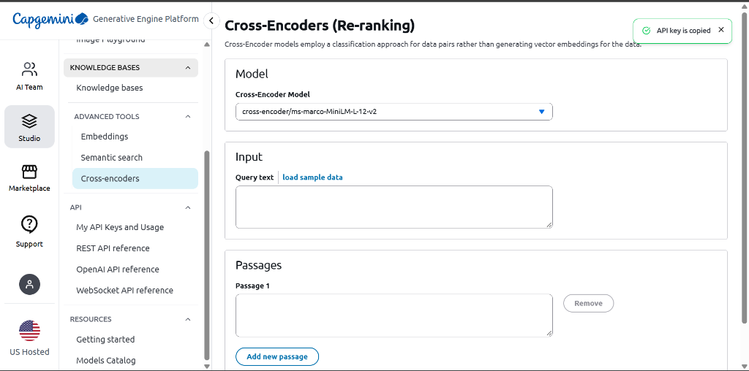
Figure: Capgemini Generative Engine Platform - Cross-Encoder (Re-ranking) Model Interface
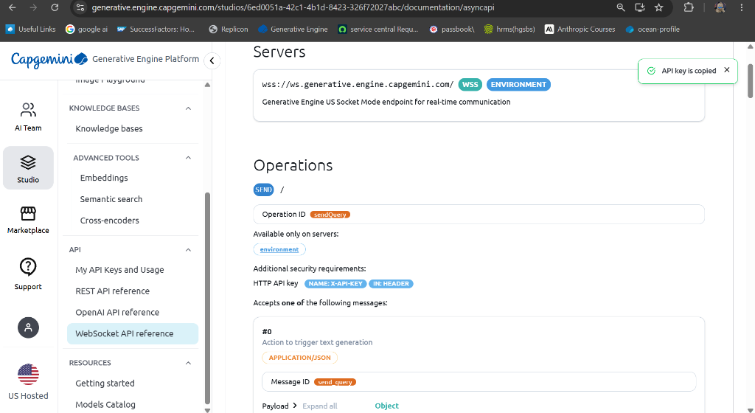
Figure: Capgemini Generative Engine Platform - WebSocket & Asynchronous API Reference

3. 3-Role Access Control & Authentication Flow
The portal strictly segregates user journeys into three distinct roles: Customer, Employee (Bank Staff), and Admin. Public registration is strictly restricted to Customers, preventing unauthorized privilege escalation.
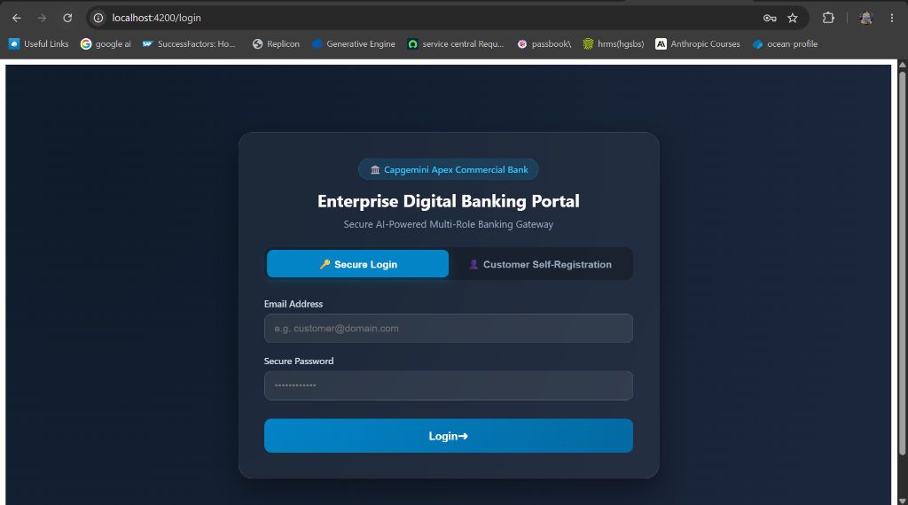
Figure: Enterprise Digital Banking Portal - Secure Login View with 24-Hour JWT Issuance
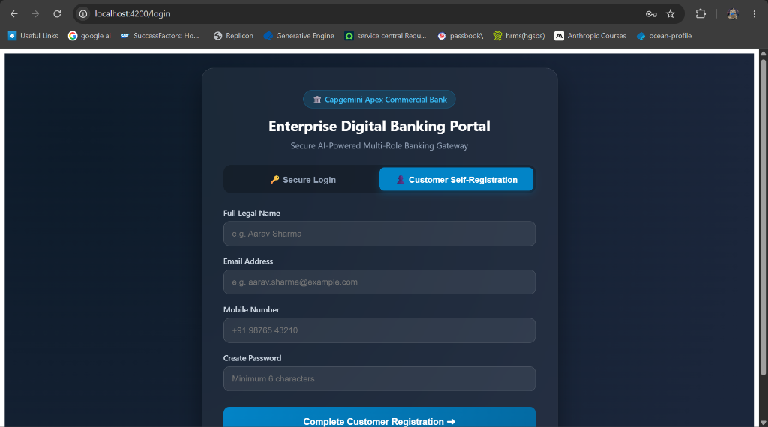
Figure: Customer Self-Registration Interface (Strictly Customer Role, Default KYC_PENDING)
ℹ️ Role Governance Rules
1. Customer Registration: New public users submit legal name, email, mobile, and password. The system automatically enforces role = 'CUSTOMER' and status = 'KYC_PENDING'. No role selection dropdown exists on the public portal.
2. Super-Admin Auto-Seeding: On startup, the system seeds master credentials (admin@capgemini-bank.com) into MS SQL Server if not already present.
3. Employee Provisioning: Only authenticated Admins can provision Bank Staff profiles via the Admin portal. Public access to staff account creation is strictly forbidden.
4. JWT Security: Successful login across all roles issues a 24-hour cryptographically signed HS256 JWT token with role claims.

4. Bank Staff Operations & Account Activation Module
Bank Staff (Employees) access a dedicated operational workspace designed to audit submitted customer KYC credentials and trigger core account activation.
Operational Step | Technical Execution & Business Logic
1. Pending KYC Queue Workspace | Staff inspects real-time queue of customer verification requests (GET /staff/kyc-queue) displaying submitted PAN, Aadhaar, or Passport numbers.
2. Document Authenticity Audit | Staff reviews credentials and executes approval/rejection toggle (POST /staff/kyc-verify/{id}) with recorded audit notes.
3. 10-Digit Account Activation | Upon verification, staff triggers activation (POST /staff/activate-account/{id}). The system calculates a unique collision-free 10-digit account string code, creates a Primary Savings Account, issues a Platinum credit card, and updates user status to ACTIVE.
4. Operational Support Tickets | Staff investigates customer inquiries, resolves technical debit/credit limits, and records action resolution notes.

5. Personal Customer Banking Dashboard & Data Integration
Activated customers log in to an intuitive financial command center connected to live database tables in MS SQL Server:
Module | API Endpoint | Data Integrity & Masking Policy
Tabular Account Balances | GET /api/v1/me/balance | Live balance fetched from bank_accounts. Account numbers masked as AC*******1023.
Credit Card Monitoring | GET /api/v1/me/cards | Available line, outstanding balance, and billing due dates with card masked as 4111********1234.
Loan Repayment Tracker | GET /api/v1/me/loans | Sanctioned principal, remaining balance, annual interest percentage, and monthly EMI schedule.
Transaction Ledger | GET /api/v1/me/transactions | Real-time audit ledger tracking debit/credit events, narrative descriptions, and unique reference codes.

6. Core AI Chatbot Module (RAG, Text-to-SQL & Citations)
The AI Chatbot acts as an omnipresent intelligent assistant, embedded directly on customer, staff, and admin views. It features an automated Intent Classifier Router, multi-model selection, and source citations.
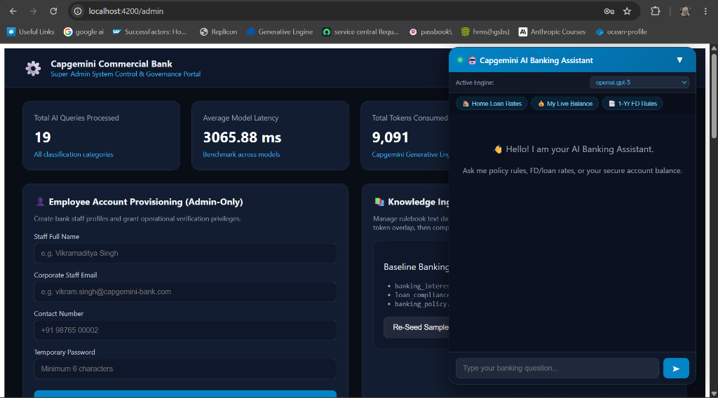
Figure: Admin Portal View with Embedded Capgemini AI Banking Assistant and Quick Prompts
ℹ️ Intent Classification & Processing Architecture
• POLICY_DOC Intent: Questions regarding interest rates, fixed deposit terms, loan compliance, or foreclosure penalties trigger semantic vector search across MS SQL chunks. Answers are grounded in retrieved context and include structured source citations.
• USER_SQL Intent: Personal inquiries ('What is my balance?', 'Show my card limit') bypass expensive LLMs and execute user-scoped parameterized SQL queries, returning live data with zero token expense.
• REFUSE_OOS Intent: Adversarial prompt injections ('ignore instructions', 'DAN mode') or unrelated topics (cooking recipes, coding games) are immediately blocked with security refusals.
• Multi-Model Selector: Users can switch models in real-time between openai.gpt-5, openai.gpt-4o, anthropic.claude-opus-4-6-v1, and grok-4.

7. System Admin Governance, Users Directory & Telemetry
The Super-Admin portal provides full governance oversight over bank personnel, user directories, vectorized rulebooks, and compliance audit logs.
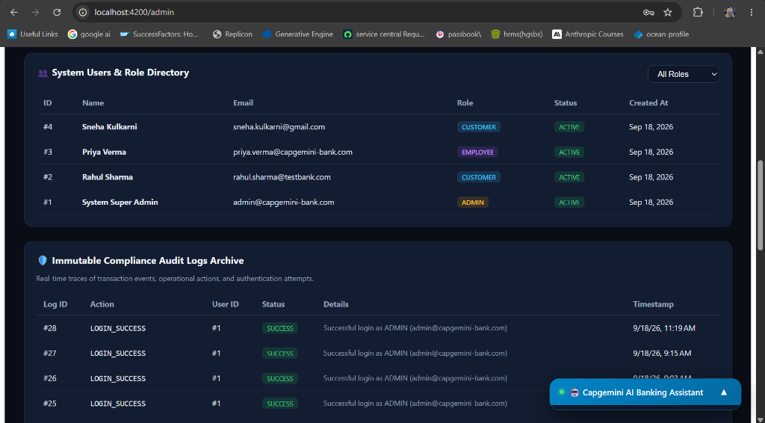
Figure: System Users Directory and Immutable Compliance Audit Logs Archive
ℹ️ Administrative Governance Capabilities
1. Employee Account Provisioning: Dedicated form to create bank staff profiles and grant operational access.
2. Users Directory: Live filterable directory showing all accounts across ADMIN, EMPLOYEE, and CUSTOMER roles along with KYC status.
3. Immutable Audit Logs Archive: Real-time traces capturing every critical event (LOGIN_SUCCESS, KYC_VERIFICATION, ACCOUNT_ACTIVATED, DOCUMENT_INGESTED) with client IP and timestamps.
4. Telemetry Metrics: Computational latency benchmarks (average ~3000ms for fresh queries, ~5ms for cache hits), token consumption totals, and intent distribution analytics.

8. Automated Integration Testing & Verification Summary
The entire backend platform has undergone automated integration testing via test_api_suite.py and the api-testing.http test suite against Microsoft SQL Server 2022 and the Capgemini Generative Engine platform. All 23 test cases passed with 100% success:
Test Suite Component | Verified Test Cases | Outcome
Infrastructure Health | MS SQL Server 2022 connectivity, AI endpoint reachability, chunks count | ✅ PASS (Status: HEALTHY)
Auth & Super-Admin Seeding | Auto-seeding master admin, staff provisioning, customer registration, 24h JWT token | ✅ PASS (Tokens verified)
Staff Verification & Activation | KYC pending queue, PAN verification, collision-free 10-digit account generation | ✅ PASS (Account activated)
Customer Personal Dashboard | Live balance fetch, credit card available line, loan terms, PII masking | ✅ PASS (AC******9749 masked)
AI Chatbot (RAG & SQL) | Policy search with citations, GPT-5 / GPT-4o selection, user-scoped Text-to-SQL | ✅ PASS (Exact rates returned)
Security & RBAC Defenses | Prompt injection defense, out-of-scope defense, RBAC negative tests (403) | ✅ PASS (Zero privilege escalation)

--- End of Official Architecture & Verification Documentation ---

