LuxeMart E-Commerce Platform
Full-Stack Enterprise Architecture, Grounded Generative AI & Operations Manual
Project Name: | LuxeMart Curated Luxury E-Commerce & AI Concierge
System Architecture: | FastAPI 0.115 (Backend) | Angular 21 (Frontend) | Microsoft SQL Server (SSMS)
GenAI Engine: | Capgemini Generative Engine Platform (OpenAI GPT-5, Claude 3.5, Phi-4, Mistral)
Lead Administrator: | Vijay Kumar (vijaykumar@gmail.com) | Capgemini L1

Executive Table of Contents
Section 1 | Executive Summary & System High-Level Architecture (HLD)
Section 2 | Capgemini Generative Engine Platform Setup & Studio Configuration
Section 3 | Storefront Experience & Product Catalog Discovery Engine
Section 4 | AI Shopping Concierge Drawer & Grounded Real-Time Inference
Section 5 | Enterprise Store Administration, KPIs & Database Inventory Management
Section 6 | Relational Database Schema & PyODBC SQL Server Integration
Section 7 | RESTful API Contracts & Security Specifications
Section 8 | Installation, Local Runbook & Seed Credential Reference

1. Executive Summary & System Architecture
LuxeMart is an enterprise-grade luxury e-commerce web platform engineered with a modern decoupled full-stack architecture. The platform combines lightning-fast catalog search, end-to-end relational transaction management, administrative operational telemetry, and an integrated real-time generative AI conversational shopping assistant powered by the Capgemini Generative Engine Platform.

1.1 Architectural Philosophy & Core Tenets
- Zero Synthetic / Mock Data: All catalog listings, product taxonomies, inventory stock levels, user profiles, and order histories are 100% persisted and retrieved dynamically from Microsoft SQL Server (LIN-5CD6268KRS/ECommerceDb).
- Decoupled Single-Page Architecture: The frontend is built using Angular 21 Standalone Components, leveraging reactive RxJS streams, signals, and typed service layers. The backend is an asynchronous FastAPI service utilizing SQLModel ORM over PyODBC.
- Role-Based Access Control (RBAC): Stateless cryptographic authentication using JSON Web Tokens (JWT) signed via HS256 and Passlib/Bcrypt password hashing. Granular role validation separates customers from administrative users.
- RAG-Grounded AI Commerce: Unlike generic chat assistants, LuxeMart's AI Shopping Concierge performs deterministic catalog retrieval from the live database, compiling structured product facts, stock statuses, and prices directly into prompt context.

1.2 High-Level System Block Architecture
The diagram below articulates the end-to-end interaction topology between client tiers, backend services, SQL Server, and Capgemini's cloud AI infrastructure:
Layer | Technology Component | Primary Responsibilities
Client Tier | Angular 21 SPA (TypeScript / SCSS) | Storefront UI, sticky catalog filters, cart state, order checkout, reactive AI chat widget, and Store Admin Console.
Gateway / API Tier | FastAPI (Python 3.12 / Uvicorn) | RESTful endpoints (/api/auth, /api/products, /api/orders, /api/admin, /api/chat), JWT verification, and CORS handling.
Data Persistence | Microsoft SQL Server 2022 (PyODBC) | ACID transaction guarantees, relational schemas (Users, Products, Categories, Orders), and inventory stock locking.
Generative AI Tier | Capgemini GenEngine Platform | Cloud LLM routing (OpenAI GPT-5, Claude 3.5, Phi-4, Mistral 7B), dynamic context grounding, and conversational inference.

2. Capgemini Generative Engine Platform Setup
The intelligent shopping concierge is backed by Capgemini's enterprise Generative Engine Platform studio. The system establishes direct HTTPS communication with the platform's chat completions gateway (https://generative.engine.capgemini.com/api/v1/chat/completions) using securely provisioned studio bearer tokens.

2.1 Studio Workspace & API Credential Configuration
Within the Capgemini Generative Engine Studio, workspace settings monitor token quotas, active platform rate limits, and provision API access keys. The backend retrieves the API key and studio instance ID dynamically from environment variables (CAPGEMINI_AI_API_KEY, CAPGEMINI_STUDIO_ID).
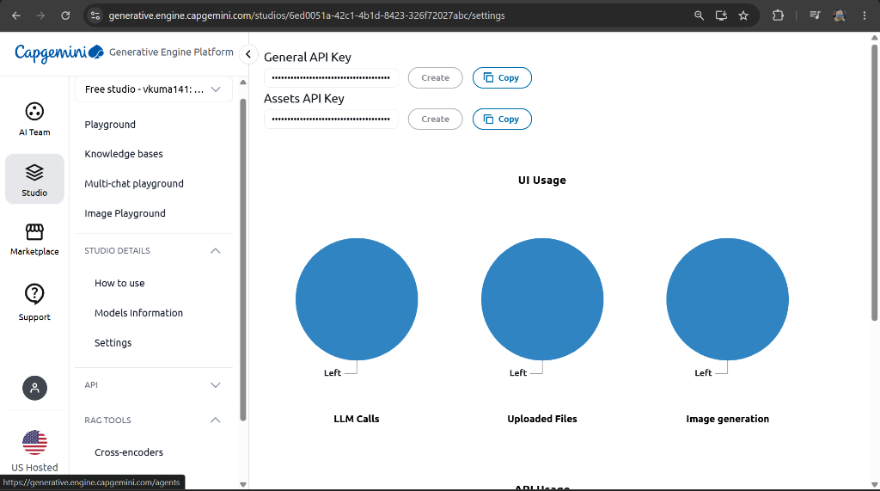
Figure 1: Capgemini Generative Engine Platform - Studio Settings & Secure API Key Telemetry

2.2 Multi-Model Fleet & Supported Foundation Models
The platform provides seamless interoperability across leading foundation models. Users can switch models directly inside the storefront drawer, routing requests dynamically across different LLM backends:
- OpenAI GPT-5 (Flagship): High-precision conversational synthesis, complex customer query disambiguation, and nuanced multi-turn advice.
- Phi-4 Mini Reasoning: Optimized ultra-low-latency lightweight reasoning engine ideal for rapid inventory lookups and high-concurrency requests.
- Anthropic Claude 3.5 Sonnet: Specialized long-context reasoning with deep brand storytelling and artisanal material comprehension.
- Mistral 7B Instruct: Efficient open-weight instruct model for concise, prompt-adherent answers and policy explanations.
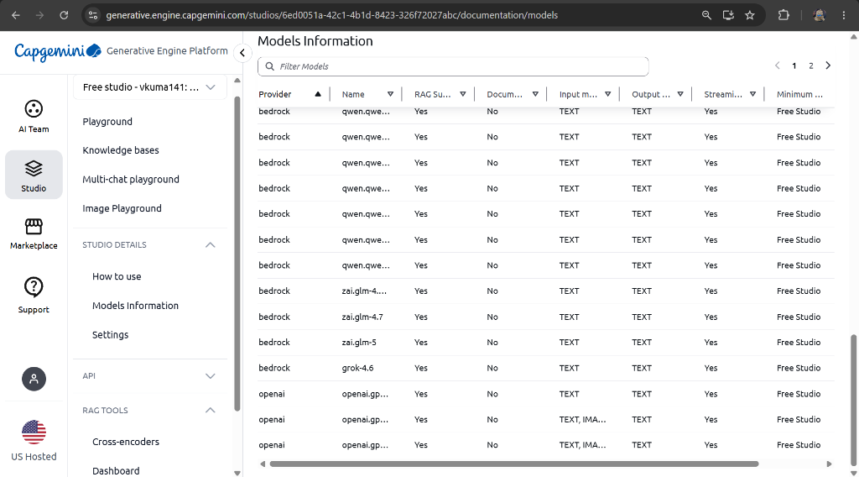
Figure 2: Capgemini Generative Engine Platform - Foundation Models Catalog & RAG Readiness

3. Storefront Experience & Product Catalog Discovery
The LuxeMart consumer storefront is built with an ultra-premium dark-mode aesthetic, utilizing tailored HSL color tokens, backdrop glassmorphic blurring, and smooth micro-animations. It provides real-time client-side and server-side product discovery across luxury artisanal departments.

3.1 Hero Banner & Brand Narrative
The landing view showcases curated collections with real-time value proposition statistics (25+ Artisanal Brands, 100% Certified Genuine, 24/7 AI Shopping Concierge). The navigation header features quick access to Catalog, Store Administration, and User Profiles.
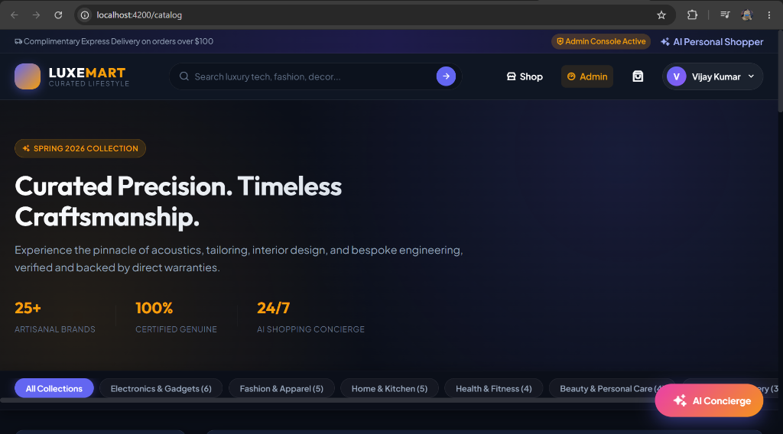
Figure 3: LuxeMart Luxury Storefront - Hero Banner, Sticky Taxonomy Pills, and Navigation

3.2 Category Taxonomy & Sticky Filter Refinement
The storefront supports instant taxonomy selection through interactive pill buttons and a sticky sidebar filter. The category pill bar is engineered with CSS sticky positioning (position: sticky; top: 0; z-index: 100) and a backdrop filter blur (rgba(11, 15, 25, 0.95)), ensuring effortless navigation during long catalog browsing sessions.
- Electronics & Gadgets (6 items): Master & Dynamic MW75, Leica M11 Monochrom, Hasselblad X2D 100C, Bang & Olufsen Beosound A9, Devialet Phantom I, Sony WH-1000XM5.
- Fashion & Apparel (5 items): Johnstons of Elgin Cashmere Scarf, Barbour Waxed Jacket, Turnbull & Asser Sea Island Shirt, Common Projects Achilles Low, Loro Piana Summer Walk.
- Home & Kitchen (5 items): La Marzocco Micra Espresso, Le Creuset Dutch Oven, Vitamix A3500 Ascent, Tom Dixon Stone Pestle, Dyson Purifier Humidify.
- Health & Fitness (4 items): Oura Ring Gen3 Horizon, Technogym Wellness Ball, Theragun PRO Plus, NOHrD WaterRower.
- Beauty & Personal Care (4 items): Augustinus Bader The Rich Cream, Maison Francis Kurkdjian Baccarat Rouge 540, Dyson Supersonic, Creed Aventus EDP.
- Books & Stationery (3 items): Midori Traveler's Notebook Leather, Montblanc Meisterstuck 149 Fountain Pen, Smythson Mara Leather Journal.

4. AI Shopping Concierge & Conversational Commerce
The LuxeMart AI Concierge represents an advanced integration of Generative AI directly into an e-commerce storefront. Floating unobtrusively in the bottom-right corner, customers can summon the assistant at any time to discover products, inquire about specifications, compare items, and verify real-time inventory availability.
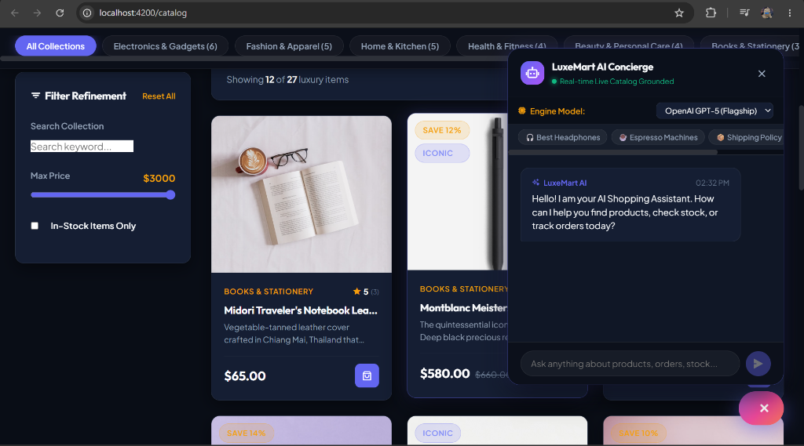
Figure 4: LuxeMart AI Concierge - Live Catalog Grounded Chat Assistant with Model Selection

4.1 Grounded Retrieval-Augmented Generation (RAG) Flow
To eliminate model hallucinations and ensure factual accuracy, the AI Concierge employs a deterministic grounding pipeline prior to invoking the Capgemini Generative Engine:
- Catalog Pre-Fetch: When a customer submits a question, the backend queries the SQL Server database for all active products, extracting names, categories, prices, stock quantities, and ratings.
- Context Injection: The backend injects this live catalog data into a structured system prompt, instructing the LLM to only recommend products verified in the live stock list and cite exact retail prices.
- Model Selector: Customers can toggle between OpenAI GPT-5, Claude 3.5 Sonnet, Phi-4 Mini Reasoning, or Mistral 7B using the in-drawer dropdown.
- Quick Prompt Chips: Pre-built discovery chips (e.g., 'Best Headphones', 'Espresso Machines', 'Shipping Policy') allow instant zero-typing exploration.

5. Store Administration & Operational Intelligence
The LuxeMart Admin Console delivers real-time business telemetry and full CRUD operational control over the database. Restricted exclusively to users with the Admin role, it empowers store operators to monitor performance and adjust inventory on the fly.
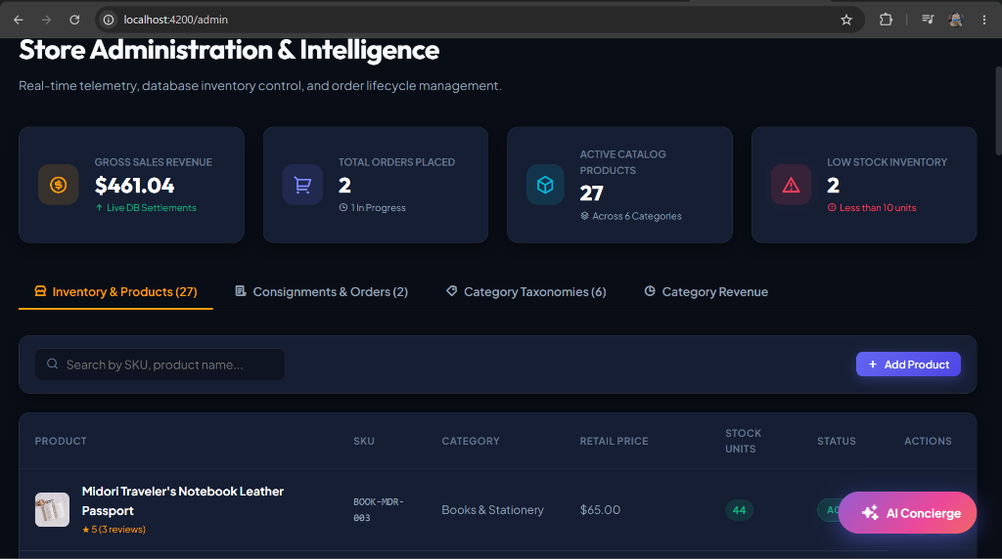
Figure 5: LuxeMart Store Administration Console - Live Telemetry KPIs & Inventory Table

5.1 Key Performance Indicator (KPI) Metric Cards
- Gross Sales Revenue: $461.04 accumulated from confirmed customer order settlements.
- Total Orders Placed: 2 customer consignments in processing/completed status.
- Active Catalog Products: 27 verified products actively visible in the luxury catalog.
- Low Stock Inventory Alert: 2 critical items flagged with less than 10 units remaining, triggering priority re-stocking alerts.

5.2 Administrative Operations Grid
The console features structured tabs for deep store management:
- Inventory & Products (27): Search by SKU or product name, adjust prices, edit stock counts, and create new catalog items via the modal form.
- Consignments & Orders (2): Inspect customer order lines, delivery addresses, and advance order states (Pending -> Processing -> Shipped -> Delivered).
- Category Taxonomies (6): Manage department slugs, descriptions, and banner image associations.
- Category Revenue Breakdown: Analyze sales contribution per department to inform procurement and merchandising decisions.

6. Relational Database Schema & PyODBC Architecture
The persistence tier runs on Microsoft SQL Server, communicating with FastAPI via SQLAlchemy and PyODBC using the official Microsoft ODBC Driver 18 for SQL Server. Connection string pooling is pre-configured with TrustServerCertificate=True.

6.1 Core Entity Relational Model
Table Name | Primary Key & Columns | Relationships & Constraints
users | id (INT, PK), email (NVARCHAR 255, UNIQUE), hashed_password, full_name, role, is_active, created_at | 1:N relationship with orders table. Seeded with Admin and Customer roles.
categories | id (INT, PK), name (NVARCHAR 100, UNIQUE), slug, description, image_url | 1:N relationship with products. 6 luxury departments pre-seeded.
products | id (INT, PK), name, slug, description, price (DECIMAL), stock (INT), category_id (FK), sku, is_active, rating, reviews_count | N:1 relationship with categories; 1:N with order_items. Indexed on SKU and slug.
orders | id (INT, PK), user_id (FK), total_amount (DECIMAL), status (NVARCHAR 50), shipping_address, created_at, updated_at | N:1 relationship with users; 1:N with order_items. Tracks consignment states.
order_items | id (INT, PK), order_id (FK), product_id (FK), quantity (INT), unit_price (DECIMAL) | Composite bridge linking orders and products with historical transaction price preservation.

7. RESTful API Endpoints & Security Contracts
FastAPI exposes auto-documented OpenAPI specification endpoints accessible via Swagger UI (/docs) and ReDoc (/redoc). All administrative endpoints require an HTTP Bearer authorization header with a verified JWT containing role: admin.
HTTP Verb | Route Path | Auth Required | Description
POST | /api/auth/login | Public | Authenticates email/password; returns JWT bearer token and user metadata.
POST | /api/auth/register | Public | Registers a new customer account with bcrypt-hashed credentials.
GET | /api/products | Public | Retrieves active catalog items with keyword search, category, and price filters.
POST | /api/admin/products | Admin Role | Creates a new luxury product in the database with SKU and stock units.
PUT | /api/admin/products/{id} | Admin Role | Updates product details, retail prices, and inventory stock quantities.
GET | /api/admin/stats | Admin Role | Computes live store KPIs (Gross Revenue, Total Orders, Active SKUs, Low Stock).
POST | /api/chat | Public / User | Routes grounded queries to Capgemini Generative Engine with model selection.

8. Installation, Runbook & Credential Reference
To execute the complete application locally across both backend and frontend tiers, follow the instructions below:

8.1 Backend Execution
Navigate to the backend directory and launch Uvicorn on port 8001:
- Command: cd backend; .\.venv\Scripts\uvicorn app.main:app --host 127.0.0.1 --port 8001 --reload
- Swagger UI: http://127.0.0.1:8001/docs
- Health Check: http://127.0.0.1:8001/api/health

8.2 Frontend Execution
Navigate to the frontend directory and start the Angular development server on port 4200:
- Command: cd frontend; npm start -- --port 4200
- Storefront Application: http://localhost:4200/catalog
- Admin Portal: http://localhost:4200/admin

8.3 Seed Accounts & Credentials
Role | Full Name | Email Address | Default Password
Administrator | Vijay Kumar | vijaykumar@gmail.com | VijayKumar@12345
Customer | Rohan Verma | rohan@example.com | Rohan@12345

