Enterprise Email Agent Workspace
Comprehensive Technical Architecture, Multi-Agent Cognitive Pipeline & Operational User Guide
Attribute | Specification / Value
Project Title | Enterprise Email Agent Workspace (Nexus AI Engine)
Organization | Capgemini Engineering / Applied AI Solutions
Platform Core | Multi-Agent Orchestrator, FastAPI Microservice, MSSQL, Angular 19
AI Gateway | Capgemini AI Passport Gateway (OpenAI / WebSocket API compatible)
Primary Models | Amazon Nova Micro (Routing/Extraction), Claude Sonnet 5 (Reasoning/Drafting)
Relational DB | Microsoft SQL Server (MSSQL 2019/2022) with ODBC Driver 18
Ecosystem Connectors | Microsoft Graph API (Outlook Inbox & Calendar) + Resilient Mock Fallbacks
Document Version | Version 1.0 (Enterprise Comprehensive Technical & User Guide)
Classification | Capgemini Internal Technical Specification & User Manual

📌 DOCUMENT OBJECTIVE & SCOPE
This document is an exhaustive, production-grade technical and functional manual for the Enterprise Email Agent Workspace. It contains end-to-end architectural blueprints, multi-agent cognitive loops, database schemas, API catalogs, enterprise safety guardrails, step-by-step installation guides, and comprehensive visual walkthroughs of all five user interface screenshots.

1. Executive Summary & Business Problem Statement
In modern enterprise corporate culture, professionals face an escalating volume of daily communications. Industry studies demonstrate that the typical corporate employee spends approximately 28% to 33% of their working day (equivalent to over 2.5 hours every day) merely triaging incoming emails, parsing lengthy conversational threads, manually checking calendar availability across conflicting time zones, writing down action items in disjointed to-do applications, and drafting polite corporate responses. This manual friction introduces severe operational costs:
- 1. Deliverable Amnesia: High-priority deadlines and task commitments buried in long email chains go unlogged and are forgotten.
- 2. Calendar Scheduling Latency: Days are lost in endless back-and-forth email ping-pong just to find a mutually open 30-minute slot.
- 3. Cognitive Overload & Context Switching: Constantly switching between email, calendar, and task trackers impairs deep work.
- 4. Communication Inconsistency: In hasty responses, corporate etiquette, tone alignment, and completeness suffer.
The Enterprise Email Agent Workspace was conceived to solve these enterprise friction points permanently. Rather than functioning as a simplistic chatbot or a naive prompt wrapper, the workspace implements a sophisticated cognitive multi-agent pipeline following the Observe → Think → Act → Audit → Draft paradigm. Specialized autonomous agents collaborate asynchronously to normalize raw messages, classify underlying intent, autonomously query corporate Outlook calendar availability, persist structured tasks directly into Microsoft SQL Server (MSSQL), audit for ambiguous or missing details with interactive human clarifications, and compose contextually tailored drafts under 100% human-in-the-loop governance.
Strategic Impact: Key Measurable Business Benefits:
- Up to 80% reduction in email processing and triage time for busy corporate executives and knowledge workers.
- Zero lost action items: Deliverables are instantly parsed and ACID-committed to Microsoft SQL Server with urgency tagging.
- Sub-second calendar availability calculations via Microsoft Graph API and staged meeting proposals.
- Multi-tone adaptive communication matching corporate etiquette (Professional, Friendly, Concise, Executive).
- Strict enterprise security guardrails preventing prompt injection attacks, sensitive credential leaks, and PII exposure.
2. End-to-End System Architecture
The platform is engineered as a loosely coupled, resilient multi-tier microservice architecture designed for high throughput, strict security compliance, and sub-second reactive frontend telemetry. The system comprises five distinct architectural tiers:
- Tier 1 - Presentation: Client Presentation Tier (Angular 19 Standalone): Executive 3-column dashboard featuring glassmorphism aesthetics, an adaptive collapsible navigation sidebar (235px to 64px rail), real-time counters, interactive AI Intelligence Hub, MSSQL Kanban task board, calendar staging deck, and live telemetry log viewer.
- Tier 2 - API & Gateway: API & Gateway Layer (FastAPI Microservice): Asynchronous ASGI framework hosting high-throughput REST endpoints, bi-directional WebSocket connections (/ws/stream) for real-time telemetry streaming, and automated request lifecycle management.
- Tier 3 - Security & Guardrails: Enterprise Safety & Guardrail Shield (EnterpriseGuardrails): High-speed pre-execution filter intercepting all payloads before they touch foundation models, performing regex-based prompt injection detection, PII scrubbing (SSN, credit card, passwords), and output credential sanitization.
- Tier 4 - Cognitive Multi-Agent Core: Multi-Agent Cognitive Orchestrator: Master coordinator driving asynchronous agent workflows, supporting concurrent split execution (via Python asyncio.gather for mixed-intent emails), self-reflection critic verification, and multi-stage lifecycle state machines.
- Tier 5 - Ecosystem & Persistence: Enterprise Integrations & Persistence: Microsoft SQL Server (MSSQL) with ODBC Driver 18 for ACID persistence; Microsoft Graph API with MSAL authentication for Outlook inbox and calendar synchronization; and Capgemini AI Passport Gateway for multi-model LLM access.
System Architecture Flow & Component Mapping
The following structured component map illustrates the flow of data from raw corporate email ingestion to autonomous multi-agent execution, external API integration, and real-time dashboard presentation:
Layer | Component / Module | Technology | Primary Responsibility
Presentation | Angular Executive Dashboard | Angular 19, TypeScript, Vanilla CSS | 3-column UI, Kanban board, WebSocket live stream, AI Hub
API Gateway | FastAPI Core Application | FastAPI, Uvicorn, Pydantic v2 | REST endpoints, WebSocket broadcast (/ws/stream), CORS handling
Safety Layer | EnterpriseGuardrails | Python Regex, Custom Filter | Blocks prompt injection, redacts PII, masks API credentials
Orchestration | Master Orchestrator | Python 3.11, asyncio.gather | Coordinates Observe -> Think -> Act -> Audit -> Draft loop
Agent 1 | Reader Agent | app.agents.reader | Normalizes payload, strips confidentiality disclaimers & email noise
Agent 2 | Router Agent | Amazon Nova Micro (Capgemini Engine) | Classifies intent: meeting, task, mixed_intent, inquiry, ambiguous
Agent 3 | Entity Extractor Agent | Microsoft Graph + Nova Micro | Queries Outlook Calendar free/busy slots & stages proposals
Agent 4 | Task Extractor Agent | Amazon Nova Micro + MSSQL | Extracts deliverables, owners, deadlines, urgency & commits to DB
Agent 5 | Supervisor Agent | Claude Sonnet 5 (Deep Reasoning) | Audits completeness, pauses vague emails, stages quick choices
Agent 6 | Critic Agent | Self-Reflection Loop | Audits generated draft against slots & tasks to eliminate hallucinations
Agent 7 | Reply Generator Agent | Claude Sonnet 5 (Context Replier) | Synthesizes slots & tasks into multi-tone executive draft responses
Database | Microsoft SQL Server | MSSQL 2019/2022, PyODBC, SQLAlchemy | ACID persistence for Emails, Tasks, Proposals, Drafts, Logs
Ecosystem | Microsoft Graph Client | MSAL Python 1.28+, Graph REST v1.0 | Outlook Mail & Calendar sync with automated mock fallback

3. Capgemini AI Passport Gateway & Multi-Model Infrastructure
The cognitive foundation of the Enterprise Email Agent Workspace is powered by the Capgemini AI Passport Gateway (Nexus Generative Engine Platform). The AI Passport Gateway is an enterprise-grade AI aggregation and governance platform that provides standardized, secure, and monitored access to top-tier foundation models while enforcing strict data privacy, audit logging, usage metering, and corporate compliance.
Studio Environment, API Keys & Budget Monitoring
Developers and automated enterprise workloads connect to the Gateway using studio-allocated API keys. The workspace is configured to authenticate against the user studio: 'Free studio - vkuma141'. Every studio environment provides transparent budget governance, tracking token expenditures across both interactive UI playground sessions and programmatic REST/WebSocket API invocations.
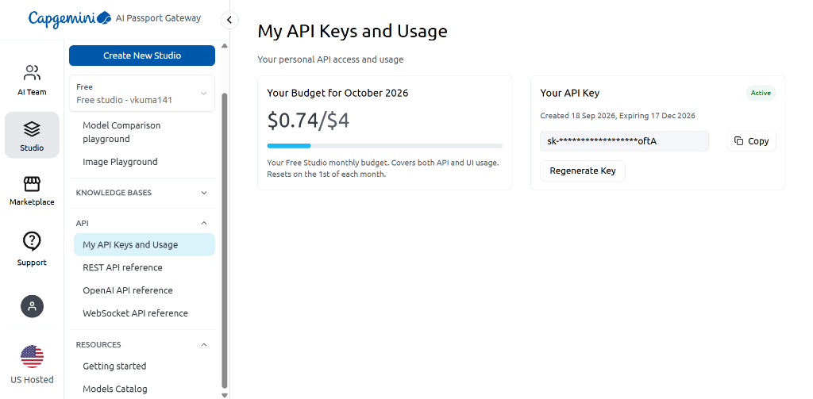
Figure 1: Capgemini AI Passport Gateway - API Keys and Usage Console: The Capgemini AI Passport Gateway management dashboard displaying the active personal studio ('Free studio - vkuma141'), monthly consumption budget ($0.74 spent of $4.00 allocated for October 2026), active production API key (sk-*********************oftA, valid from 18 Sep 2026 to 17 Dec 2026), API reference links (REST, OpenAI, WebSocket), and the foundational Models Catalog.

Exhaustive Breakdown of Figure 1 (Gateway Console):
- Left Navigation Rail: Navigation & Ecosystem: The left sidebar provides access to AI Team collaboration, Studio environments, the AI Marketplace, and Developer API References (REST API reference, OpenAI API reference, and WebSocket API reference).
- Studio Allocation: Active Studio ('Free studio - vkuma141'): Represents the dedicated sandbox environment allocated to the user. All agent invocations originating from the backend microservice route their token consumption directly against this studio quota.
- Monthly Usage Meter: Budget Meter ($0.74 / $4): Displays active expenditure for October 2026. The platform utilizes ultra-efficient models like Amazon Nova Micro for routine routing and task extraction, keeping overall enterprise inference costs exceptionally low (under $1 for thousands of email cycles). The quota automatically resets on the 1st of each month.
- API Key Security: Active API Key ('sk-...oftA'): Represents the bearer token utilized by the backend application (backend/.env NEXUS_API_KEY). The gateway provides one-click 'Regenerate Key' functionality to rotate credentials seamlessly without interrupting active studio configurations.
- Infrastructure Hosting: Deployment Region ('US Hosted'): All model inference calls route through high-availability US-hosted enterprise infrastructure with SOC2 and ISO compliance guarantees.
Multi-Model Orchestration & Cascading Fallback Hierarchy
Rather than relying on a single monolithic language model for all tasks, the workspace implements a specialized multi-model hierarchy. Tasks requiring rapid classification and strict schema adherence use lightweight models, while tasks requiring nuanced language, tone matching, and quality gatekeeping leverage deep reasoning models:
Role / Agent | Config Parameter | Assigned Model | Rationale & Architecture Advantage
Router Agent (Intent) | MODEL_ROUTER | amazon.nova-micro-v1:0 | Ultra-low latency (<200ms), sub-cent cost, perfect JSON adherence
Entity & Task Extractor | MODEL_EXTRACTOR | amazon.nova-micro-v1:0 | Fast structured extraction of dates, times, attendees, and tasks
Supervisor (Audit) | MODEL_REASONING | anthropic.claude-sonnet-5 | Superior contextual reasoning, edge-case analysis, ambiguity detection
Smart Replier (Drafting) | MODEL_DRAFTING | anthropic.claude-sonnet-5 | Nuanced corporate tone generation, synthesis of disparate entities
Self-Reflection Critic | MODEL_REASONING | anthropic.claude-sonnet-5 | Rigorous draft verification against calendar slots and task lists
Enterprise Fallback | MODEL_FALLBACK | openai.gpt-4o | Cascading failover if Amazon or Anthropic endpoints experience latency
Open-Source Fallback | MODEL_BACKUP | meta.llama3-8b-instruct | Secondary resilient tier ensuring 100% operational uptime

📌 RESILIENCE & OFFLINE CAPABILITY
Resilient Fallback Guarantee: In the event of network disruption or Gateway rate-limits, the Router Agent automatically switches to an embedded deterministic regex heuristic engine. Similarly, if Microsoft Graph credentials are not supplied, the system transparently activates mock calendar and mock email adapters, ensuring zero application crashes during testing or offline demonstrations.

4. The Multi-Agent Cognitive Lifecycle
The core intelligence of the platform operates on an asynchronous 5-step cognitive loop: Observe → Think → Act → Audit → Draft. Every phase is strictly instrumented with sub-millisecond telemetry and streamed live over WebSockets to the frontend dashboard.
Step 1: OBSERVE - Reader Agent (app.agents.reader)
When an incoming email arrives via REST ingestion or Microsoft Graph polling, it often contains heavy noise such as mobile signatures ('Sent from my iPhone'), repetitive legal confidentiality disclaimers, external disclaimer banners, and non-standard line breaks (CRLF). The Reader Agent executes payload normalization:
- Strips multi-paragraph corporate confidentiality statements and GDPR disclaimers using pre-compiled regex filters.
- Removes mobile footer signatures ('Sent from Outlook for iOS', 'Sent from my Android device').
- Normalizes Windows CRLF line endings (\r\n -> \n) and collapses redundant whitespace.
- Extracts clean sender display names, recipients, timestamps, and thread history context.
Step 2: THINK - Router Agent (app.agents.router)
The cleaned context is passed to the Router Agent, which invokes Amazon Nova Micro with a strict JSON response schema. The Router classifies the email into one of five distinct intent categories:
- 1. meeting - Meeting: Sender requests a synchronous discussion, demo, call, or meeting (e.g., 'Let's meet tomorrow afternoon').
- 2. task - Task: Sender assigns a deliverable, deadline, or action item (e.g., 'Please send the revised budget deck by Friday 5 PM').
- 3. mixed_intent - Mixed Intent: Complex real-world communications containing BOTH a meeting request AND an action item.
- 4. general_inquiry - General Inquiry: Informational emails requesting documentation, updates, or status queries.
- 5. ambiguous - Ambiguous / Incomplete: Vague requests lacking critical context (e.g., 'Let's connect sometime to discuss that thing').
Step 3: ACT - Specialized Execution Agents
Depending on the classified intent, the Master Orchestrator routes execution to specialized domain agents:
- Case 1 (Meeting): Entity Extractor Agent (Calendar Finder): Parses requested dates, target timeframes, meeting duration, topic, and participants. Calls Outlook Calendar service (via Microsoft Graph or mock adapter) to calculate non-overlapping free/busy slots. Generates a Stage 1 Meeting Proposal.
- Case 2 (Task): Task Extractor Agent (To-Do List Creator): Scans the email for concrete deliverables. Extracts task title, description, assigned owner ('Me' or named colleague), due date, and urgency level (low, medium, high, urgent). Commits the record directly into Microsoft SQL Server (MSSQL) Tasks table.
- Case 3 (Mixed Intent): Concurrent Split Router: In Case 3 (Mixed Intent), the Orchestrator initiates both Entity Extractor and Task Extractor concurrently via Python asyncio.gather. Both agents execute in parallel, reducing overall pipeline latency by over 50%.
Step 4: AUDIT - Supervisor Agent & Critic Agent (Case 5 & Self-Reflection)
Before generating an outgoing communication, the pipeline passes through dual quality gates:
- Supervisor Audit: Supervisor Agent (Case 5: The Double-Checker): Powered by Claude Sonnet 5, evaluates whether the incoming request is actionable or critically underspecified. If critical fields (time zone, date, topic) are missing, the Supervisor halts automated processing, marks email status as 'clarification_needed', persists a record in ClarificationRequests table, and generates 2-3 interactive multiple-choice quick options.
- Critic Verification: Critic Agent (Self-Reflection Loop): Once a draft is formulated, the Critic reviews the text against original email constraints, confirmed calendar slots, and extracted tasks. If hallucinations or inaccurate commitments are detected, the Critic automatically corrects the draft before saving.
Step 5: DRAFT - Reply Generator Agent (Case 4: The Smart Replier)
The Reply Generator Agent synthesizes all verified facts (extracted calendar free slots, logged task commitments) into a complete, polished email draft. The agent supports 4 dynamic corporate communication tones:
- Tone 1 - Professional: Professional: Standard corporate etiquette, formal greeting, structured bullet points, polished sign-off.
- Tone 2 - Friendly: Friendly: Warm, collaborative, empathetic phrasing ideal for internal team members and peers.
- Tone 3 - Concise: Concise: Direct, bulleted, action-first draft designed for rapid decision-making and fast-paced teams.
- Tone 4 - Executive: Executive: High-level, strategic summary with minimal operational clutter tailored for C-suite recipients.
5. The 5 Core Business Use Cases & Flows (Deep Dive)
The platform addresses five foundational enterprise business scenarios, each engineered with specialized agent logic, deterministic fallbacks, and transactional database persistence:
Case ID | Business Title | Trigger Scenario | Participating Agents | Primary Enterprise Outcome
Case 1 | The Calendar Finder | Incoming email requests a sync, demo, or meeting | Reader, Router, Entity Extractor | Checks Outlook availability, stages free slots (Stage 1), confirms to Stage 2
Case 2 | The To-Do List Creator | Incoming email assigns an action item or deadline | Reader, Router, Task Extractor | Extracts deliverables and persists directly into MSSQL Tasks table
Case 3 | The Multi-Task Router | Incoming email has BOTH meeting & action items | Router, Orchestrator (asyncio.gather) | Executes Calendar Finder & Task Extractor concurrently in parallel
Case 4 | The Smart Replier | Synthesizes extracted data into a reply | Reply Generator, Critic Agent | Drafts contextual response in 4 tones (Professional, Friendly, Concise, Exec)
Case 5 | The Double-Checker | Incoming email is ambiguous or missing context | Supervisor Agent, Human-in-Loop | Pauses pipeline, flags clarification needed, stages 2-3 interactive options

Case 1: The Calendar Finder (Staged Meeting Coordination)
A major innovation in the workspace is the two-stage calendar proposal workflow. In traditional automation systems, software often blindly books appointments, causing scheduling conflicts and awkward cancellations. The workspace implements a structured two-stage model:
- Stage 1: Stage 1 (User Review & Staged Proposal): The Entity Extractor identifies the desired meeting duration (e.g., 30 minutes) and preferred timeframe (e.g., 'tomorrow afternoon'). It queries Microsoft Graph getSchedule to evaluate the user's corporate calendar. It selects up to 3 non-overlapping open windows and saves them to the MeetingProposals table with stage=1. The frontend displays these proposals as selectable interactive slot cards.
- Stage 2: Stage 2 (Auto-Coordinated & Calendar Booking): When the user reviews the proposals and clicks 'Confirm Slot (Advance to Stage 2)', the backend locks the slot, updates the proposal status to 'confirmed', increments stage to 2, and dispatches a Microsoft Graph POST /events call to officially schedule the meeting on the corporate Outlook calendar.
Case 2: The To-Do List Creator (ACID MSSQL Persistence)
When an email assigns tasks (e.g., 'Please send the revised budget deck by Friday 5 PM'), the Task Extractor Agent parses the natural language and extracts five discrete attributes: Title, Description, Owner, Due Date, and Urgency. Crucially, tasks are not held in temporary browser memory or transient Redis caches; they are immediately committed to Microsoft SQL Server (MSSQL) in the Tasks table. This guarantees zero data loss, enterprise auditability, and immediate availability on the Kanban Task Board.
Case 3: The Multi-Task Router (Zero Sequential Latency)
Real-world business emails frequently combine multiple intents. For example, a project manager might write: 'Hi team, please finish the budget deck by Friday 5 PM EST. Also, let's meet tomorrow afternoon to review the progress.' Sequential processing would first spend 1.5 seconds extracting calendar slots, and only then spend 1.5 seconds extracting tasks, doubling user wait time. The Master Orchestrator detects 'mixed_intent' and invokes asyncio.gather(_run_calendar(), _run_tasks()). Both agents execute simultaneously in parallel threads, delivering complete calendar proposals and logged tasks in a single execution window.
Case 4: The Smart Replier (Contextual Multi-Tone Synthesis)
Once calendar slots are calculated and tasks are saved, the Reply Generator Agent constructs a response draft. The draft is deeply context-aware: it references the exact free calendar slots discovered and confirms that the assigned tasks have been officially logged in the system. The user can switch tones on the fly via the UI dropdown, regenerating the draft between Professional, Friendly, Concise, and Executive styles.
Case 5: The Double-Checker (Supervisor Ambiguity Guardrail)
When an incoming email contains vague expressions such as 'Let's catch up sometime whenever you have a minute', scheduling agents often fail or hallucinate arbitrary meeting dates. The Supervisor Agent audits every incoming message. If mandatory scheduling parameters are absent, it intentionally halts processing. The system stores a record in ClarificationRequests and presents the user with structured quick-choice buttons on the dashboard (e.g., 'Tomorrow morning', 'Tomorrow afternoon', 'Next week'). The user resolves the ambiguity with a single click, immediately resuming the pipeline.
6. User Interface & Executive Dashboard Walkthrough
The frontend is built using Angular 19 Standalone Components, styled with modern glassmorphism principles, high-contrast dark mode palettes, and reactive WebSocket state signals. The following sections provide an in-depth visual analysis of the screenshots demonstrating the system operating in live production.
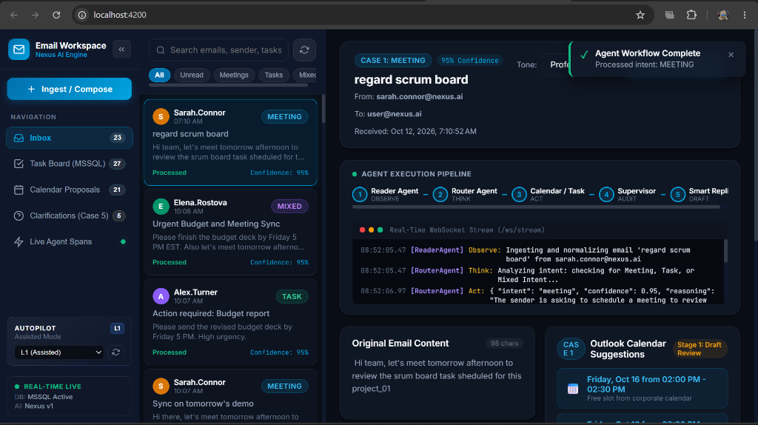
Figure 2: Executive Dashboard - Real-time Multi-Agent Pipeline & WebSocket Streaming: The live Email Workspace dashboard at localhost:4200 displaying the active email 'regard scrum board' from Sarah Connor. Highlights include the 5-step Agent Execution Pipeline stepper, the real-time WebSocket telemetry terminal (/ws/stream), detected Case 1 Meeting Intent (95% Confidence), Stage 1 Outlook Calendar Suggestions, and the 'Agent Workflow Complete' toast.

Exhaustive Breakdown of Figure 2 (Pipeline & Stream):
- Left Navigation Deck: Navigation & Counter Badges: The left navigation bar displays live database counters: Inbox (23), Task Board (MSSQL) (27), Calendar Proposals (21), and Clarifications (Case 5) (6). The green dot next to 'Live Agent Spans' confirms active WebSocket connectivity.
- Autopilot Indicator: Autopilot Controller (L1 Assisted): The Autopilot dropdown at the lower left is configured to 'L1 (Assisted)', indicating the system autonomously analyzes emails and stages proposals, requiring human confirmation before final dispatch.
- Telemetry Event Stream: Real-Time Telemetry Terminal: The black terminal window titled 'Real-Time WebSocket Stream (/ws/stream)' broadcasts live JSON events directly from backend agents. At 08:52:05.47, ReaderAgent observes and normalizes the payload. At 08:52:05.47, RouterAgent initiates Think phase. At 08:52:06.97, RouterAgent acts, outputting {'intent': 'meeting', 'confidence': 0.95, 'reasoning': 'The sender is asking to schedule a meeting to review...'}.
- Pipeline Visualizer: 5-Step Execution Pipeline Stepper: Across the top of the AI hub, numbered circular badges visually illuminate as execution advances: 1. Reader Agent (OBSERVE) -> 2. Router Agent (THINK) -> 3. Calendar / Task (ACT) -> 4. Supervisor (AUDIT) -> 5. Smart Replier (DRAFT).
- Notification Banner: Agent Workflow Complete Toast: A sleek dark-green notification banner in the upper right confirms successful execution: 'Agent Workflow Complete: Processed intent: MEETING'.
- Proposed Meeting Slot: Outlook Calendar Suggestions (Stage 1): Lower right card shows the discovered free slot: 'Friday, Oct 16 from 02:00 PM - 02:30 PM (Free slot from corporate calendar)' staged in Draft Review mode.
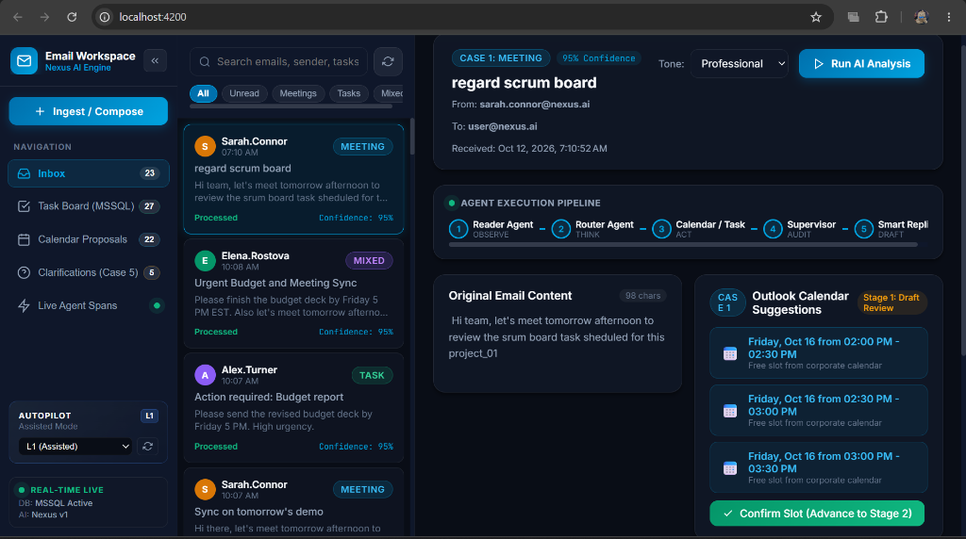
Figure 3: AI Intelligence Hub - Interactive Analysis & Slot Confirmation (Stage 1 to Stage 2): The detailed AI Intelligence Hub view displaying the interactive 'Run AI Analysis' trigger button, Tone selection dropdown ('Professional'), extracted calendar slots, and the prominent green 'Confirm Slot (Advance to Stage 2)' booking button.

Exhaustive Breakdown of Figure 3 (AI Hub & Slot Booking):
- Manual Trigger: Run AI Analysis Button: An interactive bright cyan action button in the top right ('Run AI Analysis') allows users to trigger or re-run the cognitive multi-agent pipeline on any selected email with custom parameters.
- Tone Customization: Tone Selector Dropdown: Located adjacent to the intent badge, allowing the user to select between 'Professional', 'Friendly', 'Concise', and 'Executive' tones prior to draft synthesis.
- Calendar Slot Candidates: Discovered Free Slots Grid: The Outlook Calendar Suggestions card lists three non-overlapping open slots identified from the corporate calendar: (1) Friday, Oct 16, 02:00 PM - 02:30 PM; (2) Friday, Oct 16, 02:30 PM - 03:00 PM; (3) Friday, Oct 16, 03:00 PM - 03:30 PM.
- Stage 2 Promotion: Confirm Slot (Advance to Stage 2) Action: The prominent green button at the bottom of the suggestions card. Clicking this button triggers POST /api/scheduled-meetings/{id}/confirm, locking the slot, updating proposal stage from 1 to 2, and booking the meeting invite via Microsoft Graph Calendar API.
- Synchronized Counters: Dynamic Counter Updates: Reflects live counter increments: Calendar Proposals incremented to 22, and Clarifications decremented to 5 as requests are resolved.
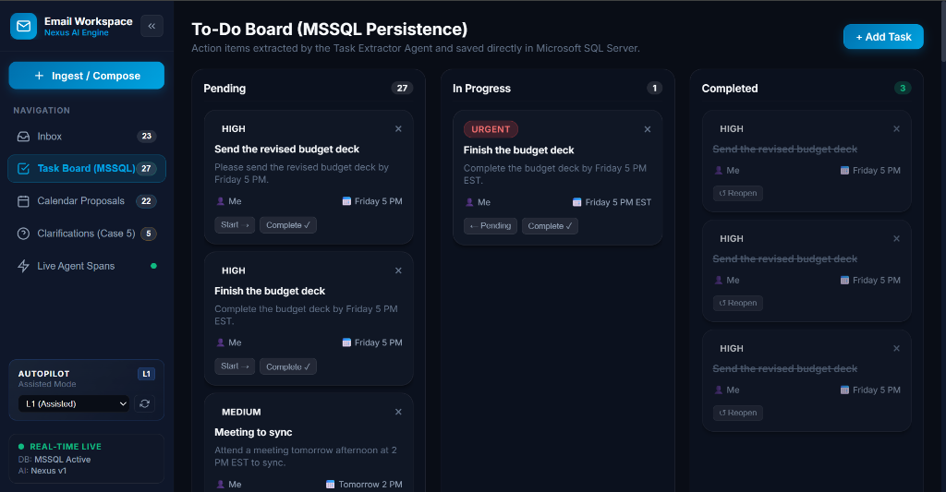
Figure 4: MSSQL To-Do Kanban Board - Task Extraction & Lifecycle Management: The full To-Do Board view illustrating action items extracted by the Task Extractor Agent and persisted directly in Microsoft SQL Server. Tasks are categorized into three columns: Pending (27), In Progress (1), and Completed (3) with distinct urgency badges and lifecycle buttons.

Exhaustive Breakdown of Figure 4 (Kanban Task Board):
- Database Integrity: MSSQL Relational Persistence: The board title explicitly notes '(MSSQL Persistence)', confirming all cards represent live ACID database records from the Tasks table.
- Kanban Stages: Column Groupings & Badges: The board is organized into three workflow columns: (1) Pending (27 tasks waiting to be started); (2) In Progress (1 active task currently being executed); (3) Completed (3 successfully finished deliverables).
- Urgency Indicators: Urgency Classification Badges: Each card features a color-coded urgency tag derived from LLM semantic analysis: 'URGENT' in high-contrast red badge (e.g., 'Finish the budget deck by Friday 5 PM EST'); 'HIGH' in light badge (e.g., 'Send the revised budget deck'); and 'MEDIUM' in neutral badge (e.g., 'Meeting to sync').
- Lifecycle Controls: Task Card Anatomy & Controls: Each card displays task title, description, assigned owner (Owner: Me), and target deadline (Friday 5 PM). Interactive action controls allow one-click status transitions: 'Start ->' (moves Pending to In Progress), 'Complete v' (moves to Completed), and 'Reopen' (restores Completed to Pending).
- Manual Addition: Manual Task Creation (+ Add Task): A cyan action button in the upper right allows users to manually inject new corporate deliverables directly into the database.
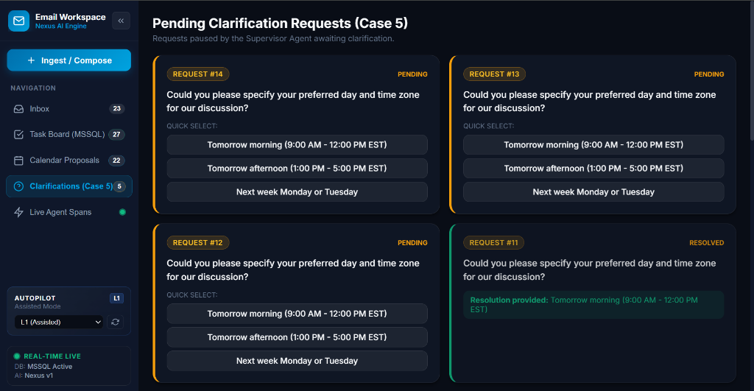
Figure 5: Pending Clarification Requests Deck (Case 5: The Double-Checker): The Clarification Requests interface displaying emails paused by the Supervisor Agent due to incomplete or ambiguous information. Displays pending cards (#14, #13, #12) with interactive Quick Select option chips, and resolved request #11 showing captured resolution.

Exhaustive Breakdown of Figure 5 (Clarification Deck):
- Workflow Pause Gate: Automated Workflow Pausing: Demonstrates Case 5 in live action. When emails omit required scheduling context, the Supervisor Agent pauses processing rather than making erroneous assumptions.
- Ambiguity Cards: Pending Clarification Cards (#14, #13, #12): Each card features a high-contrast amber 'PENDING' badge and the clarifying question formulated by the agent: 'Could you please specify your preferred day and time zone for our discussion?'.
- Quick Select Chips: Interactive Quick Select Option Chips: Below the question, the Supervisor generates three pre-calculated, clickable multiple-choice options: [Tomorrow morning (9:00 AM - 12:00 PM EST)], [Tomorrow afternoon (1:00 PM - 5:00 PM EST)], and [Next week Monday or Tuesday]. Clicking any option immediately resolves the request without requiring manual text entry.
- Resolution Confirmation: Resolved Clarification State (#11): Displays a successfully completed request card highlighted with an emerald border and 'RESOLVED' badge. The card confirms: 'Resolution provided: Tomorrow morning (9:00 AM - 12:00 PM EST)'.
- Pipeline Resumption: Unblocking the Pipeline: Submitting a resolution triggers POST /api/clarifications/{id}/reply, injecting the selected answer into the email context and automatically resuming the downstream scheduling and drafting pipeline.
7. Autopilot Governance & Multi-Level Autonomy (L0 to L3)
To satisfy corporate governance standards across varying organizational risk tolerances, the system implements a four-tier autonomy framework (Levels L0 through L3), configurable via environment variables and real-time UI toggles:
Autonomy Level | Level Name | System Behavior | Human Governance Model
L0 | Manual Only | Pipeline runs only on explicit user click ('Run AI Analysis'). Drafts require manual approval. | 100% Manual Intervention
L1 | Assisted Mode | Auto-normalizes, extracts tasks to DB, stages calendar proposals and drafts automatically. (Current Default) | Human Review & 1-Click Confirmation
L2 | Semi-Autonomous | Auto-approves routine emails exceeding 85% confidence threshold. Promotes meetings to Stage 2. | Exception-based Human Override
L3 | Full Autopilot | End-to-end zero-touch execution: automatically coordinates calendar invites and dispatches replies. | Fully Autonomous with Audit Logging

📌 SAFETY FALLBACK POLICY
Production Governance Safeguard: Even when operating in L2 or L3 mode, any email flagged by the Supervisor Agent (Case 5: Ambiguous) or failing Enterprise Guardrails automatically drops to L1 Assisted Mode, preventing unverified or unsafe autonomous actions from ever executing.

8. Database Architecture & Relational Schema (MSSQL)
Persistence is anchored in Microsoft SQL Server (MSSQL 2019/2022) with full ACID transaction guarantees. The relational schema is normalized into six primary tables connected by cascading foreign keys:
Table Name | Primary Key | Foreign Key(s) | Key Columns & Types | Purpose & Lifecycle Role
Emails | id (INT IDENTITY) | None | subject (VARCHAR 255), sender, recipient, body (NVARCHAR MAX), status, intent, confidence | Master inbox records, processing status, and intent classification
Tasks | id (INT IDENTITY) | email_id -> Emails.id (CASCADE) | title (VARCHAR 255), description, owner, due_date, urgency, status (pending/in_progress/completed) | Extracted action items persisted for Kanban task board tracking
MeetingProposals | id (INT IDENTITY) | email_id -> Emails.id (CASCADE) | requested_dates, participants, proposed_slots_json (NVARCHAR MAX), status, stage (1=Review, 2=Confirmed) | Staged calendar proposals and confirmed Outlook bookings
Drafts | id (INT IDENTITY) | email_id -> Emails.id (CASCADE) | recipient, subject, body (NVARCHAR MAX), tone, status (staged/approved/sent), approved_at, sent_at | Contextual email replies staged for human approval and dispatch
AgentLogs | id (INT IDENTITY) | email_id -> Emails.id (CASCADE) | agent_name, step, action, thought, input_data, output_data, model_used, latency_ms | Sub-millisecond execution telemetry and compliance audit trails
ClarificationRequests | id (INT IDENTITY) | email_id -> Emails.id (CASCADE) | missing_fields, question, options_json (NVARCHAR MAX), status (pending/resolved), resolution | Stores Case 5 paused clarification questions and captured resolutions

9. Enterprise Security, Guardrails & PII Protection
Security and data privacy are core architectural tenets of the platform. Implemented in app.core.guardrails.EnterpriseGuardrails, all data flows through active defense barriers:
- 1. Injection Defense: Prompt Injection Mitigation: Evaluates all incoming subject lines and bodies against malicious prompt override signatures including 'ignore previous instructions', 'system prompt override', 'developer mode', 'jailbreak', and SQL injection strings ('drop table'). Requests containing injection payloads are blocked at the gateway with an HTTP 400 GuardrailViolation error.
- 2. PII Redaction: PII Scrubbing & Token Masking: Automatically scans text for sensitive personal identifiable information before transmission to external AI models. Credit card numbers (\b(?:\d{4}[-\s]?){3}\d{4}\b) are replaced with [REDACTED_CREDIT_CARD]; Social Security Numbers (\b\d{3}-\d{2}-\d{4}\b) are replaced with [REDACTED_SSN]; and passwords or secrets are masked with [REDACTED_SECRET].
- 3. Output Sanitization: Credential Leak Prevention: Scans generated outgoing email drafts to ensure internal API keys (matching sk-[a-zA-Z0-9_\-]{16,}) or server connection strings are never inadvertently exposed to external email recipients.
10. Complete REST API & WebSocket Protocol Reference
The FastAPI gateway exposes a comprehensive set of RESTful endpoints and a continuous WebSocket event stream:
Method | Endpoint Path | Request Body | Response Model | Description & Operation
GET | / | None | SystemStatus | Root health check, MSSQL database connectivity, and model mapping
GET | /api/emails | None (Query params) | EmailListResponse | Lists inbox emails with filtering by status, intent, and pagination
POST | /api/emails | EmailCreate | EmailResponse (201) | Ingests a new raw corporate email into the system
GET | /api/emails/{id} | None | EmailResponse | Retrieves complete details of a specific email record
POST | /api/process | ProcessRequest (email_id, tone) | ProcessResponse | Triggers the full multi-agent cognitive pipeline on target email
GET | /api/tasks | None (Query params) | TaskListResponse | Retrieves all tasks for Kanban board (filter by status, urgency)
POST | /api/tasks | TaskCreate | TaskResponse (201) | Manually creates a new task card in the MSSQL database
PUT | /api/tasks/{id} | TaskUpdate | TaskResponse | Updates task lifecycle status (pending -> in_progress -> completed)
DELETE | /api/tasks/{id} | None | Status 204 | Permanently deletes a task record from MSSQL
GET | /api/scheduled-meetings | None | MeetingProposalListResponse | Lists staged (Stage 1) and confirmed (Stage 2) meeting proposals
POST | /api/scheduled-meetings/{id}/confirm | None | MeetingProposalResponse | Advances Stage 1 proposal to Stage 2 and books Outlook event
GET | /api/drafts | None | List[DraftResponse] | Retrieves generated email drafts awaiting approval or dispatch
POST | /api/drafts/{id}/approve | None | DraftResponse | Marks a staged draft as officially approved by user
POST | /api/drafts/{id}/send | None | DraftResponse | Dispatches approved draft via Microsoft Graph Outlook service
GET | /api/clarifications | None | List[ClarificationResponse] | Retrieves pending and resolved Case 5 clarification requests
POST | /api/clarifications/{id}/reply | ClarificationReply | ClarificationResponse | Submits clarification answer and resumes paused pipeline
WS | /ws/stream | WebSocket Handshake | JSON Stream | Real-time telemetry event broadcast of agent execution traces

11. Developer Quickstart, Setup & Operations Guide
This section outlines the exact steps required to set up, configure, and operate the complete Enterprise Email Agent Workspace from scratch.
System Prerequisites
- Python 3.11 or higher installed on host machine.
- Node.js v18.x or higher with npm.
- Microsoft SQL Server (MSSQL 2019 or 2022) running on host or network.
- ODBC Driver 18 for SQL Server installed (standard driver for pyodbc connections).
1. Backend Configuration & Startup
Step-by-Step Instructions: Open a PowerShell terminal, navigate to the backend directory, and initialize the environment:
- Navigate to backend directory: cd email-agent-workspace/backend
- Create virtual environment: python -m venv venv
- Activate environment (Windows): .\venv\Scripts\activate
- Install dependencies: pip install -r requirements.txt
- Configure backend/.env with your MSSQL connection string and Capgemini Gateway credentials:
Environment Variable | Configured Sample Value | Description
MSSQL_SERVER | LIN-5CD6268KRS | SQL Server instance host name
MSSQL_DATABASE | EmailAgentWorkSpaceDb | Target relational database name
MSSQL_USER | sa | Database authentication username
MSSQL_PASSWORD | Capgemini@12345 | Database authentication password
MSSQL_DRIVER | ODBC Driver 18 for SQL Server | ODBC Driver specification
MSSQL_TRUST_CERT | yes | Bypasses SSL certificate validation for internal instances
CAPGEMINI_API_KEY | sk-x3FOSdELzRNhQ1fpzloftA | Capgemini AI Passport Gateway bearer API token
CAPGEMINI_BASE_URL | https://openai.generative.engine.capgemini.com/v1 | Gateway REST base endpoint
MODEL_ROUTER | amazon.nova-micro-v1:0 | Model for high-speed routing and extraction
MODEL_DRAFTING | anthropic.claude-sonnet-5 | Model for reasoning, supervision, and drafting
USE_MOCK_OUTLOOK | true | Enables mock Outlook adapter when Azure AD credentials omitted

Execution Command: Launch the FastAPI backend server using Uvicorn:
- python -m uvicorn app.main:app --host 127.0.0.1 --port 8000 --reload
- Access Interactive Swagger Documentation: http://127.0.0.1:8000/docs
- Access Redoc API Specifications: http://127.0.0.1:8000/redoc
2. Frontend Setup & Startup
Instructions: Open a second PowerShell terminal, navigate to the frontend directory, and run:
- Navigate to frontend: cd email-agent-workspace/frontend
- Install Node dependencies: npm install
- Start Angular development server: npm start
- Open browser and navigate to: http://localhost:4200
3. Validation & Automated Testing
Testing Tools: The project includes automated Pytest suites and an interactive REST Client file:
- Automated Pytest Suite: Run 'python -m pytest tests/ -v' from backend directory to execute unit tests and guardrail attack simulations.
- Interactive HTTP Client: Open backend/api-testing.http in VS Code REST Client to execute end-to-end scenarios covering Cases 1 through 5 and prompt injection attacks with one click.
12. Troubleshooting & Best Practices
Guidance for diagnosing and resolving common operational issues during development and production deployment:
Symptom / Error | Root Cause | Resolution Procedure
ODBC Driver 18 login timeout / connection error | SQL Server service stopped or TCP/IP protocol disabled in SQL Server Configuration Manager | Ensure SQL Server (MSSQLSERVER) is running. Open SQL Server Configuration Manager -> SQL Server Network Configuration -> Protocols -> Enable TCP/IP -> Restart service.
WebSocket connection failed (/ws/stream) | Backend Uvicorn server is not running or CORS blocked | Verify Uvicorn is active on port 8000. Ensure frontend origin (http://localhost:4200) is included in CORS_ORIGINS in backend/.env.
Gateway 401 Unauthorized / Expired API Key | API key expired or budget exhausted in AI Passport Gateway | Log in to Capgemini AI Passport Gateway (Figure 1), check studio budget, regenerate API key if expired, and update CAPGEMINI_API_KEY in backend/.env.
Meeting proposals not advancing to Stage 2 | Slot conflict or network error during Outlook event creation | Check MeetingProposals table in MSSQL. The confirm endpoint automatically detects colliding slots and selects the next available non-overlapping window.
Prompt injection false positives | Email body contains keywords like 'developer' or 'override' in ordinary text | Refine regex patterns in app.core.guardrails.EnterpriseGuardrails to require contextual privilege escalation phrasing rather than isolated words.

