# **Inter-Galaxy Communicator**

* I have prepared the solution by following the simple design. Please find below for your reference.

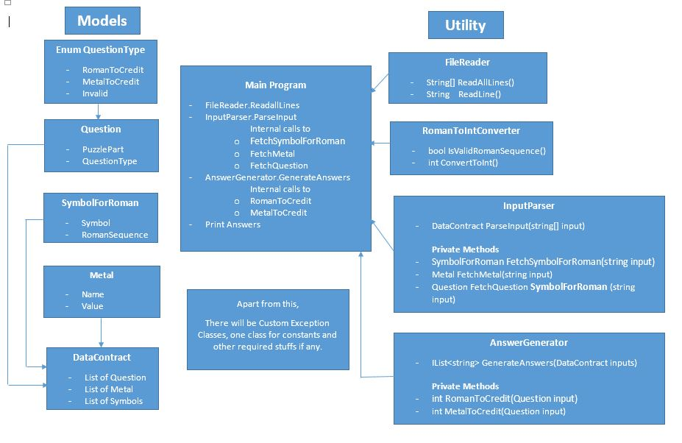

* However, there is one change from the diagram. One communication-processor layer came in @ later stage of development.
* It’s a simple console application with C#-.Net 4.5 framework and developed on VS 2013 Ultimate version.
* I have included most of the test cases with mocking wherever needed (covering more than 80% of area and 100% coverage in main business methods).
* There isn’t any complex process to run it.
* Simply, open the solution in Visual studio, you’ll get below screen.

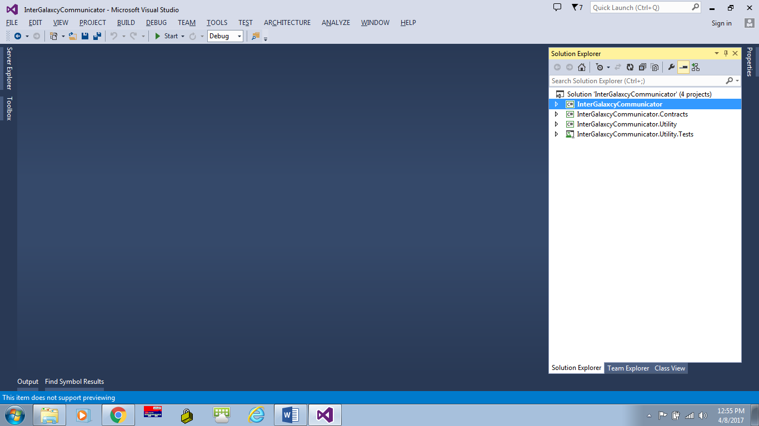

* Press F5 or start button & here, you are. Application started.

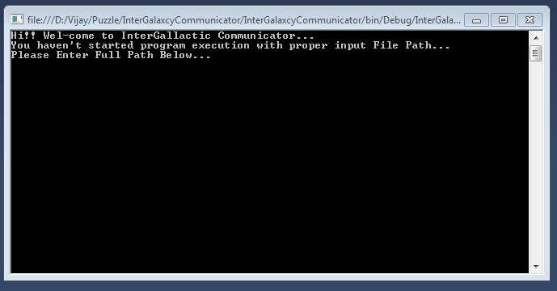

* As msg says, just enter the text file path, in which input data is available.

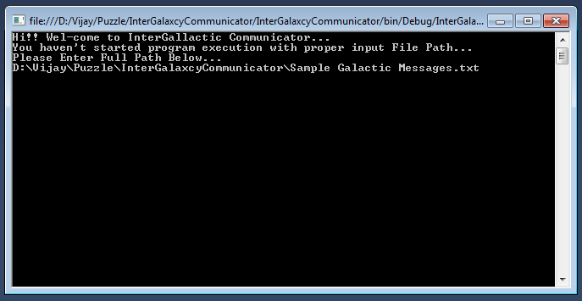

* My sample data contains the input I received in email & I am attaching that file with the solution.
* After entering full path, just press enter and then you will receive the solution as below.

