**@Test:**

This annotation is a replacement of org.junit.TestCase, which indicates that public void method to which it is attached can be executed as a test Case

**@BeforeClass:** executed before all test cases

**@Before:** executed before each test cases

**@AfterClass:** executed after all test cases

**@After:** executed after each test cases

**@Ignore:** Using @Ignore, this execution is ignored

**@Test (expected):** it will check for specified exception during its execution

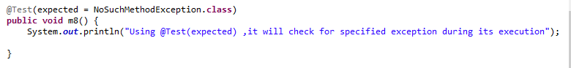**@Test (timeout):** it can be used to enforce timeout in JUnit4 test case

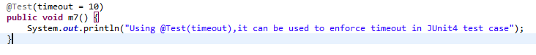

**Parameterized Test:**

Parameterized Test allows a developer to run the same test repeatedly using different values.

**Why it is required?**

**Example: Login page:** If we want to check the login page like username, password with different values

Then we can pass one case with proper username and password and in other case, we can pass with incorrect username and password.