1. **What is spring boot? Why did you use spring boot in your project? Why not spring?**

**Spring Boot –** is a spring module

**Elaborating –** Spring boot is a framework for RAD build using spring framework with extra support of auto configuration and embedded application servers(Like tomcat, Jetty)

**It provides RAD –** Rapid Application Development.

**It helps us in creating efficient fast stand-**alone applications, which you can just run it removes a lot of configurations and dependencies.

1. **What RAD that you are talking about? How you can achieve RAD using spring boot?**

RAD is modified waterfall model, which focuses on developing software in a short span of time

Phases of RAD are as follows:

**Business Modelling:**

Business model is designed for the product to be developed.

**Data Modelling:**

Data Model is designed, the relation between these data objects are established using information gathered in first phase.

**Process Modelling:**

Process model is designed. Process description for adding, deleting, retrieving or modifying a data object are given

**Application Generation**

The actual product is built using coding. Convert process and data models into actual prototypes.

**Testing and Turnover**

Product is tested and if changes are required, the whole process starts again.

**Note:** By using spring application, fourth step will consume more time. By using spring boot this will be reduced.

**(3) Is this possible to change the port of embedded tomcat server in spring boot?**

Put server. Port properties in application. Properties



**(4)Can we override or replace embedded tomcat server in spring boot?**

Yes, we can replace the embedded tomcat with any other servers by using starter dependencies

**Example:** You can use spring-boot-starter-jetty as a dependency for each project as you need

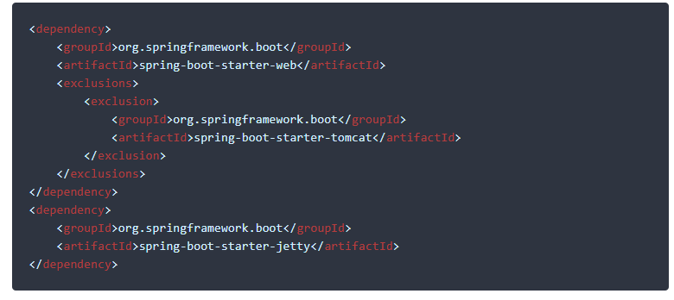

**(5)Can we disable the default web server in web application?**

The major strong point in spring is to provide the flexibility to build your web application loosely coupled. Spring provides features to disable the web server in a quick configuration. Yes, we can use the application. Properties to configure web application type i.e. Spring.main.web-application-type = none.



**(6)How to disable a specific auto-configuration class?**

You can use the exclude attribute of @EnableAutoConfiguration, if you find any specific auto configuration classes that you do not are being applied.

//By using exclude

@EnableAutoConfiguration (exclude = {DataSourceAutoConfiguration.class})



**@Configuration:**

It is a class level annotation.

Annotating a class with @configuration indicates that the class can be used by

Spring container as a source of bean definitions can use the class.

**Example:**

@Configuration

Class AppConfig {

@Bean

Public Student getStudentObject () {

return new Student ()

}

}

**@EnableAutoConfiguration:**

This Annotation auto configures the beans that are present in the classpath.This simplifies the developers work by guessing the required beans from classpath and configure it to run the application.

For Example, if you have tomcat-embedded.jar in the class path, then you will need a Tomcat Embedded servlet container factory bean to configure the tomcat server. This will be searched

And configured without any manual xml configurations.

**@ComponentScan**

It scans a package and all of its sub packages, looking for classes that could be automatically registered as beans in spring container

**(7) What does the @SpringBootApplication annotation do internally?**

As per the spring boot doc, the @SpringBootApplication annotation is equivalent to using @configuration, @EnableAutoConfiguration, and @ComponentScan with their default attributes. Spring Boot enable the developer to use a single annotation instead of using multiple. However, as we know, spring provided loosely coupled features that we can use for each individual annotation as per project

**(8) How to use property defined in application. Properties file into your java class.**

Use the @Value annotation to access the properties, which is defined in application. Properties file

@Value (“${server.port}”)

private String serverPort;

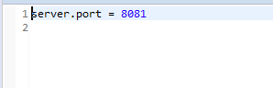

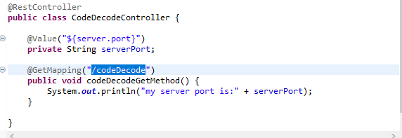

**(9)Explain @Rest Controller annotation in spring?**

@RestController is a convenience annotation for creating restful controllers. It is a specialization of @component and is auto detected through class path scanning. It adds @controller and @response Body annotations. It converts the response to JSON or XML.

Which eliminates the need to annotate every request handling method of the controller class with the

@ResponseBody annotation. It is typically used in combination with annotated handler methods based on the @Request mapping annotation.

Indicates that the data returned by each method will be written straight into the response body instead of rendering a template.

**(10) Difference between @RestController and @Controller in Spring Boot?**

To answer this we first understand the difference between a web application and a REST API.

It is that the response from a web application is generally a view (HTML+CSS+JAVASCRIPT)

Because they are intended for, human viewers while rest API just returns data in form of JSON OR XML because most of the REST clients are programs.

Same goes with @RestController and @Controller annotation.

@Controller Map of the model object to view or template and makes it human readable

But @RestController simply returns the object and object data is directly written into http response as JSON OR XML.

**(11) What is the difference between @RequestMapping and @GetMapping?**

RequestMapping can be used with GET, POST, PUT and many other request methods using the method attribute on the annotation. Whereas get mapping is only the extension of request mapping, which helps you to improve clarity on request.

**(12)What is the use of profiles in spring boot?**

When developing applications for the enterprise, we typically deal with multiple environments such as Dev, QA, and prod.The configuration properties for the environment are different.

For Example, we might be using an embedded H2 database for Dev, but Prod could have the proprietary Oracle or DB2.Even if the DBMS is the same across environments, the URLS would definitely be different.

To make this easy and clean, spring has the provision of profiles, to help separate the configuration for each environment.so that instead of maintaining this programmatically, the properties can be kept in separate files such as application-dev. properties and application-prod.properties.The default application. Properties points to the currently active profile using spring.profile.active so that the correct configuration is picked up.

**(13) What is Spring Actuator? What are its advantages?**

Actuator is a manufacturing term that refers to a mechanical device for moving or controlling something. Actuators can generate a large amount of motion from small change.

In spring boot, Actuator Is an additional feature that helps you monitor and manage your application when you push it to production. These features includes Auditing, Health, and Metrics gathering and may more features that can be automatically applied to your application.

You can enable this feature by adding the dependency: spring-boot-starter-actuator in pom.xml

Using spring actuator, you can access those flows like what bean is created, what is the CPU usage, http hits that your server has handled.

**How to use Actuator in Spring Boot Application:**

Add dependency in pom.xml

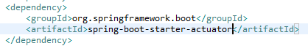

**Hit:**

<http://localhost:8081/actuator/health>

O/P:

{“status”:”UP”}, Without doing anything because of dependency