Generator Commands

The commands are generated in function GenerateMotorCommands() solving the equations:
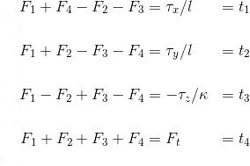

Where,
all the F1 to F4 are the motor's thrust,
𝜏(x,y,z) are the moments on each direction,
Ft is the total thrust,
k is the drag/thrust ratio and
l is the drone arm length over square root of two.

Body Rate Control

The body rate control is implemented applying a P controller and the moments of inertia.
The parameter KpPQR has to be tuned to stop the drone from flipping. However, since GenerateMotorCommands() doesn’t command thrust, we have to command some thrust in the altitude control. A good value would be thrust = mass * CONST_GRAVITY.

Roll/Pitch Control

We need to apply a P controller to the elements R₁₃ and R₂₃ of the rotation matrix from body frame acceleration and world frame acceleration.

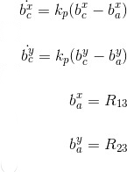

In order to calculate roll and pitch rates, we need to apply the following equation:

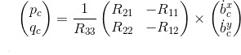

It is important to notice you received thrust and it needs to be inverted and converted to acceleration before applying the equations. After the implementation is done, start tuning kpBank and kpPQR until the drone flies more or less stable upward.

Position/Velocity and Yaw Angle Control
There are three methods to implement here:
- AltitudeControl: This is a PD controller to control the acceleration, meaning the thrust needed to control the altitude.

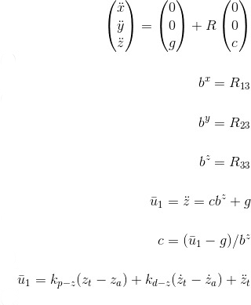

- LateralPositionControl: This is another PID controller to control acceleration on x & y.
- YawControl: This is a simpler case because it is P controller. It is better to optimize the yaw to be between [-pi, pi].

Once all the code is implemented, put kpPosXY,kpVelXY, kpPosZ and kpVelZ to zero and start tuning from the altitude controller to the yaw controller.

