#### **1. Valid Inputs**

* **Test Case 1.1: Valid Core Model Input**
  + **Input**: EE25/13/7
  + **Expected Output**:
    - Core Factors: (Calculated value)
    - Effective Volume (Ve): (Calculated value)
    - Effective Length (le): (Calculated value)
    - Effective Area (Ae): (Calculated value)
    - Minimum Area (An): (Calculated value)
  + **Description**: Test with a valid core model string to ensure the calculations are correct and the results are displayed properly.

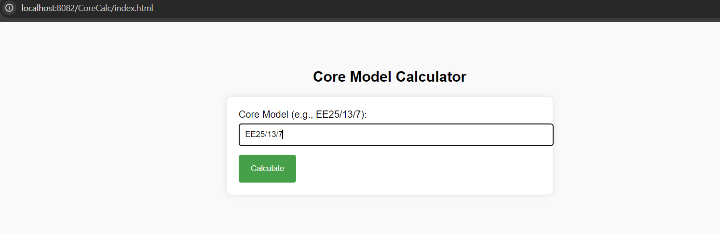

O/P : 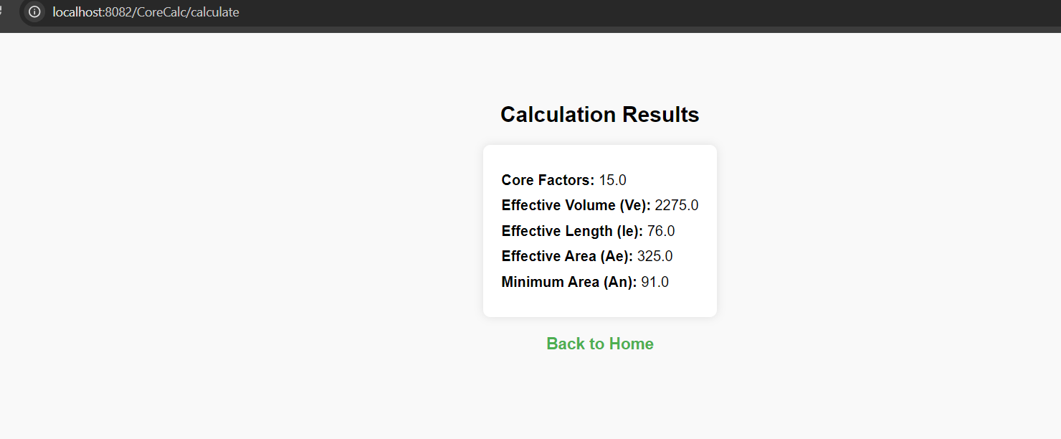

**Test Case 1.2: Different Valid Core Model**

* **Input**: E32/22/12
* **Expected Output**:
  + Core Factors: (Calculated value)
  + Effective Volume (Ve): (Calculated value)
  + Effective Length (le): (Calculated value)
  + Effective Area (Ae): (Calculated value)
  + Minimum Area (An): (Calculated value)
* **Description**: Test with another valid core model to verify that different inputs are processed correctly.

**Input** :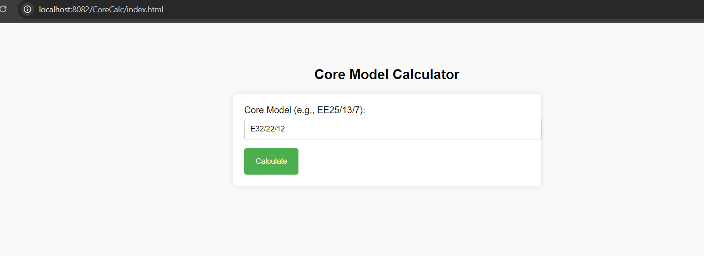

O/P - 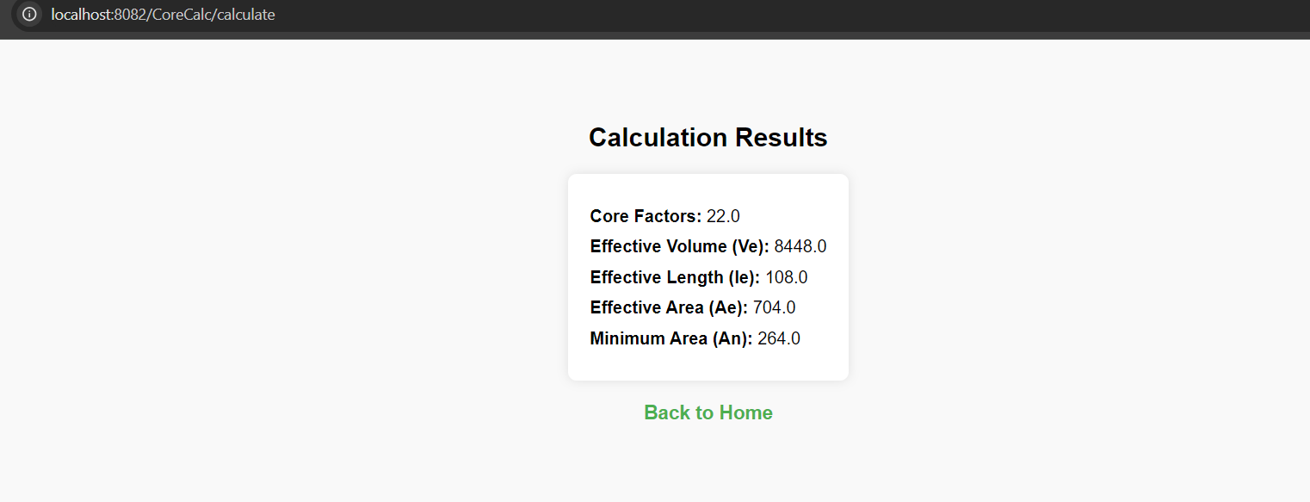

#### **2. Invalid Inputs**

* **Test Case 2.1: Incorrect Core Model Format**
  + **Input**: EE25-13-7
  + **Expected Output**: Error message indicating invalid format
  + **Description**: Test with an incorrect core model format to ensure the system handles invalid input gracefully.

**Input** -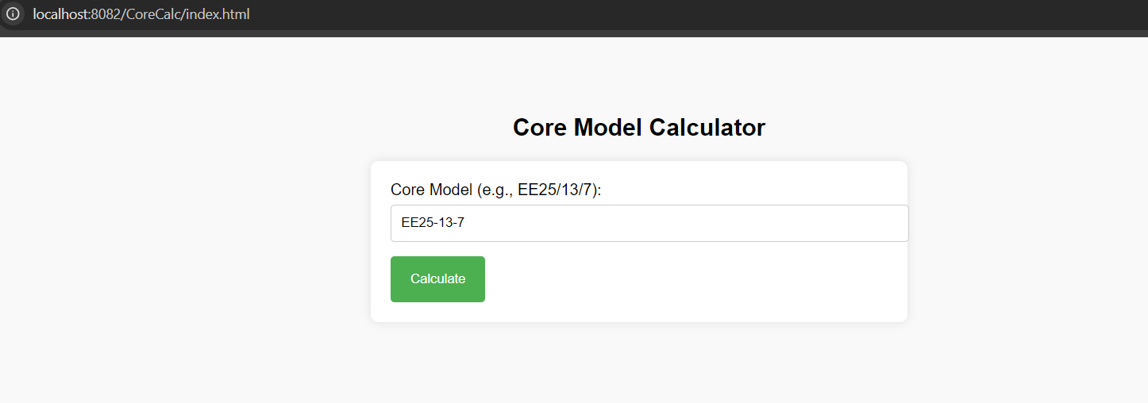

O/P -

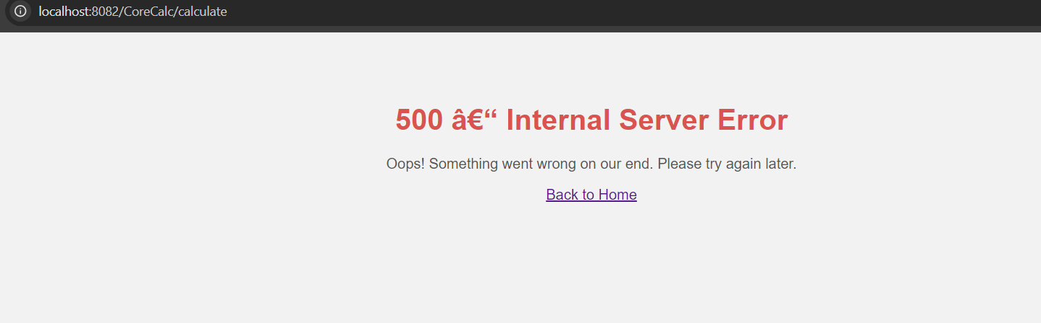

**Test Case 2.2: Empty Input**

* **Input**: (Empty field)
* **Expected Output**: Error message indicating that input is required
* **Description**: Test with an empty input field to ensure the system prompts the user to enter a value.

Input : 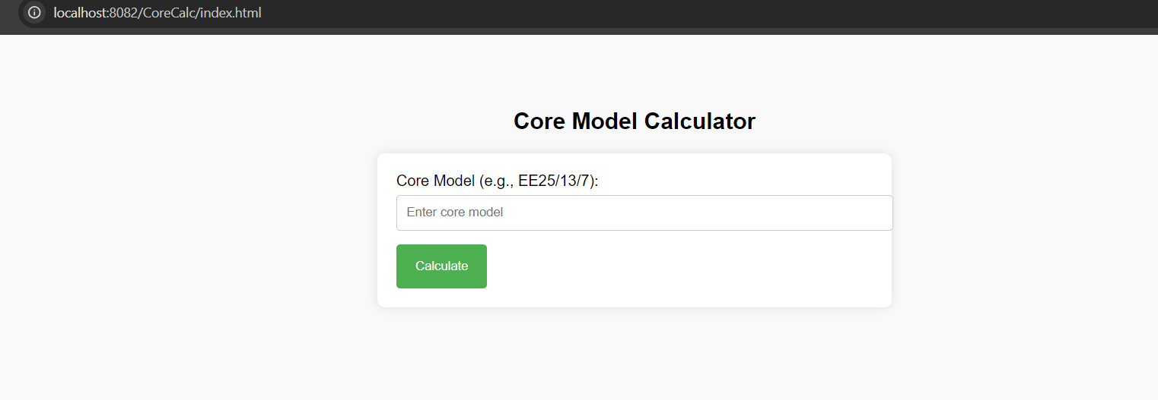

O/P -

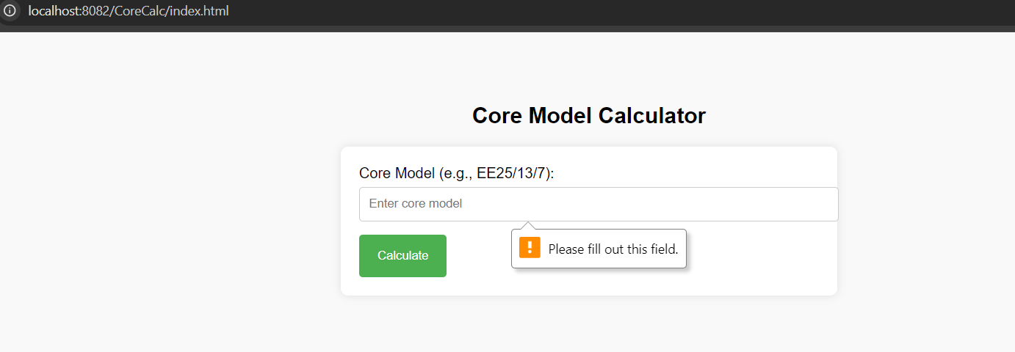

**Test Case 2.3: Non-Numeric Characters**

* **Input**: EE25/13/abc
* **Expected Output**: Error message indicating invalid format or characters
* **Description**: Test with non-numeric characters in the input to ensure the system validates input correctly.

**Input :** 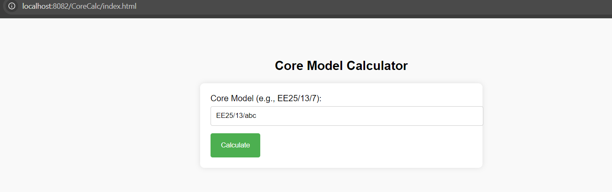

**O/P :** 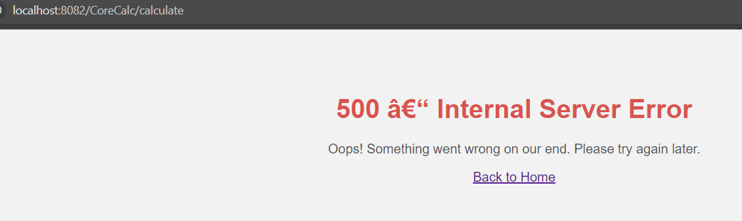

#### **. Edge Cases**

* **Test Case 3.1:** Minimum Valid Input Length
  + Input: E01/01/01
  + Expected Output:
    - Core Factors: (Calculated value)
    - Effective Volume (Ve): (Calculated value)
    - Effective Length (le): (Calculated value)
    - Effective Area (Ae): (Calculated value)
    - Minimum Area (An): (Calculated value)
  + Description: Test with the smallest possible valid core model values to ensure the system handles minimal input correctly.

Input : 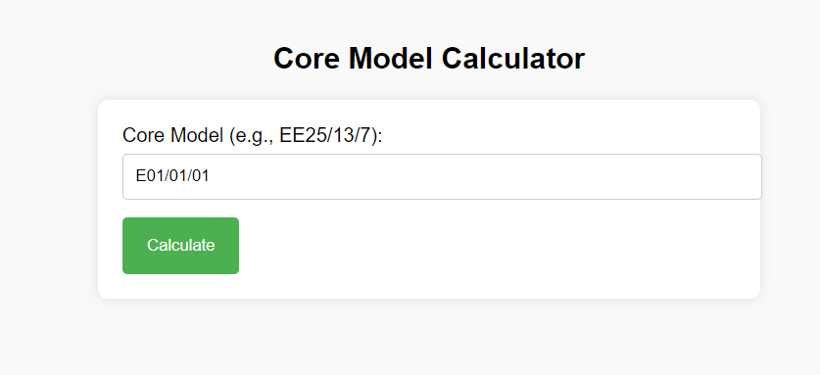

O/P : 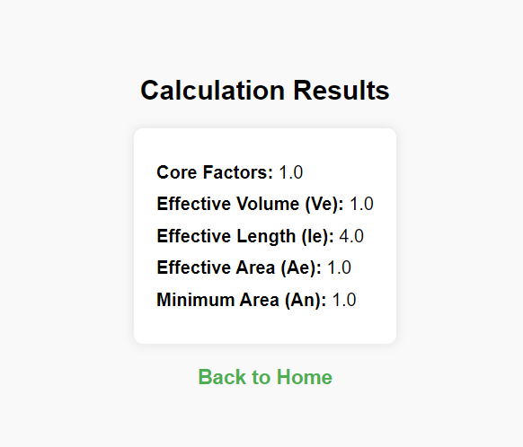

#### **Error Handling**

* **Test Case 3.2: Server Error Handling**
  + **Scenario**: Simulate a server error (e.g., by stopping the server).
  + **Expected Output**: The user should be redirected to a custom 500 error page.
  + **Description**: Ensure that the application handles server errors properly and displays an informative error page.