CUSTOMER SEGMENTATION & CHURN PATTERN ANALYSIS IN EUROPEAN BANKING

Kantekar Vijay Kumar
Masters of Business Administration
ABSTRACT
Customer churn is a major challenge faced by banking institutions as it directly impacts profitability, customer retention, and long-term growth. This project focuses on analysing customer churn patterns using a European banking dataset containing customer demographic, financial, and account-related information. The study aims to identify key factors influencing customer attrition and develop a predictive model to estimate the likelihood of customer churn. Exploratory Data Analysis (EDA), visualization techniques, and Machine Learning were utilized to derive meaningful insights and support strategic decision-making. A Streamlit-based interactive dashboard was also developed to provide real-time churn predictions and analytics.

1. INTRODUCTION
Customer retention has become one of the most important objectives in the modern banking sector. Acquiring new customers often costs significantly more than retaining existing ones. Therefore, understanding why customers leave a bank is critical for improving customer satisfaction and maintaining profitability.
This project analyses customer churn behaviour using a European banking dataset. Various demographic and financial factors such as geography, age, credit score, balance, tenure, and product usage were examined to identify customer groups with higher churn tendencies. Furthermore, a Machine Learning model was developed to predict future churn risk and support data-driven decision-making.

2. OBJECTIVES
The primary objectives of this study are:
- To measure the overall customer churn rate.
- To identify customer segments with higher churn probability.
- To analyse the influence of demographic and financial variables on churn behaviour.
- To build a Machine Learning model capable of predicting customer churn.
- To develop an interactive Streamlit dashboard for live customer churn prediction.
- To provide strategic recommendations for improving customer retention.

3. DATA OVERVIEW
The dataset consists of approximately 10,000 customer records from a European banking institution.
The dataset includes:
- Customer ID
- Credit Score
- Geography
- Gender
- Age
- Tenure
- Balance
- Number of Products
- Has Credit Card
- Is Active Member
- Estimated Salary
- Exited (Target Variable)
The target variable "Exited" indicates whether a customer has left the bank (1) or remained with the bank (0).

4. METHODOLOGY
The project was completed in four major stages:
4.1 Data Collection and Understanding
The banking dataset was imported and reviewed to understand customer attributes and business requirements.
4.2 Data Cleaning and Preprocessing
- Missing values were checked.
- Data types were validated.
- Categorical variables were encoded.
- Numerical features were standardized using feature scaling.
4.3 Exploratory Data Analysis (EDA)
Various pivot tables, charts, and visualizations were created to analyse churn patterns across different customer segments.
4.4 Machine Learning Model Development
A churn prediction model was trained using customer features. The trained model was saved and integrated into a Streamlit dashboard for real-time predictions.

5. RESULTS
5.1 Geography-wise Churn Analysis
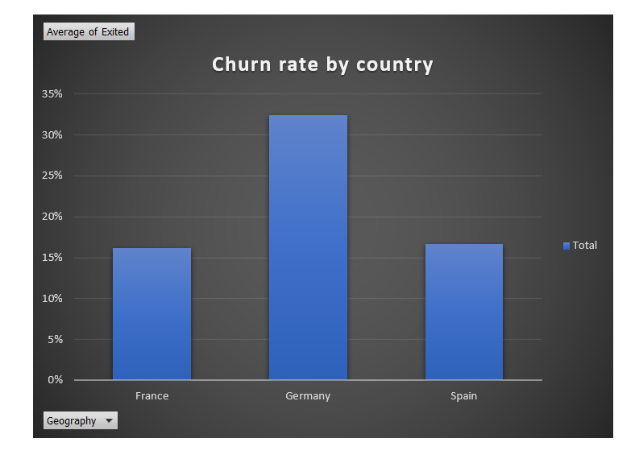
Customer churn varied significantly across geographical regions. Germany exhibited the highest churn rate compared to France and Spain, indicating possible regional service challenges or competitive pressures.

Figure 1: Geography-wise Churn Analysis

5.2Gender-wise Churn Analysis
The analysis indicated differences in churn behaviour between male and female customers. Female customers showed a slightly higher tendency to churn compared to male customers.
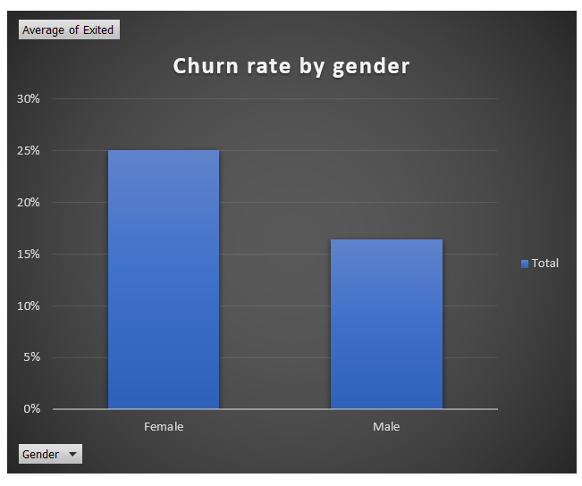
Figure 2: Gender-wise Churn Analysis

5.3 Age-wise Churn Analysis
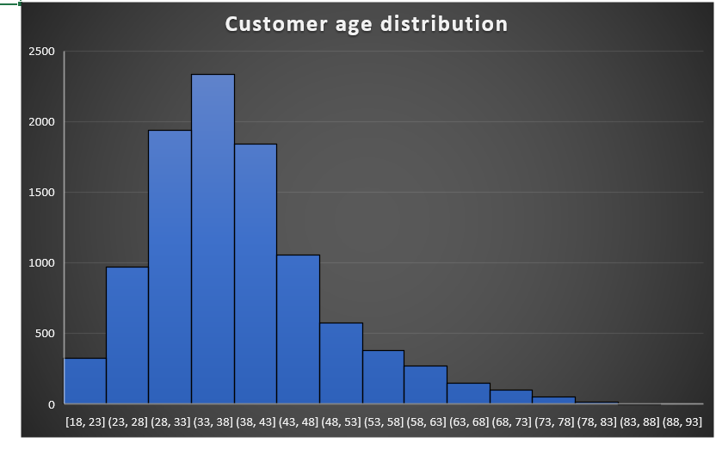
Customer churn increased noticeably among middle-aged customers. Older customer groups demonstrated higher churn tendencies compared to younger customers.

Figure 3: Age-wise Churn Analysis

5.4 Balance-wise Churn Analysis
Customer account balance was found to have a significant influence on churn behaviour. Certain balance segments displayed higher churn probabilities than others.
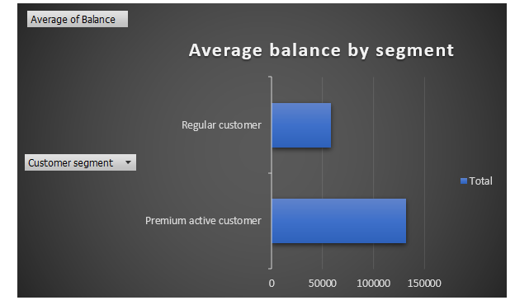

Figure 4: Balance-wise Churn Analysis

5.5 Product Usage Analysis
Customers utilizing only a single banking product were more likely to churn compared to customers using multiple banking products.
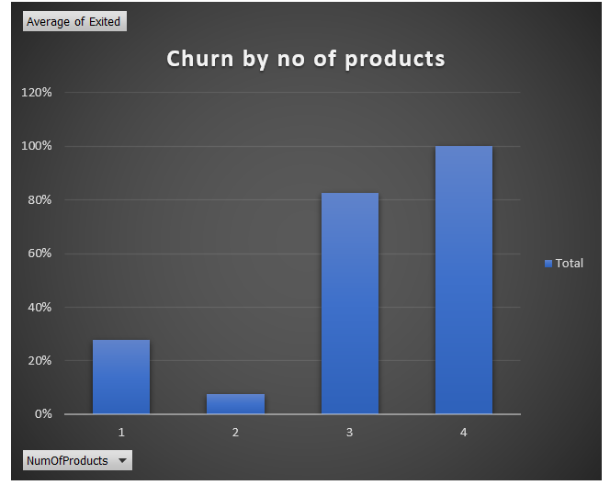

Figure 5: Product Usage Analysis

5.6 Customer Activity Status Analysis
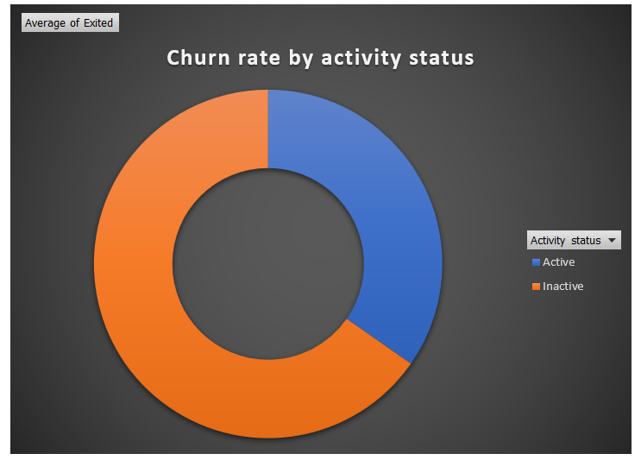
Customer activity status was found to be a significant factor influencing customer retention. Active customers demonstrated stronger engagement with banking services and showed a lower tendency to leave the bank. In contrast, inactive customers exhibited a higher likelihood of churn, indicating the importance of customer engagement programs and relationship management strategies.

Figure 6: Customer Activity Status Analysis

6. KEY INSIGHTS
- Approximately one-fifth of customers have exited the bank.
- Germany recorded the highest customer churn among all geographical regions.
- Female customers showed slightly higher churn tendencies.
- Middle-aged customers were more likely to leave the bank.
- Inactive customers displayed significantly higher churn rates.
- Customers with only one banking product were more likely to churn.
- Balance and tenure were important indicators of customer retention.
- Customer engagement strongly influenced loyalty and retention.

7. RECOMMENDATIONS
1. Improve Customer Engagement
The bank should implement personalized communication strategies, promotional campaigns, and loyalty programs to increase customer engagement.
2. Focus on High-Risk Regions
Special retention initiatives should be introduced for regions exhibiting higher churn rates, particularly Germany.
3. Increase Product Adoption
Cross-selling and bundled product offerings can encourage customers to utilize multiple banking products and reduce churn.
4. Strengthen Retention Programs
Targeted retention campaigns should be developed for inactive and high-risk customers.
5. Utilize Predictive Analytics
The churn prediction model developed in this project can be used proactively to identify customers at risk and initiate timely retention actions.

8. CONCLUSION
This project successfully analysed customer churn patterns within a European banking environment using data analytics and machine learning techniques. The study identified key customer segments associated with higher churn risk and highlighted important factors influencing customer retention.
An interactive Streamlit dashboard was developed to provide real-time churn predictions and visual analytics. The findings can assist banking institutions in designing targeted retention strategies, improving customer satisfaction, and reducing future customer attrition.

REFERENCES
- European Banking Customer Churn Dataset
- Python Programming Language
- Scikit-Learn Machine Learning Library
- Streamlit Framework
- Pandas and NumPy Libraries
- Matplotlib Data Visualization Library

