USER MANUAL

## How to install Software:

**copy the Online Shopping folder to C:\Users\<username>\Documents\NetBeansProjects**

### Hardware Requirement-

* Intel Pentium/Celeron or similar processor based PC at Client/Server end.
* 128 MB RAM and 4GB HDD space (for Database) is desirable.
* Standard I/O devices like Keyboard and Mouse etc.
* Printer is needed for hard-copy reports.
* Local Area Network (LAN) is required for Client-Server Installation

### Software Requirement-

* Windows XP/2007 OS is desirable.
* NetBeans Ver 7.2 or higher should be installed with JDK and JVM.
* MySQL Ver 6.1 with onlineshopping Database must be present at machine.

### Database Installation

The software project is distributed with a backup copy of a Database named **onlineshopping** with required tables. Some dummy records are present in the tables for testing purposes, which can be deleted before inserting real data. The project is shipped with **onlineshopping.sql** file which installs a database and tables in the computer system.

Note: The PC must have MySQL server with user (***root***) and password (***0000***). If root password is any other password, it can be changed by running MySQL Server Instance Configure Wizard.

Start ⏵Program ⏵ MySQL ⏵MySQL Server ⏵MySQL Server Instance Config Wizard

Provide current password of root and new password as “**0000**”, this will change the root password.

To install a MySQL database from a dump file ***(onlineshopping.sql)***, simply follow the following steps.

**Step 1:** Copy the onlineshopping.sql file in **C:\Program files\MySQL\MySQL server**

**5.1\Bin** folder.

**Step 2:** Open MySQL and type the following command to create the database

mysql> create database onlineshopping;

**Step 3:** Open Command Window (Start ⏵Run ⏵ cmd)

**Step 4:** Go to the following folder using CD command of DOS.

**C:\Program files\Mysql\MySQL server 5.1\Bin>**

**Step 5:** type the following command on above prompt -

**C:….\bin>** mysql -u ***root*** –p***0000*** onlineshopping < onlineshopping.sql

This will create a onlineshopping database with required tables.

## 

## Working with Software Project:

The New Clothing Store consists of the following logically organised structure for the easy functionality. User may choose the options for corresponding works.

 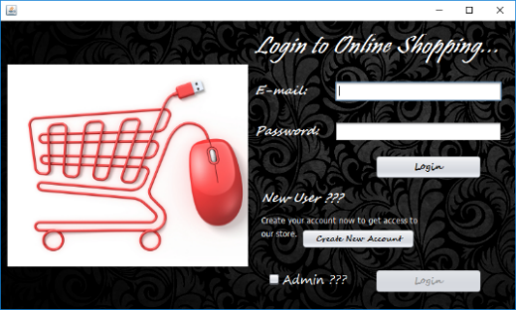 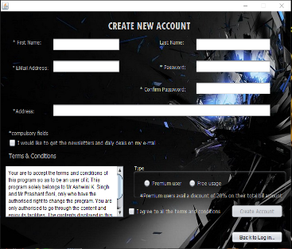

**SIGN IN:**

Through this the user can sign in to the program with a valid username and password, so as to explore the program.

**SIGN UP:**

If the user is new, he can create his new account.

**ENTER MEN SECTION:**

Through this button, one can enter the men section, which displays various kinds of products. The products shown are just a demo and programmer can add or delete the products for later usage.

**ENTER WOMEN SECTION:**

Through this button, one can enter the men section, which displays various kinds of products. The products shown are just a demo and programmer can add or delete the products for later usage.

**BILLING WINDOW:**

Through this button, one can see the items in his cart and place order by specifying the quantity required.

**ADMIN SECTION:**

Through this button, one can enter the admin section by providing suitable user id and password. This section is especially designed for the administrator for updating stock, viewing item details, registered user details and transaction details.