SESSION 4 : 2400030635

Containerize a simple RESTful CRUD app (Node.js/Express or Python/FastAPI) using a multi-stage Dockerfile. Build an image under 300 MB, run it with a mounted volume for development.
-------------
Your project folder contains:
project/
├── Dockerfile
├── package.json
└── index.js

index.js :
const express = require("express");
const app = express();
const port = 3000;
app.use(express.json());
let items = {};
// Default Route for GET /
app.get("/", (req, res) => {
res.send("Welcome to the Item API!");
});
// POST - Create new item
app.post("/items/:id", (req, res) => {
items[req.params.id] = req.body.item;
res.json({ message: "Item created", item: items[req.params.id] });
});
// GET - Retrieve an item by ID
app.get("/items/:id", (req, res) => {
const item = items[req.params.id];
if (item) {
res.json({ item });
} else {
res.status(404).json({ message: "Item not found" });
}
});
// PUT - Update an existing item
app.put("/items/:id", (req, res) => {
items[req.params.id] = req.body.item;
res.json({ message: "Item updated", item: items[req.params.id] });
});
// DELETE - Delete an item by ID
app.delete("/items/:id", (req, res) => {
const deletedItem = items[req.params.id];
delete items[req.params.id];
if (deletedItem) {
res.json({ message: "Item deleted", item: deletedItem });
} else {
res.status(404).json({ message: "Item not found" });
}
});
// Start the server
app.listen(port, '0.0.0.0', () => {
console.log(`Server running on port ${port}`);
});

Package.json :
{
"name": "crud-app",
"version": "1.0.0",
"main": "index.js",
"scripts": {
"dev": "nodemon index.js"
},
"dependencies": {
"express": "^4.19.2"
},
"devDependencies": {
"nodemon": "^3.0.3"
}
}
**Dockerfile :
# ---------- Builder stage ----------
FROM node:20-alpine AS builder
WORKDIR /app
COPY package*.json ./
RUN npm install
# ---------- Runtime stage ----------
FROM node:20-alpine
WORKDIR /app
COPY --from=builder /app/node_modules ./node_modules
COPY . .
EXPOSE 3000
CMD ["node", "index.js"]

Execution:
1.Create image
docker build -t crudapp_image .
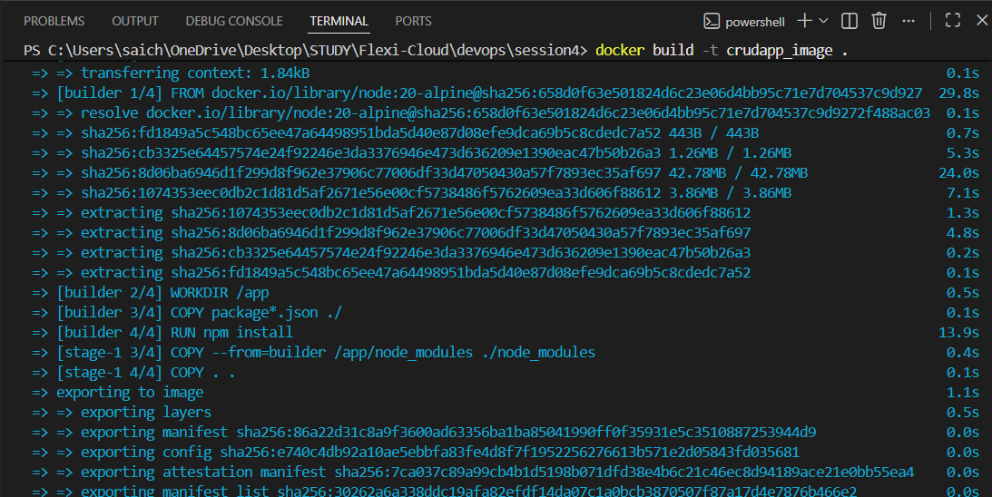
2.Create the container and mount the volume
docker run -d --name crudapp -p 3000:3000 -v app_volume:/app crudapp_image
3.Verify container is running
docker ps
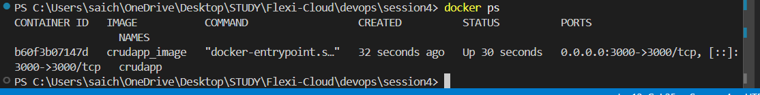
4.Open browser type in url
http://localhost:3000/
Output : Welcome to the Item API!
