|  |  |
| --- | --- |
| **NAME :** | AAKASH V |
| **DEPARTMENT :** | ELECTRONICS AND COMMUNICATION ENGINEERING |
| **COLLEGE :** | GOVERNMENT COLLEGE OFTECHNOLOGY |
| **NAANMUDHALVANCOURSE:** | DIGITALMARKETING |
| **NAANMUDHALVANID :** | BA72699BE89F27298854D368E5A902B4 |

ASSIGNMENTONDIGITALMARKETING

1. Createablogorwebsiteusingblogspotandwordpress.Customizethethemedesign and post new article with500words.

Blogspot:

<https://amaxxxx.blogspot.com/2023/08/chess.html?m=1>

Wordpress:

<https://aakashv2203.wordpress.com/2023/10/27/a-mind-game/>

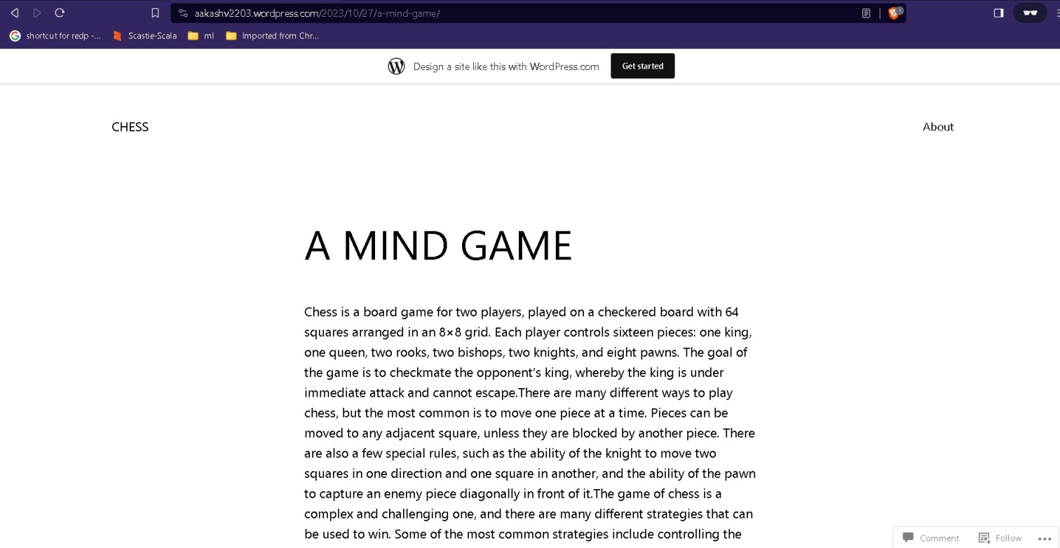

1. Create and design a social media advertisement poster using canva.

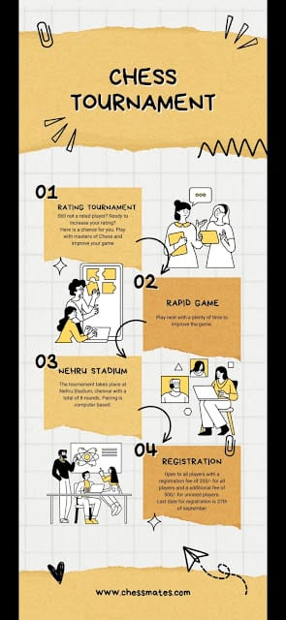

3.Create email news letter design using Mailchimp or canva tool:

