**Instructions for Group Projects:**

1. All project related emails including group details (refer #2) and evaluations should be directed to [ta2017pm@gmail.com](mailto:ta2017pm@gmail.com). If something is urgent, feel free to email me on [neetika@tamu.edu](mailto:neetika@tamu.edu)
2. You are assigned your group numbers in eCampus. As a group, you need to send me following details in a single email till **February 9, 5 PM** with subject line ISYS 630 - <Section#> - Group<Group#>:

* Your group email id and the website link

*~~[~~*

~~Create your group Gmail account which you will use to send your group evaluations. Your email id should have following format: 2017<section#>group<Group#>@gmail.com~~

~~For example: Group 2 of section 601 will have email id:~~ [~~2017601group02@gmail.com~~](mailto:2017601group02@gmail.com)

~~If user name availability issues are there then feel free to make small changes.~~

*~~]~~*

1. With respect to signed contracts and project summary documents:

It is a group submission; please ensure that only one person from the group uploads these documents on ecampus as per the deadlines mentioned in the syllabus. Ecampus link will be created soon.

*Team contract will not go on your website. Project summary may be uploaded once your website is created.*

1. Assignment 1 is due on Feb 9. Ecampus link will be created and only one person from the team need to upload the assignment in PDF form. Along with ecampus, all the assignments from assignment#1 onwards need to be uploaded on your group website.
2. One hard copy needs to be submitted just before the class, this applies to team contract, project summary and all other group assignments.
3. Which group will you evaluate? What is their website link on which you can find their assignment deliverables? - >

I will upload an excel sheet on eCampus by February 10, which will specify details for each group including **group email id and website link**. You will evaluate assignments of the same assigned groups throughout the semester. As shown below, you can see which groups you are going to evaluate:

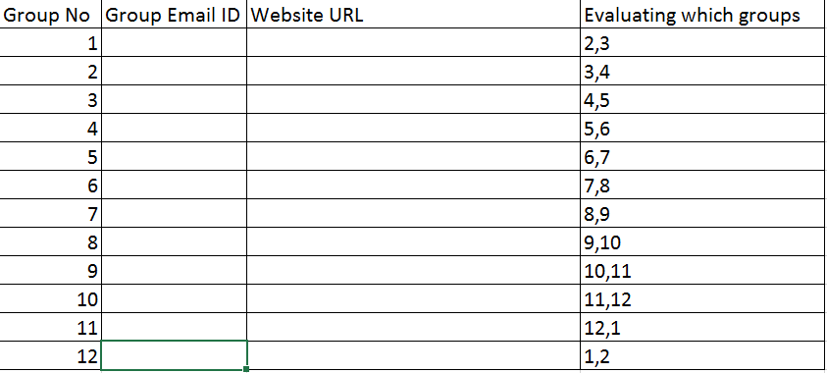

1. Make sure your website is up to date with all required documents/ assignments on the due date. This is important for the peer groups that will be evaluating you all semester.
2. All assignments from assignment#1 onwards will be evaluated by peer groups as per the excel sheet to be uploaded on ecampus. (Project summary need not to be evaluated)
3. Due date for sending peer evaluations:

One week after the assignment due date. So, for Assignment#1 which is due on Feb 9, peer evaluations should be sent by Feb 16, 11:59 PM.

1. Format of peer evaluation email:

You need to send 2 separate emails of evaluation for the groups assigned to you in the following format.

**To:** The group email id for which the evaluation is done (refer the excel sheet to be uploaded on ecampus)

**CC:** [ta2017pm@gmail.com](mailto:ta2017pm@gmail.com), your own group members’ tamu email ids

**Subject line:**

ISYS 630_Section <#>_Group <#>_Assignment <#> Evaluation for Group <#>

*Example: ISYS 630_Section 601_Group 6_Assignment 1 Evaluation for Group 8*

**Email Content:**

***Assignment Name: <#>***

***Strengths:***

*Atleast 2 points*

***Areas of Improvements:***

*Atleast 2 points*

***Overall score:*** *out of 5. (scale: 0-5)*

Do let me know if you need any other clarifications.