Report Functional Specification

< ZAFGR261 – Costed BOM Report – Purchasing : SO Cost Component report -Purchasing>

PCR034981-Need to add price strategy column in ZAFGR261 report.
VERSION: 12.0
LAST UPDATED: 04/16/2021

DOCUMENT CONTROL:

REVISION HISTORY:

Version # | Date Modified | Modified By | Brief Description of Change
1.0 | 5/8/2012 | Kumar Saket Deva | Initial Draft
2.0 | 7/23/2018 | Ram Mohan Thammineni | SO cost component report option added
3.0 | 03/15/2019 | Ram Mohan Thammineni | Additional attributes to be added in the output of the report
4.0 | 03/27/2019 | Ram Mohan Thammineni | Field length changes of Config Alpha, platform and fab name
5.0 | 4/15/2019 | Ram Mohan Thammineni | Add Planning BOM cost estimate to the report
6.0 | 5/30/2019 | Ram Mohan Thammineni | No Touch MCOS project changes – Add fields and Z table update
7.0 | 11/19/2019 | Keyur Panchal | Copying Existing ZAFGR252 Report and Adding New fields for DiGFP project requirement
8.0 | 04/14/2020 | Keyur Panchal | ITC1 Defect # 1760 Removing existing logic for Subcon PO. So program can bring all PO for cost component view.
9.0 | 07/15/2020 | Keyur Panchal | ITC2 Defect # 3588 Adding additional column to filter out ZMAT Buy and related details
10.0 | 08/24/2020 | Keyur Panchal | UAT Defect # 4378 Adding Costing SPK to the report layout
11.0 | 11/09/2020 | Keyur Panchal
12.0 | 04/16/2021 | Hari Krishna Gedala | Need to add price strategy column in ZAFGR261 report.

APPROVALS:

Author | Keyur Panchal | Date Created: | 11/19/2019
Functional Team Lead | Sapan Shenoy | Signature and Date Approved:
Business Process Owner | Seth Wallis | Signature and Date Approved:
Technical Team Lead | Yvonne Tai | Signature and Date Approved:
Project Manager | Sharon Tang | Signature and Date Approved:

TABLE OF CONTENTS:

I. INTRODUCTION 4
A. Purpose of the document 4
B. Request Overview 4
II. OVERVIEW 5
A. Business Driver 5
B. Key business requirements 5
C. High level Process overview 5
III. DETAILS 5
A. Detail Processing Logic 5
B. Selection Screen 5
C. Report/Form Layout 5
D. Paper Requirements 5
E. Print Requirement 6
F. Special characteristics 6
G. Exception Handling Rules 6
H. Special Requirements 6
I. Dependencies 6
J. Constraints 6
K. Scheduling Requirements 6
L. Test Specification 6
1. Functional Test Scenarios 6
2. Test Data & Other Needs 7
3. Test System & Environment 7
M. Audit Requirements/Integrity Controls 7
N. Security/Authorization Requirements 7

INTRODUCTION

Purpose of the document
The purpose of this document is to document any SAP code modification or additional processing logic requirements to further enhance the standard SAP delivered functionality. This document once approved by the appropriate authorities as mentioned in section “Document Control” forms the basis of Technical specification and the development work by the Development team.

Request Overview

1. Scenario ID:
2. Scenario Title: SO Cost Component Report – Purchasing
3. Process ID:
4. Process Title:
5. Development Spec ID:
6. Name of Enhancement:
7. Short Description:

8. Type: ABAP Report Form Query
Other_________________
9. Tools used ABAP Program Report Painter Report Writer
Information System ALV SAP Script
Smartform Other
10. Data latency: Batch On-demand
11. Frequency: Annually Quarterly Monthly Weekly
Daily Other
12. Requesting Team: ___Finance_________________
13. Systems Impacted: R/3 CRM APO EBP BW SEM
Other____________
14. Modules Impacted: FI CO SD MM PP QM BW SEM
Other.
15. Complexity High Medium Low
16. Spec Created on: 07/23/2018
17. Date required by: 07/23/2018
18. Created by: Keyur Panchal
19. Functional Analyst:
Keyur Panchal
20. Technical Analyst: TBD
21. Business Owner: ___Seth Wallis______________________ Phone:

Version 1.0

Assumptions: List assumptions that will be used in the document
The report is for Sale order BoM Cost Estimate.

The Costed BoM report will provide data in Local (legal view) and Group currencies (Group view), For Baccini (Co.code 0007), LC is EUR.

Out of Scope:

Costed BoM report includes direct COS only. Other cost which don’t have direct linkage to a SO (PPV, Scrap, Inventory Shrinkage…), G&A, RD&E and M&S are out of scope. And will not be covered by the new Costed BoM report

Out of scope order type
- Vendor sell back is just selling to vendor at cost , so it’s out of scope

Business Driver (Purpose)
Internal reporting – Applied Materials Management also required and will use this report as a means to better evaluate the BoM components and associated costs involved in the specific sales orders and determine the production order associated with the SO.
The reporting logic will pull data strictly from the ECC system. The reporting data is Cost estimate based.
Process Description

Background info

•
Requirement

Selection screen

Parameter  Name | Table field/Check Box | Select-Options(S) or Parameters(P) | Mandatory  Y/N | Default Value | Comments
P_BURKS | Table Field | P | Y | 0007 | Company code, relevant to retrieve the fiscal period
S_GJAHR | Table Field | P | Y | Current Fiscal Year | Fiscal Year
S_POPER | Table Field | S | Y | Current Period | Posting Period
S_ERDAT | Table Field | S | N | - | Sales Order Created date
S_profitctr | Table Field | S | N | 113301-113309 | Profit center
S_ORDER | Table Field | S | N |  | Sales document
S_CUST | Table Field | S | N |  | Customer

Authorization check

Authorization to execute this report should use authorization object to check if user has access to CO: Bus. Trans., Actual Postings and Plan/act. Allocations

Object S_TCODE
Class AAAB Cross-application Authorization Objects
Check access to Tcode ZAFGR252 (The Tcode for this new Costed BoM report)

Report output for posting log

ALV detail list report

# | Report Field | Field Description (if different from field) | Field | Derivation Logic
1 | SO / Proj# |  | VBAK-VBELN
2 | SDI | Item | VBAP-POSNR
3 | Material | Material number | VBAP-MATNR
4 | Material descr. | Material desciption | VBAP-ARKTX
5 | SO Costed BoM Materials |  | BAPI_COSTESTIMATE_GETEXPLOSION-MATERIAL | Enter output from KEKO- BZOBJ, KEKO-KALNR, KEKO-KALKA, KEKO-TVERS, KEKO-BWVAR, KEKO-LOSGR in the BAPI input selection for the Header Material (SDI).
6 | SO Costed BoM Activity Type |  | BAPI_COSTESTIMATE_GETEXPLOSION-ACTIVITY_TYPE | Enter output from KEKO- BZOBJ, KEKO-KALNR, KEKO-KALKA, KEKO-TVERS, KEKO-BWVAR, KEKO-LOSGR in the BAPI input selection for the Header Material (SDI).
7 | Description |  | BAPI_COSTESTIMATE_GETEXPLOSION-DESCRIPTION | Enter output from KEKO- BZOBJ, KEKO-KALNR, KEKO-KALKA, KEKO-TVERS, KEKO-BWVAR, KEKO-LOSGR in the BAPI input selection for the Header Material (SDI).
8 | Value in LC |  | BAPI_COSTESTIMATE_GETEXPLOSION- CCODE_CURRENCY_TOTAL_VALUE | Where KEKO-BWVAR = Y03  Total of value for the header item should match with BSIS-DMBTR for the VBAP-MATNR per UoM.
9 | Value in GC |  | BAPI_COSTESTIMATE_GETEXPLOSION- CO_AREA_CURRENCY_FIXED_VALUE | Where KEKO-BWVAR = Y04  Total of value for the header item should match with BSIS-DMBE2 for the VBAP-MATNR per UoM.
10 | Production Order | Order | AFPO-AUFNR | Enter in AFPO with AFPO-KDAUF=VBAP-VBELN and AFPO-KDPOS=VBAP-POSNR and retrieve Production order.
11 | Costing Period | Posting Period | KEKO-POPER
12 | Costing Year | Posting Date YYYY | KEKO-BDATJ

Step by step process

- Selection screen validation

For performance reason, should only allow one company code in the selection (default company code = 0007)

- Sales Order Cost Estimate processing
a) First read sales document (VBELN) for specified date range (ERDAT) for Table VBAK, plus period (poper BETWEEN p_frpd AND p_topd), fiscal year (bdatj BETWEEN p_fryr AND p_toyr ) and Company code selection criteria.

c) Get all the subitem of Sales item from VBAP . If there is no subitem, Then list the high level item only as subitem

For e.g.

Input the following field
VBAP-VBELN = 3030000392
VBAP-UEPOS = 10

Output
VBELN = 3030000392
POSNR = 11, 12, 13

For sales order related costed BoM estimate:

Select KEKO by KEKO- BWVAR = ‘Y03’ and costing variant Y003 for LC and Y004 for GC (Valuation variant),KEKO-MATNR, KEKO- VBELN (Sales document) and KEKO- POSNR (Subitem line number) and KEKO- FEH_STA = ‘VO’ (costing status)

If can’t find the product cost estimate no. from the above step, then do the below: For non sales order related costing estimate

Select KEKO by KEKO- BWVAR = ‘Y02’ and costing variant Y0L1 for LC and Y0G1 for GC (Valuation variant), KEKO- FEH_STA = ‘FR’ (costing status), KEKO- MATNR=VBAP- MATNR (Subitem level), KEKO- WERK=VBAP-WERKS.

- Costed BoM data read

Select FM / BAPI - ‘BAPI_COSTESTIMATE_GETEXPLOSION’ and pass on the input values (KEKO- BZOBJ, KEKO- KALNR, KEKO- KALKA, KEKO-TVERS, KEKO- BWVAR and KEKO-LOSGR) for the header material (KEKO-MATNR = VBAP-MATNR )
This fetches values in LC (Co Code Cry) and GC (CO Area Currency) at item level (Materials, Activities and OH) for multilevel BoM of header material.

OVERVIEW

Business Driver

Key business requirements

Version: 2.0

To show cost component report for a SO and relevant SO item, and for multiple SO’s at various levels

- Cost components to be based upon OBOM Standard Cost. As such there is not a requirement / expectation that this report tie exactly to any GL account
  - Any manual adjustments (JVs) to SO costing will not be included in this report’s output
  - Also as this report will be used for forecast and therefore there may not be any underlying GL account data
- Version 7.0
As part of Display project user like to see Purchasing details to the existing ZAFGR252 report. Copying existing ZAFGR252 reprot to ZAFGR261 report and adding Purchasing details to the report. New column will be added to report like, vendor (Supplier) number, GR Date, Purchase order, Po item number etc.

Also, adding, material number, vendor number and Po delivery date to the selection screen.

High level Process overview
<Attach process flow chart and system architecture showing all the concerned systems if required>

DETAILS

Detail Processing Logic

Step 1 – Leverage existing report ZAFGR252 of SO costing report to develop new report for SO cost component report in same program.

Step 2 – Selection Parameter of the report : Add/change below selection parameter of the existing report ZAFGR252

 |  | Field |  | Default
1 | Report Selection option – Add heading “Costed BOM Report “ |  |  |  | Add this Heading
2 | Itemization view |  |  |  | Radio button – If selected this option, existing report output should display
3 | Cost Component View |  |  |  | If selected this option, new report logic should execute to show Cost Comp view
4 | Costing Variant |  |  | Y004 | Default with Y004 costing variant for standard cost values in Group currency
5 | Company Code field ( Plant CCode) | Company Code | BUKRS(VBAP- WERKS) |  | Company Code of the plant in SO item (VBAP- WERKS)
6 | OBOM levels
7 | Costing Status |  | KEKO-FEH_STA |  | Include as range

- If Itemization view is selected then existing report logic should continue and report output also should be same.
- If Cost component view is selected, then below new logic should be applied to show SO cost component report.
- Also existing Company code selection need to be changed to reflect CoCode of the plant in SO item (VBAP-WERKS) so that even SO line item related to other Company code will be pulled in output of the report.
- Selection parameter from 4 to 7 are specific to Cost component report related and not to be used in existing report logic.

Step 3 – Sales Order Cost Estimate processing
a) First read sales document (VBELN) for specified date range (ERDAT) for Table VBAK, plus period (poper BETWEEN p_frpd AND p_topd), fiscal year (bdatj BETWEEN p_fryr AND p_toyr ) is based on costed period ie ( from KEKO instead of SO creation date) and Company code selection criteria( using table T001K get plants and match with SO’s plant VBAP-WERKS).

b) Get all the subitem of Sales item from VBAP – Obtain SO item no. in VBAP, and then go KEKO table to get relevent Sales Order item where SO costing completed.

c) For sales order related costed BoM estimate:

Obtain records from KEKO table by costing variant (KEKO- KLVAR) = Y003 (from selection parameter) for LC or Y004 for GC (from selection parameter), KEKO- VBELN (Sales document) and KEKO- FEH_STA = ‘VO’ (costing status from selection parameter)
Note – In review meeting, decided to add costing status in selection parameter so that if required user can add VF and other costing status related cost estimate also.

Obtain records will show product cost estimate no. (KEKO- KALNR1), Material (KEKO-MATNR) , KEKO- VBELN (Sales document) and KEKO- POSNR (Subitem line number)

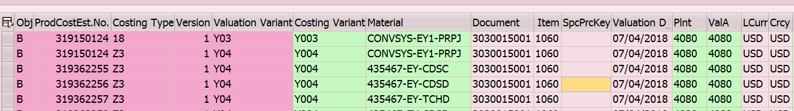

Note :
1. SO order line item number obtain can belong to different plants ( representing different company code). For example SO header ( CoCode 0001) and Item 1060 in plant 4080 (CoCd 0001) and item no 1070 in plant 4060 (CoCd 0028)

2. If can’t find the product cost estimate no. from the above step related any SO, then that means successful SO cost estimate doesn’t exist and can be ignored other than VF and VA status.

Step 4 – Cost component structure naming and mapping to table KEPH ( Cost component table)

Cost components are saved in KEPH table are based on assignment columns in TCKH3 table (Cost component names). From Table TCKH3, cost component name (TCKH3-TXELE) to be pulled using Cost Component structure Z1.

Field TCKH3-ELEMT shows costo component key, whereas TCKH3-EL_HV shows the correlative number assigned for full costs. This correlative number matches with KST001, KST002 and so on in table KAPH.

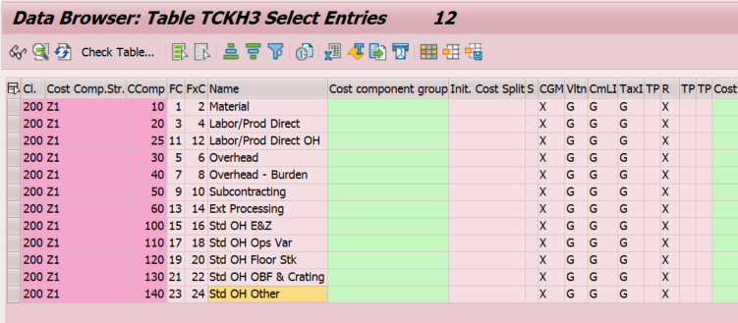

For the full cost of each cost component system automatically assigns a number in TCKH3 table. The fields are TCKH3-EL_HV

Considering cost component TCKH3-EL_HV value will represent which cost (KEPH-KSTXXX) amount in KEPH tables.

TCKH3-EL_HV | TCKH3-TXELE | Corresponding amt in KEPH table
1 | Material | KEPH-KST001
3 | Labor/Prod Direct | KEPH-KST003
11 | Labor/Prod Direct OH | KEPH-KST011
5 | Overhead | KEPH-KST005
7 | Overhead - Burden | KEPH-KST007
9 | Subcontracting | KEPH-KST009
13 | Ext Processing | KEPH-KST013
15 | Std OH E&Z | KEPH-KST015
17 | Std OH Ops Var | KEPH-KST017
19 | Std OH Floor Stk | KEPH-KST019
21 | Std OH OBF & Crating | KEPH-KST021
23 | Std OH Other | KEPH-KST023

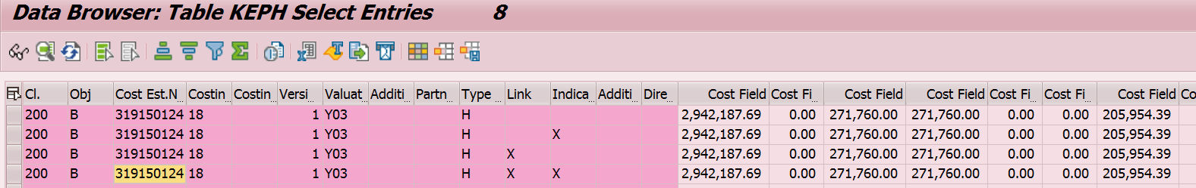

Step 5 – Below are two Function module to be used to pull cost estimate and cost component view cost for a SO.

BAPI_COSTESTIMATE_GETDETAIL – BAPI to get cost component view

Based on records from KEKO using cost estimate no. above BAPI can extract details related to cost component.

Records captured in KEKO ( in step 3) need to be as input in BAPI to extract cost component of SO.
Below are Input parameters for BAPI :

REFERENCEOBJECT B
COSTINGNUMBER 000319150124 (from KEKO- KALNR1)
COSTINGTYPE 18 ( from KEKO- KALKA )
COSTINGDATE
COSTINGVERSION 01 ( from KEKO- TVERS)
VALUATIONVARIANT Y03 ( from KEKO- BWVAR)
ENTEREDMANUALLY
COST_COMPONENT_VIEW 01
COST_COMPONENT_GROUP
CURRENCY_ORG_UNIT 00

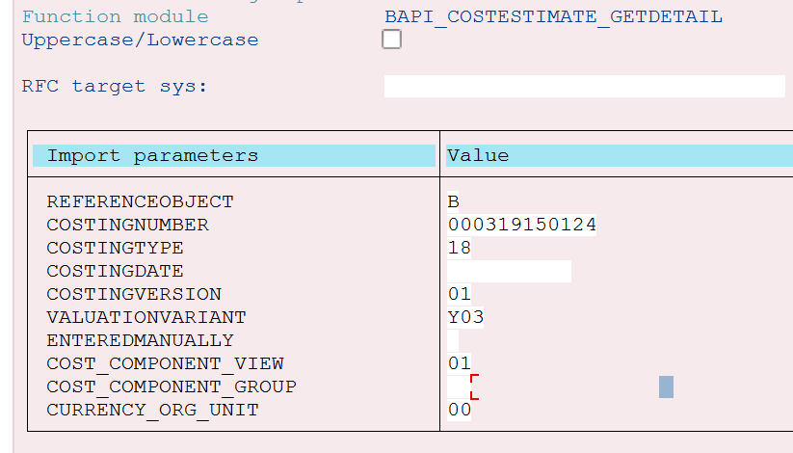
Note – Curency Org Unit – LC is 00 and GC is 02

Output from BAPI :

- .From Cost_estimate_header table, “Total amount(std cost)” can be obtained from “Total_AMT” field.

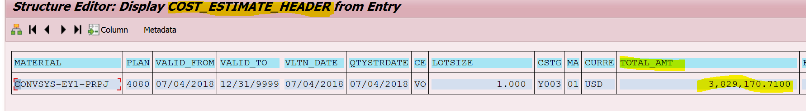

- From Cost_Components table, complete components details for that record can be fetched

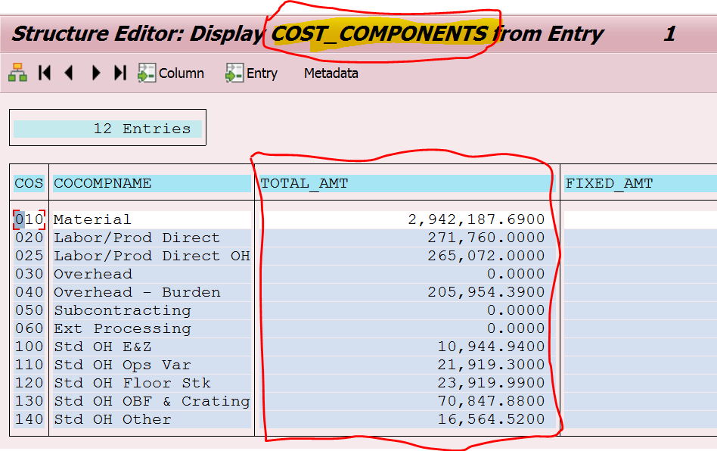
Values from BAPI output can be compared with CK53N cost component view
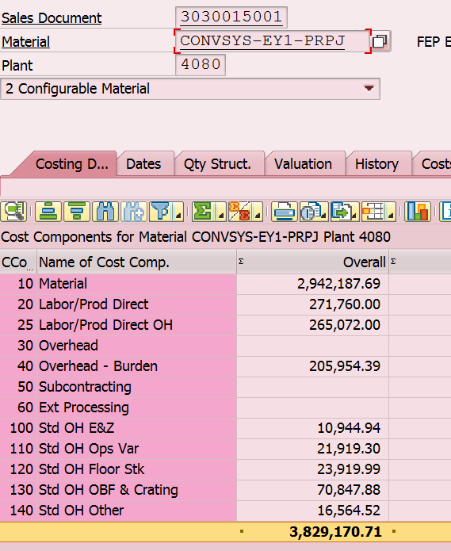

Note – Special care required in coding to make sure performance issues are reduced because program will be executed with multiple SO and OBOM have multiple levels.

Step 6 – Below is expected output of the SO cost component report :

Column no. | Description of the Field | Table name | Field name | Comments
1 | SO | KEKO | VBELN
2 | SO Item | KEKO | POSNR
3 | OBOM Level | KEKO
4 | Plant | KEKO | WERKS
5 | Material | KEKO | MATNR
6 | Procurement Type | MARC-BESKZ
7 | Special Procurement | MARC-SOBSL
8 | Costing Variant | KEKO
8a | Costing status | KEKO
8b | Currency key
9 | Total Amount(Std Cost)
10 | Material
11 | Labor/Prod Direct
12 | Labor/Prod Direct OH
13 | Overhead
14 | Overhead – Burden
15 | Subcontracting
16 | Ext Processing
17 | Std OH E&Z
18 | Std OH Ops Var
19 | Std OH Floor Stk
20 | Std OH OBF & Crating
21 | Std OH Other
22 | Validation Calculation |  |  | Column 9 - (sum of column 10 to 21)

Expected Output of the report :
Example 1 :
Example 2:
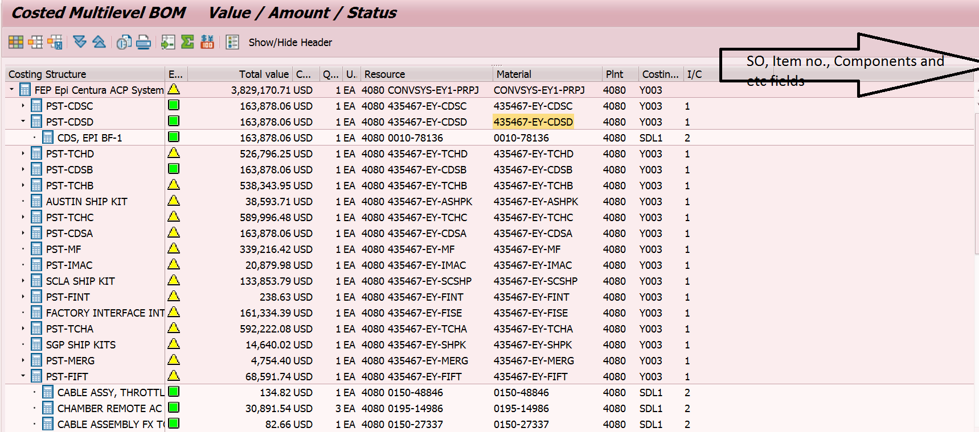

Note – 1. Based on technical complexity, report will have “costing structure” for levels similar to above standard report CK87_99 in example 2 or just simple report as shown in example 1.
2. Parent level material as new column will be added if logic is not complex.

Date : 03/15/2019
Version 3 : Additional attributes in the output report :

Following are the additional fields requied in the output of the report :

- Sales Order Line Header (1000) – SO Higher level Item (VBAP-UEPOS)
- Sales Order Type – Sales order type (VBAK-AUART)
- BOM Type (ex. Sales Order BOM / Planning BOM) – If SO exist then update as “Sales order BOM”
- Rejection Status description – Reason for Rejection(VBAP-ABGRU)
- OPID – Take OPP ID (ZAV0505- OPP_NO) and OPP ID line item (ZAV050-OPP_ITEM_NO) based on SO (ZAV0505- SALES_ORDER) and SO higher Level Item (ZAV0505- SALES_ORDER_LNO )

Take this OPID and line item no. and fetch data from BW table /BIC/MGBPCOPITM. This is staging master table in BW used for BPC. Instead of adding logic to derive each field related OPID, it is proposed to get data from BW staging table itself which will avoid reconciliation issue.

Following are attributes which need to be fetched through RFC trigger once all data is populated in the report so as minimax no. of times RFC trigger.

- Slot Number – can be obtained from “Slot number” field in BW opportunity item master data table. Or Slot no. is updated in “Your Reference” (VBKD-IHREZ_E) of SO item related SO higher Item.
- Opportunity Type (SYS_ITEM) – Get from field “Opportunity Type” from BW table
- OPPORTUNITY SUB TYPE - Get from field “Opportunity Sub Type” of BW field
- Alpha Config –Based on the OPID, Alpha Config can be pulled from “Config Alpha” field of BW table.
- Count of Chamber – Get from field “Chamber Count” of BW field based on OPID.
- Single / Dual Build – Get from “AMAT Pickup Type/Str” field of BW table based on OPID but refine the data by taking values after “_” ( for example 003_DB-AUSGPU but required to be shown as DB-AUSGPU. Instead data also available in ZAC0012-BUILD_STRAT
- Platform – Get from “Platform Type” field in the BW table. But need to refine text by removing initial charater upto “_”. For example, in table showing as XX_ETCH PRODUCER GT but to show as ETCH PRODUCER GT. It is also available in ECC field ZAC0012-PLATFORM1
- Fab Name - Get from “FAB Name” field in the BW table.
- Region - Get from “Region” field in the BW table but they are not in text. So need to convert from code like 04 to text “AMC”. Text is also available in BW in another separate table. If getting another table from BW is issue, then can use ECC table zam0205 to get text. Since ZAM0205 code text is different than what BPC text values for region, we need to create new TVARC variable S-ZAFGR252_REGION to get text like AMC, AME etc.
- G3 – Get from “Product ID” field in the BW table but need to show description instead of code. Then go to table ZAF0204 to get description of G3.
- Build BU – Get it from “Build BU Description” field from BW table.

These other field which need to be added in report :

- Parent Customer – Get sold to party customer (VBAK- KUNNR ) from SO and go to KNVH and get parent customer (KNVH- HKUNNR) by inputing customer(KNVH- KUNNR). Then show name of the customer from table KNA1-NAME1
- Revenue BU – From Sales header item Division (VBAK-SPART) or SO Item division( 1000 line item) (VBAP-SPART). From Division table obtain Division name(TSPAT- VTEXT)
- SO Profit center – Get from VBAP-PRCTR of SO item related to 1060 instead of higher level item
- G1 – Using G3 value in ZAF0207-AMAT_PRODUCT to get G1 ( ZAF0207-PROD_LINE_G1 ) with valid to and valid from range. Then go to table ZAF0205 to get description of G1
- G2 – Using G3 value in ZAF0207-AMAT_PRODUCT to get G2 ( ZAF0207-PROD_LINE_G2 ) with valid to and valid from range. Then go to table ZAF0206 to get description of G2.
- Product – Using G3 and Description of G3. For example, Product should show “P2056 - REFLEXION LK” which is G3 code + “-“ + G3 description.

TVARC created for region code description :
D08K9A062U 200 X072006 PCR023021 A_SIMG_TVARVC for Region description in ZAFGR252

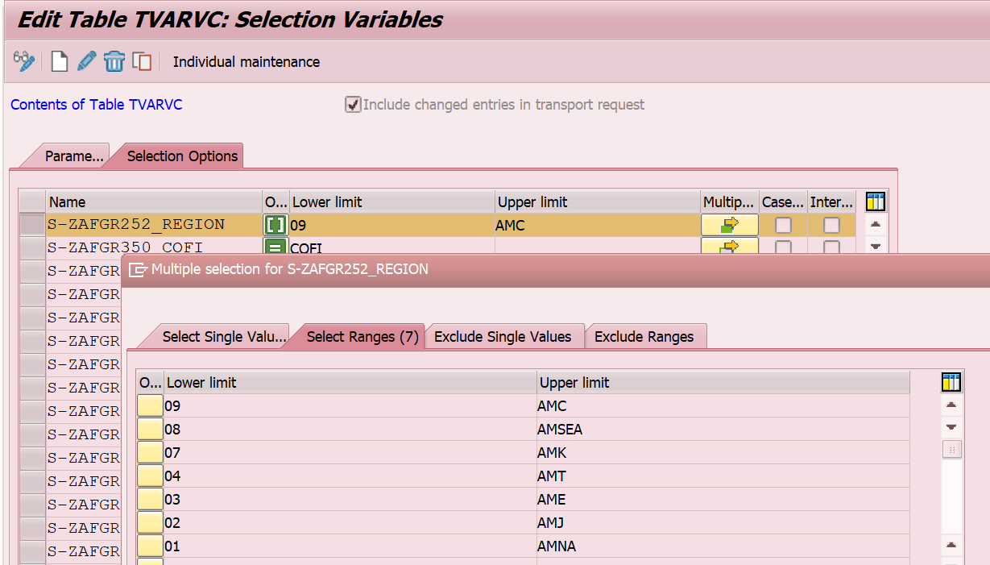

Date : 03/15/2019
Version 4 : Additional attributes in the output report – Output field length changes :

Change field length of Config Alpha, platform and fab name, which are fields in the output of the report. Field should match with fields of the BW staging table length like Config alpha to 60 Char

Date : 4/15/2019
Version 5 : Add Planning BOM cost estimate to the report

Planning team uses planning material (material group M0001) and planning BOM for the tools built forecasting.
As part of low touch reporting requirement, ZAFGR252 report required to included planning BOM cost component.
Add selection parameter :

1. Include “Planning BOM” checkbox
2. Plants – If entered then will limit output of materials of plant in ZAC0001(MPP tables). If not entered, then plants under Company code which are entered will fetch data from ZAC0001 (MPP) ie all plants within that company code.
In selection parameter planning BOM Plant is replaced with Plant. As program is taking lot of time to run for open SO and Planning BOM selection parameter. As company code in the selection parameter is too wide to be used so decided to use plant additional parameter. With this option, we can run specific plants of SSG. And also same plant field will be used for planning BOM selection as it will go to ZAC0001 table to filter.
3. Opp ID (ZAV0505-OPP_NO) – Include in General section. If Opp Id is entered in selection parameter then it should to go table ZAV0505 and find linked SO. And also based on Oppid, go to ZAC0001 and obtain Slot number and relevant GPIR, CPIR and SPIR material. In the output, then show cost component of the SO and GPIR, CPIR and SPIR linked with Opp id.
If opp id is given, other selection parameter will also be applied. For example, if Oppid is given then it will check for SOs in ZAV0505 and then will show up in the report only if other selection parameter meets the criteria. And if “Planning BOM” checkbox is selected then it will show planning materials also in output.

Detail Processing Logic

1. If planning BOM indicator is selected then go to MPP table ZAC0001 with planning BOM plant ( ZAC0001-PLANT) and ( if left blank, assume all plants and material) and fetch records.

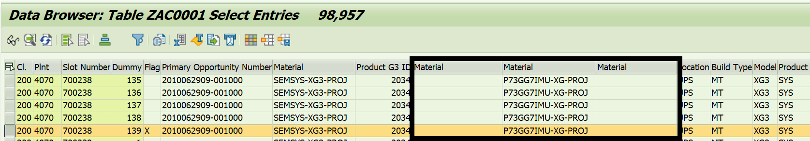

2. When going to ZAC0001, select records with active flag as same Slot number has many records.
3. There are three materials in the ZAC0001 which need to be shown in output in three different rows for a slot number :
Planning BOM GPIR: ZAC0001-PLA_MATNR1
Planning BOM CPIR: ZAC0001-PLA_MATNR2
Planning BOM SPIR: ZAC0001-PLA_MATNR3

Note – If in these fields updated as CP’ed instead of material no. then ignore the record

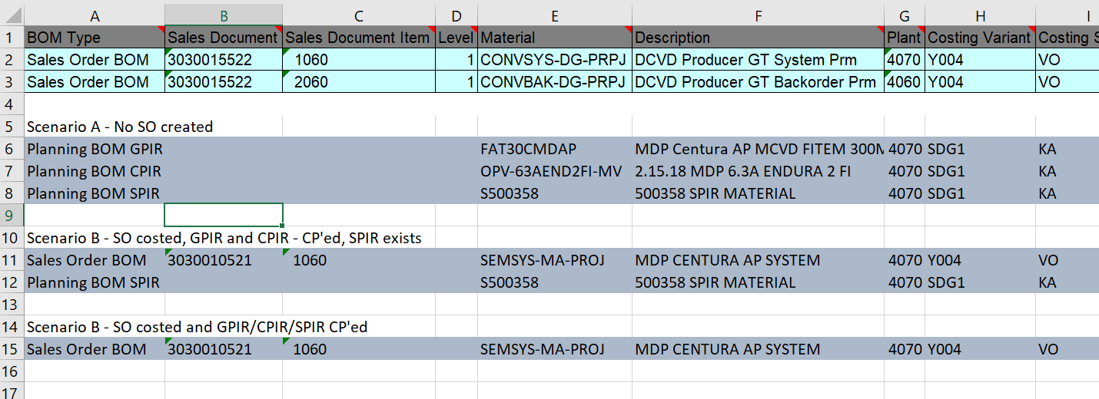

4.Get Cost component of the planning BOM material :
a. Obtain product cost estimate no. (KEKO- KALNR1) record from KEKO table by costing variant (KEKO- KLVAR) = SDG1 (from selection parameter) for GC or SDL1 for LC (from selection parameter), Material (KEKO- MATNR) and plant (KEKO- WERKS).
b. Perform BAPI_COSTESTIMATE_GETEXPLOSION to find out lower level material
c. Then from table KEPH obtain cost component for the planning material by inputing product cost estimate no. and show in the output of the report.

5. Other attributes in the output related to planning BOM – other attributes such as SO no., order type, rejection reason, region, parent customer, revenue BU which fetched based on SO will be blank but other information will be obtained from MPP tables.

6. Output fields for planning BOM records

BOM Type | Planning BOM GPIR/CPIR/SPIR
Sales Document | NA
Sales Document Item | NA
Level
Material | KEKO
Description | Mara - description
Plant | ZAC0001
Costing Variant | KEKO
Costing Status | KEKO
SpecProcurement Key | Exisiting logic - MARC
Procurement type | Exisiting logic - MARC
Quantity | KEKO
Base Unit of Measure | KEKO
Parent
Total amount
Currency
Material
Labor/Prod Direct
Overhead
Overhead Burden
Subcontracting
Labor/Prod Direct OH
Ext Processing
Std OH E&Z
Std OH Ops&Var
Std OH Floor Stk
Std OH OBF & Crating
Std OH Other
Higher-level item | NA
Sales Document Type | NA
Reason for rejection | NA
Opportunity number | ZAC0001
Slot Number | ZAC0001
Opportunity Type | BW based on OPP
Opportunity Subtype | BW based on OPP
Alpha Configuration | BW based on OPP
Chamber Count | BW based on OPP
Build Strategy | BW based on OPP
Platform | BW based on OPP
FAB Name | BW based on OPP
Region | BW based on OPP
Parent Customer | NA
Product G3 Desc | from ZAC0001 - then use existing logic to get description
Build BU | BW based on OPP
Revenue BU | NA
Profit Center | Based on amat product id in ZAC0001, then go to table ZAF0207 to get profit center
Product Line G1 Description | Exisiting logic - ZAF0204
Product Line G2 Description | Exisiting logic - ZAF0204
Product | Exisiting logic - ZAF0204

Date : 5/30/2019
Version 6 : No Touch MCOS project changes - Add new fields and Z table update

In SO cost component report ZAFGR252, need to add following additional fields in the output of the report :
- Alpha config – currently alpha config field length is 60 which need to extended 180 similar to fields in BW. In BW table, alpha config are stored in three fields ie /BIC/MGBPCOPITM- /BIC/GBCNFG_N1, /BIC/GBCNFG_N2 and /BIC/GBCNFG_N3. In the ZAFGR252 report, we need to concatenate three fields of BW and show in the output.
- Opp ID line item – Currently report is showing opp ID but need corresponding OPP ID line item also. Take OPP ID (ZAV0505- OPP_NO) and OPP ID line item (ZAV0505-OPP_ITEM_NO) based on SO (ZAV0505- SALES_ORDER) and SO higher Level Item (ZAV0505- SALES_ORDER_LNO ). Check for active field in the ZAV0505 table.
- Opportunity ID – For planning BOM records, Opportunity ID is obtained from Primary opp id(ZAC0001-PRI_OPP) so need to change it to take from Driving Opp ID (ZAC001-DRIVING_OPP). Also consider deletion flag in ZAC0001.
- SO Rejection Status Code – Reason for Rejection(VBAP-ABGRU)
- SO Schedule line category – With SO and SO item, check Schedule line category (VBEP-ETTYP). If there are multiple schedule line items, then pick up where order quantity (WMENG) is not equal to zero
- Product Hierarchy – Add Product Hierarchy (VBAP-PRODH) field in the output of the report, which we are adding based on request from BW.
- Costing period and Year - KEKO-POPER and KEKO-BDATJ.
- Currently, ZAFGR252 report fetches data from SO based on selection parameter. But logic need to be changed :
  - First, Go to BW table OPP ID Item master table /BIC/MGBPCOPITM and get all opportunity ID item into ECC.
  - Based on these OPP ID item, get all the linked SO no. from opportunity table ZAV0505 with active flags(ZAV0505-ACTIVE_LINES). Once SOs determined, continue with current logic to get SO cost component.
  - Similarly for planning BOM logic, get all the slots (ZAC0001) with OPP ID item obtained from BW.
  - For OPP ID item for which there is no SO or Slot, those OPP ID item will displayed in output of the report but with zero cost.
  - We don’t want to miss any OPP ID Item or any OPP ID which have been dropped or linked to other SO.
- Add selection parameter :
  - Separate selection parameter for planning BOM level – Currently BOM level in selection parameter is same for SO and planning BOM. Need ability to run report with SO at BOM level 3 and planning BOM at level 1 so as to reduce data in Z table.

ZAFGR252 output in Z table.
Output of the report need to be updated in the Z table.

Detail logic :
1. Create new program which will call ZAFGR252 report – Since we need to update output of the report in Z table so required a separate program which can do update when report executed. Couple of reason behind creating new program, first, we don’t want business user to update records in z table when they run report and second, following the program naming convention need to use ZAFGU252 instead of ZAFGR252 to update tables.
2. In ZAFGU252 program, will have same selection parameters and in addition, one checkbox to “update output in Table”. If having all selection parametes is difficult, then we can look into option of 252 report variant selection parameter in ZAFGU252.
3. ZAFGU252 program will call ZAFGR252 program when executed as any reports changes in ZAFGR252 are also reflected in ZAFGU252.
4. ZAFGU252 program will not be provided access to business users but GIS will have access through FFID roles
5. Once “Table update” checkbox field is checked, then program need to update output of the report in the Z table including time stamp (Date and time of record insert). Two Z tables are updated by the program :
a. BPC ZAFGR252 table – Program will update the output of the report in this table with time stamp for BPC.
- Recods with BOM level 1
- This table will be snapshot of all OPP ID items.
- Batch job to run every 12 hours to update in Z table
- Run with success (VO) and failure (VF) SO are sent
- ECC and BW reconciliation, Records for past 7 days will be kept in the z table and deleted records which are more than 7 day old.
b. Hadoop ZAFGR252 table – In this table, program will update output of records with time stamp for Hadoop for BOBJ reporting.
- Records with BOM level upto 3
- Batch job to run daily to update records in Z table.
- Run the report with VO and KF status
6. Following fields need to be updated in the table.

S.No. | Field Description | Comparison fields | Key fields
1 | BOM Type | X
2 | Sales Document | X
3 | Sales Document Item | X
4 | Level | X
5 | Material | X
6 | Description
7 | Plant | X
8 | Costing Variant
9 | Costing Status | X
10 | SpecProcurement Key
11 | Procurement type
12 | Quantity
13 | Base Unit of Measure
14 | Parent
15 | Total amount | X
16 | Currency
17 | Material Cost
18 | Labor/Prod Direct
19 | Overhead
20 | Overhead Burden
21 | Subcontracting
22 | Labor/Prod Direct OH
23 | Ext Processing
24 | Std OH E&Z
25 | Std OH Ops&Var
26 | Std OH Floor Stk
27 | Std OH OBF & Crating
28 | Std OH Other
29 | Higher-level item
30 | Sales Document Type
31 | Reason for rejection Code
32 | Reason for rejection Description
33 | Opportunity number |  | X
34 | Opportunity line item |  | X
35 | Slot Number
36 | Opportunity Type
37 | Opportunity Subtype
38 | Alpha Configuration
39 | Chamber Count
40 | Build Strategy
41 | Platform
42 | FAB Name
43 | Region
44 | Parent Customer
45 | Product G3 Desc
46 | Build BU
47 | Revenue BU
48 | Profit Center
49 | Product Line G1 Description
50 | Product Line G2 Description
51 | Product
52 | SO Schedule line category
53 | Costing Period/Year
54 | Insert Date |  | X
55 | Insert Time |  | X

7. Delta changes only to be updated in Z table – Hadoop ZAFGR252 table
As program will be running frequently with BOM level upto 3, it is expected to be lot of records in the Z table. So to minimize the records in the z table, only delta records to be updated. Before updating records the output of the report, program needs to check if that records exist in z table and there is change on required fields values. Whether record exist or not in z table, it has be compared with BOM level 1 records only.
- Record exists in z table – Where record already exist in table, then compare required fields values with output of the report values and if there is change in any of the required fields value, then update the record in the z table along with lower level BOM. Note-Comparison of the required fields values between output of the report and z table records is against BOM level 1 records only.

- Following are the fields which need to be compared from existing records in table:
A. For SO releated data :

S.No. | Field Description | fields
1 | BOM Type | X
2 | Sales Document | X
3 | Sales Document Item | X
9 | Costing Status | X
15 | Total amount | X

B. Planning BOM related data :

S.No. | Field Description | fields
1 | BOM Type | X
5 | Material | X
7 | Plant | X
9 | Costing Status | X
15 | Total amount | X

Purge/Delete records in the Z table :

ZAFGR252 table records will be extracted into Hadoop by BI and business user will have access to these records through BOBJ report. Records in Hadoop will not be deleted. But records records in ECC Z table expected to keep growing with millions of records, therefore requirement is delete the records which older than one year to not impact performance of the 252 report.

Detail logic :
1. In ZAFGU252 program, logic for purge of records from z table to be written.
2. BPC ZAFGR252 table - Whenever ZAFGU252 is executed, it needs to check Z table records which are older than 7 days and delete those records. Read insert date field in the Z table to find out records which are older than 7 days from date of ZAFGU252 run date.
3. Hadoop ZAFGR252 table - Whenever ZAFGU252 is executed, it needs to check Z table records which are older than 3 months and delete those records. Read insert date field in the Z table to find out records which are older than 3 months from date of ZAFGU252 run date.
4. Instead of hardcoding of time period, TVARC variable can be maintained where period will be read.
4. Can also consider of deleting records which have old version but keep the latest active records

Version 7.0 : DiGFP GAP : ZMAT CM PO

Copy ExistingZAFGR252 Report and add two fields on selection screen and few fields in report output to show ZMAT CM PO information like Purchase order number, PO Line item, Supplier, GR date for ZMAT material.

Selection Screen :

Screen Label | Referenced Field | Range of Value | Attributes, Default Values | Validations / Checks | Comments/ Selection Criteria (select options, parameters, radio buttons, checkboxes)
Vendor Number | EKKO-LIFNR | Multiple |  |  | Optional :Text field with range
Delivery Date | EKET-EINDT | Multiple/ Date range |  |  | Optional :Text field with range
Material number | MARA-MATNR | Multiple |  |  | Optional :Text field with range

Report Output fields and Logic

- Check if Material Type (MARA-MTART = ZMAT) and SOBSK = ‘SC’ or ‘E5’if yes then show detail for below fields.
  - Purchase Order Number and Purchase order item.
    - Pass Sales order and sales order item to EKKN table to get Purchase order and Purchase order item.
      - Purchase order number : EKKN. EBELN
      - Purchase order item : EKKN.EBELP
    - Pass Purchase order and item number to EKKO table to get vendor number (EKKO.LIFNR)
    - Pass Purchase order and item number to EKBE table along with EKBE. BEWTP =’E’ to get GR date (EKBE.BUDAT) for PO item.
  - Report layout Fields.

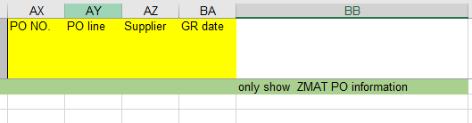

Also add Vendor name (LFA1-NAME1) as report out put column.

Version 8.0 ( ITC1 Defect # 1760)

Currently program just looking at Subcon PO. Business would like to see regular ZMAT PO as well so add below conditions to existing condition.

- Check if Material Type (MARA-MTART = ZMAT) and/or SOBSK = ‘SC’ or ‘E5’, “ Blank “if yes then show additional PO related fields to the report.

Version 9.0

- Add below details to Cost component view only.
- Add new column “ZMAT BUY”
- Check if Material Type (MARA-MTART = ZMAT) PT = F then Mark Line as “X” in new column ZMAT BUY.
- Check if Material type is ZMAT , PT = F and SOBSL = SC/E5 then if PO number available then go to EKET table and get RSNUM from EKET table based on PO number and item. Insert RSNUM to RESB table and get all the component related to the PO number. Once we have all the part then Mark “X” as ZMAT Subcon part as well as Component under subcon PO.

Version 10

Add a costing SPK MARC-SOBSK field to report layout.

Version 11.0

Currently PO are disply if PT = F so report should show PO when PT = X. also when PT = X and SOBSL is blank then if Subcon PO exists then it should show subcon PO details as well.

Create a new column PO type to display when Material mater SPK is blank.

Version 12.0- PCR034981 :Add Price Strategy field line in output report

We have already using the functional module BAPI_COSTESTIMATE_GETEXPLOSION from here, will get the product cost estimate number based on part number, here we will take
Product cost estimate number, costing type and costing version.

Go to KEKO table and give the Product cost estimate number, costing type and costing version and get the Material Valuation(BWSMR)

Selection Screen
<Describe the selection screen if used. Specify the fields for the selection and what checks need to be done after the user has entered his or her criteria.>

Screen Label | Referenced Field | Range of Value | Attributes, Default Values | Validations / Checks | Comments/ Selection Criteria (select options, parameters, radio buttons, checkboxes)
SO header CoCode | VBAK-BUKRS_VF | No |  |  | Rename existing field Company Code to SO header CoCode
Report Selection option – Costed BOM Report
Itemization view |  |  |  |  | Radio Button
Cost Component View |  |  |  |  | Radio Button
Costing Variant | KEKO- KLVAR | No | Y004 |  | Field is mandatory if Cost component view option is selected
Costing Status | KEKO | Yes
OBOM levels |  | No |  |  | Field is mandatory if Cost component view option is selected
Include Planning BOM |  |  |  |  | Checkbox
Planning BOM Plants | ZAC0001
Planning BOM Material | ZAC0001

Report/Form Layout
<If a separate file has been created to define the output or form, embed in the document or mention the network path and filename here>

Screen Label | Referenced Field | Range of Value | Attributes, Default Values | Validations / Checks | Comments/ Selection Criteria (select options, parameters, radio buttons, checkboxes)
SO | KEKO- VBELN
SO Item | KEKO- POSNR
OBOM Level | KEKO
Plant | KEKO- WERKS
Material | KEKO- MATNR
Procurement Type | MARC-BESKZ
Special Procurement | MARC-SOBSL
Costing Variant | KEKO- KLVAR
Costing Status | KEKO
Currency | KEKO- HWAER
Total Amount(Std Cost)
Material
Labor/Prod Direct
Labor/Prod Direct OH
Overhead
Overhead – Burden
Subcontracting
Ext Processing
Std OH E&Z
Std OH Ops Var
Std OH Floor Stk
Std OH OBF & Crating
Std OH Other
Validation Calculation |  |  |  |  | Total amount(std cost) - (sum of column from material to Std OH Other)
- Sales Order Line Header
- Sales Order Type
- BOM Type
- Rejection Status description
- OPID
- Slot Number
- Opportunity Type (SYS_ITEM)
- OPPORTUNITY SUB TYPE
- Alpha Config
- Count of Chamber
- Single / Dual Build
- Platform
- Fab Name
- Region
- G3
- Build BU
- Parent Customer
- Revenue BU
- SO Profit center
- G1
- G2
- Product
- Product Hierarchy
- Schedule line Category
- Costing period
- Costing year
- Rejection status code
- Opp ID item

Paper Requirements
<Type of paper required, preprinted or not>

Print Requirement
<Identify the print requirement if any. Type of layout, type of printer, etc.>

Special characteristics
< Sorting, grouping, where total or subtotals should occur, if any, drilldown, etc.>

Exception Handling Rules
<Specify instructions to be followed when errors occur, or any processing outside the normal process flow.>

Special Requirements
<Provide any special requirements related to this development effort such as language translations, configurability or personalization allowed, etc.>

Dependencies
<List any dependencies to other technical objects or configuration objects>

Constraints
<Discuss all the constraints or the limitations if any for this technical object>

Scheduling Requirements
<Specify whether jobs should run during off-peak hours, frequency, manual or automatic start. Dependencies, etc>

Test Specification
<This portion of the document is used to plan the unit testing. It includes items such as defining the test participants, the test environment, the schedule, and scope of the testing event.>

Functional Test Scenarios
<Document test scenarios to test all of the functional requirements. Include a test scenario for each different business scenario that may occur.>

ID | Test Scenario | Expected Results | Comments
1
2
3

Test Data & Other Needs
<If any, specify test data set-up & refresh needs, volume of data, timeliness of data, etc.>

Test System & Environment
<Identify test system and client.>

Test System:
Client:

Audit Requirements/Integrity Controls
<Specify the controls that are required to ensure that the data has been processed correctly.>

Security/Authorization Requirements
<Provide any special authorization checking or data security provisions required.>

Authorization object such as company and plant need to be created.

TECHNICAL SECTION

Object Type:
Report ( x ) Interface ( ) Conversion ( ) Enhancement ( ) Workflow ( ) Form ( ) WebDynpro ( ) Other ( ) Specify: _____________

All Z Objects Information
Object Type | Report Source Code
Object Name | ZAFGI252F  ZAFGI252T  ZAFGR252
Object Description | Costed BOM Report
Development Class | ZAFG
Transaction Code | ZAFGR252
Message Class | ZAF
Other Relevant Information | N/A

Object Type | Report Texts
Object Name | ZAFGR252
Object Description | Costed BOM Report
Development Class | ZAFG
Transaction Code | ZAFGR252
Message Class | ZAF
Other Relevant Information

Verison 3

Object Type | Report Source Code
Object Name | ZAFGR252
Object Description | Costed BOM Report
Development Class | ZAFG
Transaction Code | ZAFGR252
Message Class | ZAF
Other Relevant Information | N/A

Object Type | Program
Object Name | ZAFGI252F, ZAFGI252T
Object Description | Costed BOM Report include
Development Class | ZAFG
Transaction Code | ZAFGR252
Message Class | ZAF
Other Relevant Information

Object Type | Class
Object Name | ZCL_AFG_READ_TABLE_UTILITY  CONVERT_RANGE_TO_SELECT  CONVERT_SELECT_TO_WHERE_CLAUSE
Object Description | Read table utility
Development Class | ZAFG
Transaction Code
Message Class
Other Relevant Information

Object Type | Table Type
Object Name | ZTAF_RFC_DB_FLD
Object Description | Table type for RFC_DB_FLD
Development Class | ZAFG
Transaction Code
Message Class
Other Relevant Information

Technical Specifications:
Please refer functional spec prior and code according to the requirements.

Modify the selection screen to look as below

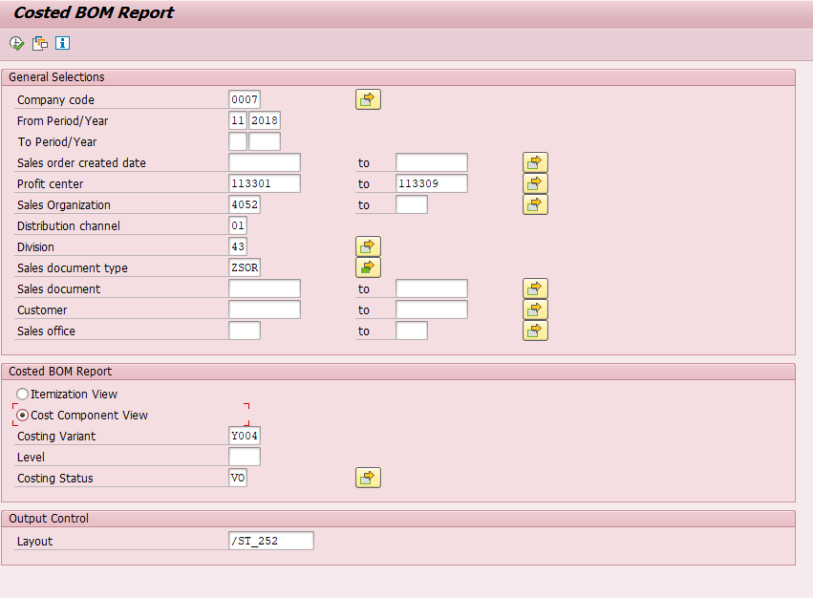

Output ALV to show the cost component splits for sales orders as below

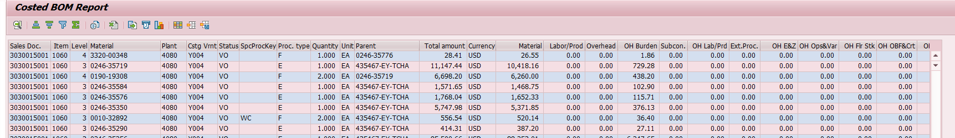

Version3:

Please make changes as per functional requirement to add new columns as requested.
Sample Code:
FORM get_opportunity_data.
CONSTANTS lc_under TYPE char1 VALUE '_'.
CHECK gt_keko IS NOT INITIAL.
CLEAR: gt_opp, gt_bwopp.
SELECT opp_no opp_item_no sales_order sales_order_lno
FROM zav0505 INTO TABLE gt_opp FOR ALL ENTRIES IN gt_keko
WHERE sales_order = gt_keko-vbeln
AND sales_order_lno = gt_keko-uepos.
IF gt_opp IS NOT INITIAL.
PERFORM get_bw_opp_data.
ENDIF.
ENDFORM.
FORM get_bw_opp_data.
CONSTANTS: lc_query_table TYPE dd02l-tabname VALUE '/BIC/MGBPCOPITM',
lc_a TYPE char1 VALUE 'A'.
DATA lrt_ver TYPE RANGE OF char1.
DATA lrt_opp TYPE RANGE OF char32.
DATA: lt_fields TYPE STANDARD TABLE OF rfc_db_fld,
ls_fld TYPE rfc_db_fld.
DATA lt_field_ranges TYPE zcl_afg_read_table_utility=>tt_field_range.
DATA lv_rfcdest TYPE rfcdest VALUE '%16CLNT200'.
DATA ls_bwopp TYPE ty_bwopp.
CHECK gt_opp IS NOT INITIAL.
DATA(lv_sysid) = sy-sysid(1).
IF lv_sysid IS NOT INITIAL.
REPLACE '%' IN lv_rfcdest WITH lv_sysid .
ENDIF.
CHECK zcl_afg_read_table_utility=>check_rfc_destination( lv_rfcdest ) EQ abap_true .
* prepare fields to be fetched from BW table query
lt_fields = VALUE #( BASE lt_fields ( fieldname = '/BIC/GBPCOPP' ) "Opportunity id
( fieldname = '/BIC/GBPCOPPIT' ) "Opp item
( fieldname = 'REGION' ) "Region
( fieldname = '/BIC/GBPLTFRMT' ) "Platform type
( fieldname = 'DOC_NUMBER' ) "Sales Doc
( fieldname = '/BIC/GBPCSLTNM' ) "Slot number
( fieldname = '/BIC/GBPICKTYP' ) "AMAT Pick str.
( fieldname = '/BIC/GBOPPST' ) "opp subtype
( fieldname = '/BIC/GBFABNA' ) "Fabname
( fieldname = '/BIC/GBCNFGAF' ) "Alpha config
( fieldname = '/BIC/GBCMBRCNT' ) "chamber count
( fieldname = '/BIC/GBPRDCT_I' ) "product id for G3
( fieldname = '/BIC/GBBLDBUD' ) "build BU desc
( fieldname = '/BIC/GBPCOPTYP' ) "opportunity type
).
* prepare version select option range for BW table query
lrt_ver = VALUE #( BASE lrt_ver ( sign = 'I' option = 'EQ' low = lc_a ) ) .
* prepare opportunity item select option range for BW table query
lrt_opp = VALUE #( BASE lrt_opp FOR ls_opp IN gt_opp ( sign = 'I' option = 'EQ' low = |{ ls_opp-opp_no }_{ ls_opp-opp_item_no ALPHA = OUT }| high = space ) ).
lt_field_ranges = VALUE #( BASE lt_field_ranges ( field_name = '/BIC/GBPCOPITM' length = 32 range = lrt_opp )
( field_name = 'OBJVERS' length = 1 range = lrt_ver )
).
* Creates the where condition with ranges.
DATA(lt_where) = zcl_afg_read_table_utility=>prepare_where_clause(
it_field_ranges = lt_field_ranges
iv_table_name = lc_query_table
).
DATA(lt_data) = zcl_afg_read_table_utility=>read_remote_table(
EXPORTING
iv_rfcdest = lv_rfcdest
iv_query_table = lc_query_table
* iv_delimiter =
* iv_no_data =
* iv_rowskips =
* iv_rowcount =
it_options = lt_where
it_fields = lt_fields
) .
LOOP AT lt_data INTO DATA(ls_data).
MOVE ls_data TO ls_bwopp.
APPEND ls_bwopp TO gt_bwopp.
ENDLOOP.
ENDFORM.
*&---------------------------------------------------------------------*
*& Form GET_PARENT_CUSTOMER_LIST
*&---------------------------------------------------------------------*
* text
*----------------------------------------------------------------------*
* --> p1 text
* <-- p2 text
*----------------------------------------------------------------------*
FORM get_parent_customer_list .
DATA lt_tkeko LIKE gt_keko.
IF gt_keko IS NOT INITIAL.
lt_tkeko = gt_keko.
SORT lt_tkeko BY kunnr .
DELETE ADJACENT DUPLICATES FROM lt_tkeko COMPARING kunnr.
ENDIF.
CHECK lt_tkeko IS NOT INITIAL.
SELECT kunnr hkunnr FROM knvh INTO TABLE gt_knvh FOR ALL ENTRIES IN
lt_tkeko WHERE kunnr = lt_tkeko-kunnr.
IF gt_knvh IS NOT INITIAL.
SORT gt_knvh BY kunnr hkunnr.
DELETE ADJACENT DUPLICATES FROM gt_knvh COMPARING kunnr hkunnr.
SELECT kunnr name1 INTO TABLE gt_kna1
FROM kna1 FOR ALL ENTRIES IN gt_knvh
WHERE kunnr = gt_knvh-hkunnr .
ENDIF.
ENDFORM.
*&---------------------------------------------------------------------*
*& Form PREPARE_OPP_DATA
*&---------------------------------------------------------------------*
* text
*----------------------------------------------------------------------*
* --> p1 text
* <-- p2 text
*----------------------------------------------------------------------*
FORM prepare_opp_data USING is_keko TYPE ty_cc_keko
CHANGING cs_output TYPE ty_cc_output .
DATA ls_opp TYPE ty_opp.
DATA ls_bwopp TYPE ty_bwopp.
DATA lv_hkunnr TYPE kunnr.
CHECK cs_output-level EQ 1.
MOVE: is_keko-uepos TO cs_output-uepos ,
is_keko-prctr_v TO cs_output-prctr ,
is_keko-auart TO cs_output-auart .
cs_output-bom_type = COND #( WHEN cs_output-vbeln IS NOT INITIAL THEN |Sales Order BOM| ELSE |Planning BOM| ).
IF is_keko-abgru IS NOT INITIAL.
TRY.
cs_output-reason_rjt = gt_reason[ abgru = is_keko-abgru ]-bezei .
CATCH cx_sy_itab_line_not_found .
CLEAR cs_output-reason_rjt.
ENDTRY.
ENDIF.
TRY.
cs_output-revenue_bu = gt_tspat[ KEY k1 COMPONENTS spart = is_keko-sparti ]-vtext .
CATCH cx_sy_itab_line_not_found .
CLEAR cs_output-revenue_bu .
ENDTRY.
CLEAR ls_opp.
TRY.
ls_opp = gt_opp[ KEY k1 COMPONENTS sales_order = is_keko-vbeln
sales_order_lno = is_keko-uepos ].
cs_output-opid = ls_opp-opp_no .
CLEAR ls_bwopp.
TRY.
ls_bwopp = gt_bwopp[ KEY k1 COMPONENTS opp_id = ls_opp-opp_no
opp_itm = |{ ls_opp-opp_item_no ALPHA = OUT }| ].
cs_output-slot_no = ls_bwopp-slot .
cs_output-opp_type = ls_bwopp-opp_ty .
cs_output-opp_subty = ls_bwopp-opp_subty .
cs_output-alpha_cfg = ls_bwopp-alpha .
cs_output-chamber_cnt = ls_bwopp-chamber_cnt .
cs_output-build = COND #( WHEN ls_bwopp-pickst IS NOT INITIAL THEN substring_after( val = ls_bwopp-pickst sub = '_' ) ELSE space ).
cs_output-platform = COND #( WHEN ls_bwopp-platform IS NOT INITIAL THEN substring_after( val = ls_bwopp-platform sub = '_' ) ELSE space ).
cs_output-fab_name = ls_bwopp-fab.
cs_output-region = ls_bwopp-region .
cs_output-build_bu = ls_bwopp-build_bu.
CATCH cx_sy_itab_line_not_found .
CLEAR ls_bwopp .
ENDTRY.
CATCH cx_sy_itab_line_not_found .
CLEAR ls_opp .
ENDTRY.
* region from region code
IF cs_output-region IS NOT INITIAL.
TRY.
cs_output-region = grt_region[ low = cs_output-region ]-high.
CATCH cx_sy_itab_line_not_found .
ENDTRY.
ENDIF.
*parent customer
TRY.
lv_hkunnr = gt_knvh[ kunnr = is_keko-kunnr ]-hkunnr.
TRY.
cs_output-parent_ku = gt_kna1[ kunnr = lv_hkunnr ]-name1.
CATCH cx_sy_itab_line_not_found .
cs_output-parent_ku = lv_hkunnr .
ENDTRY.
CATCH cx_sy_itab_line_not_found .
CLEAR cs_outp
ut-parent_ku .
ENDTRY.
IF ls_bwopp-product IS NOT INITIAL.
* get g3, product
TRY.
cs_output-g3 = gt_zaf0204[ KEY k1 COMPONENTS amat_product = ls_bwopp-product ]-prod_desc.
cs_output-product = |{ ls_bwopp-product }-{ cs_output-g3 }| .
CATCH cx_sy_itab_line_not_found .
cs_output-g3 = ls_bwopp-product.
cs_output-product = ls_bwopp-product .
ENDTRY.
* get g1, g2
TRY.
DATA(ls_zaf0207) = gt_zaf0207[ KEY k1 COMPONENTS amat_product = ls_bwopp-product ].
TRY.
cs_output-g1 = gt_zaf0205[ KEY k1 COMPONENTS prod_line_g1 = ls_zaf0207-prod_line_g1 ]-line_g1_desc.
CATCH cx_sy_itab_line_not_found .
cs_output-g1 = ls_zaf0207-prod_line_g1 .
ENDTRY.
TRY.
cs_output-g2 = gt_zaf0206[ KEY k1 COMPONENTS prod_line_g2 = ls_zaf0207-prod_line_g2 ]-line_g2_desc .
CATCH cx_sy_itab_line_not_found .
cs_output-g2 = ls_zaf0207-prod_line_g2 .
ENDTRY.
CATCH cx_sy_itab_line_not_found .
CLEAR ls_zaf0207.
ENDTRY.
ENDIF.
ENDFORM.

Detail Technical Specification → PCR024090

Object Type | Report
Object Name | ZAFGR252 / ZAFGU252 / ZAFGU255
Object Description | Report & Update program
Development Class | ZAFG
Transaction Code | ZAFGR252 / ZAFGU252 / ZAFGU255
Message Class
Other Relevant Information | Class→ ZCL_AFG_READ_BPC_MASTERDATA  Data elements for table ZAK0252 and ZAK0251  ZAF_ALPHA_CFG  ZAF_BOMTYPE  ZAF_BUILD_BU  ZAF_BUILD_STRATEGY  ZAF_CHAMBER_CNT  ZAF_KSTEL_EXT_PROC  ZAF_KSTEL_LABPRO  ZAF_KSTEL_MAT  ZAF_KSTEL_OH_BURDEN  ZAF_KSTEL_OH_EZ  ZAF_KSTEL_OH_FLRSTK  ZAF_KSTEL_OH_LABPRO  ZAF_KSTEL_OH_OBFCRT  ZAF_KSTEL_OH_OPSVAR  ZAF_KSTEL_OH_OTHERS  ZAF_KSTEL_OVERHEAD  ZAF_KSTEL_SUBCON  ZAF_OPPSUBTYPE  ZAF_OPPTYPE  ZAF_REVENUE_BU  ZAK_BOBJ_COUNT  ZAF_BOM_LEVEL

- Now created new tables ZAK0252/ZAK0251 to provide data for BW BPC & BOBJ reporting
- ZAFGR252 contains update custom tables code section, but code can only be triggered using TCODE → ZAFGU252
- ZAFGU252 will submit ZAFGR252 report with separate update variants for BPC and BOBJ tables
- New class ZCL_AFG_READ_BPC_MASTERDATA created to provide set and update to custom tables ZAK0252/ZAK0251
- ZAK0252 Will only contain level 1 bom materials along with Opp id parameters, we don’t do delta to this table every run will be loaded in to table with new timestamp
- ZAK0251 Will contain upto level 3 bom materials along with Opp id parameters and also it will update only delta if value changes then we send entry to this table with timestamp, so always latest record will contain correct set of data
- New fields added to ZAFGR252 report
  - Alpha config
  - Opp ID line item
  - Opportunity ID
  - SO Rejection Status Code
  - SO Schedule line category
  - Product Hierarchy
  - Costing period and Year
  - Add selection parameter :
    - Separate selection parameter for planning BOM level – Currently BOM level in selection parameter is same for SO and planning BOM. Need ability to run report with SO at BOM level 3 and planning BOM at level 1 so as to reduce data in Z table.

- Following locked object added in the program for adding, modifying and deleting
  - EZAK0251 and EZAK0252
  - EZLAK0251 and EZLAK0252
- New program ZAFGU255 created to purge ZAK0252 and ZAK0251 tables
- ZAK0251 will be purged if record is older than 90 days when compared to latest record with the key
- ZAK0252 will be purged If record is older than 7 days when compared to latest record with the key
- Introduced new Unit test Cases in program, and 2 new classes been created to do automated unit testing of this logic LTCL_PURGE_LOGIC_251 AND LTCL_PURGE_LOGIC_252
- These test classes can be executed using short cut keys CTRL+SHIFT+F10 or F11

VERSION 7 -PCR026486

APPROVALS:
Version # | Date Modified | Modified By | Brief Description of Change
7.0 | 02/11/2020 | Krishna Kamma | Modifications in report ZAFGR261

Author | Krishna K/Krishi | Date Created: | 02/11/2020
Functional Team Lead | Sapan Shenoy | Signature and Date Approved:
Technical Team ASM | Yvonne Tai | Signature and Date Approved:
Technical Team Lead | Yvonne Tai | Signature and Date Approved:
Project Manager | Sapan Shenoy | Signature and Date Approved:

Object Type:
Report (X) Interface ( ) Conversion ( ) Enhancement ( ) Workflow ( ) Form ( ) WebDynpro ( )Other ( ) Specify: _____________

Systems
BW ( ) CRM( ) CUA/GRC( ) ECC(X ) EPP( ) GTS( ) HCM ( ) MDM( ) PLM( ) SCM( ) SNC( ) SEM( ) SLM ( ) SRM ( ) XI( ) Web Method( )

Object Type | Report Source Code
Object Name | ZAFGR261
Object Description | Costed BOM Report
Development Class | ZAFG
Transaction Code | ZAFGR261
Message Class | ZAF
Other Relevant Information | N/A

Object Type | Report Source Code
Object Name | ZAFGR261T
Object Description | Costed BOM Report
Development Class | ZAFG
Transaction Code
Message Class | ZAF
Other Relevant Information | N/A

Object Type | Report Source Code
Object Name | ZAFGR261F
Object Description | Costed BOM Report
Development Class | ZAFG
Transaction Code
Message Class | ZAF
Other Relevant Information | N/A

Requirement
Copy ExistingZAFGR252 Report and add two fields on selection screen and few fields in report output to show ZMAT CM PO information like Purchase order number, PO Line item, Supplier, GR date for ZMAT material.
Sample Code:
Get supplier name from lfa1 and populate to purchase details table if sale order is not initial.
IF it_vbap IS NOT INITIAL.
SELECT ekkn~ebeln
ekkn~ebelp
ekkn~vbeln
ekkn~vbelp
ekpo~matnr
ekko~lifnr
ekbe~bewtp
ekbe~budat
lfa1~name1 "PCR026486++
INTO TABLE me->gt_purch_details
FOR ALL ENTRIES IN it_vbap
WHERE ekkn~vbeln EQ it_vbap-vbeln
AND ekkn~vbelp EQ it_vbap-posnr.
ENDIF.
Get supplier name from lfa1 and populate to purchase details table if KEKO is not initial
IF it_keko IS NOT INITIAL.
SELECT ekkn~ebeln
ekkn~ebelp
ekkn~vbeln
ekkn~vbelp
ekpo~matnr
ekko~lifnr
ekbe~bewtp
ekbe~budat
lfa1~name1 "PCR026486++
INTO TABLE me->gt_purch_details
FOR ALL ENTRIES IN it_keko
WHERE ekkn~vbeln EQ it_keko-vbeln
AND ekkn~vbelp EQ it_keko-posnr.
ENDIF.
Get PO data
*Begin of changes - PCR026486++
lcl_purchasing=>go_purch->get_so_from_purch_input(
EXPORTING
irt_vbeln = s_vbeln[]
irt_lifnr = s_lifnr[]
irt_eindt = s_eindt[]
irt_matnr = s_matnr[] ).
IF lcl_purchasing=>go_purch->gv_po_sel_provided = abap_true AND
lcl_purchasing=>go_purch->gv_sales_ord_found = abap_false.
RETURN.
ENDIF.
*Begin of changes - PCR026486++
lcl_purchasing=>go_purch->filter_cvbap_from_po_sel(
CHANGING ct_cvbap = it_cvbap ).
* End of changes - PCR026486++
IF it_cvbap IS NOT INITIAL.
*Begin of changes - PCR026486++
lcl_purchasing=>go_purch->set_material_details( it_vbap = it_cvbap ).
lcl_purchasing=>go_purch->set_po_item_details( it_vbap = it_cvbap ).
* End of changes - PCR026486++

New fields to output
*Begin of changes - PCR026486++
IF wa_expo-item_category = 'L'. "Show PO details only for subcontracting item
ls_poitem_details = lcl_purchasing=>go_purch->get_po_for_sales_items(
iv_vbeln = wa_expot-vbeln
iv_posnr = wa_expot-posnr
iv_matnr = wa_expomaterial).
wa_expot-ebeln = ls_poitem_details-ebeln.
wa_expot-ebelp = ls_poitem_details-ebelp.
wa_expot-lifnr = ls_poitem_details-lifnr.
wa_expot-name1 = ls_poitem_details-name1.
wa_expot-budat = ls_poitem_details-budat.
ENDIF.

Build Fieldcatalog
* Begin of changes - PCR026486++
PERFORM column_name USING lr_columns 'EBELN' 'PO No.' 'PO No.'.
PERFORM column_name USING lr_columns 'EBELP' 'PO Item' 'PO Item'.
PERFORM column_name USING lr_columns 'LIFNR' 'Supplier Number' ' '.
PERFORM column_name USING lr_columns 'NAME1' 'Supplier Name' ' '.
PERFORM column_name USING lr_columns 'BDATJ' 'Costing Year' 'CostYear'.
PERFORM column_name USING lr_columns 'BUDAT' 'PO GR date' 'PO GR Date'.
*End of changes - PCR026486++
wa_fieldcat1-tabname = TEXT-041.wa_fieldcat1-fieldname = 'BUDAT'.
wa_fieldcat1-seltext_l = TEXT-046. wa_fieldcat1-col_pos = 33.
wa_fieldcat1-outputlen = 10. wa_fieldcat1-no_sum = c_x.
APPEND wa_fieldcat1 TO it_fieldcat1. CLEAR wa_fieldcat1.
*End of changes - PCR026486++

TVARVC ENTIRES : ( TR # X08K925640)

As per requirement created TVARVC entris for SPK ( SOBSK) and Material Type (MTART) for report executing.

*{Begin of Defect# 1760/ PCR026486
Issue: Report to get regular POs also since currently program getting Subcontract PO’s only.

TVARVC ENTRIES: (TR # X08K927659)

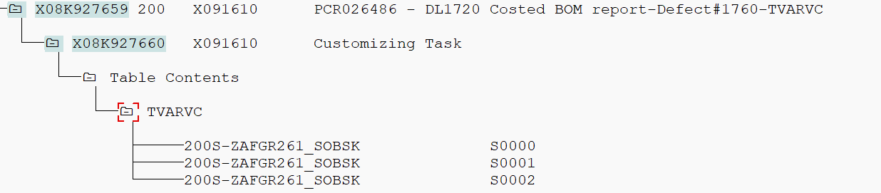

Solution: 1) Made changes in program ZAFGR261 to get all type of POs

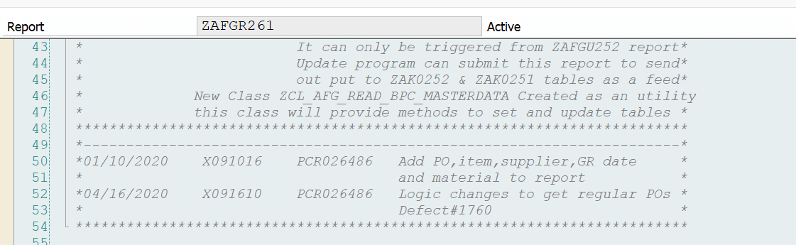

METHOD set_po_item_details.
******************************************************************************
* Get PO item details for queried Sales items
* PO items need to be shown only for specific materials
* Query is optimized or performed only if such materials exist in sales items.
*******************************************************************************
* IF iv_check_materials = abap_true AND
* me->gt_marc IS INITIAL.
* RETURN.
* ENDIF.

IF it_vbap IS NOT INITIAL.
SELECT ekkn~ebeln
ekkn~ebelp
ekkn~vbeln
ekkn~vbelp
ekpo~matnr
ekko~lifnr
ekbe~bewtp
ekbe~budat
lfa1~name1 "PCR026486++
FROM ( ( ekkn AS ekkn INNER JOIN ekko AS ekko
ON ekkn~ebeln EQ ekko~ebeln AND
ekko~loekz EQ abap_false )
INNER JOIN ekpo AS ekpo
ON ekkn~ebeln EQ ekpo~ebeln AND
ekkn~ebelp EQ ekpo~ebelp AND
* ekpo~pstyp EQ me->gc_3 AND "PCR026486/Defect#1760--
ekpo~loekz EQ abap_false )
INNER JOIN lfa1 ON lfa1~lifnr EQ ekko~lifnr "PCR026486++
LEFT OUTER JOIN ekbe AS ekbe
ON ekkn~ebeln EQ ekbe~ebeln AND
ekkn~ebelp EQ ekbe~ebelp AND
ekbe~bewtp EQ 'E' "CR comment - Constant not required, not used anywhere else
INTO TABLE me->gt_purch_details
FOR ALL ENTRIES IN it_vbap
WHERE ekkn~vbeln EQ it_vbap-vbeln
AND ekkn~vbelp EQ it_vbap-posnr.
"sy-subrc check not required
ENDIF.

IF it_keko IS NOT INITIAL.
SELECT ekkn~ebeln
ekkn~ebelp
ekkn~vbeln
ekkn~vbelp
ekpo~matnr
ekko~lifnr
ekbe~bewtp
ekbe~budat
lfa1~name1 "PCR026486++
FROM ( ( ekkn AS ekkn INNER JOIN ekko AS ekko
ON ekkn~ebeln EQ ekko~ebeln AND
ekko~loekz EQ abap_false )
INNER JOIN ekpo AS ekpo
ON ekkn~ebeln EQ ekpo~ebeln AND
ekkn~ebelp EQ ekpo~ebelp AND
* ekpo~pstyp EQ me->gc_3 AND "PCR026486/Defect#1760--
ekpo~loekz EQ abap_false )
INNER JOIN lfa1 ON lfa1~lifnr EQ ekko~lifnr "PCR026486++
LEFT OUTER JOIN ekbe AS ekbe
ON ekkn~ebeln EQ ekbe~ebeln AND
ekkn~ebelp EQ ekbe~ebelp AND
ekbe~bewtp EQ 'E' "CR comment - Constant not required, not used anywhere else
INTO TABLE me->gt_purch_details
FOR ALL ENTRIES IN it_keko
WHERE ekkn~vbeln EQ it_keko-vbeln
AND ekkn~vbelp EQ it_keko-posnr.
"sy-subrc check not required
ENDIF.
ENDMETHOD.
METHOD get_so_from_purch_input.
IF irt_eindt IS INITIAL AND
irt_lifnr IS INITIAL AND
irt_matnr IS INITIAL.
RETURN.
ELSE.
me->gv_po_sel_provided = abap_true.
ENDIF.

IF irt_eindt IS NOT INITIAL.
SELECT eket~ebeln
eket~ebelp
ekko~lifnr
ekkn~vbeln
ekkn~vbelp
eket~eindt
FROM eket AS eket INNER JOIN ekpo
ON eket~ebeln EQ ekpo~ebeln AND
* ekpo~pstyp EQ me->gc_3 AND "pstyp = 3 is subcontracting items "PCR026486/Defect#1760--
ekpo~loekz EQ abap_false
INNER JOIN ekkn AS ekkn
ON eket~ebeln EQ ekkn~ebeln AND
eket~ebelp EQ ekkn~ebelp
INNER JOIN ekko AS ekko
ON eket~ebeln EQ ekko~ebeln
INTO TABLE me->gt_po_sel
WHERE eket~eindt IN irt_eindt
AND ekpo~matnr IN irt_matnr
AND ekkn~vbeln IN irt_vbeln
AND ekko~lifnr IN irt_lifnr
AND ekko~loekz EQ abap_false.

"sy-subrc checked after endif
ELSEIF irt_matnr IS NOT INITIAL.
SELECT ekpo~ebeln
ekpo~ebelp
ekko~lifnr
ekkn~vbeln
ekkn~vbelp
FROM ( ekpo AS ekpo INNER JOIN ekko
ON ekpo~ebeln EQ ekko~ebeln AND
ekko~loekz EQ abap_false )
INNER JOIN ekkn AS ekkn
ON ekpo~ebeln EQ ekkn~ebeln AND
ekpo~ebelp EQ ekkn~ebelp
INTO TABLE me->gt_po_sel
WHERE ekpo~matnr IN irt_matnr
* AND ekpo~pstyp EQ me->gc_3 "Subcontracting PO item "PCR026486/Defect#1760--
AND ekpo~loekz EQ abap_false
AND ekko~lifnr IN irt_lifnr
AND ekko~loekz EQ abap_false
AND ekkn~vbeln IN irt_vbeln.
"sy-subrc checked after endif
ELSEIF irt_lifnr IS NOT INITIAL.
SELECT ekpo~ebeln
ekpo~ebelp
ekko~lifnr
ekkn~vbeln
ekkn~vbelp
FROM ( ekko AS ekko INNER JOIN ekpo
ON ekko~ebeln EQ ekpo~ebeln AND
* ekpo~pstyp EQ me->gc_3 AND "PCR026486/Defect#1760--
ekpo~loekz EQ abap_false )
INNER JOIN ekkn AS ekkn
ON ekpo~ebeln EQ ekkn~ebeln AND
ekpo~ebelp EQ ekkn~ebelp
INTO TABLE me->gt_po_sel
WHERE ekko~lifnr IN irt_lifnr
AND ekko~loekz EQ abap_false
AND ekkn~vbeln IN irt_vbeln.
"sy-subrc checked after endif
ENDIF.
IF sy-subrc EQ 0.
me->gv_sales_ord_found = abap_true.
me->grt_vbeln_sel = VALUE #( BASE me->grt_vbeln_sel FOR ls_po_sel IN me->gt_po_sel
( sign = 'I'
option = 'EQ'
low = ls_po_sel-vbeln ) ).
ELSE.
me->gv_sales_ord_found = abap_false.
ENDIF.

ENDMETHOD.

*}End of Defect# 1760/ PCR026486

VERSION 8 -PCR026486
APPROVALS:
Version # | Date Modified | Modified By | Brief Description of Change
8.0 | 06/11/2020 | Srinivas A | Modifications in report ZAFGR261

Author | Srinivas A | Date Created: | 06/11/2020
Functional Team Lead | Sapan Shenoy | Signature and Date Approved:
Technical Team ASM | Yvonne Tai | Signature and Date Approved:
Technical Team Lead | Yvonne Tai | Signature and Date Approved:
Project Manager | Sapan Shenoy | Signature and Date Approved:

Object Type:
Report (X) Interface ( ) Conversion ( ) Enhancement ( ) Workflow ( ) Form ( ) WebDynpro ( )Other ( ) Specify: _____________

Systems
BW ( ) CRM( ) CUA/GRC( ) ECC(X ) EPP( ) GTS( ) HCM ( ) MDM( ) PLM( ) SCM( ) SNC( ) SEM( ) SLM ( ) SRM ( ) XI( ) Web Method( )

Object Type | Report Source Code
Object Name | ZAFGR261
Object Description | Costed BOM Report
Development Class | ZAFG
Transaction Code | ZAFGR261
Message Class | ZAF
Other Relevant Information | N/A

Object Type | Report Source Code
Object Name | ZAFGR261T
Object Description | Costed BOM Report
Development Class | ZAFG
Transaction Code
Message Class | ZAF
Other Relevant Information | N/A

Object Type | Report Source Code
Object Name | ZAFGR261F
Object Description | Costed BOM Report
Development Class | ZAFG
Transaction Code
Message Class | ZAF
Other Relevant Information | N/A

Detailed Technical Specifications
Requirement
Currently program just looking at Subcon PO. Business would like to see regular ZMAT PO as well so add below conditions to existing condition.

Solution
- Check if Material Type (MARA-MTART = ZMAT) and/or SOBSK = ‘SC’ or ‘E5’, “ Blank “if yes then show additional PO related fields to the report.

VERSION 9 -PCR026486
APPROVALS:
Version # | Date Modified | Modified By | Brief Description of Change
9.0 | 07/11/2020 | Krishna Kamma | Modifications in report ZAFGR261

Author | Krishna K | Date Created: | 07/11/2020
Functional Team Lead | Sapan Shenoy | Signature and Date Approved:
Technical Team ASM | Yvonne Tai | Signature and Date Approved:
Technical Team Lead | Yvonne Tai | Signature and Date Approved:
Project Manager | Sapan Shenoy | Signature and Date Approved:

Object Type:
Report (X) Interface ( ) Conversion ( ) Enhancement ( ) Workflow ( ) Form ( ) WebDynpro ( )Other ( ) Specify: _____________

Systems
BW ( ) CRM( ) CUA/GRC( ) ECC(X ) EPP( ) GTS( ) HCM ( ) MDM( ) PLM( ) SCM( ) SNC( ) SEM( ) SLM ( ) SRM ( ) XI( ) Web Method( )

Object Type | Report Source Code
Object Name | ZAFGR261
Object Description | Costed BOM Report
Development Class | ZAFG
Transaction Code | ZAFGR261
Message Class | ZAF
Other Relevant Information | N/A

Object Type | Report Source Code
Object Name | ZAFGR261T
Object Description | Costed BOM Report
Development Class | ZAFG
Transaction Code
Message Class | ZAF
Other Relevant Information | N/A

Object Type | Report Source Code
Object Name | ZAFGR261F
Object Description | Costed BOM Report
Development Class | ZAFG
Transaction Code
Message Class | ZAF
Other Relevant Information | N/A

Detailed Technical Specifications
Requirement
Adding additional column to filter out ZMAT Buy and related details.

Solution
- Add below details to Cost component view only.
- Add new column “ZMAT BUY”
- Check if Material Type (MARA-MTART = ZMAT) PT = F then Mark Line as “X” in new column ZMAT BUY.
- Check if Material type is ZMAT , PT = F and SOBSL = SC/E5 then if PO number available then go to EKET table and get RSNUM from EKET table based on PO number and item. Insert RSNUM to RESB table and get all the component related to the PO number. Once we have all the part then Mark “X” as ZMAT Subcon part as well as Component under subcon PO.

VERSION 10 -PCR026486

Version # | Date Modified | Modified By | Brief Description of Change
10 | 08/25/2020 | Krishna Kamma | Modifications in report ZAFGR261

APPROVALS:

Author | Krishna K | Date Created: | 08/25/2020
Functional Team Lead | Sapan Shenoy | Signature and Date Approved:
Technical Team ASM | Yvonne Tai | Signature and Date Approved:
Technical Team Lead | Yvonne Tai | Signature and Date Approved:
Project Manager | Sapan Shenoy | Signature and Date Approved:

Object Type:
Report (X) Interface ( ) Conversion ( ) Enhancement ( ) Workflow ( ) Form ( ) WebDynpro ( )Other ( ) Specify: _____________

Systems
BW ( ) CRM( ) CUA/GRC( ) ECC(X ) EPP( ) GTS( ) HCM ( ) MDM( ) PLM( ) SCM( ) SNC( ) SEM( ) SLM ( ) SRM ( ) XI( ) Web Method( )

Object Type | Report Source Code
Object Name | ZAFGR261
Object Description | Costed BOM Report
Development Class | ZAFG
Transaction Code | ZAFGR261
Message Class | ZAF
Other Relevant Information | N/A

Object Type | Report Source Code
Object Name | ZAFGI261F
Object Description | Costed BOM Report
Development Class | ZAFG
Transaction Code
Message Class | ZAF
Other Relevant Information | N/A

Object Type | Report Source Code
Object Name | ZAFGI261T
Object Description | Costed BOM Report
Development Class | ZAFG
Transaction Code
Message Class | ZAF
Other Relevant Information | N/A

Detailed Technical Specifications
Requirement
Add a costing SPK MARC-SOBSK field to report layout.

Solution
- Add new field ‘COSTING_SPK’ to report output,change output structure.
- Read SOBSK from MARC table based on material number,plant .
- To get components,use BAPI to explode and read from MARC,populate field SOBSK to COSTING_SPK in output.

VERSION 11 - PCR032439

Version # | Date Modified | Modified By | Brief Description of Change
11 | 12/01/2020 | Srinivasa Annapureddy | Modifications in report ZAFGR261

APPROVALS:

Author | Srinivasa Annapureddy | Date Created: | 12/01/2020
Functional Team Lead | Sapan Shenoy | Signature and Date Approved:
Technical Team ASM | Yvonne Tai | Signature and Date Approved:
Technical Team Lead | Yvonne Tai | Signature and Date Approved:
Project Manager | Sapan Shenoy | Signature and Date Approved:

Object Type:
Report (X) Interface ( ) Conversion ( )Enhancement ( ) Workflow ( ) Form ( ) WebDynpro ( )Other ( ) Specify: _____________

Systems
BW ( ) CRM( ) CUA/GRC( ) ECC(X ) EPP( ) GTS( ) HCM ( ) MDM( ) PLM( ) SCM( ) SNC( ) SEM( ) SLM ( ) SRM ( ) XI( ) Web Method( )

Object Type | Report Source Code
Object Name | ZAFGR261
Object Description | Costed BOM Report
Development Class | ZAFG
Transaction Code | ZAFGR261
Message Class | ZAF
Other Relevant Information | N/A

Object Type | Report Source Code
Object Name | ZAFGI261F
Object Description | Costed BOM Report
Development Class | ZAFG
Transaction Code
Message Class | ZAF
Other Relevant Information | N/A

Object Type | Report Source Code
Object Name | ZAFGI261T
Object Description | Costed BOM Report
Development Class | ZAFG
Transaction Code
Message Class | ZAF
Other Relevant Information | N/A

Detailed Technical Specifications
Requirement
1) BESKZ(Procurement type) should come from table MARC not from MVKE.
2) Addition of the PO Item Category text field to report output
3) Should get PO or subcon PO details when procurement type is X or F

Solution
1) Made changes to make sure value of BESKZ from MARC table only.
2) PO item category text has been added to report output.
3) Now Report getting the PO details for procurement type X or F.

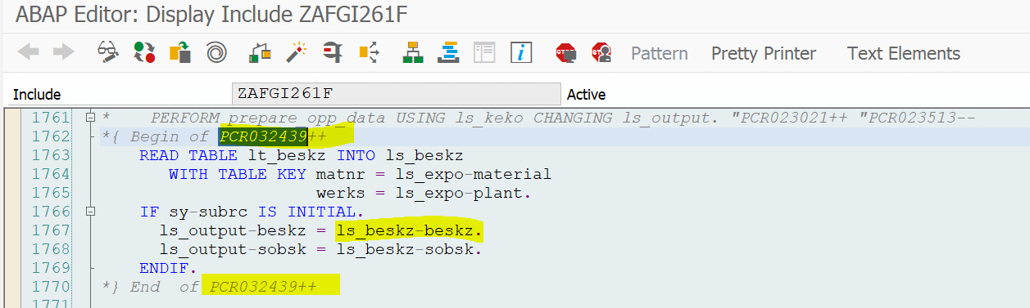
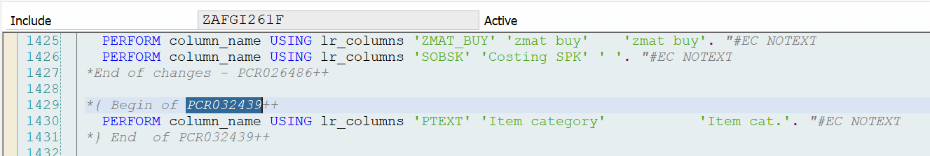

Unit Test Data and Testing Procedures
Step No. | Test System | Tcode | Test Condition | Input Parameters | Expected Results | Actual Results | Tester | Pass  / Fail
1 | X08 | ZAFGR261 | DFCT3588 |  |  | As  Expected | Krishna | Pass

Open Items / Issues Log / Proposed Solutions (Keep all history)
Indicate any issues, questions or proposed solutions related to the specification
• Gaps in functionality
• Missing or incomplete data elements
• Activity requires an organizational policy, procedural, and/or people change

Assigned To  <Name> | Date Opened | Due Date | Status | Description | Resolution

Technical Section

Version # | Date Modified | Modified By  (Name and Employee ID) | <PCR number> - Brief Description of Change
V12.0 | 05/06/2021 | Khurshida Shaik | PCR034981: Need to add price strategy column in ZAFGR261 report.

Systems:

ECC( X ) BW( ) CRM( ) CUA/GRC( ) EPP( ) GTS( )

HCM( ) MDM( ) PLM( ) SCM( ) SNC( ) SEM( )

SLM( ) SRM ( ) XI( ) Web Method( )

If others, specify ________

All Objects Information
Note: If all the objects belong to the same system, the ‘System’ column need not be filled.

Object Name | Object Type | Created/Modified/Auto-generated | Short comments (optional) | System
ZAFGR261 | Report | Modified | Costed BOM Report - Purchasing | ECC

<For subsequent versions, provide details under PCR number tag as below for every section>
Begin of <PCR034981>
Issue:
Need to add Price Strategy column in ZAFGR261 report.
Cause:
No logic exists in report to display pricing strategy, need to add new logic to display new field pricing strategy
Resolution:
Fetched field material valuation BWSMR from table KEKO (LT_KEKO_T) based on Costing number, Costing type (Costing type must not equal to blank) and Material valuation must not be blank.
Called FM ‘GET_DOMAIN_VALUES’ to get field BWSMR domain values ‘LT_DD07V.
Read material valuation from ‘LT_KEKO_T based on material and plant determined from BAPI costing element.
Based on material valuation value fetched respective domain value description from table LT_DD07V.
This description value is displayed on output list field pricing strategy.
End of < PCR034981>

Technical Unit test plan:
ID | Test Scenario | Expected Results | Test System  /Environment | Documents used for testing in Dev/QA | Comments
1 | Company code  Sales Org  Sales Document Type  Sales Document | Successful | D08 | DEV
2
3
4

