Online Inventory Management System

In this project normal users can signup with the application and then browse product list and purchase product from that list. Admin user can login to application and then View Total transaction and registered users. Admin can predict stock trending quantity by using Random Forest Machine Learning algorithm for any store location.

To train machine learning algorithm we have used WALMART sales dataset and below is the screen shots of that dataset and user also browse and purchase product from same dataset

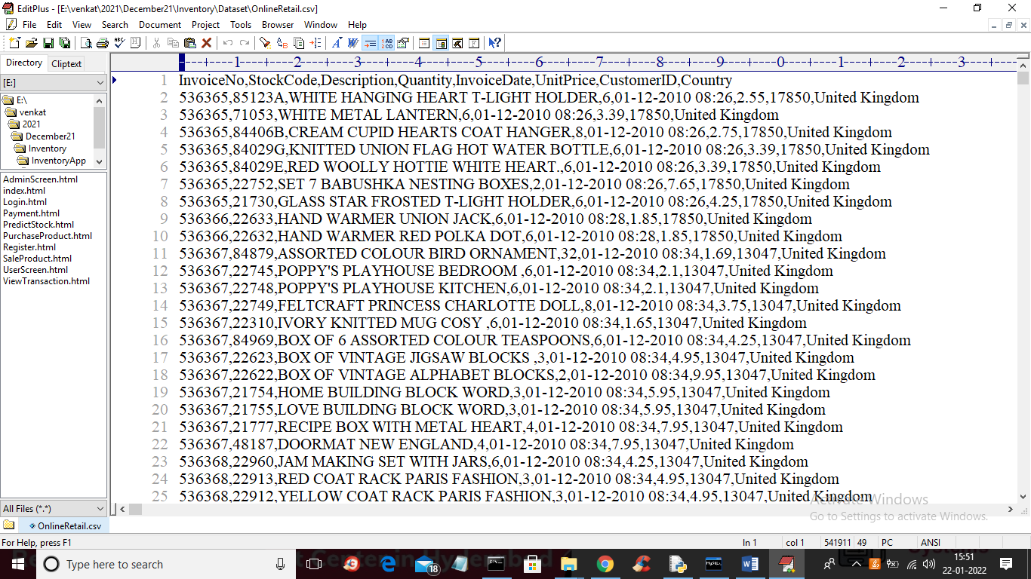

In above dataset first row contains dataset column names and remaining rows are the dataset values and admin can predict quantity for any STOCK code given in above dataset.

To run project first create database in MYSQL by copying content from ‘DB.txt’ file and paste in MYSQL console and then double click on ‘run.bat’ to start DJANGO server and then open browser and enter URL ‘http://127.0.0.1:8000/index.html’ and press enter key to get below home page

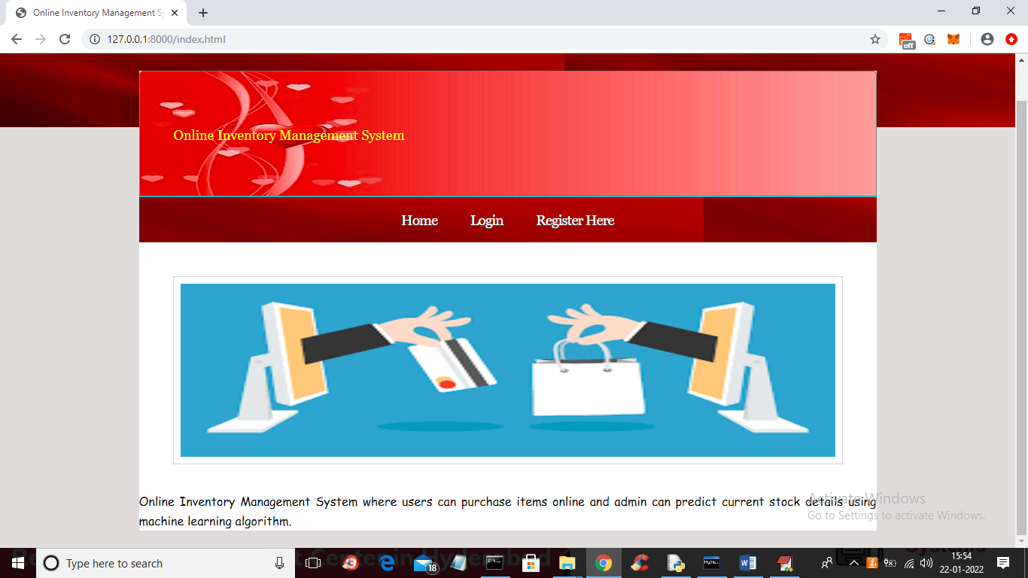

In above screen click on ‘Register Here’ link to add new user like below screen

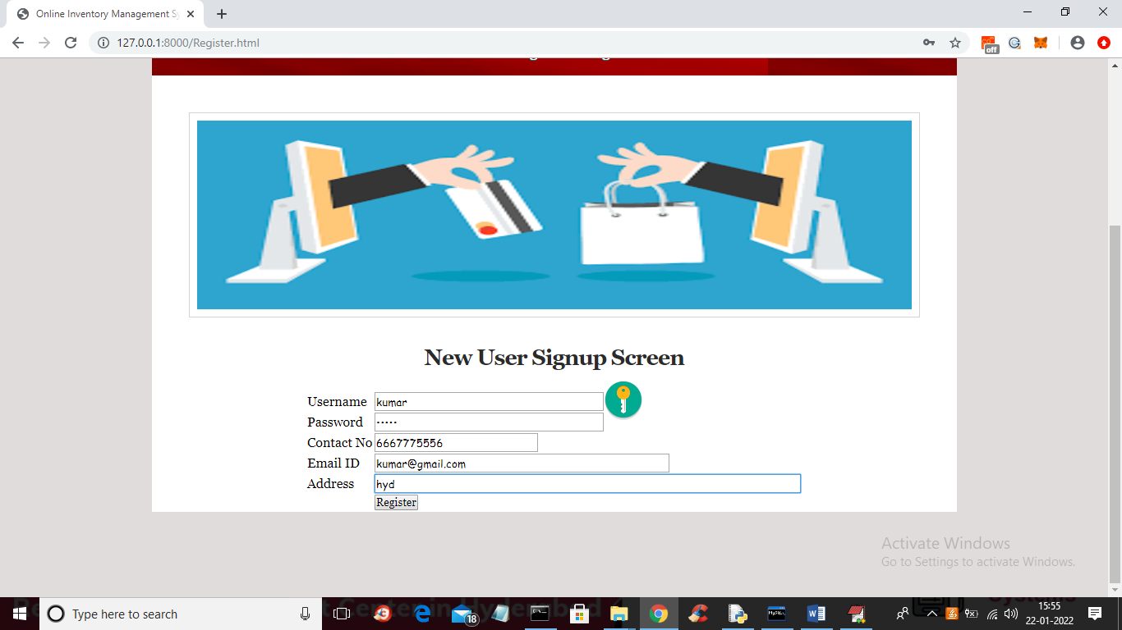

In above screen user is signup and press ‘register’ button to get below output

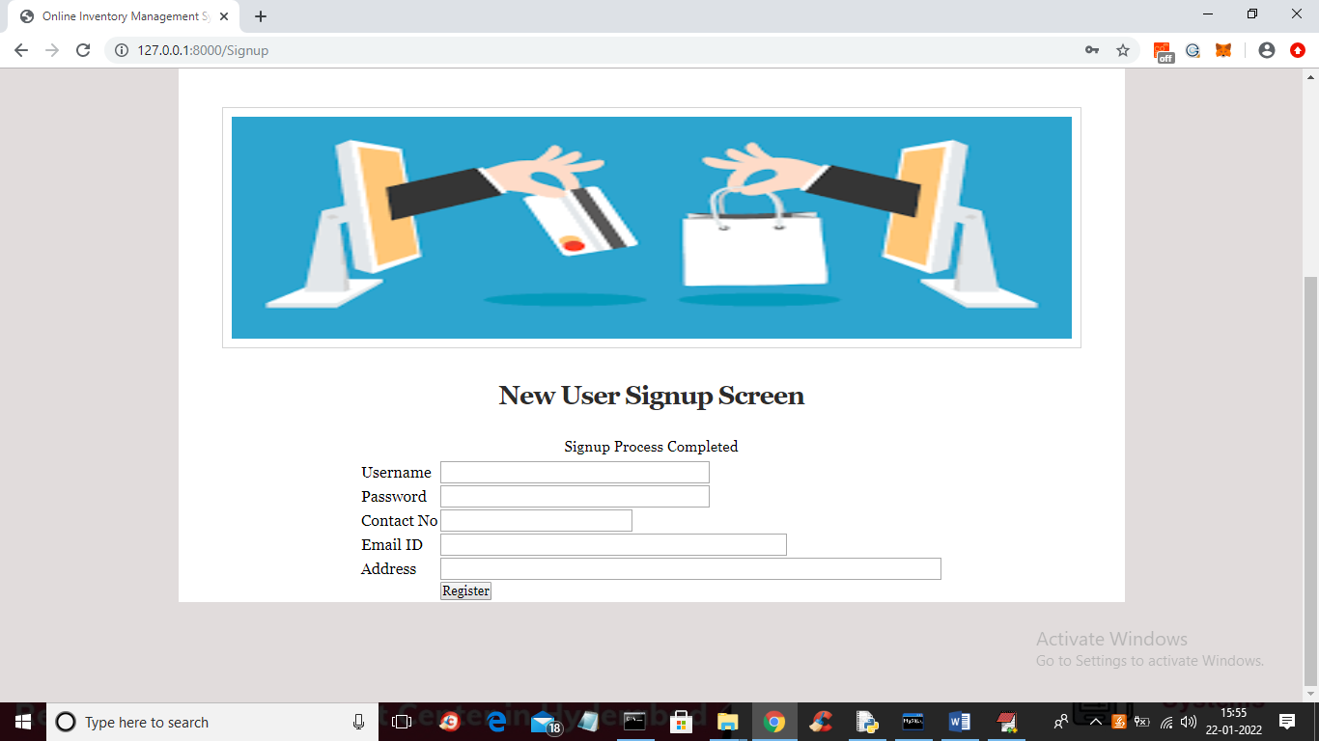

In above screen user signup process completed and now click on ‘Login’ link to get below login screen

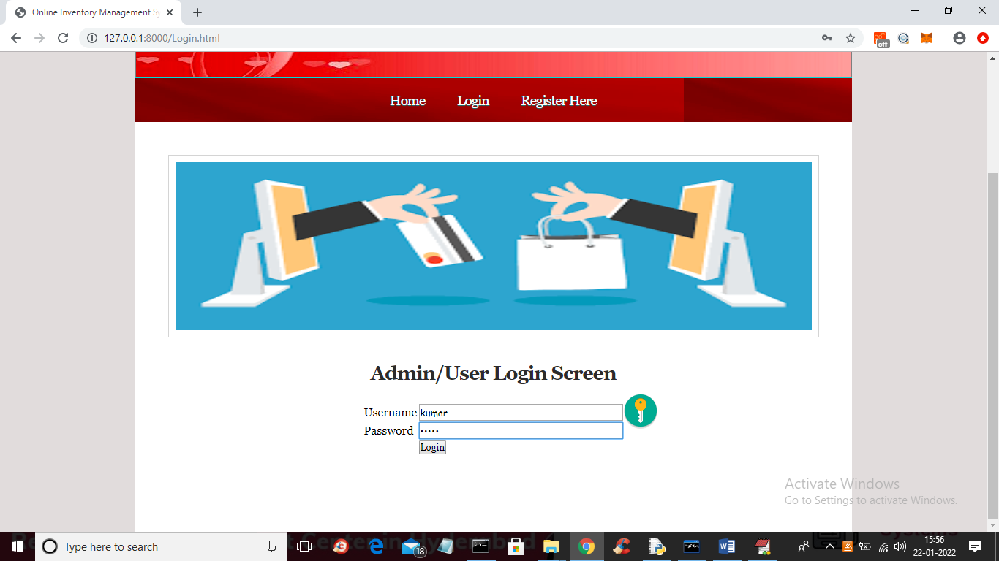

In above screen user is login and after login will get below screen

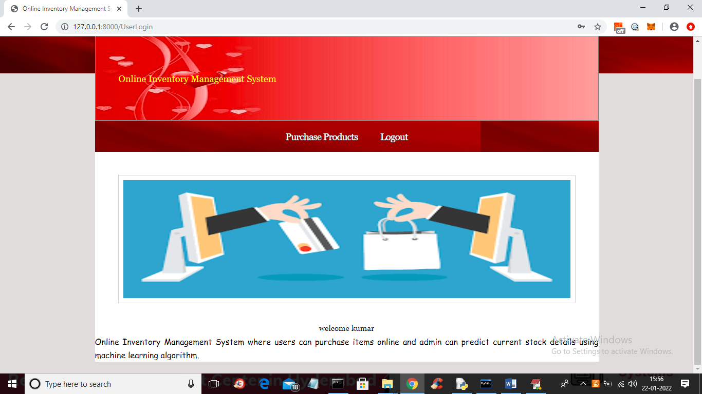

In above screen click on ‘Purchase Products’ link to get products list from dataset like below screen

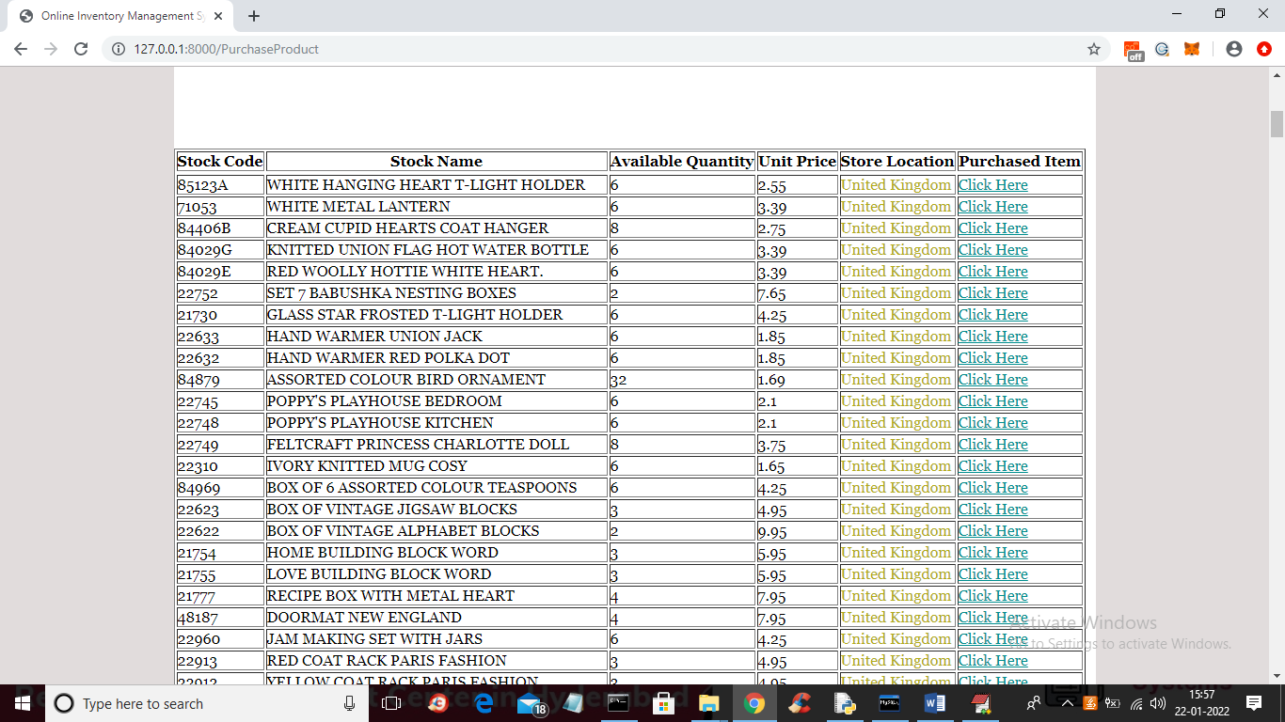

In above screen user can view all products list and then click on ‘Click Here’ link to purchase that product

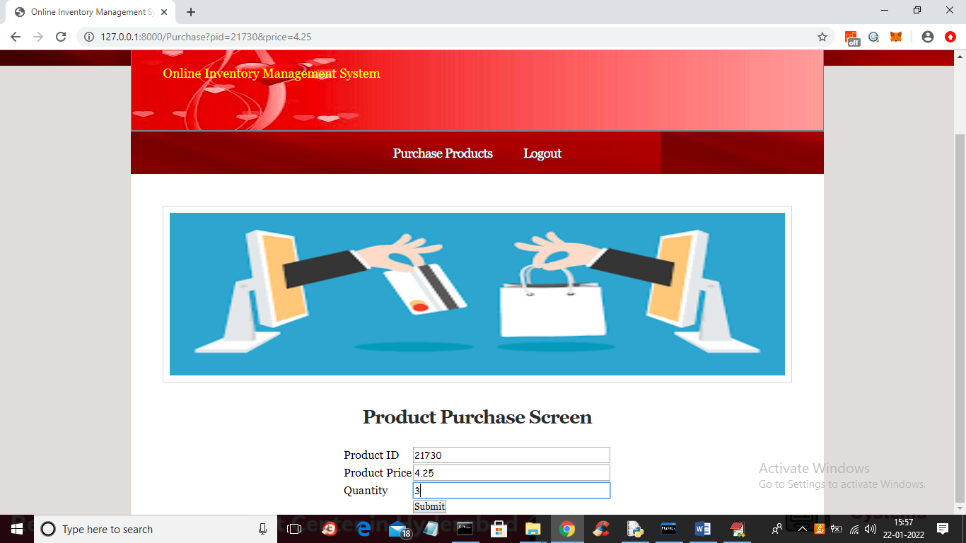

In above screen user can enter quantity and then click on ‘submit’ button to get below payment screen

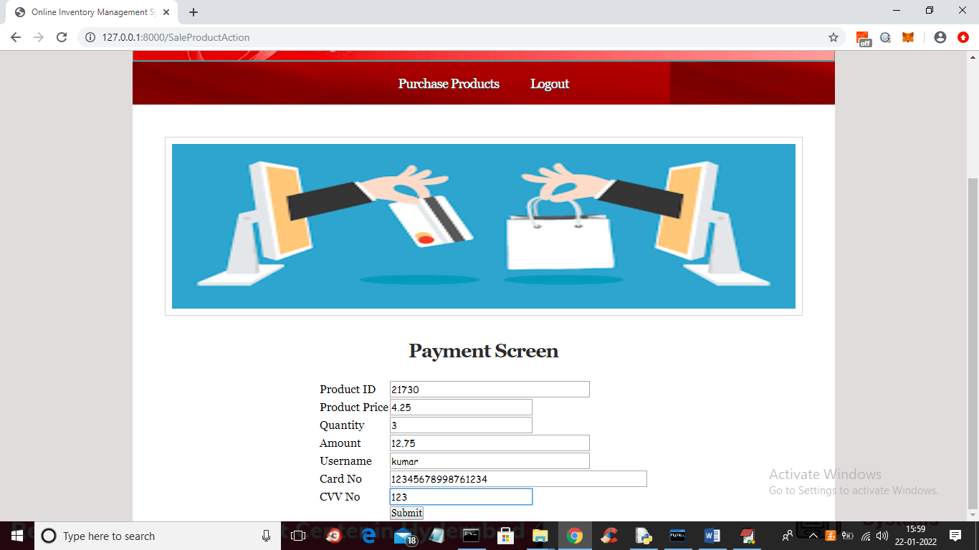

In above screen user will view all details and then enter card number and CVV number and press submit button to confirm order like below screen

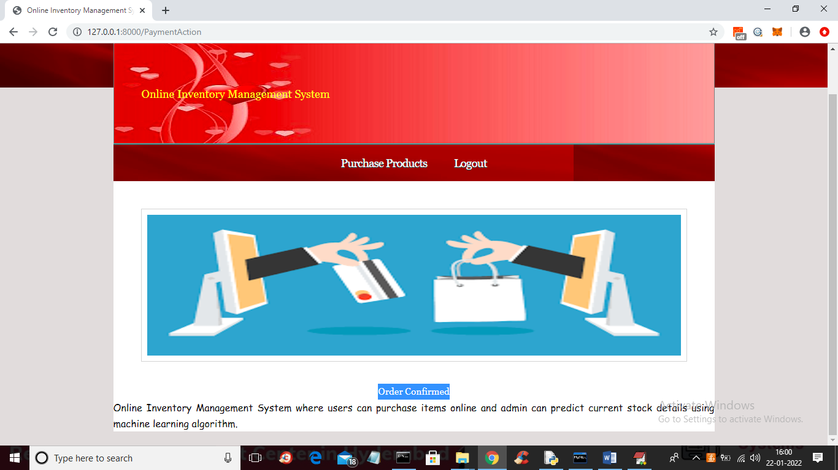

In above screen we can order is confirmed and now logout and login as ‘admin’

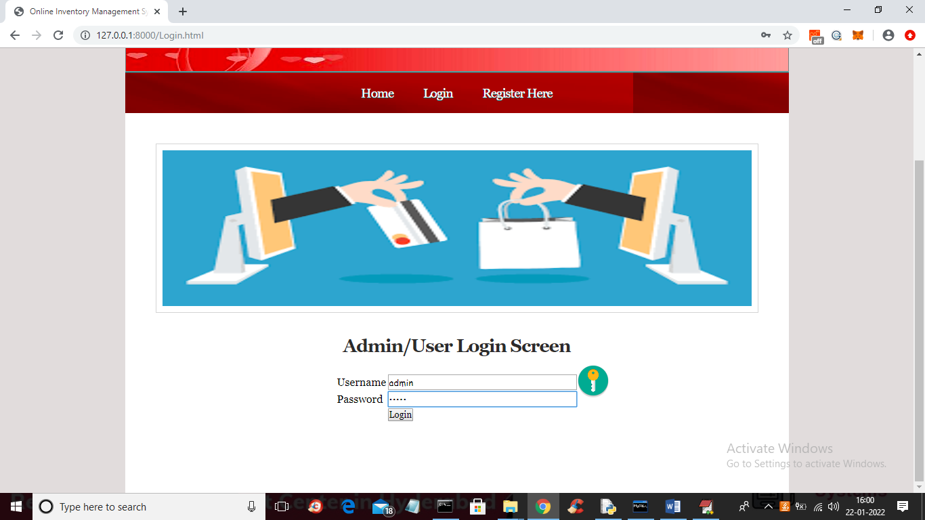

In above screen admin is login and after login will get below screen

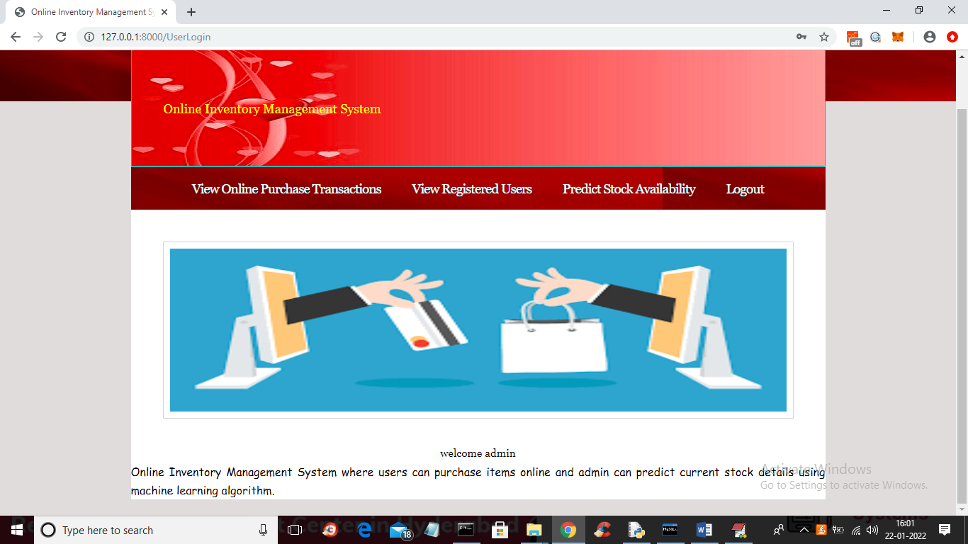

In above screen admin can click on ‘View Online Purchase Transactions’ link to view all purchased list

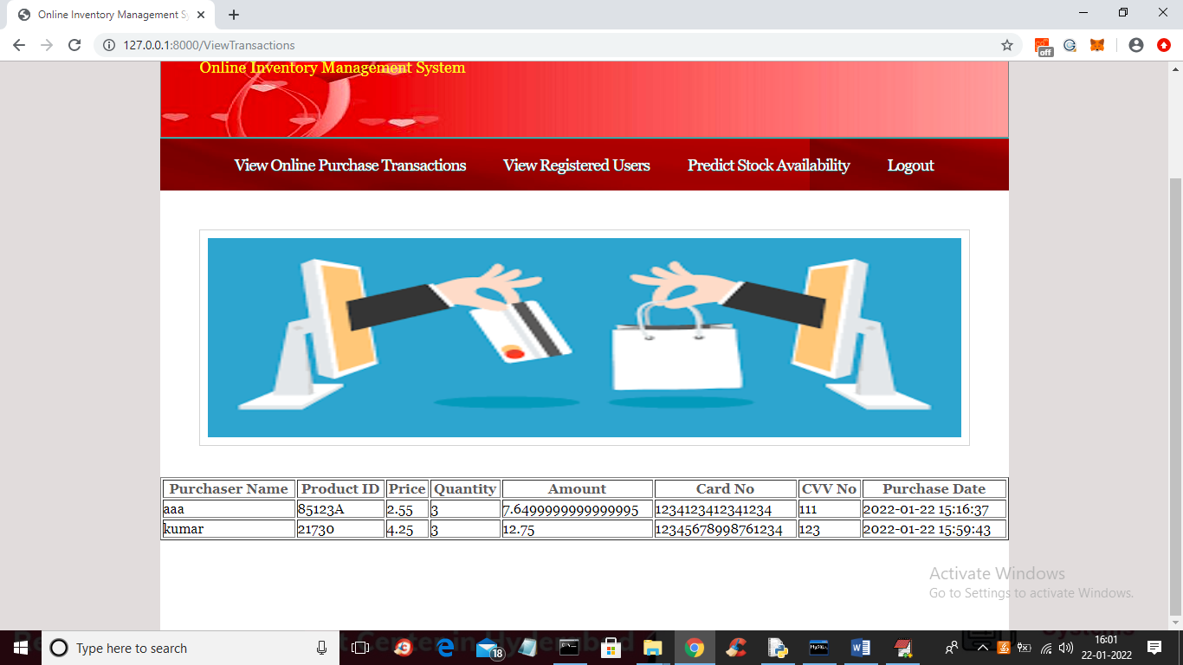

In above screen admin can view all purchase transactions and now click on ‘View Registered Users’ link to view list of users like below screen

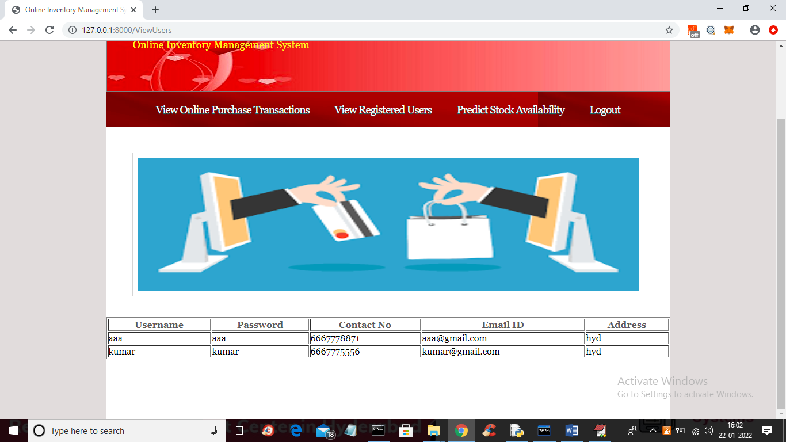

In above screen admin can view all registered user details and now click on ‘Predict Stock Availability’ link to get below screen

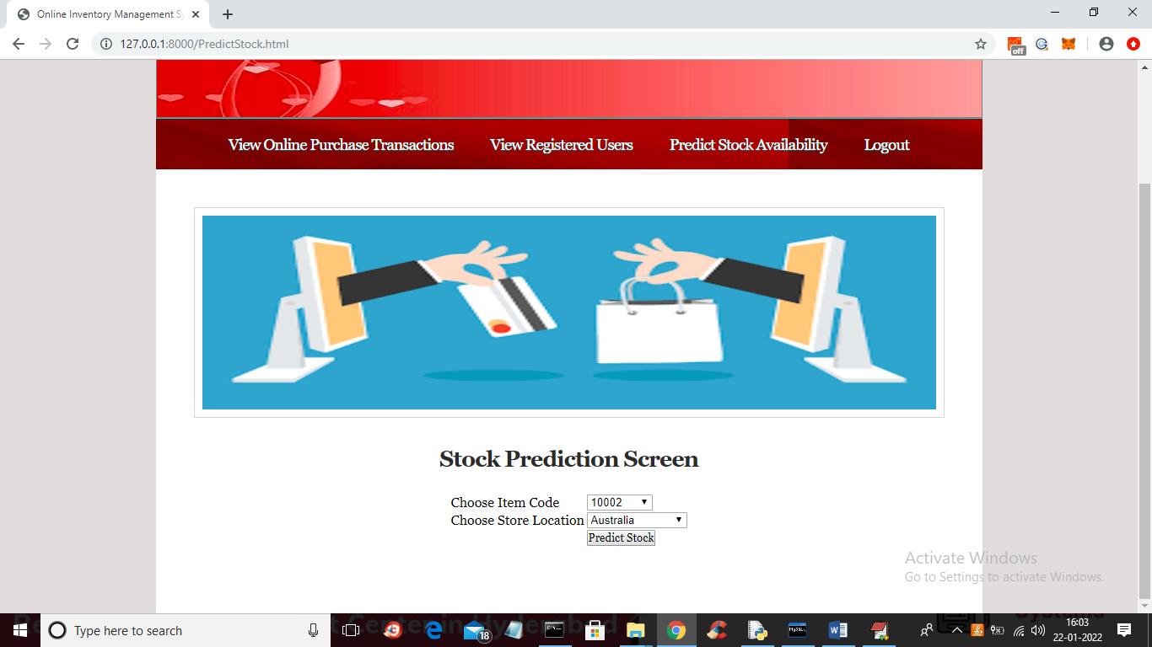

In above screen admin can predict quantity for any stock ID by selecting its code and then store location

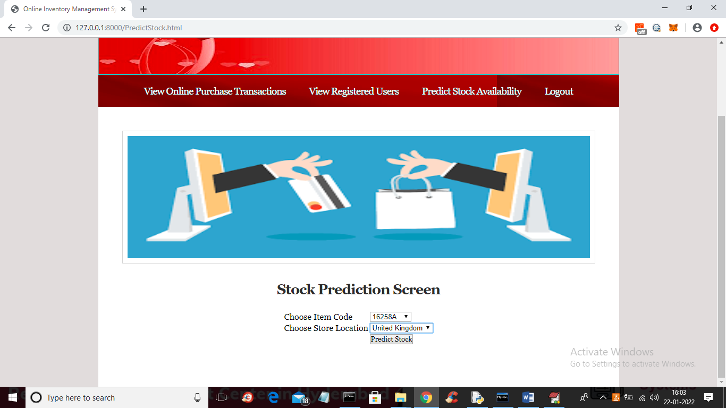

In above screen I selected stock id and store location as ‘United Kingdom’ and then press “predict Stock’ button to get below output

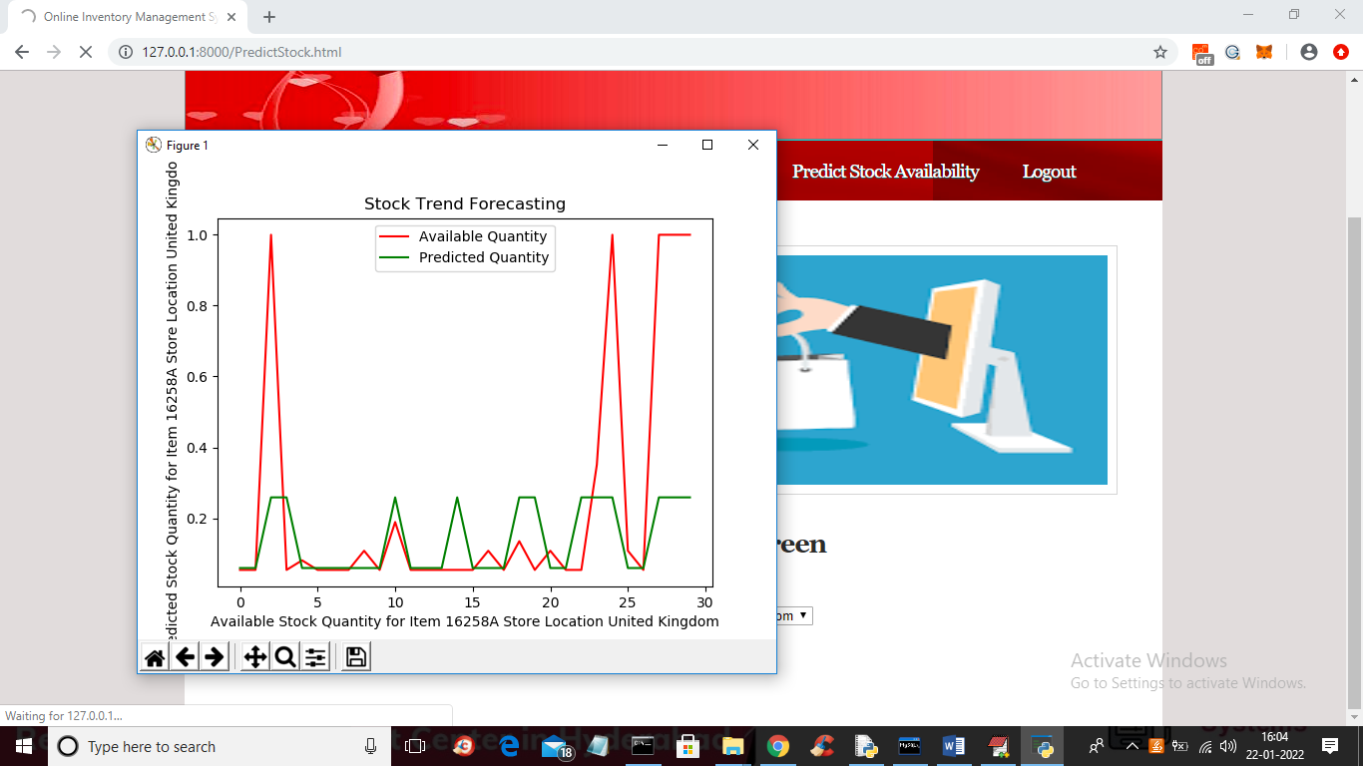

In above graph red line represents available stock for next 30 days and green line represents predicted required stock quantity and based on above graph ADMIN will arrange quantities for trending items/products and now close above graph to get actual available and predicted quantity

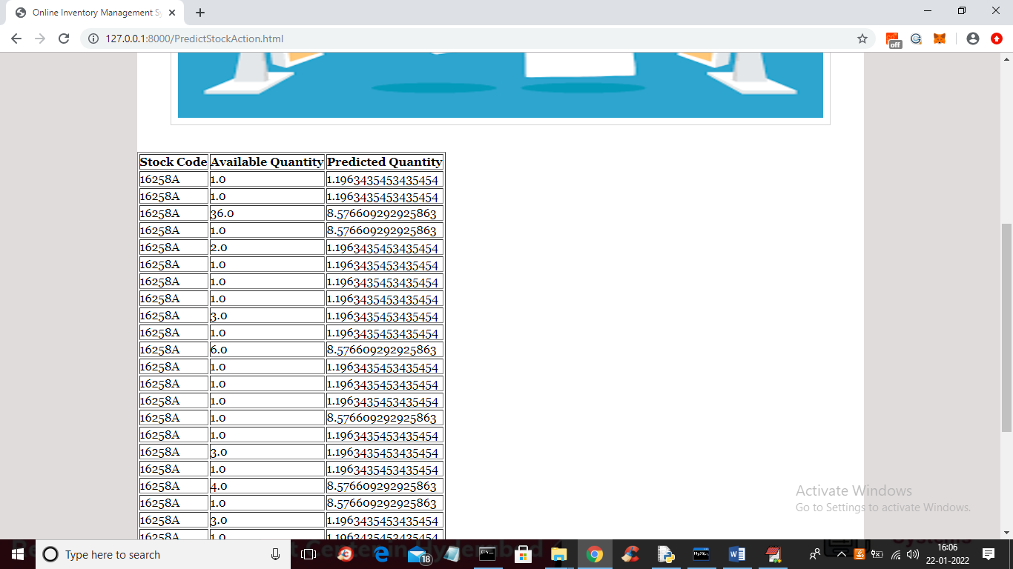

In above graph first column displaying stock ID and second column showing Available quantity and 3rd column showing predicted required quantity by Random Forest machine learning algorithm

Similarly you can purchase any items and perform prediction for any stock code