1. What are the various elements of the Excel interface? Describe how

they're used.

\*Ribbon Tabs-Ribbon Tab is a tab that organizes commands by topic

\*Ribbon Groups-Grouping of related commands

\*Dialog Box Launcher-Opens a dialog box that includes additional commands

\*Quick Access Toolbar-One click access to any frequently used command

\*Name Box-Displays cell location and can be used to navigate to a cell location

\*Select All Button-Selects all the cells in a worksheet

\*Formula Bar-View, enter, or edit cell contents

\*Insert Function Button -Displays Insert Function dialog box

\*Scroll Bars-Used to navigate up, down, left & right

\*Zoom Slider-Zoom into an area of the worksheet

\*View Buttons-Switch between Normal, Page Layout and Page Break Preview views

\*Worksheet tabs-Tabs used to select individual worksheets

\*The Workspace-The area inside of the columns and rows used in Excel

\*Columns-Columns use letters

\*Rows-Rows use numbers

2. Write down the various applications of Excel in the industry.

\*Business Analysis

\*Data Analysis

\*People Management

\*Managing Operations

\*Performance Reporting

\*Office Administration

\*Strategic Analysis

\*Project Management

\*Account Management

3. On the ribbon, make a new tab. Add some different groups, insert

commands in the groups and name them according to their commands

added. Copy and paste the screenshot of the steps you followed.

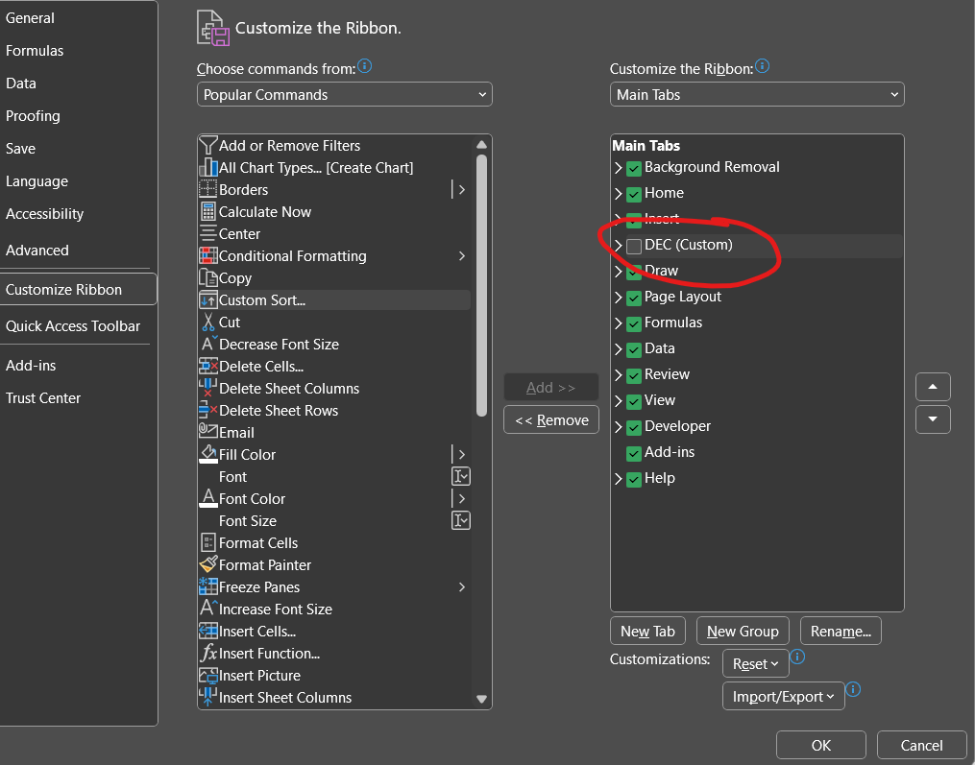

4. Make a list of different shortcut keys that are only connected to

formatting with their functions.

\*Ctrl+C → Copy selected text or graphics to the Office Clipboard.

\*Ctrl+V → Paste the most recent addition to the Office Clipboard.

\*Ctrl+Shift+A → Format all letters as capitals.

\*Ctrl+B → Applies or removes bold formatting.

\*Ctrl+I → Applies or removes italic formatting.

\*Ctrl+= → Apply subscript formatting (automatic spacing).

5. What distinguishes Excel from other analytical tools?

\*You Can Insert a New Worksheets at Will.

\*Time Saving Shortcut Keys.

\*Get Quick Sum of Numbers.

\*Filtering Data.

\*Paste Special Feature.

\*Insert Random Numbers.

\*Insert Random Fraction Numbers.

\*Goal Seek Analysis Tool.

6. Create a table and add a custom header and footer to your table.

