PROJECT REPORT

CareerSphere AI

Integrated Career Intelligence and Skill Mapping System

Submitted by
Vijay pradhap S
25322020
Department of Computer Applications (MCA)
Gandhigram Rural Institute

TABLE OF CONTENTS
1. Abstract
2. Introduction
3. Problem Statement
4. Objectives
5. Languages and Technologies Used
6. Use Case
7. System Working Flow
7.1 Process Flowchart
7.2 User Flow Chart
8. System Architecture Diagram
8.1 Data Flow Diagram (DFD)
8.2 Entity-Relationship Diagram (ERD)
9. Result
10. Conclusion
11. Future Work

1. Abstract
CareerSphere AI is a web-based career guidance system that unifies a student's academic qualifications, technical and soft skills, projects, certifications, and career interests in one platform. It compares this profile against the skills required for chosen career roles, identifies skill gaps, and presents a learning roadmap through a visual dashboard. The system answers a single question for the student: where am I now, what skills do I have, what am I lacking, and which career opportunities can I pursue?

2. Introduction
The transition from higher education to the working world can be challenging for young professionals. Despite academic and technical qualifications, many students and recent graduates struggle to understand how their skill set fits into the wider landscape of potential careers.
CareerSphere AI is a unified career guidance and analysis application that helps students identify their position within the context of their chosen profession. By combining relevant career data and analysing it against the user's personal skill set, it helps young professionals understand what they lack, what they need, and where they belong.
The application allows the user to enter and track the following career-related information:
- Academic qualifications
- Technical and soft skills
- Projects and certifications
- Career interests
- Job requirements
- Skill gaps and learning requirements
- Career opportunities
Instead of facing a multitude of disconnected pieces of information, the user can view their current status, see which skills are missing, and identify potential career paths.

3. Problem Statement
The main problem addressed by this project is the disconnect between students' academic learning and industry requirements. Students face the following challenges in current career planning systems:
- Academic and career data are managed on separate platforms.
- Students lack information about the skills required for their desired occupations.
- Most career platforms focus only on jobs, courses, and resumes.
- Existing tools do not help students identify skill gaps.
- Career planning is not automated and depends largely on human expertise.
- No unified system supports a student's learning, skills, projects, and career data together.
- Students are not shown the range of possible career options or the actions needed to reach their goals.

3.1 Proposed Solution
CareerSphere AI provides a unified dashboard that manages students' academic data, analyses it against their career goals, and visualises the results to support decision-making.

4. Objectives
- To consolidate academic, skill, project, and career data in a single platform.
- To map a student's skills against the requirements of selected career roles.
- To identify skill gaps automatically.
- To recommend learning areas, projects, and certifications that close those gaps.
- To present the analysis through clear, interactive visual components.

5. Languages and Technologies Used
The application is developed using the following languages and technologies:
Technology | Purpose
HTML5 | Application structure
CSS3 | Styling and responsive design
JavaScript | Application logic and interaction
AngularJS | Front-end application development
Chart.js / Visualization Library | Charts and graphical analysis
XML / JSON / Structured Data | Storing academic, skill, and career data
CSV / Tabular Data | Job and skill requirement data
Web Browser | Running the application
Table 1: Technology stack

5.1 Main Technology
AngularJS is the main technology used to build the dashboard and manage application components. The application supports multiple data formats, both structured and unstructured, to present students' academic, skills, course, and project data and to compare it against required skills, job roles, and career options.

6. Use Case

6.1 Main Use Case
The primary use case is to help a student understand: “Where am I now, what skills do I have, what skills am I lacking, and which career opportunities can I pursue?”

6.2 User Actions
The student (user) can perform the following actions:
- Create or enter a profile
- Enter academic information
- Enter technical skills
- Enter projects and certifications
- Select career interests
- View skill analysis and career roles
- Identify skill gaps
- View recommended learning areas
- Track career readiness

6.3 Example Scenario
Input | Value
Education | MCA
Skills | Python, C, SQL, HTML, JavaScript
Projects | Web application, IoT project
Interest | Software Development
Table 2: Sample student input
The system compiles this information, displays the student's skill profile, and shows the common skills required for the selected career roles.

7. System Working Flow
The working flow of CareerSphere AI proceeds as follows: the user supplies profile, academic, skill, project, and interest data; the system processes it; skill analysis and career analysis run in parallel; their results feed the skill gap analysis; and a learning roadmap is produced and displayed on the dashboard to support career planning.
Step | Stage | Description
1 | User Profile | The user enters education, skills, projects, certificates, and interests.
2 | Data Collection | The provided information is gathered and arranged in structured data form.
3 | Skills Analysis | Skills in the profile are identified, analysed, and shown through visual components.
4 | Career Analysis | The user's chosen career roles and the skills needed for them are displayed.
5 | Skill Gap Analysis | The user's skills are compared with the skills required for the chosen role.
6 | Career Path | Skills to develop are presented as opportunities for learning, projects, practice, and certification.
7 | Dashboard | The complete analysis is shown through charts, cards, gauges, a career map, and other visuals.
Table 3: Working flow steps

7.1 Process Flowchart
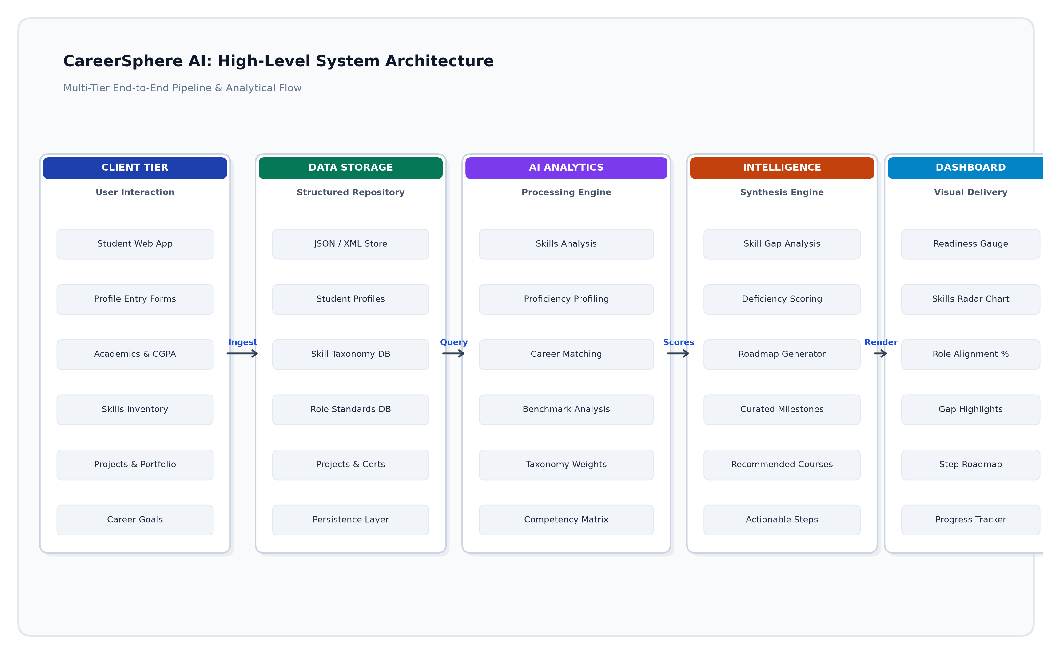
Figure 2: CareerSphere AI Process Flowchart
The Process Flowchart illustrates the detailed internal processing and decision logic of the CareerSphere AI platform. Following initialization, the system prompts the candidate to furnish comprehensive academic credentials, technical proficiencies, soft skills, portfolio projects, and professional certifications alongside their aspirational career trajectory. The ingested data undergoes normalization and profile validation. CareerSphere AI concurrently invokes analytical routines to benchmark user competencies against target industry requirements. By identifying skill deficiencies and match percentages, the engine derives targeted learning priorities and synthesizes an actionable, milestone-driven career roadmap rendered directly onto the candidate dashboard.

7.2 User Flow Chart
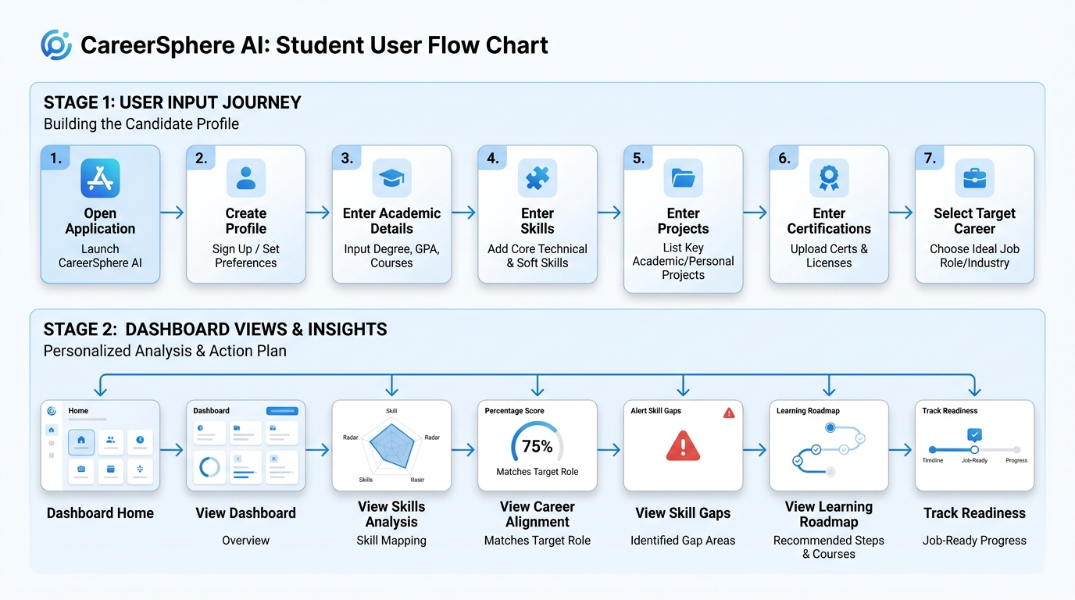
Figure 3: CareerSphere AI User Flow Chart
The User Flow Chart models the direct interaction and navigation sequence of a student candidate within CareerSphere AI. Distinct from internal background algorithms, this chart highlights the user-facing journey: beginning with platform access and secure credential authentication, progressing through step-by-step modular data entry forms for educational background, technical capabilities, projects, and certifications. Once target career interests are confirmed, the user transitions to analytical dashboard views where they can visually inspect their skill distributions, evaluate career role alignment, examine identified skill gaps, review curated learning milestones, and track ongoing career readiness over time.

8. System Architecture Diagram

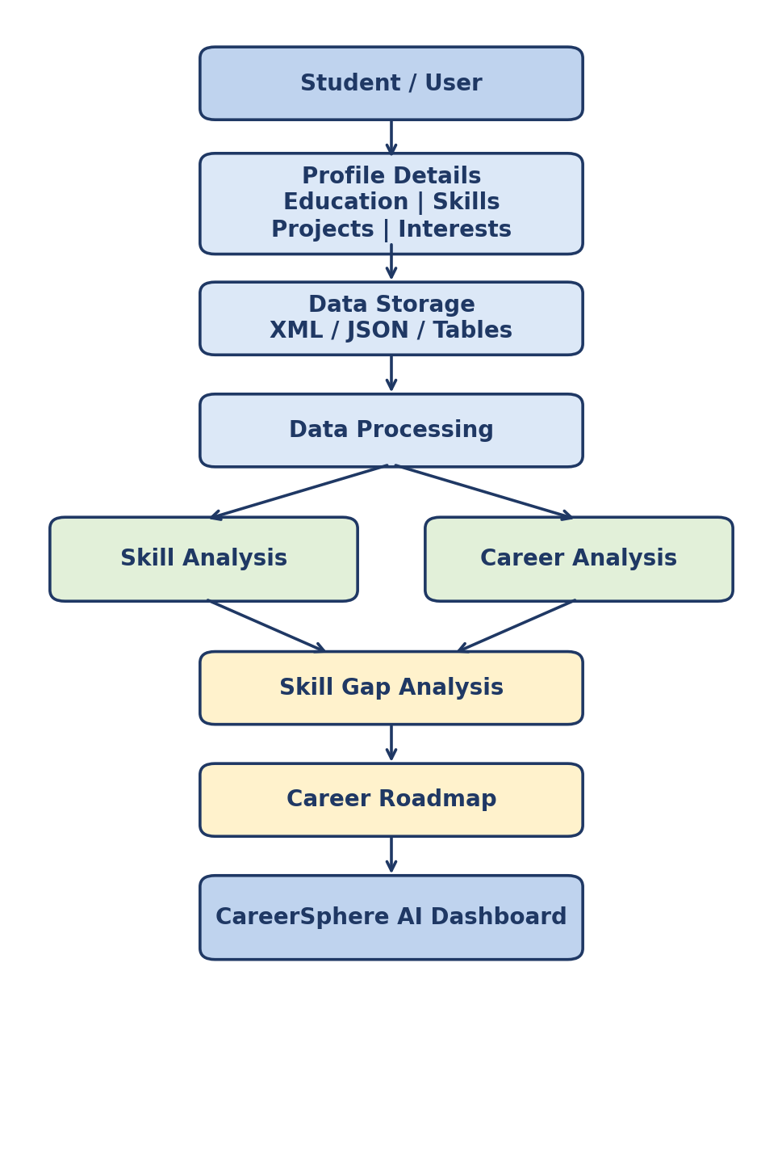
Figure 1: CareerSphere AI System Architecture

The CareerSphere AI system gets the profile information from the Student/User, who provides his educational information, skill set, projects he has completed, and hobbies. The profile information is stored in XML/JSON or tabular forms and later analyzed.
Later, the analyzed data is used for skill analysis and career analysis. Skill analysis aids in understanding the skill set of the individual, while career analysis aids in analyzing the correct career path for him. Skill Gap Analysis is performed using Skill Analysis and Career Analysis for finding out the skill sets to be learned/acquired.
Career Roadmap is generated based on Skill Gap Analysis for the future development of the individual. In the last step, all the collected data is visualized through the CareerSphere AI Dashboard through graphs and charts.

8.1 Data Flow Diagram (DFD)
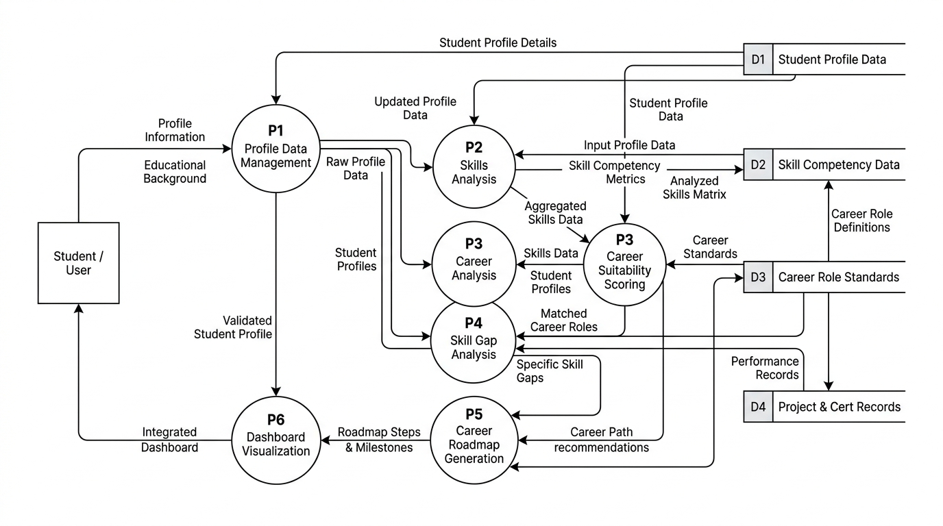
Figure 4: CareerSphere AI Data Flow Diagram
The Data Flow Diagram (DFD) delineates the movement, transformation, and persistent storage of information throughout CareerSphere AI. The Student/User functions as the primary external entity submitting profile information, skill proficiencies, project experiences, certifications, and career objectives to Process P1 (Profile Data Management). Stored profile data in D1 is retrieved by Process P2 (Skills Analysis & Profiling) to establish an evaluated competency matrix using taxonomy benchmarks from D2 (Skill Competency Data). Process P3 (Career Analysis & Mapping) correlates these findings with job criteria stored in D3 (Career Role Standards). Process P4 (Skill Gap Analysis) incorporates verified portfolio records from D4 (Project & Certification Records) to pinpoint technical deficiencies. Process P5 (Career Roadmap Generation) transforms gap assessments into personalized developmental pathways, which Process P6 (Dashboard Visualization) renders as real-time, interactive performance charts and milestone tracking for the student.

8.2 Entity-Relationship Diagram (ERD)
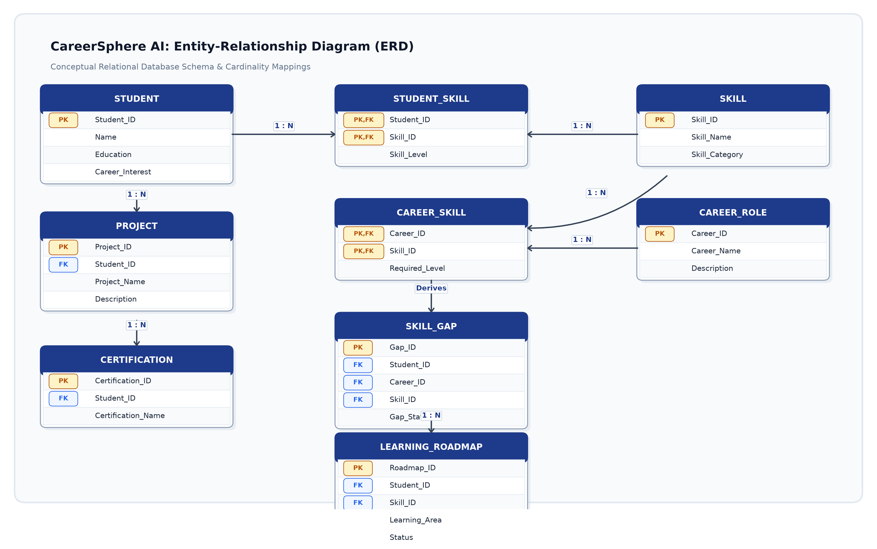
Figure 5: CareerSphere AI Entity-Relationship Diagram
The Entity-Relationship Diagram (ERD) defines the conceptual data model and relational schemas underpinning CareerSphere AI. The central STUDENT entity stores unique candidate demographics and career preferences, maintaining one-to-many (1:N) relationships with PROJECT and CERTIFICATION entities to capture practical portfolio records. Student skill evaluations are represented through the associative entity STUDENT_SKILL, linking STUDENT and SKILL via composite foreign keys alongside proficiency metrics. Similarly, industry CAREER_ROLE profiles relate to SKILL via CAREER_SKILL, defining benchmark competencies for each career path. By correlating candidate profiles with career role expectations, the system generates relational records in SKILL_GAP, which systematically guide the generation of structured milestones within the LEARNING_ROADMAP entity.

9. Result
The implementation and integration of CareerSphere AI provide a cohesive, end-to-end framework for student career planning and skill development. Through the systematic execution of the process flow, user navigation stages, layered architecture, data flow pipelines, and relational database entities, the platform successfully collects candidate credentials and analyzes proficiencies against real-world role requirements. The resulting dashboard provides real-time visibility into skill gap metrics, role readiness scores, and milestone-driven learning roadmaps, demonstrating a robust, scalable solution for academic and professional career guidance.

10. Conclusion
CareerSphere AI offers a unified platform where a student's educational and career profiles can be managed together. It brings the educational background, skills, project experience, certifications, career interests, and job criteria into one place, and its dashboard makes career information easier to understand through visual representation.
The system helps students understand their present capabilities, identify the areas that need improvement, and build a clear plan for developing their careers. CareerSphere AI is therefore a practical way to support career planning grounded in a student's academic education.

11.Future Work

S.NO | Enhancement | Description
1 | Real-time job market integration | Connect the system with current job openings and required skills.
2 | Resume integration | Upload a resume and populate the profile automatically.
3 | Learning platform integration | Link recommended skills to suitable courses and learning platforms.
4 | Career progress tracking | Let students log completed skills, projects, courses, and certifications.
5 | Interactive career visualization | Build career maps showing several career paths.
6 | College placement integration | Provide placement information, company requirements, and student placement status.
7 | Customized dashboards | Separate dashboards for students, staff, placement officers, and administration.
8 | Mobile application | Release CareerSphere AI on Android and other mobile platforms.
9 | Industry skills database | Maintain a current database of skills needed by industries.
10 | Career timeline | Chart a student's journey from education through skills, projects, internships, and employment.
Table 4: Planned enhancements

