Spring Boot Observability & Monitoring
Actuator, Prometheus and Grafana
Actuator = exposes the health and internal metrics of our application
Prometheus = collects and stores those metrics
Grafana = converts those metrics into beautiful dashboards
So the overall flow is:
Spring Boot Application
│
│
Actuator
│
/actuator/health
/actuator/metrics
/actuator/prometheus
│
▼
Prometheus
(Pull / Scrape)
│
│ stores time-series data
▼
Grafana
(Dashboards / Alerts)

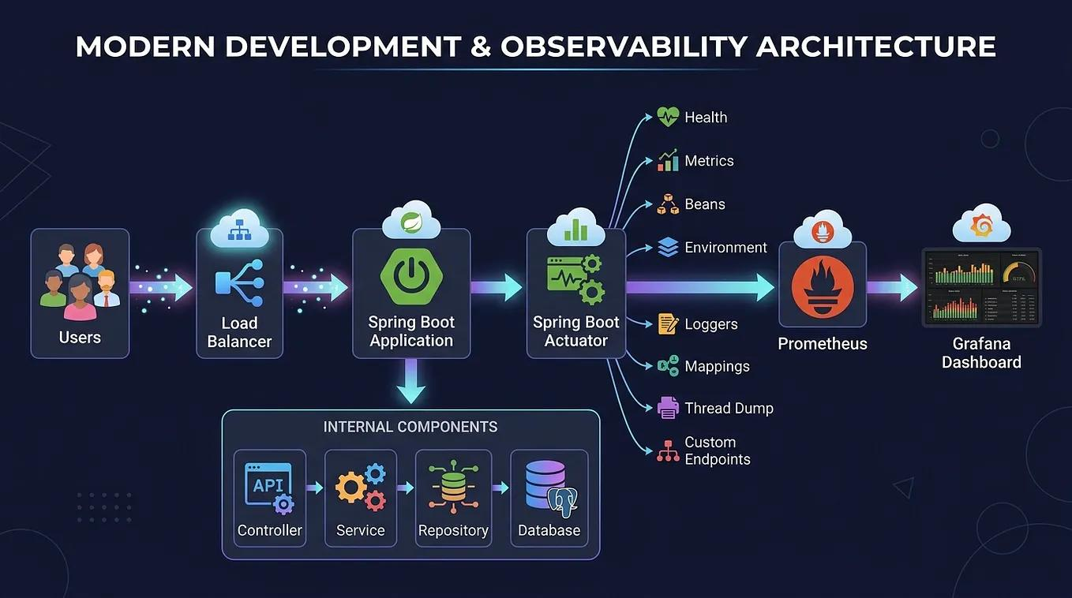

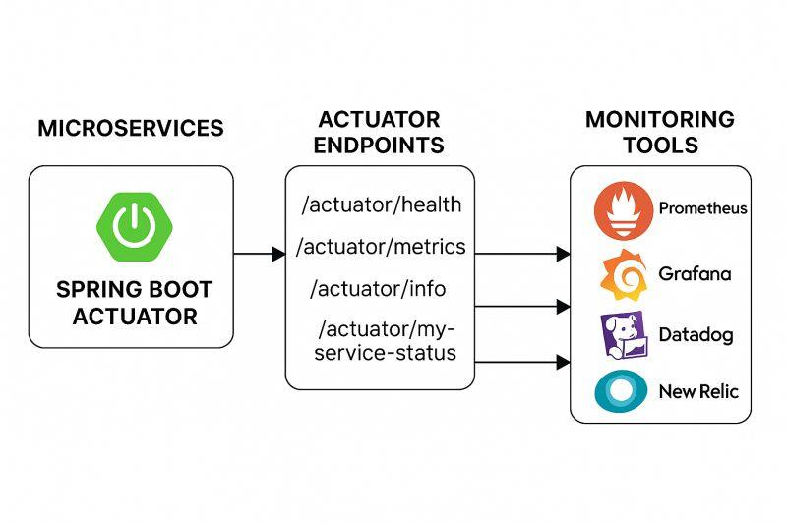
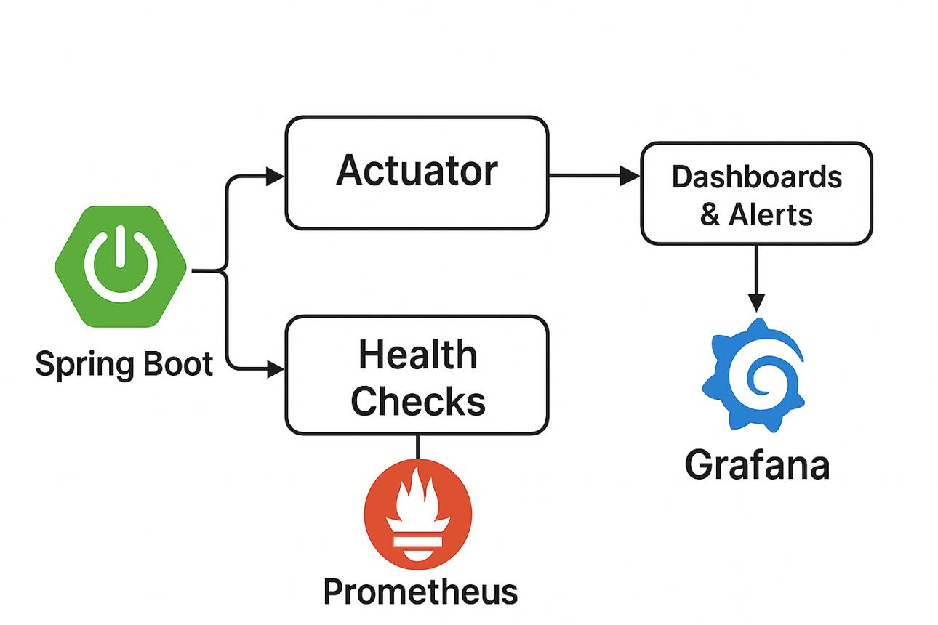

Spring Boot Actuator is a Spring Boot module that provides production-ready features for monitoring and managing an application.
In simple terms:
Actuator allows us to look inside a running Spring Boot application.
Without Actuator, our application may be running perfectly, but we have very little visibility into:
- Is the application healthy?
- Is the database available?
- How much memory is being consumed?
- How many requests are coming?
- How long are requests taking?
- How many errors are occurring?
- How many threads are being used?
- What JVM information is available?
- What configuration/environment information is exposed?

Actuator provides endpoints through which this information can be accessed.

Example
Suppose we have:
product-service

running at:
http://localhost:8081
With Actuator enabled, we can access:
http://localhost:8081/actuator/health
and get information such as:

running at:
http://localhost:8081
With Actuator enabled, we can access:
http://localhost:8081/actuator/health
and get information such as:
This tells us that the application is currently healthy.

2. Why Do We Need Actuator?
Imagine that we have 10 microservices:
Product Service
Order Service
Payment Service
Notification Service
Email Service
Auth Service
Cart Service
Inventory Service
Shipping Service
Analytics Service
A user reports I am unable to place an order.
Without monitoring, developers may have to manually check every service.
With Actuator, we can quickly inspect:
Order Service → UP
Payment Service → DOWN
Database → DOWN
Kafka → UP
Now we immediately have a direction for investigation.

Main purposes of Actuator
Purpose | Example
Health monitoring | Is application UP/DOWN?
Metrics | CPU, memory, requests
Application information | Build/version information
JVM monitoring | Threads, heap, GC
HTTP monitoring | Request counts and timings
Database health | DB connectivity
Environment information | Configuration/environment
Logging | Log-level management
Application diagnostics | Runtime information

3. How to Add Actuator
For Maven:
<dependency>
<groupId>org.springframework.boot</groupId>
<artifactId>spring-boot-starter-actuator</artifactId>
</dependency>
After adding the dependency, Spring Boot automatically provides Actuator functionality.

4. Actuator Configuration
In application.properties:
management.endpoints.web.exposure.include=health,info,metrics,prometheus
For development/demo purposes, we can expose all endpoints:
management.endpoints.web.exposure.include=*
But do not blindly expose everything in production.
A better production approach is:
management.endpoints.web.exposure.include=health,info,metrics,prometheus

5. Important Actuator Endpoints
The most important endpoints for your students are:
Endpoint | Purpose
/actuator | Shows available exposed endpoints
/actuator/health | Application health
/actuator/info | Application information
/actuator/metrics | Available application/JVM metrics
/actuator/metrics/{name} | Specific metric
/actuator/prometheus | Metrics in Prometheus format
/actuator/loggers | View/change logging levels
/actuator/env | Environment/configuration information
/actuator/beans | Spring beans
/actuator/mappings | Request mappings
/actuator/threaddump | Thread information
/actuator/heapdump | JVM heap dump
Note: Some endpoints can expose sensitive information. They should be secured or not exposed publicly.

6. /actuator/health
This is probably the most important Actuator endpoint for beginners.
GET /actuator/health
Example:
{
"status": "UP"
}
If health details are enabled:
{
"status": "UP",
"components": {
"db": {
"status": "UP"
},
"diskSpace": {
"status": "UP"
}
}
}
This can tell us whether dependencies such as the database are healthy.

7. /actuator/info
GET /actuator/info
Can provide application information such as:
Application name
Application version
Build information
Git information
For example, we can configure:
info.app.name=product-service
info.app.version=1.0.0
info.app.description=Product Microservice
Then:
GET /actuator/info
can provide that information.

8. /actuator/metrics
This endpoint provides access to application metrics.
GET /actuator/metrics
Example:
jvm.memory.used
jvm.memory.max
jvm.threads.live
process.cpu.usage
http.server.requests
system.cpu.usage
We can then ask for a specific metric:
GET /actuator/metrics/jvm.memory.used
or:
GET /actuator/metrics/http.server.requests

9. What Information Does Actuator Provide?
Actuator works with Micrometer, Spring Boot's instrumentation/metrics facade.
It can expose metrics related to:

JVM
Heap memory
Non-heap memory
Garbage collection
Threads
Classes

CPU
Process CPU
System CPU
Load

HTTP
Number of requests
Request duration
Response status

Database
Database health
Connection pool metrics

Application
Custom application metrics
Counters
Timers
Gauges
This is where Actuator becomes very powerful.

10. What is Prometheus?
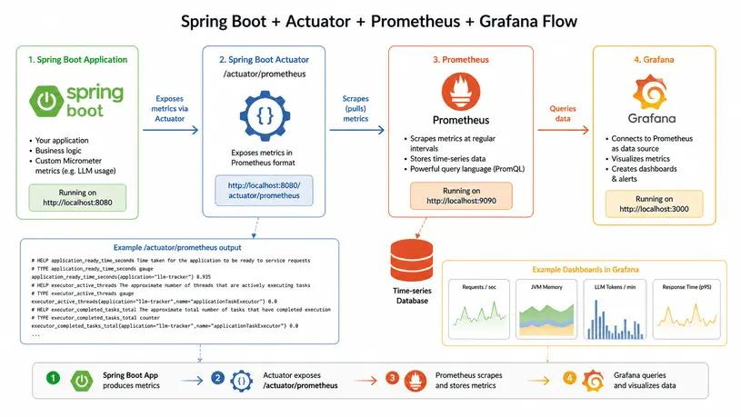

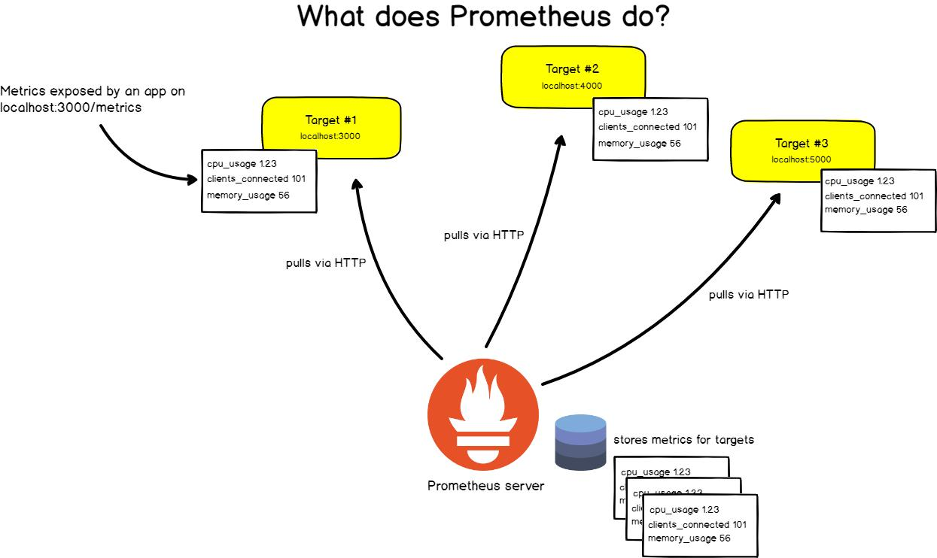

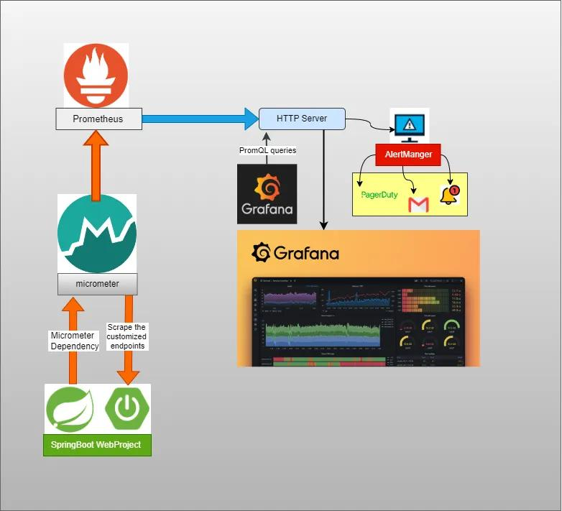

Prometheus is an open-source monitoring and time-series database system.
The easiest definition
Prometheus collects metrics from applications and stores them as time-series data.

This is the key difference. 11. Why Do We Need Prometheus?
Suppose Actuator gives us:
CPU = 65%
Memory = 700 MB
Requests = 1,250
Errors = 35
That's useful.
But what happened one hour ago?
What happened yesterday?
What happened during the last 7 days?
Actuator itself isn't intended to be your long-term metrics database.
Prometheus solves this problem.
It periodically collects metrics:
10:00 → CPU 35%
10:01 → CPU 42%
10:02 → CPU 55%
10:03 → CPU 71%
10:04 → CPU 68%
Now we have a time series.
Actuator exposes metrics.
Prometheus collects and stores metrics.

12. Prometheus Pull Model
One important concept students should understand:
Prometheus normally pulls/scrapes metrics from applications.
For example:
Prometheus
│
│ GET
▼
/actuator/prometheus
│
▼
Product Service
Every configured interval, Prometheus asks:
"Give me your current metrics."
The application responds.
Prometheus stores them.

13. What is /actuator/prometheus?
This is extremely important.
Spring Boot Actuator has:
/actuator/prometheus
This endpoint exposes metrics in a format that Prometheus understands.
For example:
http_server_requests_seconds_count
jvm_memory_used_bytes
process_cpu_usage
system_cpu_usage
Prometheus can scrape this endpoint.

14. Add Prometheus Dependency
We need:
<dependency>
<groupId>io.micrometer</groupId>
<artifactId>micrometer-registry-prometheus</artifactId>
</dependency>
Together:
Spring Boot
↓
Actuator
↓
Micrometer
↓
Prometheus Registry
↓
/actuator/prometheus

15. Prometheus Configuration
In prometheus.yml:
global:
scrape_interval: 15s

scrape_configs:

- job_name: 'product-service'
metrics_path: '/actuator/prometheus'
static_configs:
- targets: ['localhost:8081']
Now Prometheus knows:
Job:
product-service

Target:
localhost:8081

Metrics:
/actuator/prometheus
Every 15 seconds, Prometheus scrapes the endpoint.

16. Prometheus Endpoints
Prometheus itself has HTTP endpoints.
Important examples:
http://localhost:9090/
Prometheus UI.
Prometheus API:
/api/v1/query
Range query:
/api/v1/query_range
Targets:
/api/v1/targets
Configuration:
/api/v1/status/config
However, we recommend emphasizing:
Prometheus UI
↓
Query
↓
Targets
↓
Graph
rather than overwhelming us with every internal API.

17. What Information Does Prometheus Provide?
Prometheus stores metrics such as:
CPU utilization
Memory usage
HTTP requests
Request duration
Error counts
JVM metrics
Garbage collection
Thread counts
Custom business metrics
For example:
http_server_requests_seconds_count
could tell us the number of HTTP requests.
Prometheus allows us to query these metrics using PromQL.

What is PromQL?
PromQL = Prometheus Query Language
It allows us to ask questions about our metrics.
For example:
process_cpu_usage
Or:
jvm_memory_used_bytes
We can perform calculations and aggregations.
For example:
rate(http_server_requests_seconds_count[5m])
means approximately:
"What is the request rate over the last 5 minutes?"
This becomes extremely useful in production monitoring.

19. What is Grafana?
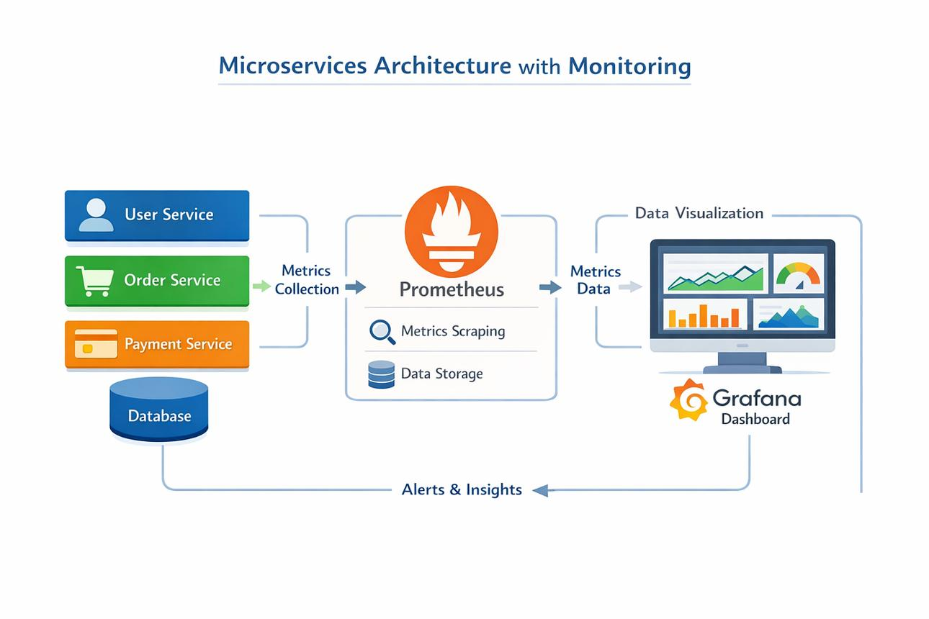
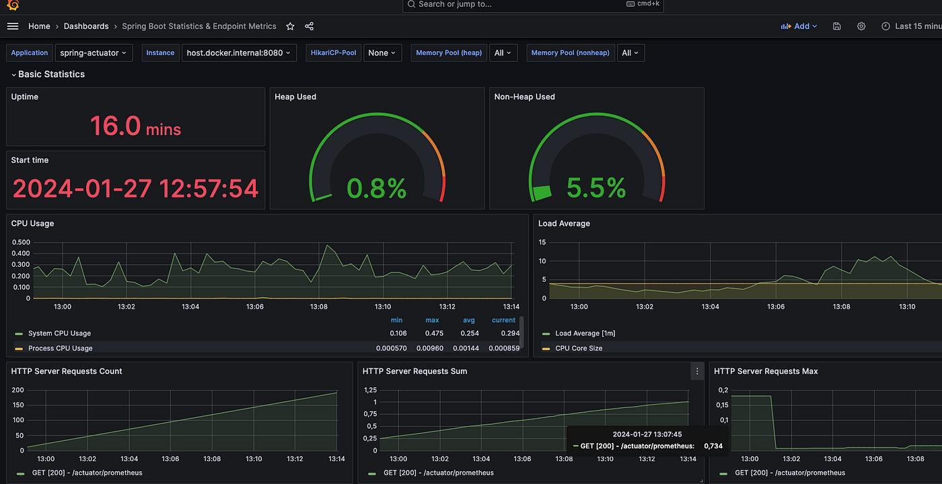

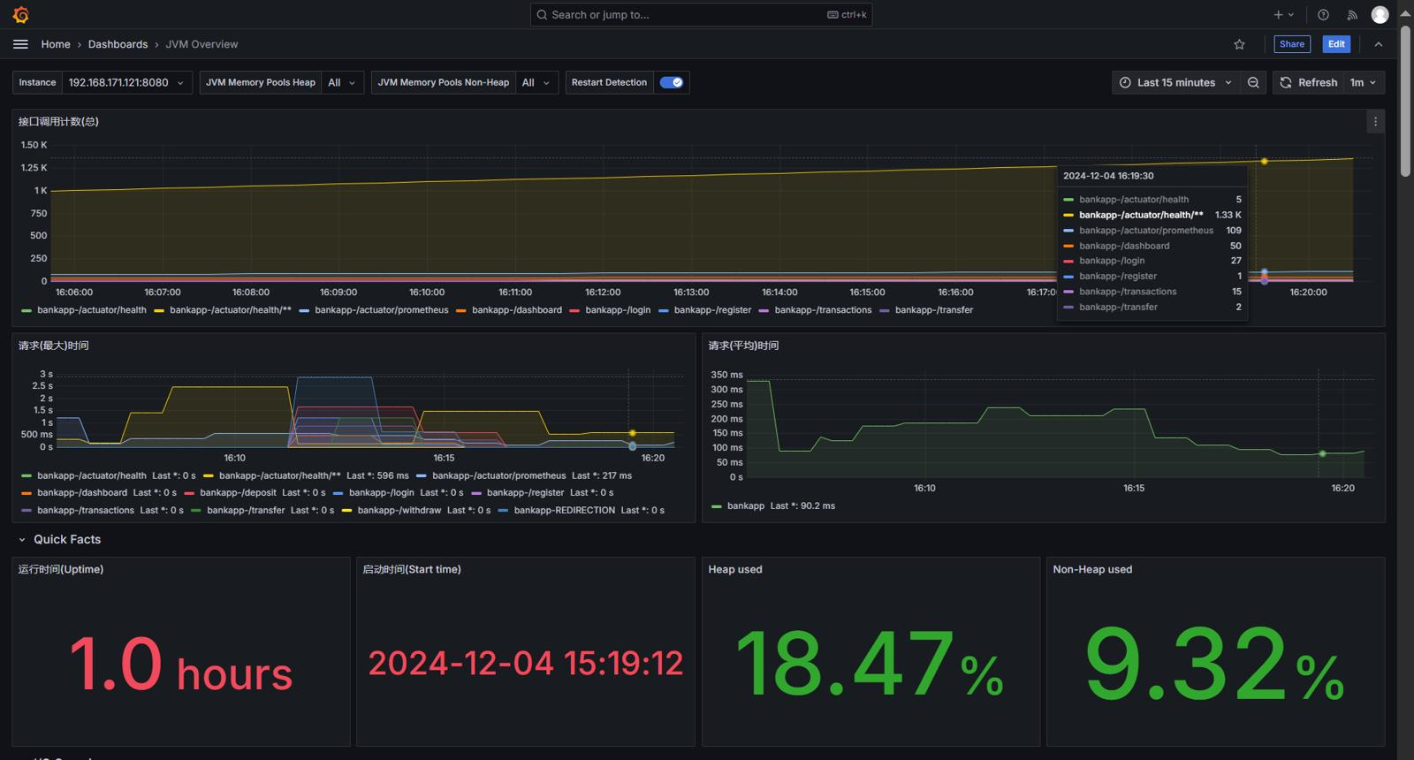

Grafana is an open-source observability and visualization platform.
Simple definition:
Grafana converts metrics into dashboards that humans can easily understand.
Instead of looking at:
jvm_memory_used_bytes 583423232
we can have:
┌──────────────────────────────────────┐
│ PRODUCT SERVICE MONITORING │
├──────────────────────────────────────┤
│ │
│ CPU Memory │
│ ███████ 65% ██████ 580 MB │
│ │
│ Requests/sec Error Rate │
│ 125/sec 2.1% │
│ │
│ Request Latency │
│ ▁▂▃▅▆▃▂▁ │

That is Grafana's strength.

20. Why Do We Need Grafana?
Prometheus is excellent at:
Collecting
Storing
Querying
But developers and operations teams need:
Dashboards
Graphs
Charts
Alerts
Visual analysis
Grafana provides this layer.

21. Grafana Architecture
The complete architecture is:
Spring Boot Application
│
│
Actuator
│
▼
/actuator/prometheus
│
│ scrape
▼
Prometheus
│
Time Series DB
│
│ PromQL
▼
Grafana
│
▼
Dashboard

22. Actuator vs Prometheus vs Grafana
Feature | Actuator | Prometheus | Grafana
Primary role | Exposes application information | Collects/stores metrics | Visualizes metrics
Runs with | Spring Boot app | Monitoring server | Dashboard server
Health checks | Yes | Can monitor health metrics | Displays health
Metrics | Exposes | Collects/stores | Displays
Historical data | Limited/not its primary role | Yes | Uses data sources
Dashboard | No | Basic UI | Excellent
Query language | Endpoint-based | PromQL | Uses datasource query
Alerting | Limited | Yes | Yes
Database | No | Time-series DB | No
Main purpose | Application visibility | Metrics monitoring | Visualization
Remember this:
Actuator exposes → Prometheus collects → Grafana visualizes.
To be precise:
Actuator is the sensor. Prometheus is the recorder. Grafana is the TV screen.

23. Actuator vs Prometheus — Important Distinction
"If Actuator already provides metrics, why do we need Prometheus?"
Suppose:
GET /actuator/metrics
returns:
CPU
Memory
Requests
Threads
That gives us current/runtime information.
But monitoring needs historical information:
10:00 → CPU 20%
11:00 → CPU 35%
12:00 → CPU 75%
13:00 → CPU 90%
Prometheus collects those values over time.
Therefore:
Actuator
↓
Expose metrics

Prometheus
↓
Collect + store metrics

Grafana
↓
Visualize metrics

24. How to Test All Three Together
Let's use:
Spring Boot Product Service
Port: 8081

Prometheus
Port: 9090

Grafana
Port: 3000

STEP 1 — Start Spring Boot Application
Run:
ProductServiceApplication
Suppose:
http://localhost:8081

STEP 2 — Test Actuator Health
Open:
http://localhost:8081/actuator/health
Expected:
{
"status": "UP"
}
🎯 Checkpoint 1
If you see UP, Actuator is working.

25. Test Actuator Metrics
Open:
http://localhost:8081/actuator/metrics
You should see metrics such as:
jvm.memory.used
jvm.threads.live
process.cpu.usage
system.cpu.usage
http.server.requests
Now test:
http://localhost:8081/actuator/metrics/jvm.memory.used
🎯 Checkpoint 2
If you get metric information, Actuator metrics are working.

26. Test Prometheus Endpoint
Open:
http://localhost:8081/actuator/prometheus
You should see Prometheus-formatted metrics:
# HELP ...
# TYPE ...
jvm_memory_used_bytes ...
process_cpu_usage ...
http_server_requests_seconds_count ...
🎯 Checkpoint 3
This proves:
Actuator + Micrometer + Prometheus registry
are working.

27. Start Prometheus
Start Prometheus.
Normally:
http://localhost:9090
Open the Prometheus UI.
Go to:
Status → Targets
You should see something like:
product-service

Endpoint:
http://localhost:8081/actuator/prometheus

State:
UP
🎯 Checkpoint 4
This is VERY important.
If target is:
UP
Prometheus is successfully scraping your Spring Boot application.

28. Test a Prometheus Query
In Prometheus, execute:
process_cpu_usage
Then:
jvm_memory_used_bytes
And:
http_server_requests_seconds_count
You should see metric values.
Try:
rate(http_server_requests_seconds_count[5m])
Now Prometheus is doing real monitoring.

29. Start Grafana
Start Grafana.
Open:
http://localhost:3000
Login.
Then configure:
Connections
↓
Data Sources
↓
Add data source
↓
Prometheus
Set the Prometheus URL:
http://localhost:9090
Click:
Save & Test
You should receive a successful connection.
🎯 Checkpoint 5
Grafana can now communicate with Prometheus.

30. Create a Grafana Dashboard
Create:
Dashboard
↓
Add visualization
Select:
Prometheus
Now create panels.

Panel 1 — CPU
process_cpu_usage

Panel 2 — Memory
jvm_memory_used_bytes

Panel 3 — Requests
rate(http_server_requests_seconds_count[5m])

Panel 4 — JVM Threads
jvm_threads_live_threads
Now you have your first monitoring dashboard.

31. The Most Important Practical Test
This is what I strongly recommend you demonstrate live.
Start your application.
Then continuously call:
GET /products
or any REST endpoint.
For example:
GET http://localhost:8081/products
Generate 100–500 requests.
Then observe:
Actuator
↓
metrics change

Prometheus
↓
stores new values

Grafana
↓
graph changes
Students can actually see monitoring happening in real time.

32. Microservices Monitoring
Now take this to the next level.
Suppose we have:
API Gateway
│
┌──────────────┼──────────────┐
│ │ │
▼ ▼ ▼
Product Order Payment
Service Service Service
:8081 :8082 :8083
│ │ │
└──────────────┼──────────────┘
│
▼
Prometheus
│
▼
Grafana
Each microservice exposes:
/actuator/prometheus
Prometheus scrapes all of them.
Example:
scrape_configs:

- job_name: product-service
metrics_path: /actuator/prometheus
static_configs:
- targets: ['localhost:8081']

- job_name: order-service
metrics_path: /actuator/prometheus
static_configs:
- targets: ['localhost:8082']

- job_name: payment-service
metrics_path: /actuator/prometheus
static_configs:
- targets: ['localhost:8083']
Grafana can then show:
Product Service UP
Order Service UP
Payment Service UP

CPU
Memory
Requests
Errors
Latency
This is where Actuator + Prometheus + Grafana becomes very valuable in a microservices architecture.

