ELK STACK

Centralized Logging and Log Analysis for Microservices

Prometheus + Grafana tells us WHAT is happening.
ELK Stack helps us understand WHY it happened.

For example:
Grafana:
Error rate increased to 25%

Developer:
Why? What exactly failed?

ELK:
2026-09-10 10:32:15 ERROR
PaymentGatewayException:
Connection timed out while calling payment provider
That creates a beautiful connection between the two topics.
1. What is the ELK Stack?
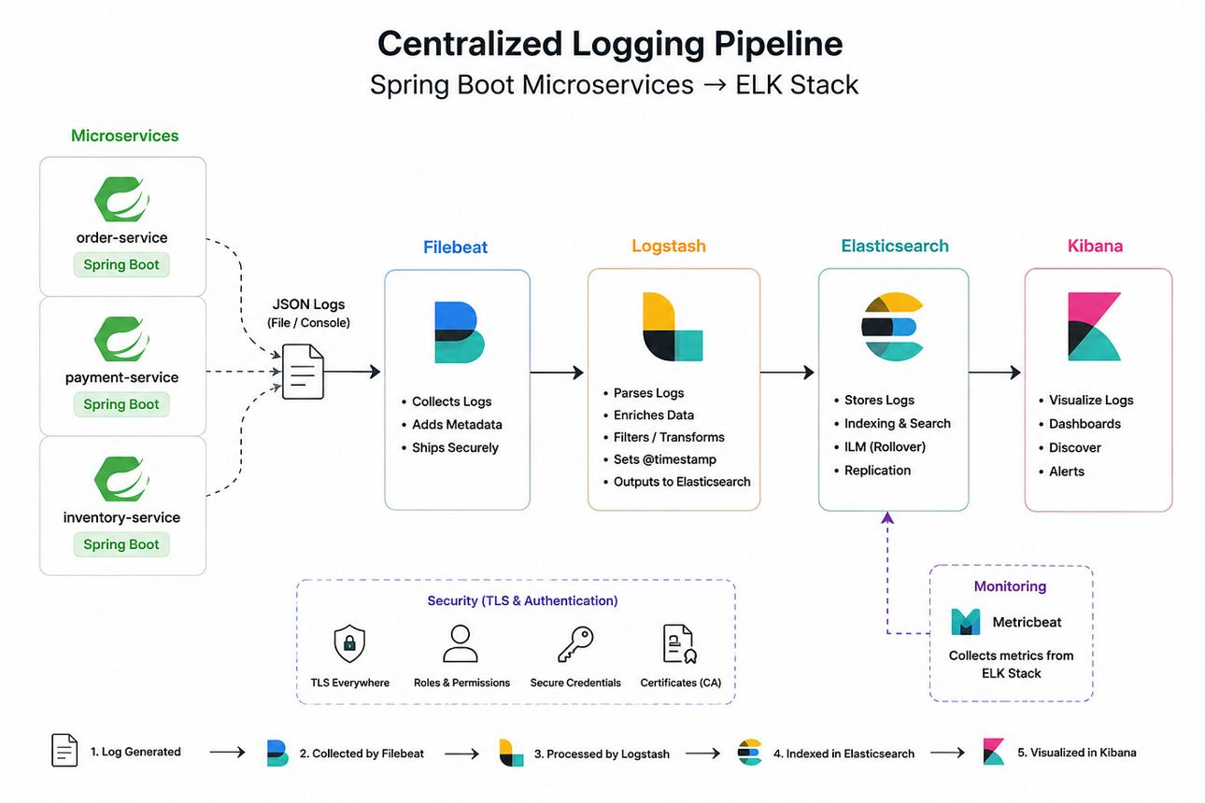
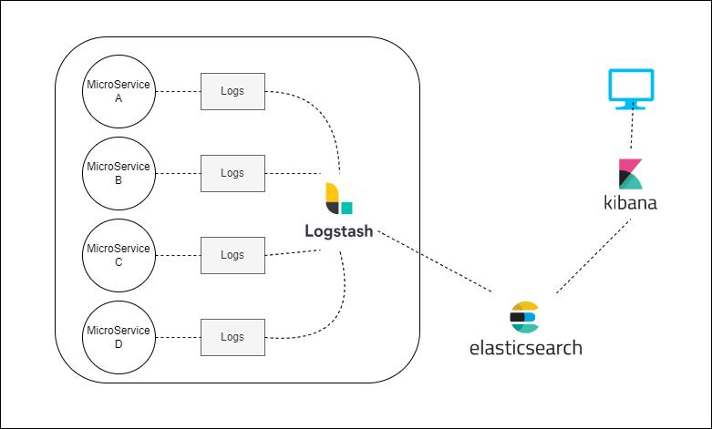

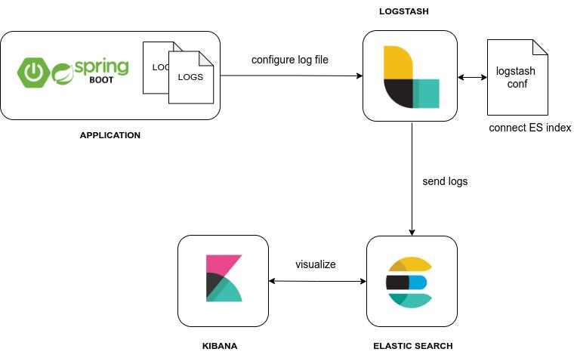
ELK Stack is a collection of technologies used to collect, process, store, search, analyze and visualize logs.
ELK stands for:
E = Elasticsearch
L = Logstash
K = Kibana
The basic architecture is:
Spring Boot Applications
│
│ Logs
▼
Logstash
│
│ Process / Transform
▼
Elasticsearch
│
│ Store / Search
▼
Kibana
│
│ Visualize
▼
Developers / DevOps
The simplest explanation for our is:
Logstash collects logs. Elasticsearch stores and searches logs. Kibana visualizes logs.

2. Why Do We Need ELK Stack?
Imagine we have a microservices application containing:
Product Service
Order Service
Payment Service
Inventory Service
Notification Service
Email Service
API Gateway
Auth Service
Each service produces its own logs.
For example:
product-service.log
order-service.log
payment-service.log
inventory-service.log
notification-service.log
Now a customer says:
"My order failed."
Where should we check?
Order Service?
Payment Service?
Inventory Service?
Notification Service?
API Gateway?
A developer may need to log into multiple servers and search through thousands of log lines.
That becomes difficult.
ELK solves this problem through:
Centralized Logging
Instead of this:
Developer
│
├── Server 1 → product-service.log
│
├── Server 2 → order-service.log
│
├── Server 3 → payment-service.log
│
└── Server 4 → inventory-service.log
We get:
All Services
│
▼
Centralized Log Platform
│
▼
Kibana
Now logs can be searched from one place.

3. The Real Problem ELK Solves
Consider an e-commerce application.
A customer places an order.
The request travels like this:
Customer
│
▼
API Gateway
│
▼
Order Service
│
├──────────► Inventory Service
│
└──────────► Payment Service
│
▼
Payment Provider
Suppose the payment fails.
Without centralized logging:
Developer checks:
payment-service.log
Maybe nothing is obvious.
Then:
Check order-service.log
Then:
Check API Gateway logs
Then perhaps:
Check another server...
Log hunting begins!
With ELK:
Kibana Search:
correlationId = ORD-12345
We can potentially trace related log events across services, provided the application is designed to include and propagate a correlation/trace ID.
API Gateway:
ORD-12345 → Request received

Order Service:
ORD-12345 → Order created

Inventory Service:
ORD-12345 → Stock reserved

Payment Service:
ORD-12345 → Payment initiated

Payment Service:
ORD-12345 → ERROR: Connection timeout
Now the failure location becomes much easier to identify.

4. What is Logstash?
Logstash is a data collection and processing pipeline.
The easiest explanation:
Logstash receives logs, processes them and sends them to a destination such as Elasticsearch.
Think of Logstash as a log processing factory.
Raw Logs
│
▼
LOGSTASH
│
├── Read
├── Parse
├── Filter
├── Transform
└── Forward
│
▼
Elasticsearch
Logstash generally works using three major concepts:
INPUT
↓
FILTER
↓
OUTPUT

5. Logstash Input
Input defines where Logstash receives data from.
Examples include:
Spring Boot application
Log files
Beats
Kafka
TCP
HTTP
Other systems
Conceptually:
input {
...
}
Example:
input {
tcp {
port => 5000
}
}
Meaning:
"Listen for log events on this input."
The exact input used depends on your logging architecture.

6. Logstash Filter
This is where Logstash becomes powerful.
Suppose it receives:
2026-09-10 10:30:15 ERROR
Payment failed for order ORD-123
Logstash can parse the event into structured fields such as:
timestamp = 2026-09-10 10:30:15
level = ERROR
message = Payment failed
orderId = ORD-123
This is important because:
Structured data is easier to search and analyze than one large text message.
For example:
filter {
grok {
...
}
}
Filters can be used for:
Parsing
Extracting fields
Transforming data
Removing fields
Adding fields
Enriching logs

7. Logstash Output
After processing, Logstash sends data somewhere.
For ELK:
Logstash
│
▼
Elasticsearch
Conceptually:
output {
elasticsearch {
hosts => ["elasticsearch:9200"]
}
}

8. The Logstash Pipeline
Remember:
LOGSTASH
┌────────────────┐
│ │
INPUT ──► FILTER ──► OUTPUT
│ │
└────────────────┘
Example:
Spring Boot Logs
│
▼
INPUT
│
▼
FILTER
│
├── Extract timestamp
├── Extract log level
├── Extract service name
├── Extract correlation ID
│
▼
OUTPUT
│
▼
Elasticsearch

9. What Information Can Logstash Process?
Logstash can process log events containing information such as:
Timestamp
Log Level
Service Name
Application Name
Thread Name
Logger Name
Message
Exception
Stack Trace
Request ID
Correlation ID
User-related request context where appropriate
For example:
2026-09-10 10:30:15
ERROR
payment-service
thread=http-nio-8083-exec-4
correlationId=ORD-12345

PaymentGatewayException:
Connection timeout
When structured properly, this becomes very powerful for searching.

10. What is Elasticsearch?



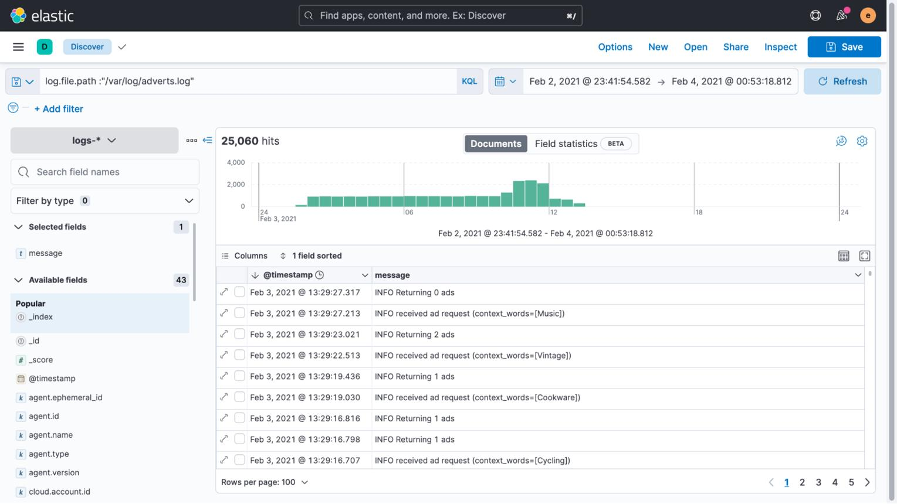

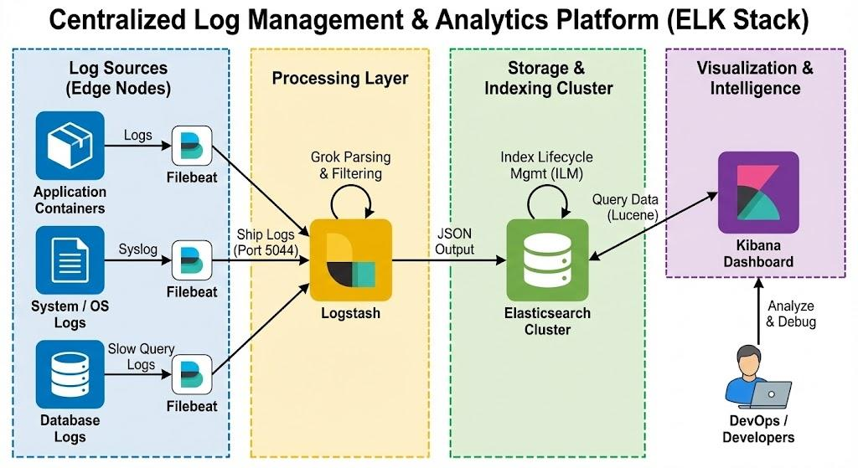

Elasticsearch is a distributed search and analytics engine.
In the ELK architecture:
Elasticsearch stores, indexes and allows fast searching of log data.
The key word is:

SEARCH
Suppose millions of logs exist:
10,000
100,000
1,000,000
10,000,000 log events
We may want to find:
All ERROR logs
or:
All payment failures
or:
All logs from payment-service
or:
All failures between 10:00 AM and 10:10 AM
Elasticsearch is designed to make this kind of searching and analysis fast.

11. Why Do We Need Elasticsearch?
Imagine logs stored only as files:
payment-service.log
You may have to search manually:
grep ERROR payment-service.log
Now imagine:
100 microservices
100 servers
Millions of logs
Manual searching becomes impractical.
Elasticsearch provides centralized indexing and searching.
All Logs
│
▼
Elasticsearch
│
├── Search
├── Filter
├── Aggregate
└── Analyze

12. Important Elasticsearch Concepts
For beginners, teach these concepts.

Document
A single JSON record.
Example:
{
"@timestamp": "2026-09-10T10:30:15Z",
"service": "payment-service",
"level": "ERROR",
"message": "Payment provider connection timed out"
}
Think of it as:
One log event.

Index
An index is a logical collection used to organize documents.
For example:
logs-payment-service
logs-order-service
logs-product-service
Conceptually:
Index
│
├── Document 1
├── Document 2
├── Document 3
└── Document 4

Cluster
Multiple Elasticsearch nodes can work together as a cluster.
Elasticsearch Cluster
┌──────────┬──────────┐
│ │ │
▼ ▼ ▼
Node 1 Node 2 Node 3
This helps Elasticsearch scale and provide resilience.

13. What Information Does Elasticsearch Store?
In our logging architecture, it can store structured log events such as:
Timestamp
Service
Environment
Log level
Message
Exception
Stack trace
Request ID
Correlation ID
HTTP method
Endpoint
Response status
Duration
Example:
{
"@timestamp": "2026-09-10T10:30:15",
"service": "order-service",
"environment": "production",
"level": "ERROR",
"correlationId": "ORD-12345",
"message": "Payment failed",
"exception": "PaymentGatewayException"
}
Now Kibana can search:
service = payment-service
AND
level = ERROR

14. What is Kibana?
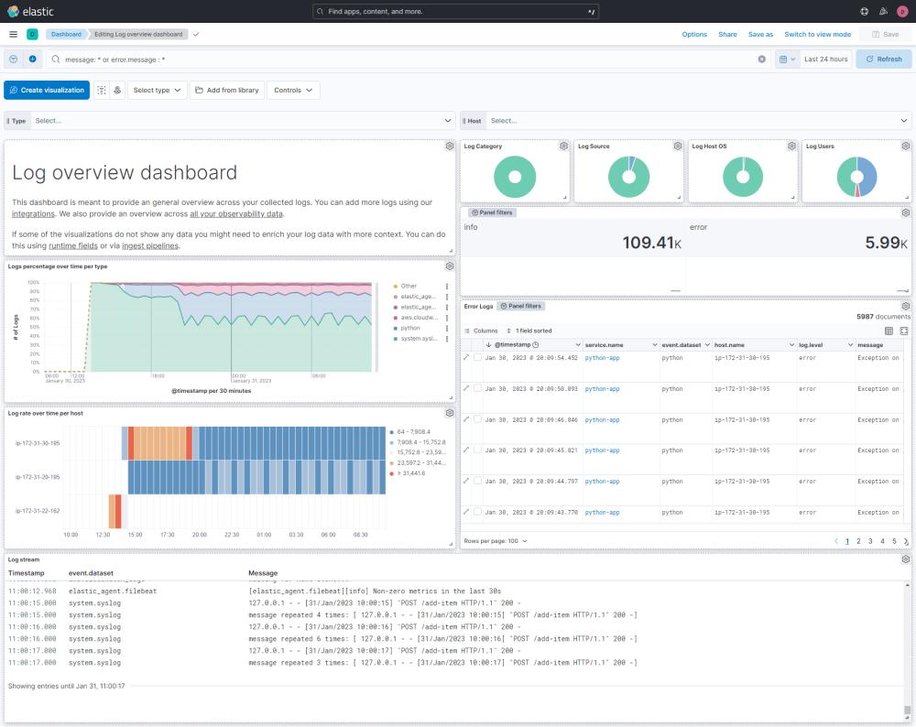
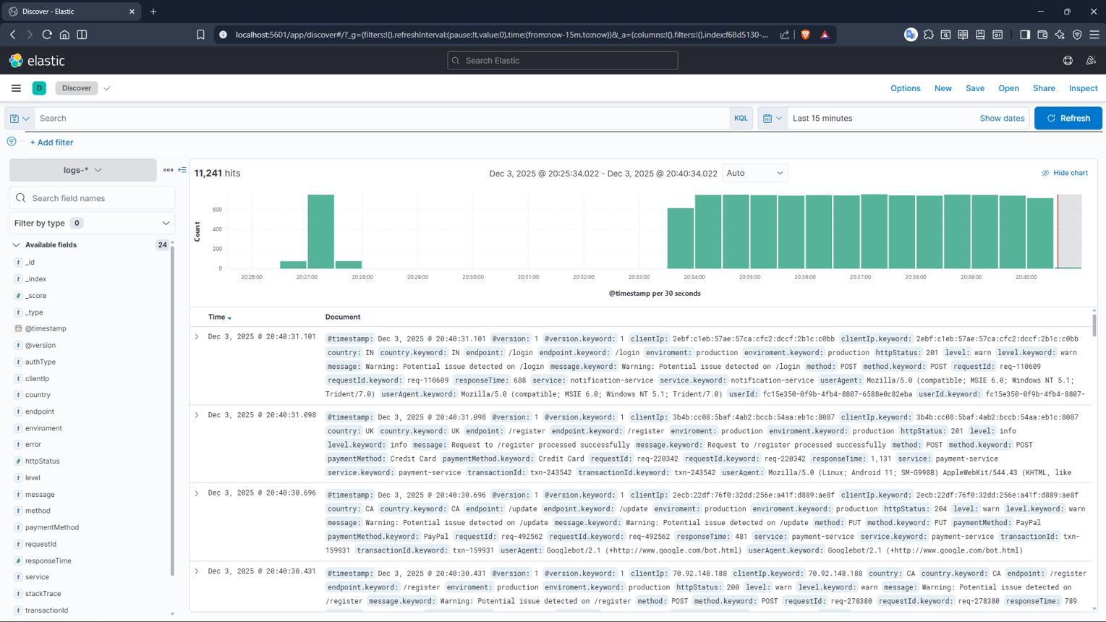
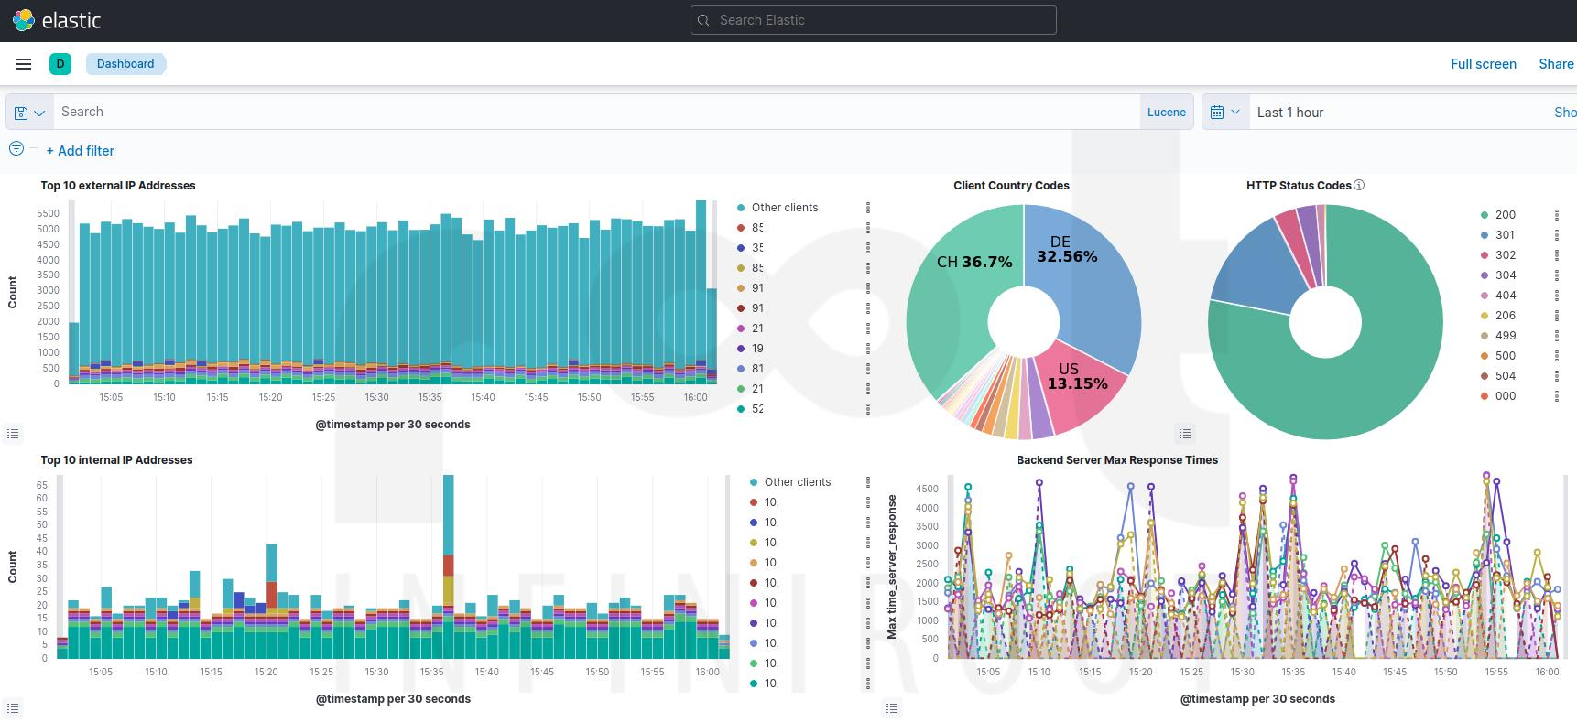
Kibana is a data visualization and exploration tool that works with Elasticsearch.
Simple explanation:
Kibana allows humans to search, explore and visualize data stored in Elasticsearch.
Suppose Elasticsearch contains:
10 million log events
Kibana helps us answer:
Show ERROR logs
Show payment-service logs
Show failures during the last hour
Show number of errors by service
Show error trend over time

15. Kibana Discover
One of the most useful features is:
Discover
Imagine a search screen like:
Time: Last 15 minutes

Service: payment-service
Level: ERROR

-----------------------------------------

10:30:15 ERROR Payment timeout
10:30:12 ERROR Connection refused
10:29:55 ERROR Payment provider unavailable
This allows developers to investigate production issues.

16. Kibana Dashboards
Kibana can also visualize log information.
For example:
┌────────────────────────────────────┐
│ APPLICATION LOG DASHBOARD │
├────────────────────────────────────┤
│ │
│ Total Logs ERROR Logs │
│ 1,250,000 1,250 │
│ │
│ Errors by Service │
│ │
│ Order Service ███ │
│ Payment Service ██████████ │
│ Product Service ██ │
│ │
│ Errors Over Time │
│ ▁▂▂▃▄▇████▆▃▂ │
│ │
└────────────────────────────────────┘
This helps identify patterns quickly.

17. The Complete ELK Architecture
Here is the architecture I recommend this first:
SPRING BOOT MICROSERVICES

┌──────────────┐
│Product Service│
└──────┬───────┘
│ Logs
┌──────▼───────┐
│ │
│Order Service │
│ │
└──────┬───────┘
│ Logs
▼
LOGSTASH
┌──────────────┐
│ INPUT │
│ ↓ │
│ FILTER │
│ ↓ │
│ OUTPUT │
└──────┬───────┘
│
▼
ELASTICSEARCH
┌──────────────┐
│ Store / Index│
│ Search │
│ Analyze │
└──────┬───────┘
│
▼
KIBANA
┌──────────────┐
│ Search │
│ Discover │
│ Visualize │
│ Dashboard │
└──────────────┘

18. ELK Stack — Role of Each Component
Component | Main Responsibility
Logstash | Collect and process logs
Elasticsearch | Store, index and search logs
Kibana | Search, explore and visualize logs
The golden line:
Logstash processes → Elasticsearch stores/searches → Kibana visualizes.

19. ELK Stack vs Actuator + Prometheus + Grafana
This is an extremely important comparison for your our.
Feature | Actuator + Prometheus + Grafana | ELK Stack
Main focus | Metrics and monitoring | Logs and log analysis
Main question | What is happening? | Why did it happen?
Data | Metrics | Logs
Example | CPU = 90% | OutOfMemoryError
Historical trends | Yes | Yes
Request rate | Excellent | Possible but not primary purpose
Memory usage | Excellent | Not primary purpose
Error message | Limited | Excellent
Stack trace | No/limited | Excellent
Root cause investigation | Limited | Excellent
Visualization | Grafana | Kibana

Best real-world approach
Use both:
Prometheus + Grafana
+
ELK
Because:
Prometheus/Grafana
↓
Detect the problem

ELK
↓
Investigate the problem

20. A Perfect Production Example
Suppose Grafana shows:
Payment Service

CPU: 92%
Memory: 85%
Error Rate: 18%
Latency: 8 seconds
The monitoring team knows:
Something is wrong!
But what exactly?
Open Kibana.
Search:
service: "payment-service"
AND
level: "ERROR"
Results:
10:30:01 ERROR Connection timeout
10:30:03 ERROR Connection timeout
10:30:05 ERROR Connection timeout
10:30:07 ERROR Connection timeout
Further logs show:
PaymentGatewayException:
External payment provider did not respond
Now we know:
Grafana → Detected problem
Kibana → Found the reason
This is the best connection between your previous topic and ELK.

21. How Does a Spring Boot Application Generate Logs?
Spring Boot applications commonly use a logging facade/API such as:
SLF4J
with a logging implementation such as:
Logback
For example:
private static final Logger log =
LoggerFactory.getLogger(PaymentService.class);
Then:
log.info("Payment started for order {}", orderId);

log.warn("Payment is taking longer than expected for order {}", orderId);

log.error("Payment failed for order {}", orderId, exception);
The logs may look like:
2026-09-10 10:30:01 INFO
Payment started for order ORD-123

2026-09-10 10:30:03 WARN
Payment is taking longer than expected for order ORD-123

2026-09-10 10:30:05 ERROR
Payment failed for order ORD-123
These logs then enter the centralized logging pipeline.

22. Complete Logging Flow
Spring Boot Application
│
▼
SLF4J Logging API
│
▼
Logback
│
▼
Application Logs
│
▼
Logstash
│
▼
Elasticsearch
│
▼
Kibana

Remember
SLF4J
↓
API / Abstraction

Logback
↓
Actual logging implementation

Logstash
↓
Collect/process logs

Elasticsearch
↓
Store/search logs

Kibana
↓
Visualize logs
This is a very good slide by itself.

23. Why Use SLF4J Instead of System.out.println()?
Bad approach:
System.out.println("Payment completed");
Problems:
No log level
Poor configurability
No proper logging framework features
Harder production management
Professional approach:
log.info("Payment completed successfully");
Or:
log.error("Payment failed for order {}", orderId, exception);
Now we have levels:
TRACE
DEBUG
INFO
WARN
ERROR

24. Log Levels
TRACE
↓
DEBUG
↓
INFO
↓
WARN
↓
ERROR

TRACE
Very detailed diagnostic information.
log.trace("Entering calculateTotal()");

DEBUG
Developer debugging information.
log.debug("Cart contains {} items", itemCount);

INFO
Normal important application events.
log.info("Order {} created successfully", orderId);

WARN
Something unexpected, but the application can continue.
log.warn("Inventory is low for product {}", productId);

ERROR
A serious operation failed.
log.error("Payment failed for order {}", orderId, exception);

25. Correlation ID — Very Important in Microservices
Suppose one request travels through:
API Gateway
↓
Order Service
↓
Payment Service
↓
Notification Service
Each service creates logs.
How do we know all these logs belong to one customer request?
Use:
Correlation ID
For example:
CORR-ABC-123
Every service logs:
[CORR-ABC-123] Request received

[CORR-ABC-123] Order created

[CORR-ABC-123] Payment initiated

[CORR-ABC-123] Payment failed
In Kibana, search:
CORR-ABC-123
Now we can follow the request across services.
This is called distributed request correlation.

26. ELK Endpoints / Ports
For a basic local setup, we commonly interact with services on ports such as:
Component | Common Port | Purpose
Elasticsearch | 9200 | REST/API access
Elasticsearch | 9300 | Internal transport in traditional deployments
Kibana | 5601 | Web UI
Logstash | Depends on pipeline | Log input
For example:
Elasticsearch
http://localhost:9200
Kibana:
http://localhost:5601
Note: Logstash does not have one universal application endpoint for receiving logs. Its ports depend on the configured input plugins and pipeline.

27. How to Test ELK Locally
Let's assume:
Spring Boot Application
Port: 8081

Elasticsearch
Port: 9200

Kibana
Port: 5601

STEP 1 — Start Elasticsearch
Verify that Elasticsearch is running.
Access its local endpoint.
A successful response generally provides cluster/node information in JSON.
Checkpoint 1
Elasticsearch is reachable.

STEP 2 — Start Kibana
Open Kibana on:
http://localhost:5601
Checkpoint 2
Kibana is available.

STEP 3 — Start Logstash
Configure the pipeline:
INPUT
↓
FILTER
↓
OUTPUT → Elasticsearch
Start Logstash.
Checkpoint 3
Logstash is ready to receive/process events.

STEP 4 — Start Spring Boot Application
Start:
product-service
Generate logs:
log.info("Product service started");

log.info("Fetching all products");

log.warn("Product stock is low");

log.error("Unable to fetch product details", exception);
These events should flow through the logging pipeline.

28. Test the Complete Flow

Generate a Request
Call:
GET /products
Application logs:
INFO Fetching products
Then create an intentional test failure in a safe development environment:
GET /products/invalid
Application logs:
ERROR Product not found
Now check the complete flow:
Spring Boot
↓
Logstash
↓
Elasticsearch
↓
Kibana
In Kibana:
Discover
↓
Select your log data view
↓
Search
Search:
ERROR
You should find the error log.
Checkpoint 4
Centralized logging is working.

29. A Very Good Kibana Test
Generate multiple types of logs.
INFO × 100
WARN × 20
ERROR × 5
Then use Kibana to analyze:
How many ERROR logs?
Which service generated the most errors?
When did the errors begin?
Which exception occurred most frequently?

30. Complete Microservices ELK Architecture
API GATEWAY
│
┌──────────────┼──────────────┐
│ │ │
▼ ▼ ▼
PRODUCT ORDER PAYMENT
SERVICE SERVICE SERVICE
│ │ │
│ Logs │ Logs │ Logs
└──────────────┼──────────────┘
│
▼
LOGSTASH
Collect / Process
│
▼
ELASTICSEARCH
Store / Index/Search
│
▼
KIBANA
Search / Dashboard
│
▼
DEVELOPERS / DEVOPS

31. ELK + Prometheus + Grafana Together
Now this is the complete observability story.
MICROSERVICES
│
┌────────────┴────────────┐
│ │
▼ ▼
METRICS LOGS
│ │
▼ ▼
ACTUATOR SLF4J
│ │
▼ ▼
PROMETHEUS LOGBACK
│ │
▼ ▼
GRAFANA LOGSTASH
│
▼
ELASTICSEARCH
│
▼
KIBANA

Left Side — Metrics
Actuator
↓
Prometheus
↓
Grafana
How is the system behaving?
For example:
CPU = 90%
Memory = 85%
Error Rate = 20%
Latency = 8 seconds

Right Side — Logs
SLF4J
↓
Logback
↓
Logstash
↓
Elasticsearch
↓
Kibana
Answers:
What exactly happened and why?
For example:
ERROR PaymentGatewayException:
Connection timed out

32. Metrics vs Logs

Metrics | Logs
Numeric measurements | Detailed event records
CPU = 80% | OutOfMemoryError
Memory = 2 GB | Database connection failed
Requests = 500/sec | Payment failed for ORD-123
Excellent for trends | Excellent for investigation
Prometheus | Elasticsearch
Grafana | Kibana

Golden sentence
Metrics tell us that something is wrong. Logs tell us what went wrong.

33. Real Production Incident
Imagine:

10:00 AM
Grafana:
Error Rate = 1%
Everything looks fine.

10:05 AM
Grafana:
Error Rate = 15%
Alert!
Developer opens Kibana.
Search:
service = payment-service
level = ERROR
Results:
10:05:01 Connection timeout
10:05:03 Connection timeout
10:05:05 Connection timeout
10:05:07 Connection timeout
Further search shows:
External payment provider unavailable
The investigation becomes:
Grafana detected the incident
↓
Kibana investigated the incident
↓
Developers fixed the root cause

