Proposal: QAI Agents Framework

# 1. Purpose

The purpose of this proposal is to present the QAI Agents Framework — a deployable, hybrid Quantum-AI execution and management platform. It combines classical AI agent technologies, quantum computation models, and orchestration mechanisms to deliver advanced solutions across enterprise, industrial, and research applications. The framework integrates our internal products (QAI Processor, QAI OS, QAI Datacenter) with classical runtimes and modern agentic AI.

# 2. Merit

The framework delivers several merits:  
- Unified orchestration of classical, quantum, and hybrid tasks.  
- Maturity-aware governance of quantum workloads.  
- Support for Quantum Computational Agents (QCA), QMARL, and automated circuit design.  
- Reuse of internal assets such as Bhadale QAI Hub, Org Framework, and PLM integration.  
- Improved explainability, provenance, and monitoring for agentic tasks.  
- Extensible adapter registry for Qiskit, PennyLane, Cirq, Azure Quantum, and internal runtimes.  
- Portable deployment on Windows, Linux, MacOS with browser and desktop clients.

# 3. Product Stack and Architecture

The stack spans multiple layers:  
1. Clients (Browser React, Win Desktop, Mobile).  
2. API Gateway (Auth, Validation, Maturity check).  
3. Bhadale QAI Hub (Control Plane) with Planner, Crew, Policy, Adapter Registry, AutoCircuit Designer, QMARL Training Service, Simulation Sandbox, and PLM/Artifact Store.  
4. Middleware (gRPC, Kafka, RabbitMQ, Temporal).  
5. Worker Pools (Classical Workers, Hybrid Executors, QCA Agents, QMARL Agents, AutoCircuit Workers, QPU Broker + Adapters, Simulators).  
6. Infra/Deployment (Kubernetes, CI/CD, QAI Datacenter).  
7. Monitoring, Audit, and KPI dashboards.

Architecture Diagram:

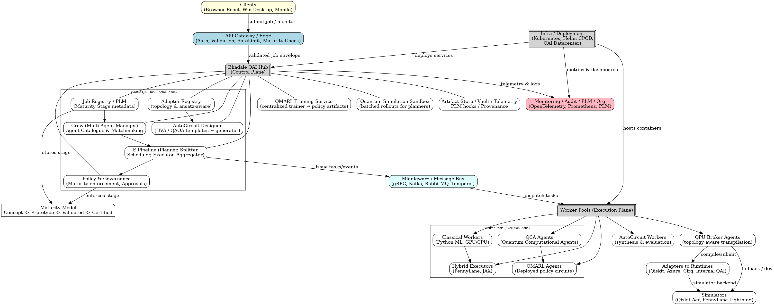

# 4. Subtasks Summary (from demo)

|  |  |  |  |  |  |
| --- | --- | --- | --- | --- | --- |
| Task ID | Type | Agent | Mean | Shots | Backend |
| 8aac2435-f86e-4de8-8e4b-7d9c58f09645 | auto_circuit | auto_circuit_service | None | None | None |
| c321d793-f23a-4b76-b18b-d4de940e5754 | hybrid_loop | qpu_broker:internal_qai | 0.5384614062621343 | 1024 | internal_qai |

# 5. Internal Products

|  |  |  |  |
| --- | --- | --- | --- |
| Product | Property | Value | Notes |
| QAI_Processor | Id | QAI-PROC-01 | Dummy internal processor - low-latency |
| QAI_Processor | Status | available |  |
| QAI_Processor | Notes | Dummy internal processor - low-latency |  |
| QAI_OS | Version | 0.1.0-dummy |  |
| QAI_OS | Status | deployed |  |
| QAI_OS | Nodes | 2 |  |
| QAI_Datacenter | Location | On-Prem Lab |  |
| QAI_Datacenter | available_nodes | 4 |  |
| QAI_Datacenter | Cooling | OK |  |

# 6. KPI Figures

