QAI_Agile_Product_Owner (QAI_APO) Master Framework Proposal

# 1. Sample Client Order

Client: QuantumTech Industries

Order: Hybrid QAI Processor + OS Prototype

Budget: 2M USD

Deadline: 6 months

Strategic Goals: Post-Quantum Security, Fidelity >99%, Low Cryogenic Power

# 2. Lifecycle Layers

* Business & Strategy (QAI PLM)
* Planning & Roadmap (QAI PLM, QAI Ops)
* Agile Execution (QAI Processor, QAI OS)
* Delivery & Feedback (QAI Ops)
* Systems & Blueprint (QAI PLM)
* Manufacturing & Prototype (QAI Robotics, QAI Transducers)
* Continuous Learning (QAI Ops, QAI Datacenter)

# 3. Key Roles

* Client, Product Owner, Scrum Master, Developers
* R&D Scientists, Systems Engineer (P.Eng), Fab Engineer
* Managers, External Stakeholders

# 4. Processes & Functions

|  |  |  |  |
| --- | --- | --- | --- |
| Layer/Phase | Processes | Functions | Iteration |
| Business & Strategy | Requirement intake, Charter | Align strategy, capture vision | Pre-PI |
| Planning | PI Planning, Budgeting | Break epics, set priorities | PI Cycle |
| Execution | Sprint Planning, CI/CD | Build, Test, Integrate | Sprint |
| Delivery | Demo, Review, Retro | Validate increment, capture feedback | End Sprint/PI |
| Blueprint | MBSE, CAD | Translate backlog to design | Design Iteration |
| Manufacturing | Lean + Six Sigma, Fab | Produce prototype, minimize waste | Fab Cycle |
| Learning | Retros, Innovation | Improve processes, scale innovation | Continuous |

# 5. KPI Dashboard

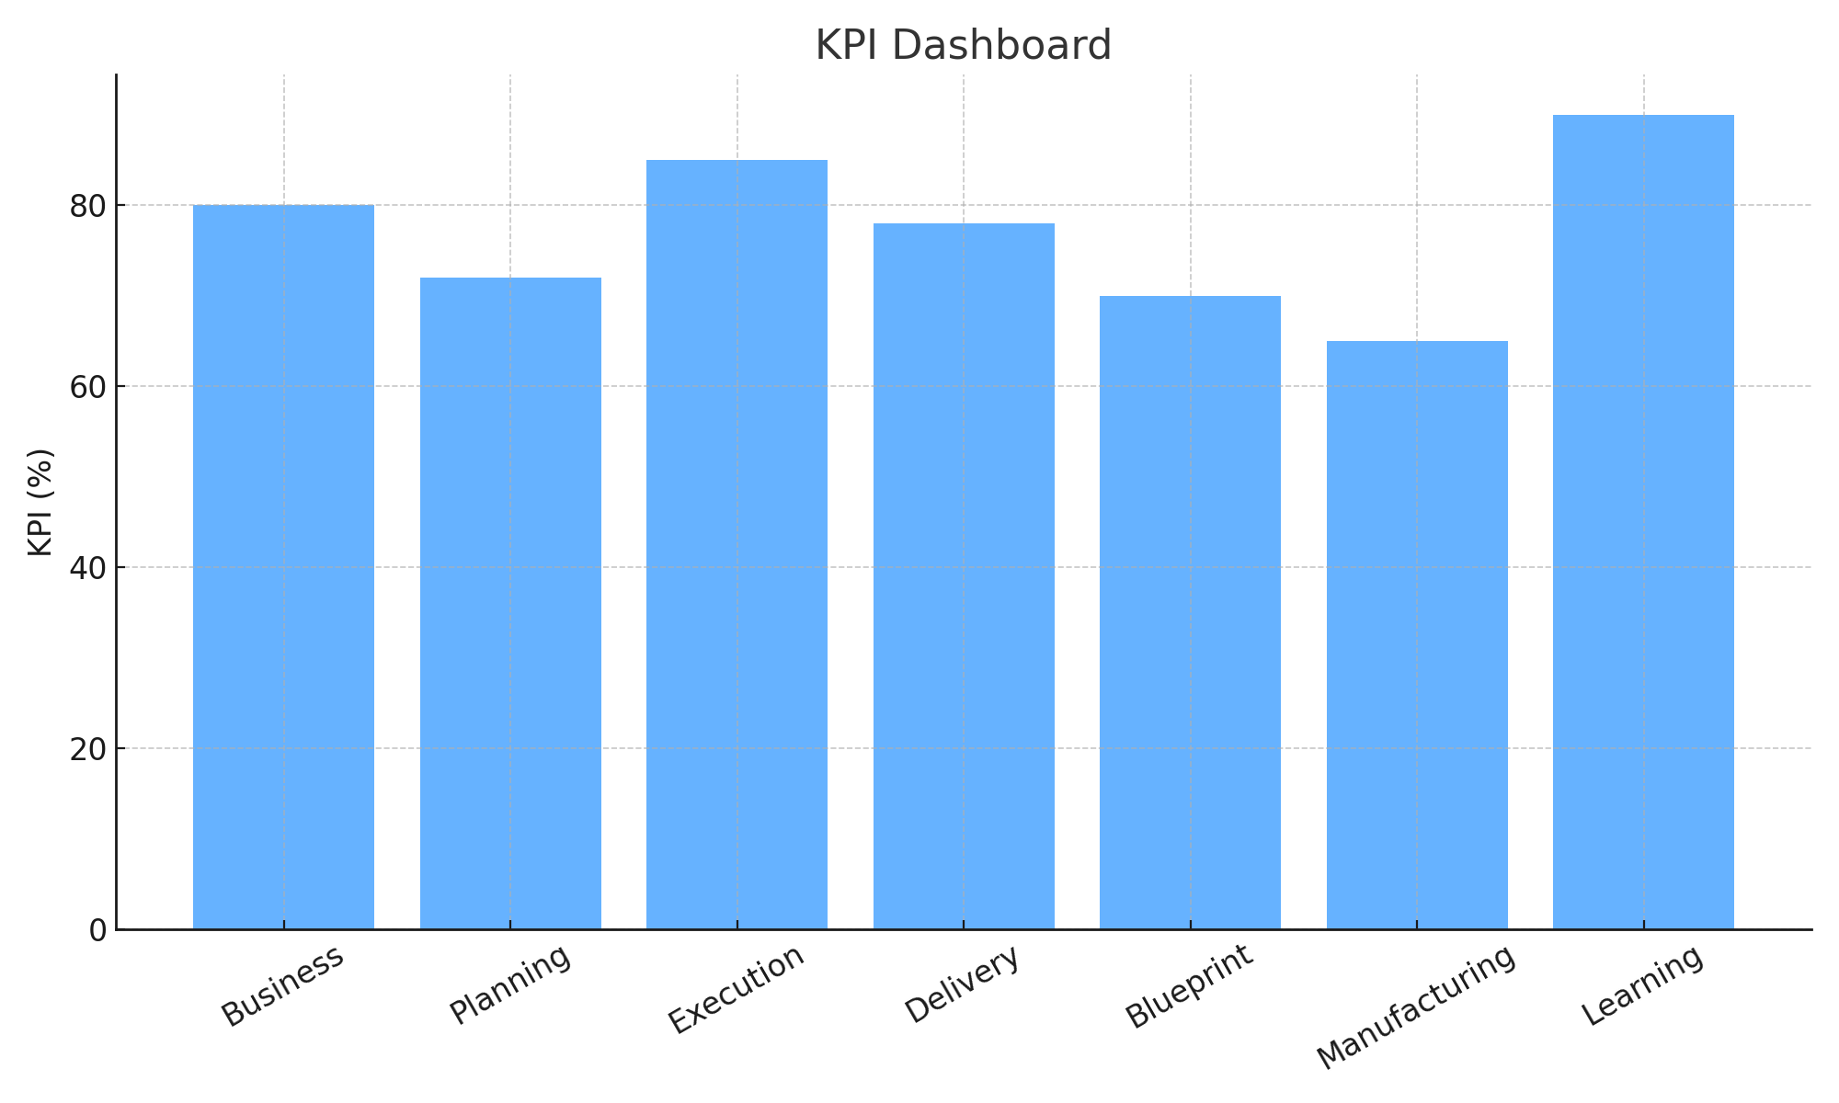

# 6. Manufacturing Yield Trend

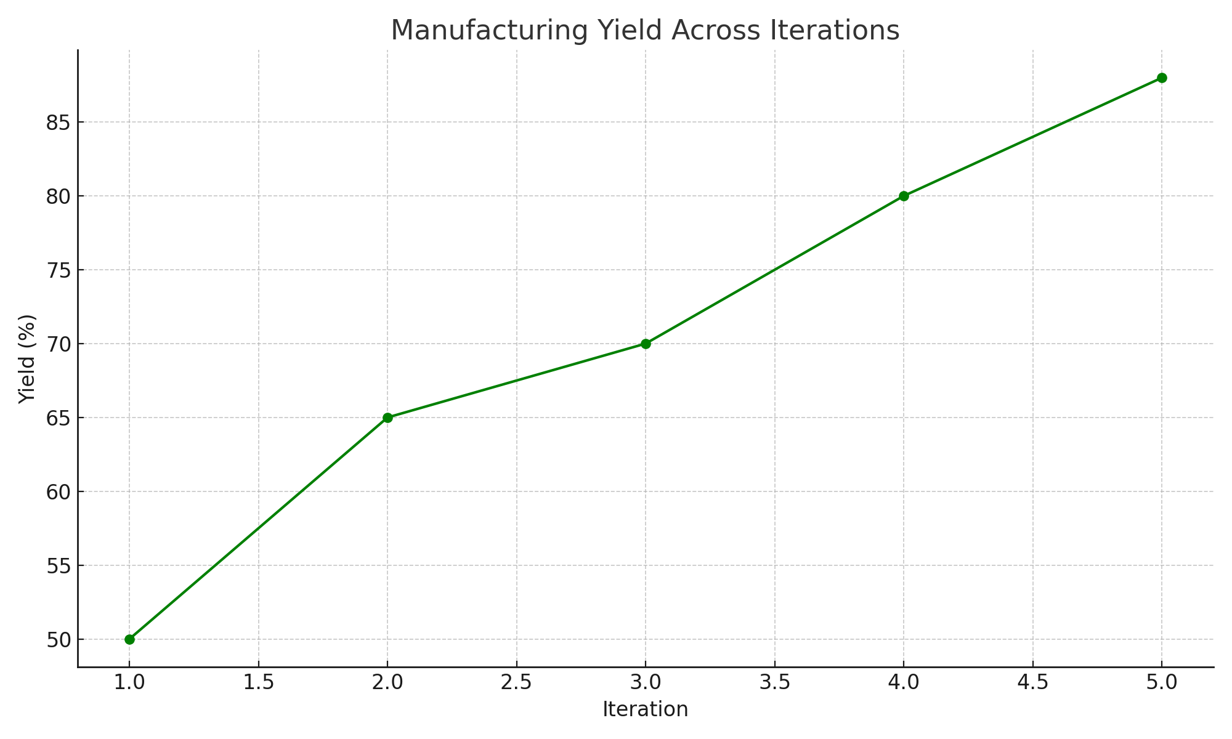

# 7. Release & Milestones

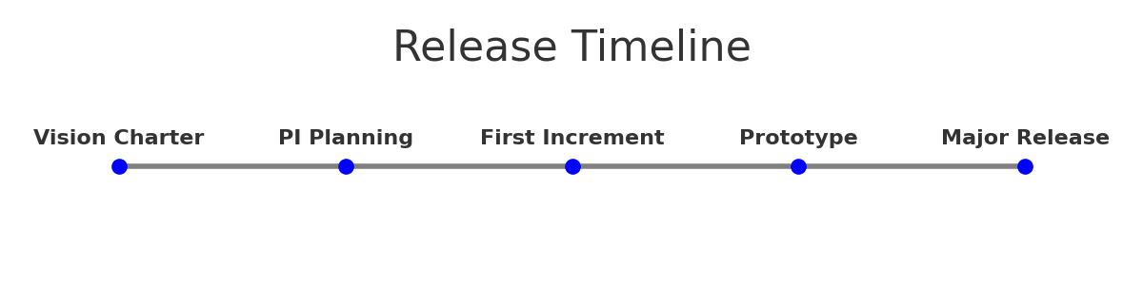

# 8. Quantum AI Feature Integration

|  |  |
| --- | --- |
| Area | QAI Feature |
| Planning | Quantum simulation fallback |
| Execution | Hybrid instruction forwarding (QAI Processor + OS) |
| Manufacturing | Nano fabrication w/ cryogenics (QAI Robotics, Transducers) |
| Security | Post-Quantum Cryptography (QAI OS Security Layer) |
| Operations | Quantum-classical bridges (QAI Datacenter) |