QAI_Agile_Product_Owner (QAI_APO) Master Framework Proposal

# Chapter 1: Executive Summary

The QAI_Agile_Product_Owner (QAI_APO) Master Framework provides an integrated approach to Agile Product Ownership in Quantum AI projects. It unifies Agile practices, systems engineering, software development, manufacturing, and compliance into a single structured lifecycle. Outcomes include faster prototyping, reduced waste, measurable KPIs, and compliance with global standards.

# Chapter 2: Problem Statement

Quantum AI projects face fragmentation across business strategy, agile execution, quantum engineering, and manufacturing. This leads to iteration delays, high prototype costs, and poor feedback loops. Without integration, scaling QAI products from labs to real-world deployments is inefficient and risky.

# Chapter 3: Proposed Solution

The QAI_APO Master Framework addresses these challenges by combining Agile at scale with systems engineering, software engineering, lean manufacturing, and adherence to standards. It leverages homegrown QAI products (Processor, OS, Ops, PLM, Robotics, Transducers, Datacenter) and common services (Ops frameworks, PLM, security, compliance).

# Chapter 4: Framework Architecture

The framework architecture includes layered processes, cross-cutting services, and iteration loops.

Visualizations include lifecycle diagrams, onion models, and cross-cutting feedback loops.

# Chapter 5: Roles & Responsibilities

* Product Owner (Licensed domain expert where required)
* Scrum Master / Agile Coach / Release Train Engineer
* Developers & Test Engineers
* R&D Scientists (Quantum, Nano, AI)
* Systems Engineer (P.Eng), Fab Engineers
* Managers & Compliance Officers
* External Stakeholders (Clients, Regulators, Partners)

# Chapter 6: Technology Stack

* Hardware: QAI Processor, Robotics, Transducers, Cryogenic Systems
* Software: QAI OS, Ops, PLM, DevOps/MLOps pipelines
* Tools: Jira, GitHub, Asana, MBSE, CAD, MES
* Security: PQC, QKD, Post-Quantum Standards
* Manufacturing: Lithography, Nano-fabrication, Lean Six Sigma

# Chapter 7: KPIs & Metrics

* Business: 80%
* Planning: 72%
* Execution: 85%
* Delivery: 78%
* Blueprint: 70%
* Manufacturing: 65%
* Learning: 90%

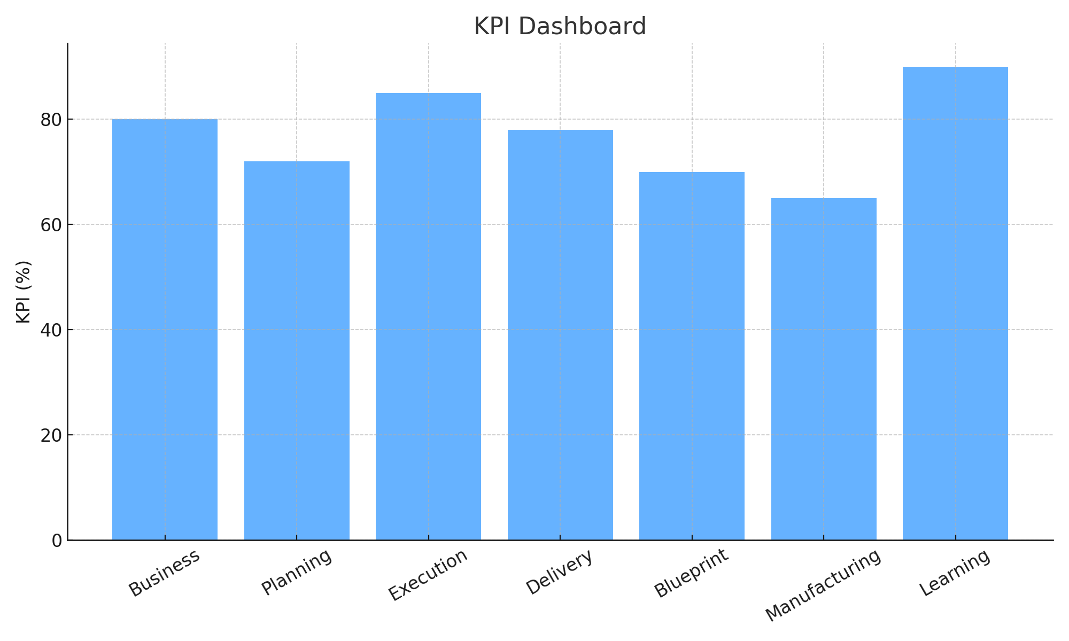

# Chapter 8: Iterations, Releases & Milestones

* Vision Charter 🚀
* PI Planning 📌
* First Increment ⚡
* Prototype 🛠
* Major Release 🏁

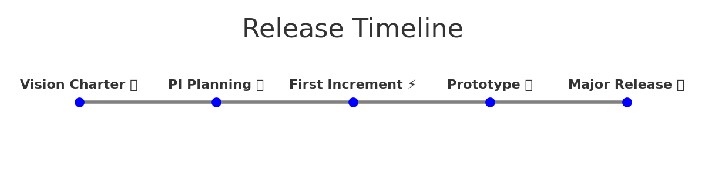

# Chapter 9: Benefits

* End-to-end integration from Client Order to Major Release
* Reduced wastage through Agile Manufacturing + Lean Six Sigma
* Compliance with ISO/NIST/IEEE/Quantum Engg standards
* Licensed professionals for accountability
* Scalable framework for domestic, industrial, and national deployments

# Chapter 10: Roadmap

* Phase 1: Pilot project with QAI Processor + OS + Ops
* Phase 2: Expansion into Manufacturing (Robotics, Transducers)
* Phase 3: Full Datacenter + Standards Compliance
* Phase 4: Multi-client, global deployments with continuous improvement

# Chapter 11: Risks & Mitigation

* Quantum hardware immaturity → fallback on simulation
* Cryogenic supply chain risks → redundancy in labs
* Security challenges → post-quantum cryptography adoption
* Resource constraints → Agile scaling and PLM coordination

# Chapter 12: Conclusion

The QAI_APO Master Framework ensures structured agility for complex QAI ecosystems. It integrates multi-disciplinary roles, technologies, and compliance to deliver prototypes and releases efficiently. It positions clients for leadership in Quantum AI innovation.