QAI_ProductDeploy_Toolkit - Proposal Document

# 1. Introduction

The QAI_ProductDeploy_Toolkit is designed to enable seamless deployment, monitoring, and management of QAI home-grown products and COTS solutions in client environments. It integrates automation, security, governance, and business mapping to ensure peak performance, compliance, and client trust.

# 2. Components and Technical Stack

The toolkit includes the following components:

* - qai-core (homegrown, version 1.4.2)
* - qai-runtime (homegrown, version 0.9.0)
* - qai-agent (homegrown, version 2.0.1)
* - cots-db (cots, version 12.3) vendor=AcmeDB
* - cots-monitor (cots, version 3.5) vendor=WatchAll

# 3. Release Manifest (Sample)

{  
 "release_id": "qai-prod-20251003134438",  
 "version": "1.4.2",  
 "created_at": "2025-10-03T13:44:38.634752",  
 "strategy": "canary",  
 "canary": {  
 "weight": 10,  
 "duration_minutes": 60  
 },  
 "artifacts": [  
 "qai-core",  
 "qai-runtime",  
 "qai-agent",  
 "cots-db",  
 "cots-monitor"  
 ],  
 "sbom": [  
 {  
 "name": "qai-core",  
 "version": "1.4.2"  
 },  
 {  
 "name": "qai-runtime",  
 "version": "0.9.0"  
 },  
 {  
 "name": "qai-agent",  
 "version": "2.0.1"  
 },  
 {  
 "name": "cots-db",  
 "version": "12.3"  
 },  
 {  
 "name": "cots-monitor",  
 "version": "3.5"  
 }  
 ]  
}

# 4. Key Performance Indicators

* release_id: qai-prod-20251003134438
* deployment_duration_minutes: 130.0
* canary_steps: 10
* canary_failure_count: 0
* promotion_success: True
* avg_cpu_percent: 34.89
* avg_mem_percent: 46.93
* avg_qpu_error_rate: 0.0195
* sla_compliance_pct: 99.13
* mttr_minutes: 7.82

# 5. Incidents and SIEM Alerts

No incidents logged.

No alerts generated.

# 6. Operational Metrics (Charts)

The following figures illustrate CPU, memory usage, QPU error distribution, and SIEM severity.

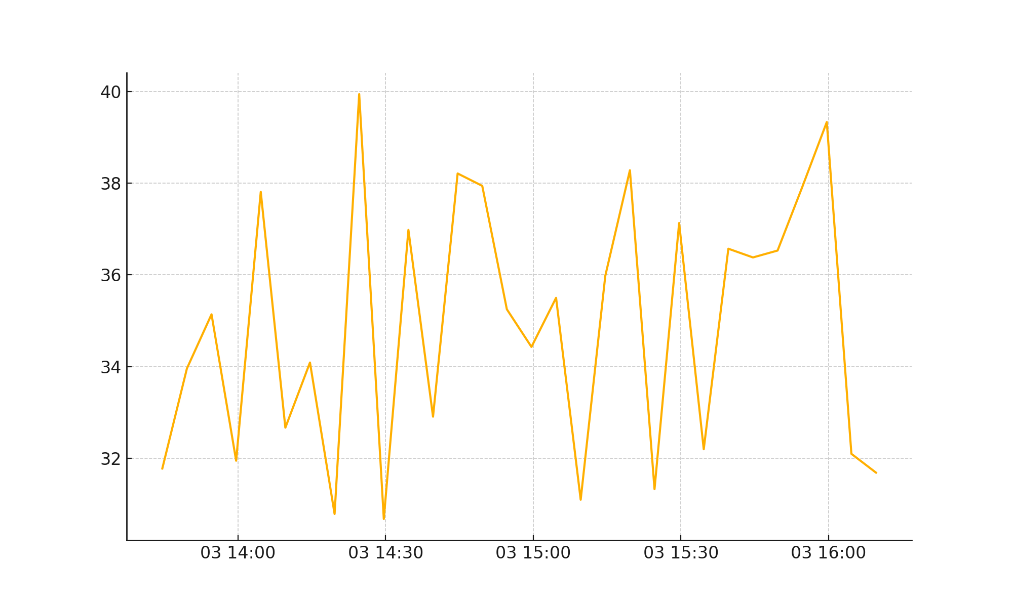

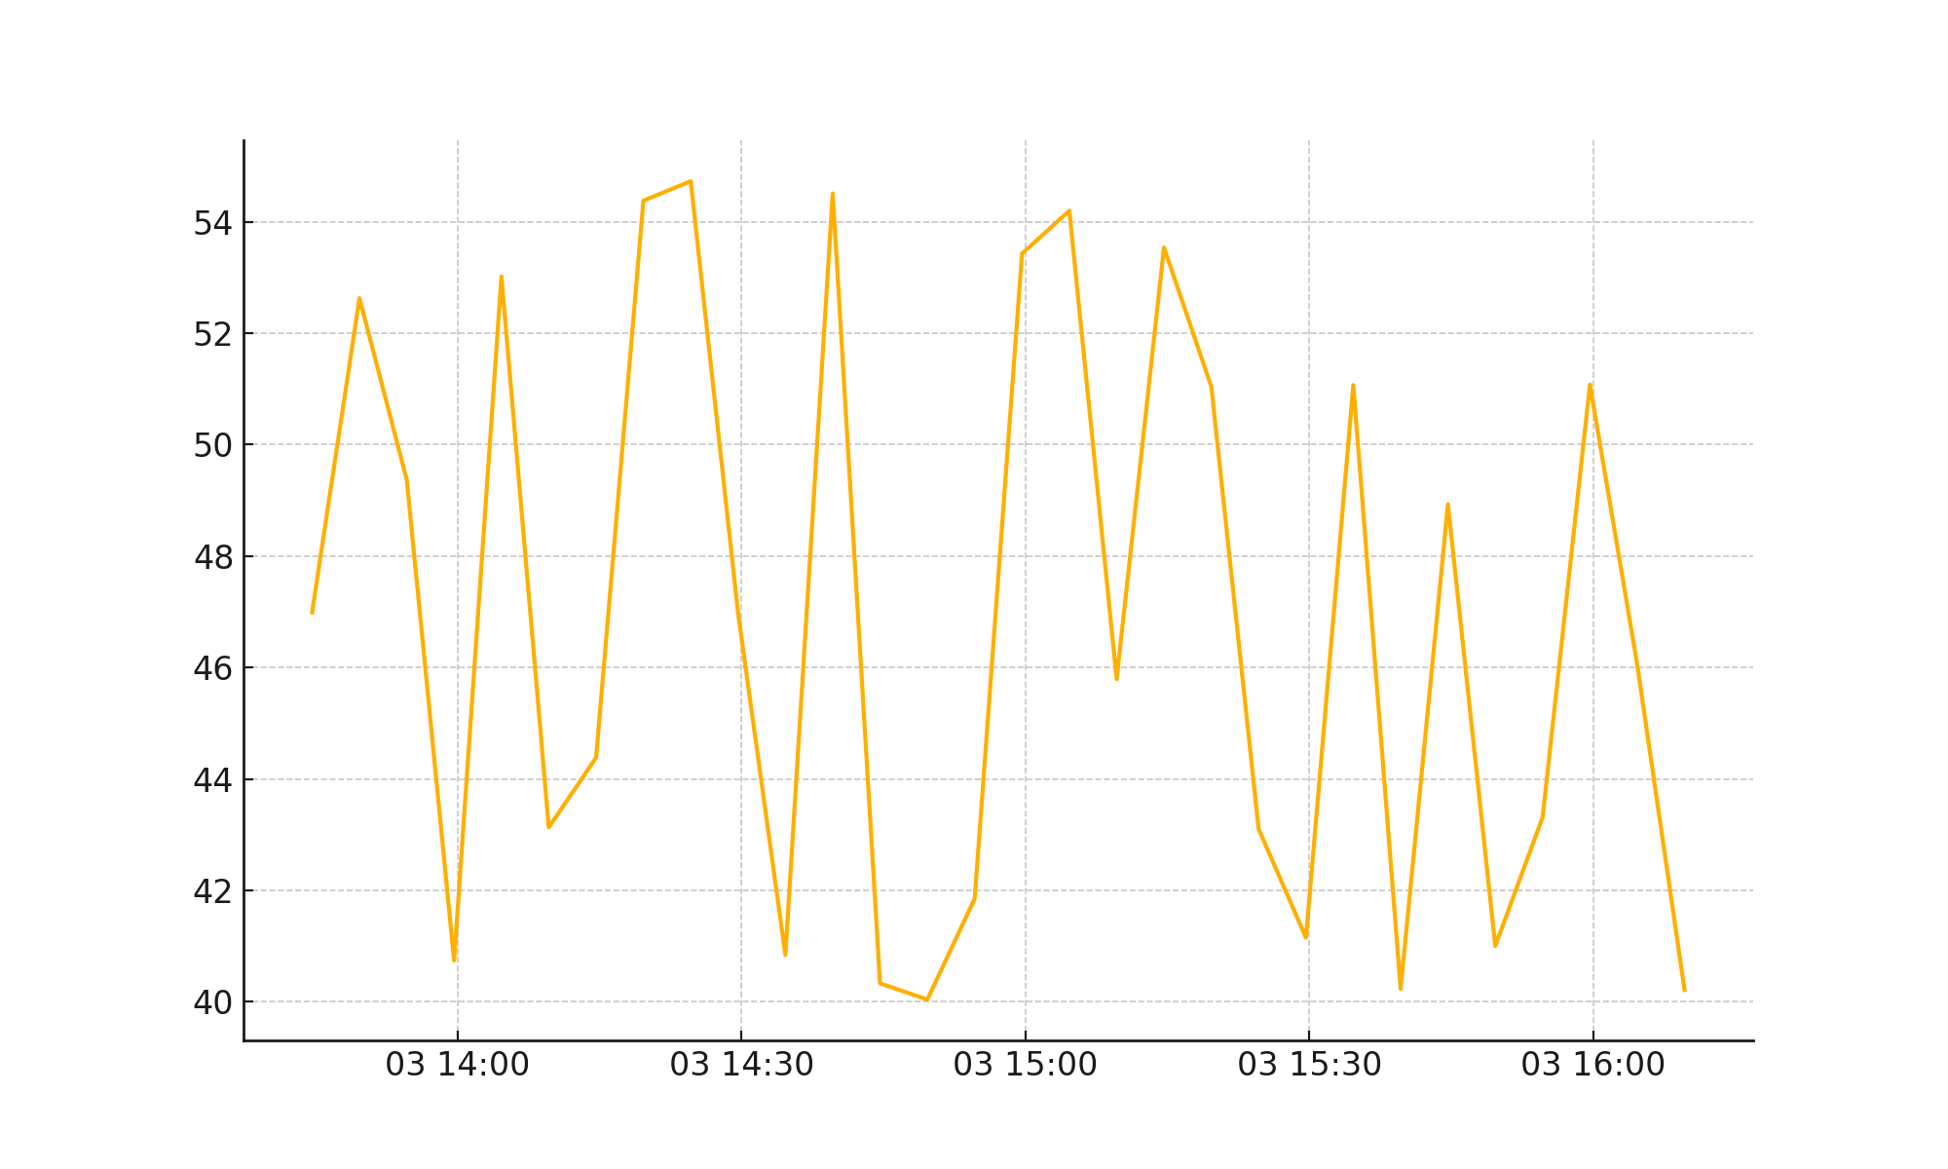

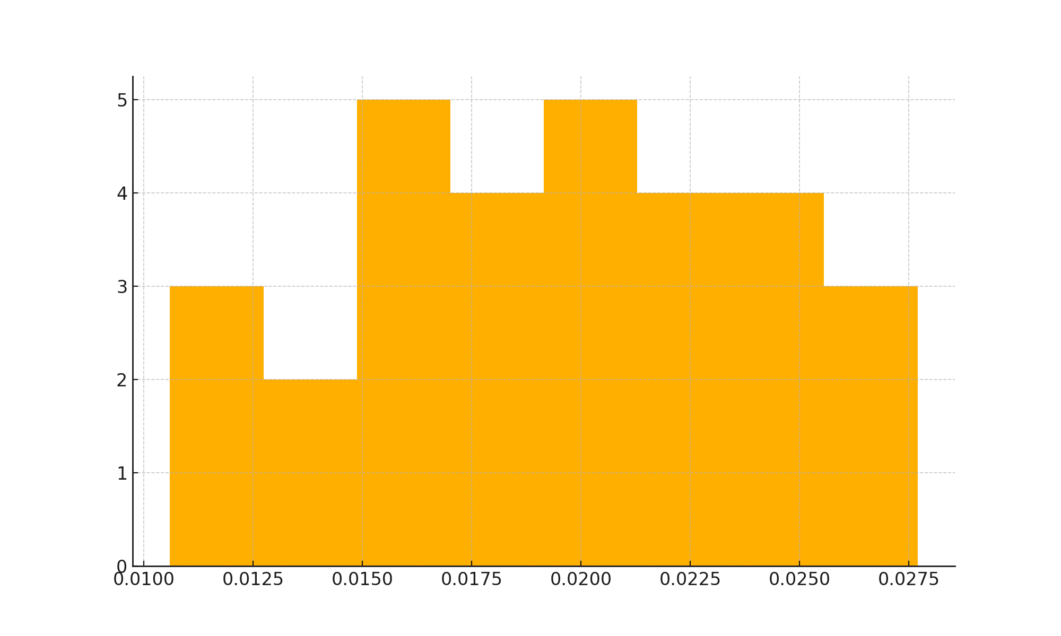

# 7. Summary

The QAI_ProductDeploy_Toolkit ensures smooth, secure, and client-aligned deployments. It provides automation, observability, compliance, and client adoption support. The toolkit integrates seamlessly with QAI Ops, Business Transformation Framework, and external ERP/IT systems to deliver a golden release experience.