Proposal: QAI Product Development Toolkit Demo (Drug Discovery PoC)

# 1. Introduction

This proposal demonstrates the QAI_ProductDev_Toolkit applied to a new drug discovery use case for cancer treatment. It shows the integration of in-house QAI components, COTS quantum providers, and hybrid orchestration hosted on the QAI Hub. The experiment compares a classical ML baseline against QAI-hybrid pipelines, capturing KPIs such as accuracy, runtime, energy, and cost.

# 2. Experiment Manifest

title: QAI_CancerDrugDiscovery_PoC_v1

description: Prototype PoC comparing classical ML baseline vs QAI-hybrid pipeline for cancer drug candidate ranking.

dataset: {'name': 'synthetic_molecules_v1', 'size': 20000}

authors: ['team-qai', 'research-group-xyz']

created_at: 2025-10-02 13:40:31

tags: ['drug-discovery', 'cancer', 'material-embeddings', 'poC']

# 3. Comparative Results (Simulated)

|  |  |  |  |  |  |  |  |  |
| --- | --- | --- | --- | --- | --- | --- | --- | --- |
| exp_id | track | provider | accuracy | runtime_s | energy_j | cost_usd | notes | fidelity |
| exp-a9f372a6 | classical | classical-cpu | 0.7068 | 6.0 | 90.0 | 30.0 | Classical ML baseline (simulated) using feature-based model. | nan |
| exp-a9f372a6 | qai-hybrid | prov-inhouse-sim | 0.8611 | 2.012 | 25.94 | 5.51 | Hybrid pipeline using circuit vqe-like-ansatz | 0.9703 |
| exp-a9f372a6 | qai-hybrid | prov-cots-qpu | 0.8305 | 4.548 | 35.28 | 6.77 | Hybrid pipeline using circuit vqe-like-ansatz | 0.9236 |

# 4. Analysis Summary

|  |  |  |  |  |  |  |  |
| --- | --- | --- | --- | --- | --- | --- | --- |
| track | provider | accuracy | accuracy_gain_vs_classical | runtime_s | runtime_overhead_s | cost_usd | cost_delta_vs_classical |
| qai-hybrid | prov-inhouse-sim | 0.8611 | 0.1543 | 2.012 | -3.988 | 5.51 | -24.49 |
| qai-hybrid | prov-cots-qpu | 0.8305 | 0.1237 | 4.548 | -1.452 | 6.77 | -23.23 |

# 5. Visualizations

Figure 1: Accuracy Comparison

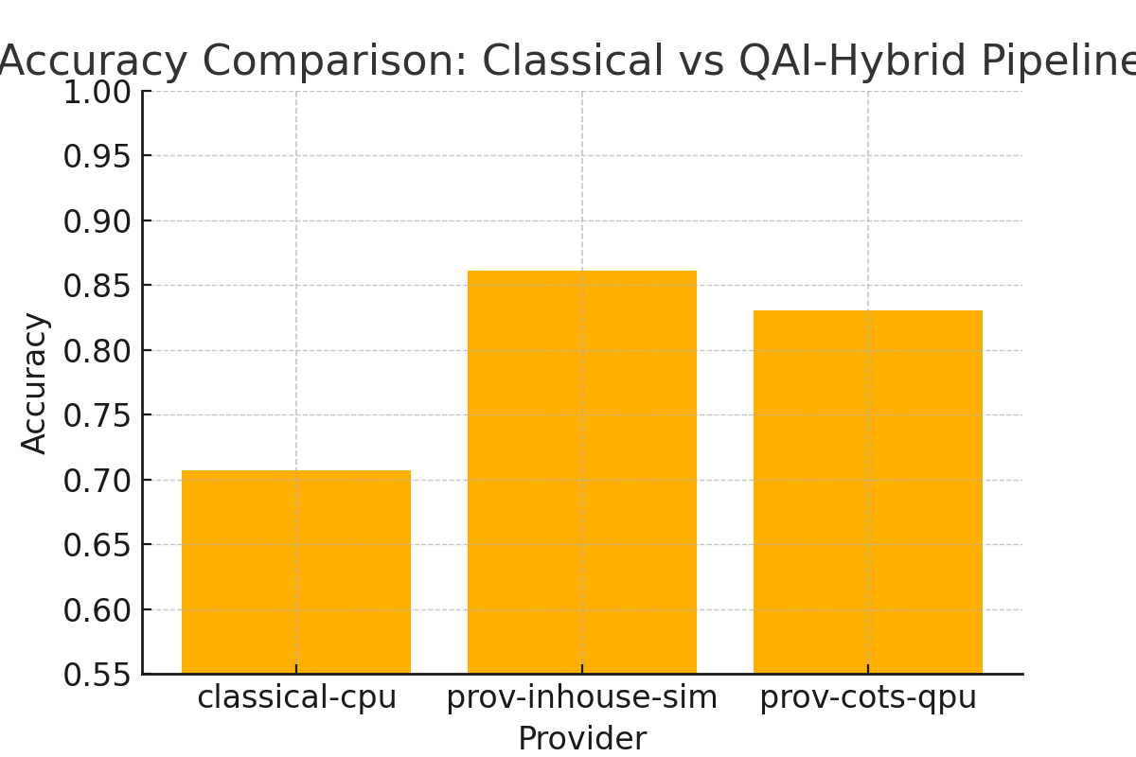

Figure 2: Runtime vs Cost Comparison

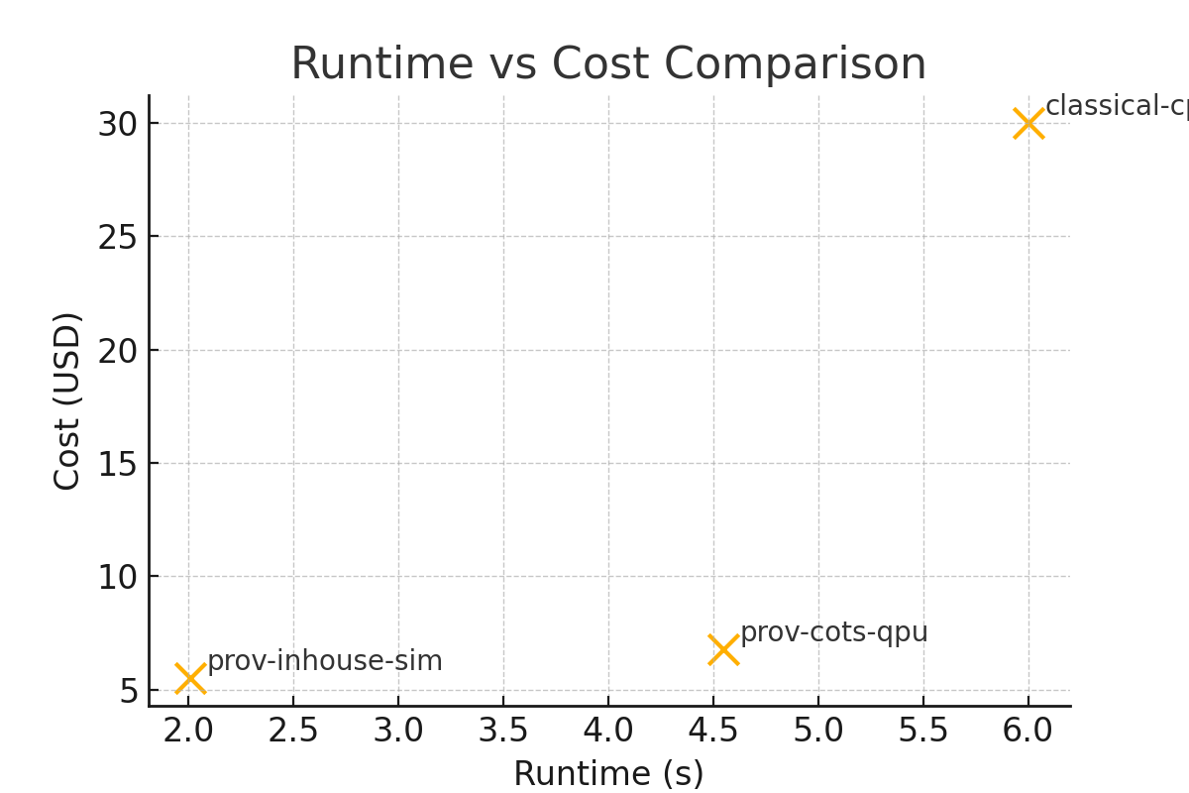

Figure 3: Energy Consumption by Track

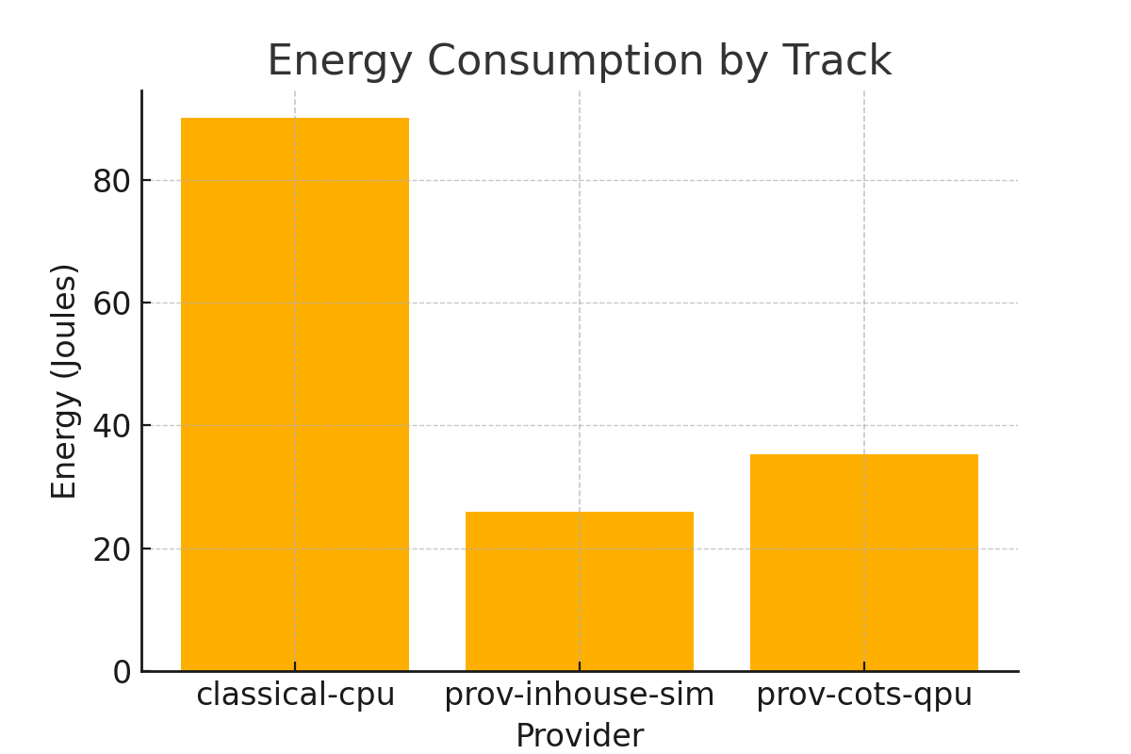

# 6. Summary & Merit

- Classical baseline is fast and low cost but less accurate.  
- QAI-hybrid pipelines can improve predictive accuracy by leveraging quantum embeddings.  
- In-house simulator: useful for development and CI; COTS QPU: potentially higher fidelity but higher cost.  
- Demonstrates integration of Hub, Orchestrator, Providers, and Experiment Manager.