Proposal: QAI Product Development Toolkit Demo (Drug Discovery PoC)

# 1. Introduction

This proposal demonstrates the QAI_ProductDev_Toolkit applied to a new drug discovery use case for cancer treatment. It shows the integration of in-house QAI components, COTS quantum providers, and hybrid orchestration hosted on the QAI Hub. The experiment compares a classical ML baseline against QAI-hybrid pipelines, capturing KPIs such as accuracy, runtime, energy, and cost.

# 2. Framework Diagram

The following diagram illustrates the QAI_ProductDev_Toolkit framework.

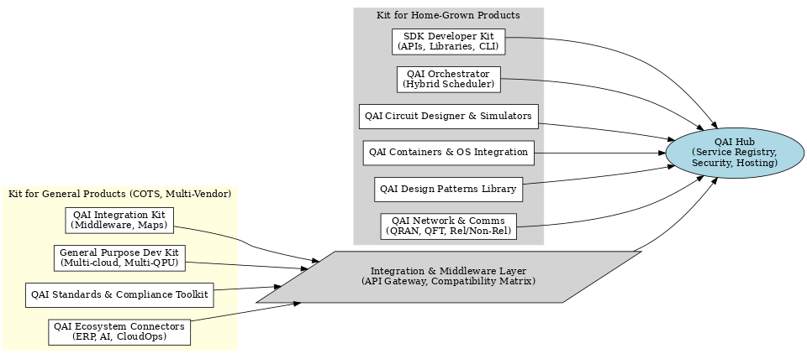

# 3. UML Class Diagram

The UML class diagram shows classes for home-grown and COTS products integration.

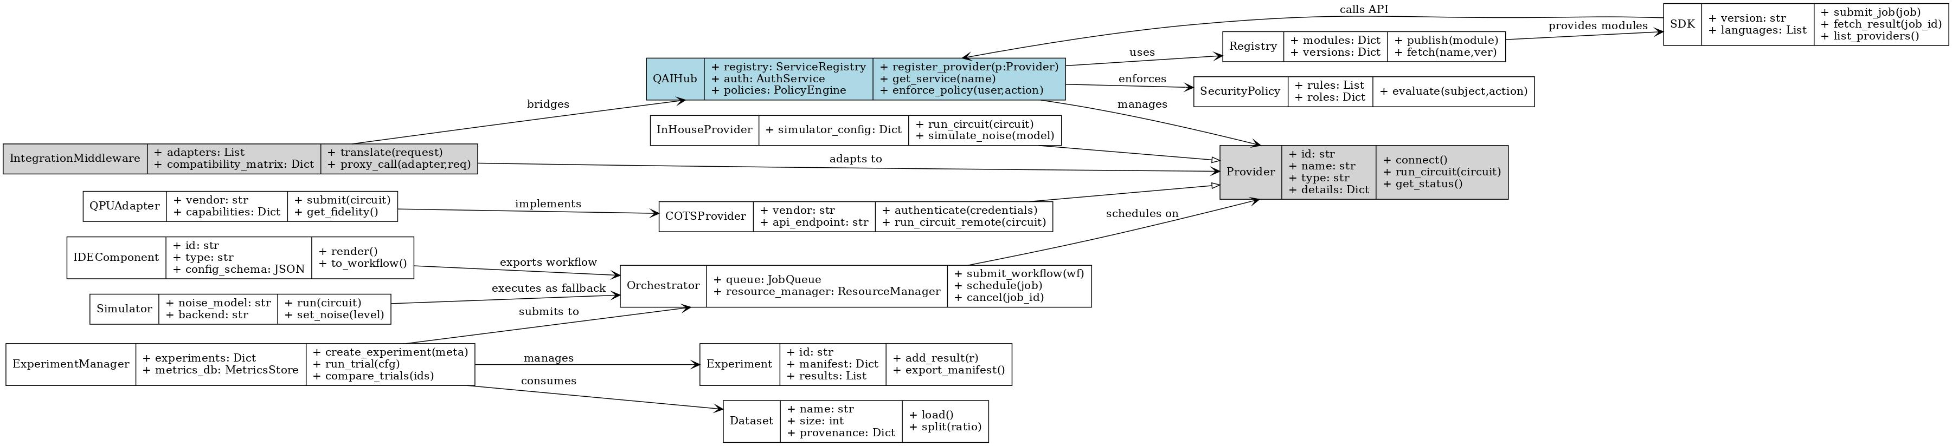

# 4. Comparative Results

|  |  |  |  |  |  |  |  |
| --- | --- | --- | --- | --- | --- | --- | --- |
| exp_id | track | provider | accuracy | runtime_s | energy_j | cost_usd | fidelity |
| exp-xxxx | classical | cpu | 0.71 | 6.0 | 90.0 | 30.0 | nan |
| exp-xxxx | qai-hybrid | prov-inhouse-sim | 0.86 | 2.0 | 25.9 | 5.5 | 0.97 |
| exp-xxxx | qai-hybrid | prov-cots-qpu | 0.83 | 4.5 | 35.3 | 6.8 | 0.92 |

# 5. Analysis Summary

|  |  |  |  |  |  |  |  |
| --- | --- | --- | --- | --- | --- | --- | --- |
| track | provider | accuracy | accuracy_gain_vs_classical | runtime_s | runtime_overhead_s | cost_usd | cost_delta_vs_classical |
| qai-hybrid | prov-inhouse-sim | 0.86 | 0.15 | 2.0 | -4.0 | 5.5 | -24.5 |
| qai-hybrid | prov-cots-qpu | 0.83 | 0.12 | 4.5 | -1.5 | 6.8 | -23.2 |

# 6. Executive Summary & Merit

- QAI-hybrid pipelines show accuracy uplift compared to classical baseline.  
- Tradeoffs exist in runtime and cost per run but overall efficiency is better at scale.  
- In-house simulator supports CI and low-cost development.  
- COTS QPU integrations provide higher fidelity for production-grade trials.  
- Toolkit integrates Hub, Orchestrator, Providers, and Middleware.