FAEP – QAI: Enabling Australia’s Industrial Future
Updated National-Priority & Critical-Technology Alignment Framework
Human-Centric Technology • Partnering for Productivity • Reusing Existing Assets • Building on National Strengths
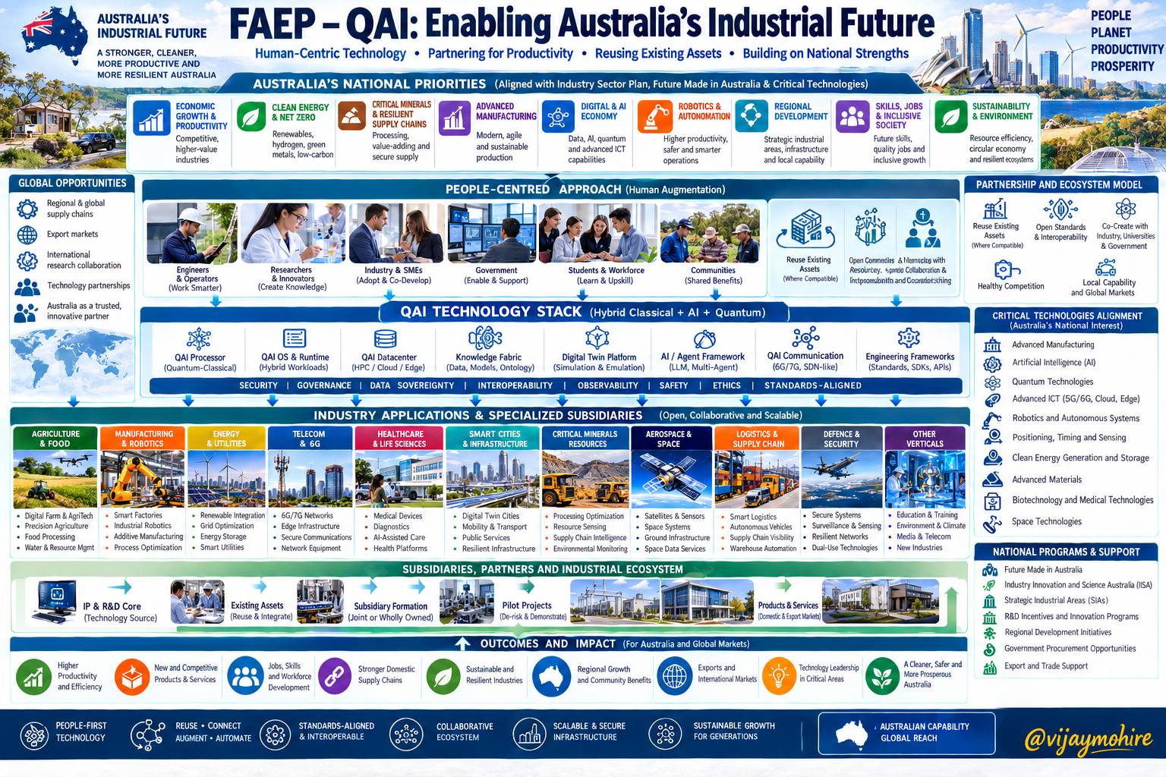
Figure 1. FAEP–QAI vision aligned to national priorities, critical technologies, industrial applications and outcomes.

1. Executive Vision
FAEP–QAI is envisioned as a people-centred, cross-industry technology and engineering ecosystem that can help organizations improve productivity, resilience, technology adoption, advanced manufacturing capability and sustainable operations while building domestic capability and global market pathways.
The model is problem-first and collaborative: reuse compatible existing assets, connect them through interoperable infrastructure, augment human work with AI and quantum technologies where validated, progressively automate suitable processes, optimize system performance, and create new products and services.

2. Strategic Architecture
- People & ecosystem — engineers, operators, researchers, industry/SMEs, government, students/workforce and communities.
- QAI technology stack — hybrid classical + AI + quantum computing, QAI runtime/datacenter concepts, knowledge fabric, digital twins, AI/agent frameworks, communications and engineering frameworks.
- Trust & control — security, governance, data sovereignty, interoperability, observability, safety, ethics and standards alignment.
- Industry applications — agriculture & food, manufacturing & robotics, energy & utilities, telecom/6G, healthcare, smart infrastructure, critical minerals, aerospace/space, logistics/supply chain and other verticals.
- Industrialization — IP/R&D core, partner integration, specialized subsidiaries, pilots, production capability, products/services and market channels.
- Outcomes — productivity, new products/services, jobs and skills, resilient supply chains, sustainable industry, regional growth, exports and technology capability.

3. Alignment with Australian National Priorities
National direction | Potential FAEP–QAI contribution
Economic growth & productivity | Human-augmented workflows, decision support, optimization and automation.
Clean energy & net zero | Energy management, renewable integration, storage optimization and resource efficiency.
Critical minerals & resilient supply chains | Processing optimization, sensing, supply-chain intelligence and scenario modelling.
Advanced manufacturing | Smart factories, robotics, additive/advanced manufacturing and predictive maintenance.
Digital & AI capability | AI/agent frameworks, data platforms, knowledge systems and hybrid AI/QAI infrastructure.
Robotics & automation | Human–robot collaboration, autonomous operations and progressive automation.
Regional development | Regional innovation hubs, specialized subsidiaries, workforce development and local capability.
Skills, jobs & society | Upskilling, engineering/research pathways, human-centred deployment and inclusive productivity.
Sustainability & resilience | Resource optimization, operational resilience, circular-economy support and environmental monitoring.

4. Critical-Technology Alignment
Critical technology | Potential role
Advanced manufacturing & materials | Digital engineering, smart factories, manufacturing optimization and advanced production workflows.
Artificial intelligence | AI/agentic workflows, predictive analytics, knowledge systems and decision support.
Advanced ICT | Cloud/edge computing, secure communications, data platforms, interoperability and distributed infrastructure.
Quantum technologies | Hybrid quantum-classical workloads, optimization, sensing and communications where appropriate.
Autonomous systems, robotics, positioning, timing & sensing | Industrial robotics, autonomous assets, sensing, orchestration and human–machine collaboration.
Clean energy generation & storage | Energy-aware optimization, storage scheduling and distributed energy management.
Biotechnology / medical technologies / space | Potential domain-specific applications through specialist partners and subsidiaries.

5. Operating Principles
- People first — technology augments people rather than being positioned as an end in itself.
- Problem first — begin with measurable industrial or community needs.
- Reuse → Connect → Augment → Automate → Optimize → Innovate.
- Open standards, interoperability and modular separation of concerns.
- Hybrid-by-design: use classical, AI and quantum resources according to evidence, maturity, economics and workload.
- Security, data sovereignty, assurance, safety and responsible technology throughout the lifecycle.
- Partner before duplicating capability; build collaborative ecosystems.
- Stage investment from assessment and validation to pilots, production and scale.
- Separate underlying QAI IP ownership from individual industrial commercialization opportunities.
- Build Australian capability while maintaining international interoperability and export potential.

6. Industrialization & Commercialization Model
QAI IP & R&D Core → Shared Technology Platforms → Specialized Subsidiaries → Niche Factories / Industrial Zones → Products & Services → Domestic Markets + Exports
- Maintain a protected QAI IP and research reservoir.
- Screen technology/IP candidates for differentiation, patentability potential, commercial need and investment case.
- Select a limited number of defensible IP families for controlled disclosure and protection.
- Form partnerships or specialized subsidiaries around validated opportunities.
- Use simulations, digital twins, emulations and pilots to establish technical and commercial evidence.
- Move validated projects into production, licensing, joint ventures or other suitable commercialization structures.
- Reinvest commercial returns into QAI R&D, engineering, talent and new industrial opportunities.

7. Industry Application Portfolio
Agriculture & Food — Digital Farm, precision agriculture, food processing, water/resource optimization.
Manufacturing & Robotics — Smart factories, industrial robotics, additive manufacturing and process optimization.
Energy & Utilities — Renewable integration, grid optimization, energy storage and smart utilities.
Telecom & 6G — 6G/7G concepts, edge infrastructure, secure communications and network optimization.
Healthcare & Life Sciences — Medical devices, diagnostics and AI-assisted workflows through appropriate partners.
Smart Cities & Infrastructure — Digital twins, mobility/transport, public services and resilient infrastructure.
Critical Minerals & Resources — Processing optimization, resource sensing, supply-chain intelligence and environmental monitoring.
Aerospace & Space — Satellite sensing, space systems, ground infrastructure and space data services.
Logistics & Supply Chain — Smart logistics, autonomous vehicles, visibility and warehouse automation.
Defence & Security — Secure systems, sensing and resilient networks subject to applicable controls.

8. Development Roadmap
Align — Map QAI capabilities to national priorities, critical technologies and concrete industrial problems.
Screen — Select a small set of commercially meaningful technology/IP opportunities.
Validate — Develop simulations, digital twins, emulations and pilots against classical baselines.
Partner — Engage industry, universities, government, investors and specialist technology/manufacturing partners.
Protect — Use controlled disclosure and appropriate IP protection before public or commercial exposure.
Commercialize — Create products, services, licenses, joint ventures or specialized subsidiaries.
Scale — Expand production, domestic adoption, exports and ecosystem participation.
Reinvest — Recycle value into R&D, engineering, talent, IP and new opportunities.

9. Proposed Positioning Statement
“FAEP–QAI is a people-centred, cross-industry technology and engineering ecosystem designed to help organizations reuse existing capabilities, connect them through interoperable digital infrastructure, augment human work with AI and quantum technologies where validated, and progressively build more productive, resilient and sustainable industrial systems.”

10. Reference Points
- Australian Industry Sector Plan: https://www.industry.gov.au/publications/industry-sector-plan/introduction
- Future Made in Australia: https://www.industry.gov.au/future-made-in-australia
- Industry Innovation and Science Australia: https://www.industry.gov.au/science-technology-and-innovation/industry-innovation/industry-innovation-and-science-australia
- List of Critical Technologies in the National Interest: https://www.industry.gov.au/publications/list-critical-technologies-national-interest
- Critical Technologies Statement: https://www.industry.gov.au/publications/critical-technologies-statement
- National Robotics Strategy: https://www.industry.gov.au/publications/national-robotics-strategy
- Critical Technology Standards: https://www.industry.gov.au/science-technology-and-innovation/technology/critical-technology-standards
- Resources Sector Plan: https://www.industry.gov.au/publications/resources-sector-plan/executive-summary
- Australian Manufacturing: https://www.industry.gov.au/manufacturing

11. Qualification
This document describes strategic alignment and potential contribution. It does not represent government endorsement, funding approval, procurement approval or automatic program eligibility. Individual opportunities should be validated through technical, IP, market, regulatory, financial and partner due diligence.

