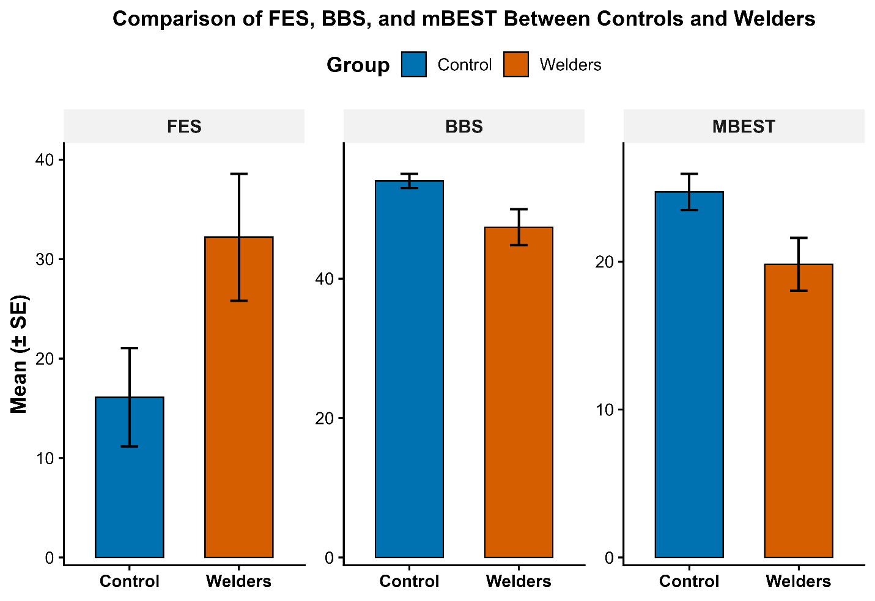
Figure 1. Comparison of balance performance in various metrics (FES, BBS, MBEST) in Welders and Control Subjects.

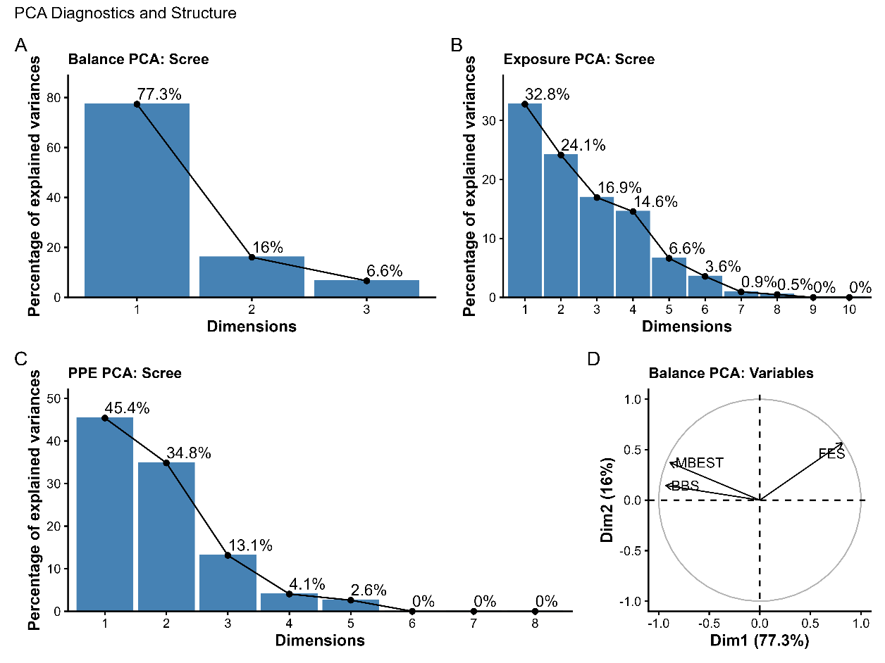
Figure 2. Principal component analysis (PCA) of balance performance, occupational exposure, and personal protective equipment (PPE) use.
Scree plots (Panels A–C) display the percentage of variance explained by each principal component for (A) balance outcomes (Berg Balance Scale, Mini-BESTest, Falls Efficacy Scale), (B) occupational exposures (noise, vibration, fumes), and (C) PPE use (hearing, respiratory, and eye protection). In all domains, the first principal component (PC1) captured the largest proportion of variance, with a dominant unidimensional structure observed for balance outcomes and more distributed variance for exposure and PPE domains. Panel D shows the PCA variable plot for balance measures, illustrating strong and concordant loadings of balance metrics on PC1, consistent with a shared underlying construct of global balance performance and fall-related confidence.

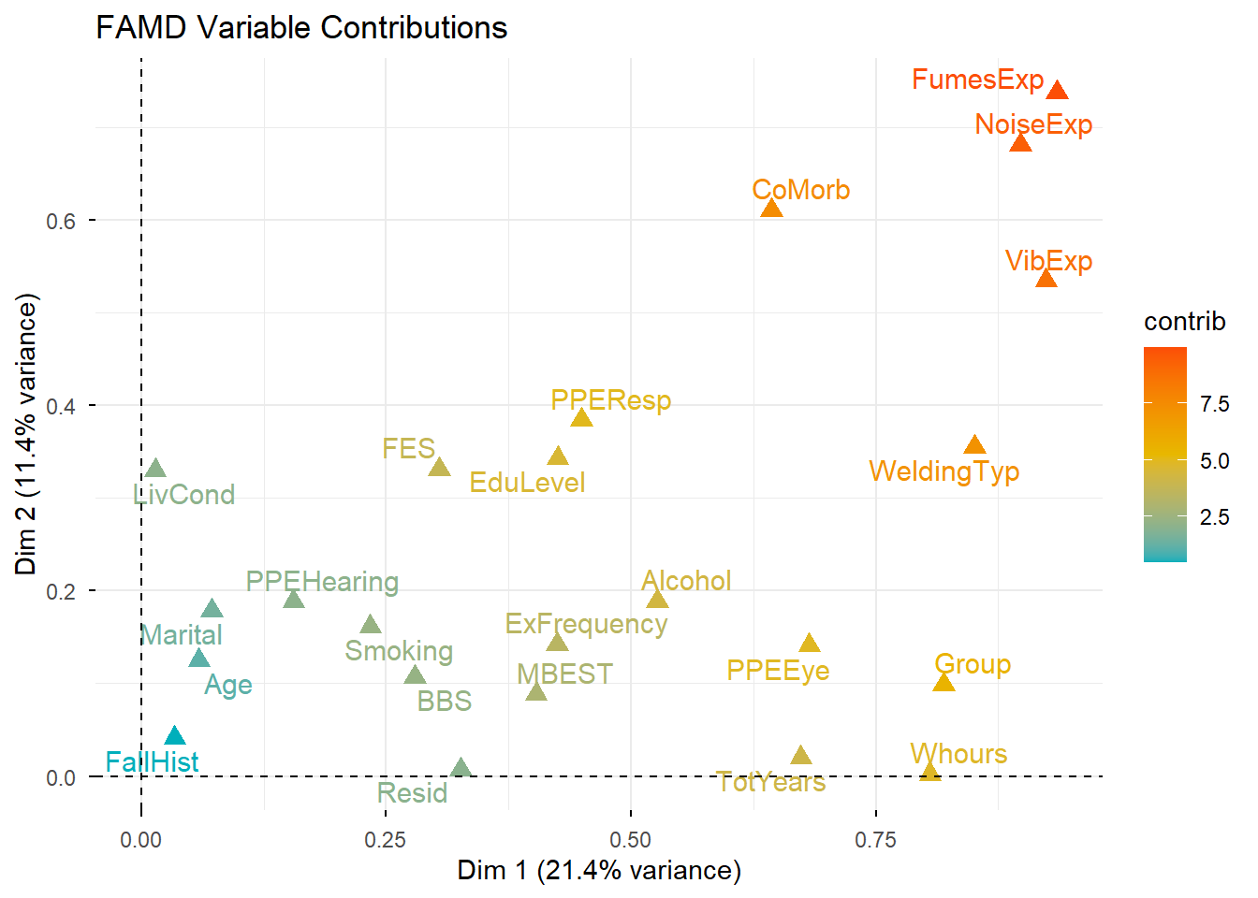
Figure 3. Variable contribution map from Factor Analysis of Mixed Data (FAMD).
Biplot of variable contributions to Dimension 1 and Dimension 2. Variables are represented as points with text labels. Colors reflect the magnitude of contribution, with warmer colors (yellow–red) indicating stronger influence on the axes. Dimension 1 primarily reflects occupational hazard exposures (fumes, vibration, noise, welding type, work hours), whereas Dimension 2 reflects a combination of exposures, comorbidities, and socio-environmental factors (education level, family environment, living conditions). The x- and y-axes indicate the proportion of variance explained by Dimension 1 and Dimension 2, respectively.

