Table 1. Demographics of Personal (Exposure) and Environmental Factors with Fall history
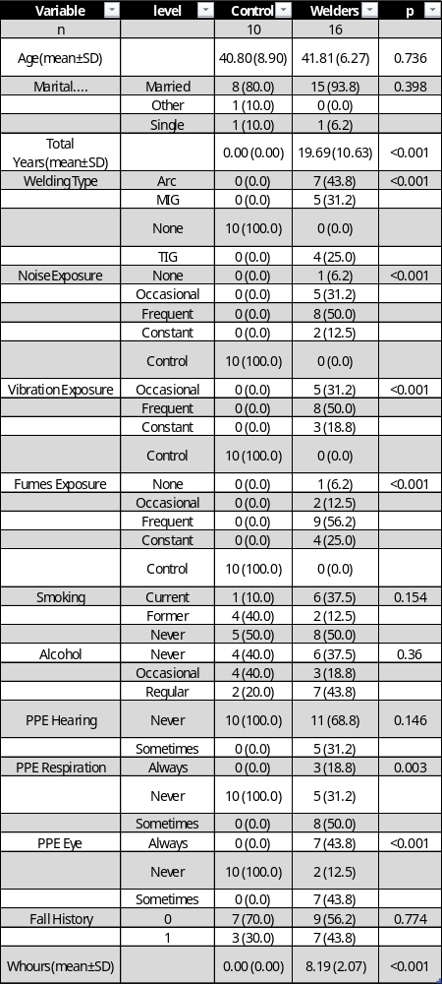

Table2. Statistical inference of the comparison of balance metrics between control subjects and welders.
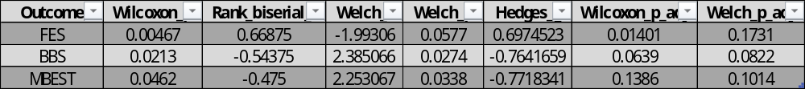

Table3. Comparison of Reduced model vs Full model in predicting Fall risk in welders.
