**INTRODUCTION**

Electronic commerce has been an important and viable part of the Internet for well over a decade now. From the behemoths like Amazon.com to the mom-and-pop online stores, e-commerce is performed in a number of ways. Despite the dozen, or hundred, of failures for every single commercial success, e-commerce can still be an excellent business tool when done properly.



**Languages Used:**

**Front-End**

* HTML5
* CSS3
* JavaScript

**Back-End**

* PHP
* MySQL

**Key Features**

**Public User**

* View Product
* Create User Account
* Login In
* Login Out
* Add a Product to cart
* See blogs about the projects

**Sign in User**

* Search Product
* View Product
* Create Order
* Change Email & Password
* Can View Previous Order with UPDATE and DELETE

**Admin**

* Add New Product
* Update Product
* Delete Product
* Confirm Order

**SKETCH OF THE UI:**

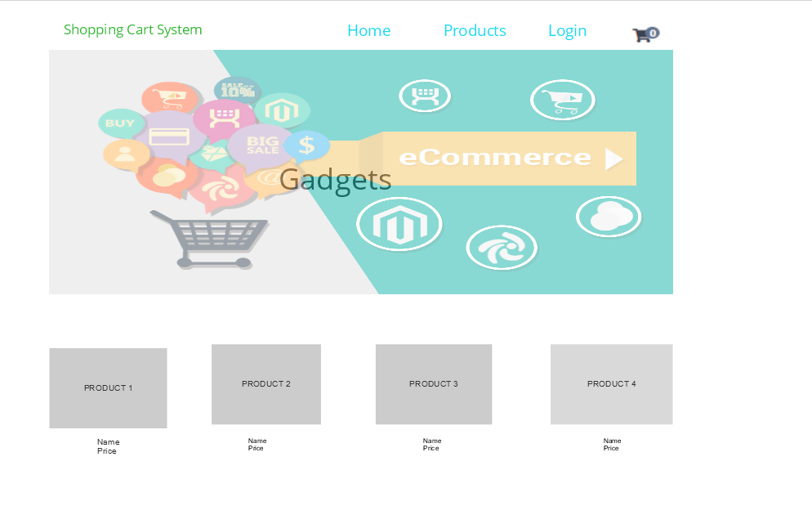

**CODING SPECIFICATIONS:**

You must finish the PHP project we have started during class. Requirements:

- Connect to database using PDO (prepared statement to prevent SQL injection)

- Ask the user details during registration (job title, phone number, picture (avatar), etc.)

- New user can see all products and blog subject but cannot vote or comment on blog post until the account status as been approved by admin.

- An approved user can modify is profile, comment on subject, flag a comment or vote for a post.

- Administrator can modify a profile, modify subject and description, approve new user accounts, and approve comments on post or product. (Admin cannot vote)

- Administrator have a dashboard with an overview of everything that is waiting for approval. (Comments, accounts, etc.)

- When a user is logged in, show a welcome page with the username in it, a button to modify is profile, see all blog subject and a button to add a new subject, button to add new product on store page, a list of the 3 most popular subject (based on votes).

- Everything on the dashboard should be clickable that brings you to the corresponding page.

- Users waiting for approval, Approved users and administrator should be redirected to different pages when they login.

- A flagged comment is not seen by anyone until an admin makes a decision, once approved after being flagged it can never be flagged again.

 - When a user comment on post or a product, show is name, is avatar, the date of the comment, is job title and the number of stars (his vote)

- A approved user can vote for a subject (/5 stars) and/ or a product but only once per post or product. (Save in db.) Your site must look good, have colors, images, header and menu etc. Make it look professional!

 - Document your work.

- Export your database in a text file, create a folder in your project called database and put the exported script in it.

- Zip the folder that contains the structure of your site and attach it here on this assignment.

**REQUIRED:**

* WAMP server for hosting locally
* Code Editor (Visual Studio Code)
* User portal
* Admin portal
* Login portal
* Logout portal
* Products page
* Cart system
* Payment system

# **CODING STANDARDS:**

* Camel casing
* Meaningful declaration of variables
* Comments for each method and variables
* Proper indentation
* Using html inside PHP functions to make the code-reusable.
* Using PDO Connection string.

**DIFFERENT FILES USED:**

* Blog.php
* Cart.php
* Comments.php
* commentStyles.php
* config.php
* functions.php
* home.php
* index.php
* Login/php
* Logout.php
* Placeholder.php
* Product.php
* Products.php
* Register.php
* Reset-password.php
* Welcome.php
* Style1.css
* Style2.css
* Style3.css

**WORKING:**

When the user checks the page, he sees a home page icon, products page and a login page.

User can browse through the home page without logging in.

User can also sign – in with his credentials, user can register, logout, comment, check blogs.

Admin can approve a user account, disapprove a user account, approve comments, delete comments, and check the order history of users.

When user adds a comment, admin can block the user from commenting further.

The application communicates with the database for login, logout and all managing done by the Admin.

**CREATING THE DATABASE:**

The database is created using phpMyAdmin from WAMP server.

The database contains three tables:

* Users
* Products
* Comments

These tables are interacting with the user interface of the web application with a PDO sqli connection.

**CONCLUSION:**

A site can make money from selling ads, in which case all that’s required of the customer is that they visit. Or a site could make money from referrals, where the hope is that the customer will use a link on the site to purchase something from another site. In both cases, what’s being asked of the user is insignificant. But when a site wants a customer to provide their full name, address, and credit card information that becomes serious business. The customer must be respected, their questions answered, their concerns addressed, and their fears mitigated in order for the site to succeed in the endeavor. So, overall it was a good experience coding an e-commerce website using PHP.