**Name**:_______________________________________

**Grade/Div.**

3 /

**Sub.**

**1.1**

**Maths**

**Sr.No.**

**Roll No**.: _____________

**Date: _**________

**Unit 1- Working with Numbers**

**1**. Write each of these numbers in **words.**

(a) 4015 **– .................................................................................................................**

**................................................................................................................................**

(b)3674 – **................................................................................................................**

**................................................................................................................................**

**2**. Write these numbers in **figures.**

(a)Nine thousand eighteen - **...........................**

(b)Eight thousand three hundred eighty- **...........................**

**3**. Write the numbers given below in **expanded form.**

(a) 9043 = **................................................................................................................**

(b) 8971= **................................................................................................................**

**4**. Fill in the missing numbers

1. 3,000 + 400 + 20 + **…………** = 3,426
2. 8,000 + **…………** + 70 + 5 = 8,275
3. **…………** + 600 + 40 + 3 = 7,643
4. 5,000 + 200 + **…………** + 9 = 5,209
5. 9,000 + 300 + 50 + **…………**= 9,357

**5**. Complete the given table by writing the **Place value** of underlined digit.

|  |  |
| --- | --- |
| **Number** | **Place Value** |
| 1. **4394** | **…………** |
| **(b) 6423** | **…………** |
| **(c) 3786** | **…………** |

**6.** Match each number **numerals** with the number **written in words.**

|  |  |
| --- | --- |
| a) 5568 | 1) nine thousand eight hundred thirty-nine |
| b) 9839 | 2) six hundred thirty-seven |
| c) 5009 | 3) five thousand five hundred sixty-eight |
| d) 637 | 4) five thousand nine |

1. **………… b) ………… c) ………… d) …………**

**7**. Writethe number shown on the **abacus** below.

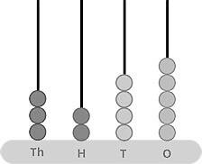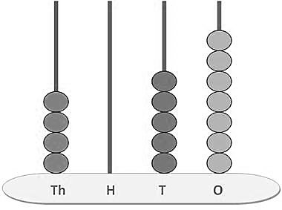

(b)

(a)