**Name**:_______________________________________

**Grade/Div.**

3 /

**Sub.**

**1.2**

**Maths**

**Sr.No.**

**Roll No**.: _____________

**Date: _**________

**Unit 1- Working with Numbers**

**1**. Arrange the numbers **in descending** order and **ascending** order.

(a) 3456, 4356, 1564, 4567, 6543

**Descending – ...........................................................................................................**

**Ascending- ...........................................................................................................**

(b) 9256, 7892, 2768, 467, 800

**Descending - ...........................................................................................................**

**Ascending- ...........................................................................................................**

**2**. Which one of the following numbers has the **smallest value**?

Put a ring around the answer.

7504 7405 7540 7450

**3.** Use these **words cards** to make four different 4-digit number.

(Use your numbers in numerals)

a) **......................**

b) **......................**

c) **......................**

d) **......................**

Hundred

Forty

Twenty

Six

Thousand

Eight

**4**. Write the **successor** of the following numbers.

(a) 5467 **......................**

(b) 3621 **......................**

**5.** Write the **predecessor** of the following numbers.

(a) **......................** 8779 (b) **......................** 5467

**6**. **Round off** the following numbers to the nearest **10s.**

(a) 1345 = **......................** (b) 3456 = **......................**

**7. Round off** the following numbers to the nearest **100s.**

(a) 4567= **......................** (b) 7654= **......................**

**8.** Which of the following is the same as **7535?** Tick the correct answer.

i)700+50+3+5

ii) 700+50+30+5

iii) 7000+500+3+5

iv) 7000+500+30+5

9. Represent the numbers below on an abacus and write the same number in an Expanded Form:

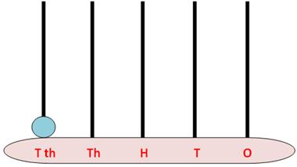a) 4567-

Expanded Form:

**.......**thousands + **.......** hundreds + **.......**tens + **.......** ones

**...................................................................**

b) 2679-

Expanded Form:

**.......** thousands + **.......** hundreds + **.......** tens + **.......** ones

**...................................................................**