**High Performance Computing**

**Practical File**



**Name**: Ashutosh Kumar

**Roll No.**: 2019UCO1647

**Branch &** **Section**: COE - 2

**Semester**: 6

**Subject Code**: COCSC18

**1. Run a basic hello world program using pThreads**

#include <stdio.h>

#include <stdlib.h>

#include <unistd.h>

#include <pthread.h>

int thread_count;

void *Hello(void *rank);

int main(int argc, char *argv[]){

    long thread;

    pthread_t *thread_handles;

    thread_count = strtol(argv[1], NULL, 10);

    thread_handles = malloc(thread_count * sizeof(pthread_t));

    for (thread = 0; thread < thread_count; thread++)

        pthread_create(&thread_handles[thread], NULL, Hello, (void *)thread);

    printf("Hello from the main thread\n");

    for (thread = 0; thread < thread_count; thread++)

        pthread_join(thread_handles[thread], NULL);

    free(thread_handles);

    return 0;

}

void * Hello(void *rank){

    long my_rank = (long)rank;

    printf("Hello from thread %ld of %d\n", my_rank, thread_count);

    return NULL;

}

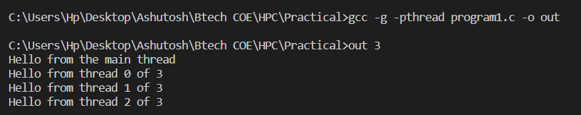

**2. Run a program to find the sum of all elements of an array using 2 processors**

#include <mpi.h>

#include <stdio.h>

#include <stdlib.h>

#include <time.h>

int main(int argc, char **argv){

    MPI_Init(NULL, NULL);

    int num_procs;

    MPI_Comm_size(MPI_COMM_WORLD, &num_procs);

    int rank;

    MPI_Comm_rank(MPI_COMM_WORLD, &rank);

    if (rank == 0){

        int n;

        printf("Enter number of elements : ");

        scanf("%d", &n);

        int arr[n];

        for (int i = 0; i < n; i++)

            arr[i] = rand() % 10000 + 1;

        printf("Array is -\n [ ");

        for (int i = 0; i < n; i++)

            printf("%d ", arr[i]);

        printf("]\n");

        int elem_to_send = n / 2;

        if (n % 2)

            elem_to_send++;

        MPI_Send(&elem_to_send, 1, MPI_INT, 1, 0, MPI_COMM_WORLD);

        MPI_Send(&arr[n / 2], elem_to_send, MPI_INT, 1, 1, MPI_COMM_WORLD);

        float t1 = clock();

        int local = 0;

        for (int i = 0; i < n / 2; i++)

            local = local + arr[i];

        int s_rec = 0;

        float t2 = clock();

        printf("Time taken by process %d : %f\n", rank, (t2 - t1) / CLOCKS_PER_SEC);

        MPI_Recv(&s_rec, 1, MPI_INT, 1, 2, MPI_COMM_WORLD, MPI_STATUS_IGNORE);

        local = local + s_rec;

        printf("Total sum of array is %d\n", local);

    }

    else{

        float t1 = clock();

        int size;

        MPI_Recv(&size, 1, MPI_INT, 0, 0, MPI_COMM_WORLD, MPI_STATUS_IGNORE);

        int arr[size];

        MPI_Recv(arr, size, MPI_INT, 0, 1, MPI_COMM_WORLD, MPI_STATUS_IGNORE);

        float t2 = clock();

        printf("Total time for recieving : %f", (t2 - t1) / CLOCKS_PER_SEC);

        t1 = clock();

        int local = 0;

        for (int i = 0; i < size; i++)

            local = local + arr[i];

        printf("\nProcess %d sending sum %d back to main...\n", rank, local);

        t2 = clock();

        printf("Time taken by process for addition %d : %f\n", rank, (t2 - t1) / CLOCKS_PER_SEC);

        MPI_Send(&local, 1, MPI_INT, 0, 2, MPI_COMM_WORLD);

    }

    MPI_Finalize();

}

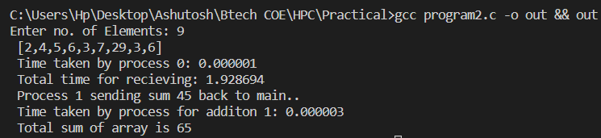

**3. Compute the sum of all the elements of an array using p processors**

#include <mpi.h>

#include <stdio.h>

#include <stdlib.h>

#include <time.h>

int main(int argc, char **argv){

    MPI_Init(NULL, NULL);

    int num_procs;

    MPI_Comm_size(MPI_COMM_WORLD, &num_procs);

    int rank;

    MPI_Comm_rank(MPI_COMM_WORLD, &rank);

    if (rank == 0){

        int n;

        printf("Enter number of elements : ");

        scanf("%d", &n);

        int arr[n];

        for (int i = 0; i < n; i++)

            arr[i] = rand() % 10 + 1;

        printf("Array is -\n [ ");

        for (int i = 0; i < n; i++)

            printf("%d ", arr[i]);

        printf("]\n");

        int elem_to_send = n / num_procs;

        int tag = 0;

        for (int i = 1; i < num_procs; i++){

            if (i != num_procs - 1){

                elem_to_send = n / num_procs;

                MPI_Send(&elem_to_send, 1, MPI_INT, i, i + num_procs, MPI_COMM_WORLD);

MPI_Send(&arr[i * (elem_to_send)], elem_to_send, MPI_INT, i, i + num_procs + 1, MPI_COMM_WORLD);

continue;

            }

            elem_to_send = n / num_procs + n % num_procs;

            MPI_Send(&elem_to_send, 1, MPI_INT, i, i + num_procs, MPI_COMM_WORLD);

MPI_Send(&arr[(num_procs - 1) * (n / num_procs)], elem_to_send, MPI_INT, i, i + num_procs + 1, MPI_COMM_WORLD);

        }

        int ans = 0;

        for (int i = 0; i < n / num_procs; i++)

            ans += arr[i];

        int s_rec;

        for (int i = 1; i < num_procs; i++){

            s_rec = 0;

            MPI_Recv(&s_rec, 1, MPI_INT, i, i + num_procs + 2, MPI_COMM_WORLD,

                     MPI_STATUS_IGNORE);

            ans += s_rec;

        }

        printf("Total sum of array is %d\n", ans);

    }

    else{

        int size;

        MPI_Recv(&size, 1, MPI_INT, 0, rank + num_procs, MPI_COMM_WORLD, MPI_STATUS_IGNORE);

        int arr[size];

        MPI_Recv(arr, size, MPI_INT, 0, rank + num_procs + 1, MPI_COMM_WORLD, MPI_STATUS_IGNORE);

        int local = 0;

        for (int i = 0; i < size; i++)

            local = local + arr[i];

        printf("\nProcess %d sending sum %d back to main...\n", rank, local);

        MPI_Send(&local, 1, MPI_INT, 0, rank + num_procs + 2, MPI_COMM_WORLD);

    }

    MPI_Finalize();

}

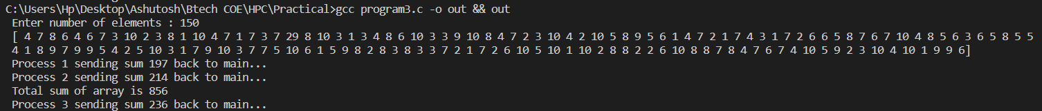

**4. Write a program to illustrate basic MPI communication routines**

#include <mpi.h>

#include <stdio.h>

int main(int argc, char **argv){

    MPI_Init(NULL, NULL);

    int world_size;

    MPI_Comm_size(MPI_COMM_WORLD, &world_size);

    int world_rank;

    MPI_Comm_rank(MPI_COMM_WORLD, &world_rank);

    char processor_name[MPI_MAX_PROCESSOR_NAME];

    int name_len;

    MPI_Get_processor_name(processor_name, &name_len);

    printf("Hello world from process %s, rank %d out of %d processes\n\n", processor_name, world_rank, world_size);

    if (world_rank == 0){

        char *message = "Hello!";

        MPI_Send(message, 6, MPI_CHAR, 1, 0, MPI_COMM_WORLD);

    }

    else{

        char message[6];

        MPI_Recv(message, 6, MPI_CHAR, 0, 0, MPI_COMM_WORLD, MPI_STATUS_IGNORE);

        printf("Message received!\n");

        printf("Message is : %s\n", message);

    }

    MPI_Finalize();

    return 0;

}

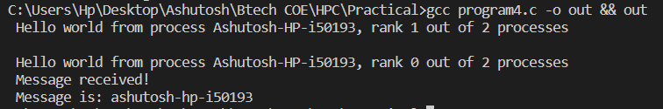

**5. Design a parallel program for summing up an array, matrix multiplication and show logging and tracing MPI activity**

#include <mpi.h>

#include <stdio.h>

#include <stdlib.h>

#include <time.h>

int main(int argc, char **argv){

    MPI_Init(NULL, NULL);

    int num_procs;

    MPI_Comm_size(MPI_COMM_WORLD, &num_procs);

    int rank;

    MPI_Comm_rank(MPI_COMM_WORLD, &rank);

    if (rank == 0){

        int n;

        printf("Enter number of elements : ");

        scanf("%d", &n);

        int arr[n];

        for (int i = 0; i < n; i++)

            arr[i] = rand() % 10000 + 1;

        printf("Array is -\n [ ");

        for (int i = 0; i < n; i++)

            printf("%d ", arr[i]);

        printf("]\n");

        int elem_to_send = n / 2;

        if (n % 2)

            elem_to_send++;

        MPI_Send(&elem_to_send, 1, MPI_INT, 1, 0, MPI_COMM_WORLD);

        MPI_Send(&arr[n / 2], elem_to_send, MPI_INT, 1, 1, MPI_COMM_WORLD);

        float t1 = clock();

        int local = 0;

        for (int i = 0; i < n / 2; i++)

            local = local + arr[i];

        int s_rec = 0;

        float t2 = clock();

        printf("Time taken by process %d : %f\n", rank, (t2 - t1) / CLOCKS_PER_SEC);

        MPI_Recv(&s_rec, 1, MPI_INT, 1, 2, MPI_COMM_WORLD, MPI_STATUS_IGNORE);

        local = local + s_rec;

        printf("Total sum of array is %d\n", local);

    }

    else{

        float t1 = clock();

        int size;

        MPI_Recv(&size, 1, MPI_INT, 0, 0, MPI_COMM_WORLD, MPI_STATUS_IGNORE);

        int arr[size];

        MPI_Recv(arr, size, MPI_INT, 0, 1, MPI_COMM_WORLD, MPI_STATUS_IGNORE);

        float t2 = clock();

        printf("Total time for recieving : %f", (t2 - t1) / CLOCKS_PER_SEC);

        t1 = clock();

        int local = 0;

        for (int i = 0; i < size; i++)

            local = local + arr[i];

        printf("\nProcess %d sending sum %d back to main...\n", rank, local);

        t2 = clock();

        printf("Time taken by process for addition %d : %f\n", rank, (t2 - t1) / CLOCKS_PER_SEC);

        MPI_Send(&local, 1, MPI_INT, 0, 2, MPI_COMM_WORLD);

    }

    MPI_Finalize();

}

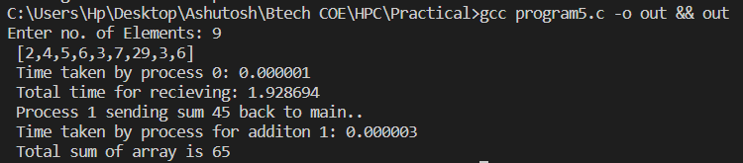

**6. Write a C program with openMP to implement loop work sharing**

#include <omp.h>

#include <stdio.h>

void reset_freq(int *freq, int THREADS){

    for (int i = 0; i < THREADS; i++)

        freq[i] = 0;

}

int main(int *argc, char **argv){

    int n, THREADS, i;

    printf("Enter the number of iterations :");

    scanf("%d", &n);

    printf("Enter the number of threads (max 8): ");

    scanf("%d", &THREADS);

    int freq[THREADS];

    reset_freq(freq, THREADS);

    #pragma omp parallel for num_threads(THREADS)

    for (i = 0; i < n; i++)

        freq[omp_get_thread_num()]++;

    #pragma omp barrier

    printf("\nIn default scheduling, we have the following thread distribution :- \n");

    for (int i = 0; i < THREADS; i++)

        printf("Thread %d : %d iters\n", i, freq[i]);

    int CHUNK;

    printf("\nUsing static scheduling...\n");

    printf("Enter the chunk size :");

    scanf("%d", &CHUNK);

    reset_freq(freq, THREADS);

    #pragma omp parallel for num_threads(THREADS) schedule(static, CHUNK)

    for (i = 0; i < n; i++)

        freq[omp_get_thread_num()]++;

    #pragma omp barrier

    printf("\nIn static scheduling, we have the following thread distribution :- \n");

    for (int i = 0; i < THREADS; i++)

        printf("Thread %d : %d iters\n", i, freq[i]);

    printf("\nUsing automatic scheduling...\n");

    reset_freq(freq, THREADS);

    #pragma omp parallel for num_threads(THREADS) schedule(auto)

    for (i = 0; i < n; i++)

        freq[omp_get_thread_num()]++;

    #pragma omp barrier

    printf("In auto scheduling, we have the following thread distribution :- \n");

    for (int i = 0; i < THREADS; i++)

        printf("Thread %d : %d iters\n", i, freq[i]);

    return 0;

}

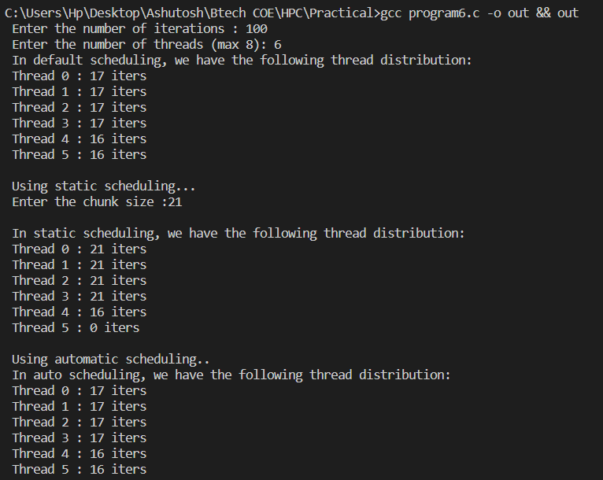

**7. Write a C program with openMP to implement sections work sharing**

#include <omp.h>

#include <stdio.h>

int main(int *argc, char **argv){

    int num_threads, THREAD_COUNT = 4;

    int thread_ID;

    int section_sizes[4] = {0, 100, 200, 300};

    printf("Work load sharing of threads...\n");

    #pragma omp parallel private(thread_ID) num_threads(THREAD_COUNT)

    {

        thread_ID = omp_get_thread_num();

        printf("I am thread number %d!\n", thread_ID);

        int value_count = 0;

        if (thread_ID > 0){

            int work_load = section_sizes[thread_ID];

            for (int i = 0; i < work_load; i++)

                value_count++;

            printf("Number of values computed : %d\n", value_count);

        }

        #pragma omp barrier

        if (thread_ID == 0)

            printf("Total number of threads are %d", omp_get_num_threads());

    }

    return 0;

}

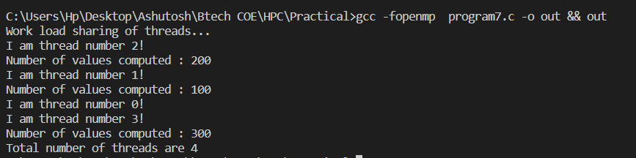

**8. Write a program to illustrate process synchronization and collective data movements**

#include <pthread.h>

#include <stdio.h>

#include <stdlib.h>

#include <string.h>

int thread_count;

struct arguments{

    int size;

    int *arr1;

    int *arr2;

    int *dot;

};

void *add_into_one(void *arguments);

void print_vector(int n, int *arr){

    printf("[ ");

    for (int i = 0; i < n; i++)

        printf("%d ", arr[i]);

    printf("] \n");

}

int main(int argc, char *argv[]){

    long thread;

    pthread_t *thread_handles;

    thread_count = 2;

    thread_handles = malloc(thread_count * sizeof(pthread_t));

    printf("Enter the size of the vectors : ");

    int n;

    scanf("%d", &n);

    printf("Enter the max_val of the vectors : ");

    int max_val;

    scanf("%d", &max_val);

    struct arguments *args[2];

    for (int i = 0; i < 2; i++){

        args[i] = malloc(sizeof(struct arguments) * 1);

        args[i]->size = n;

        args[i]->arr1 = malloc(sizeof(int) * n);

        args[i]->arr2 = malloc(sizeof(int) * n);

        args[i]->dot = malloc(sizeof(int) * n);

        for (int j = 0; j < n; j++){

            args[i]->arr1[j] = rand() % max_val;

            args[i]->arr2[j] = rand() % max_val;

        }

    }

    printf("Vectors are : \n");

    print_vector(n, args[0]->arr1);

    print_vector(n, args[0]->arr2);

    print_vector(n, args[1]->arr1);

    print_vector(n, args[1]->arr2);

    int result[n];

    memset(result, 0, n * sizeof(int));

    for (thread = 0; thread < thread_count; thread++){

        printf("Multiplying %ld and %ld with thread %ld...\n", thread + 1, thread + 2, thread);

        pthread_create(&thread_handles[thread], NULL, add_into_one, (void *)args[thread]);

    }

    printf("Hello from the main thread\n");

    for (thread = 0; thread < thread_count; thread++)

        pthread_join(thread_handles[thread], NULL);

    for (int i = 0; i < 2; i++){

        printf("Multiplication for vector %d and %d \n", i + 1, i + 2);

        print_vector(n, args[i]->dot);

        printf("\n");

    }

    free(thread_handles);

    for (int i = 0; i < n; i++)

        result[i] = args[0]->dot[i] + args[1]->dot[i];

    printf("Result is : \n");

    print_vector(n, result);

    return 0;

}

void *add_into_one(void *argument){

    struct arguments *args = argument;

    int n = args->size;

    for (int i = 0; i < n; i++)

        args->dot[i] = args->arr1[i] * args->arr2[i];

    return NULL;

}

