SHIVAM Clock

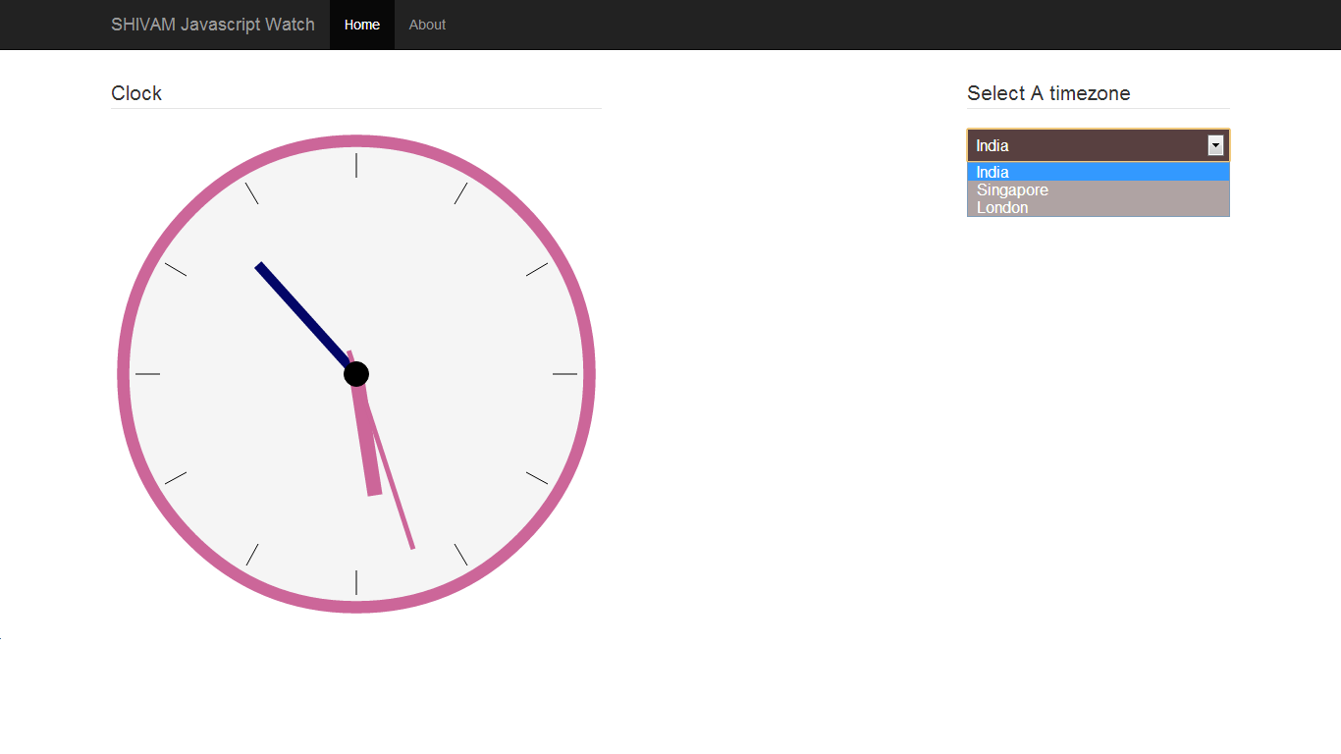

## Technology used

1. MVC 3, ASP.NET V 4.0, C#, Razor view engine
2. Responsive development CSS3 (Bootstrap.css)
3. JavaScript (Raphael.js,Jquery 1.8.2.js)

## Description

Clock has been canvassed using rapheal.js draw clock method. Using get offset and set offset this draw clock changing the current time hour’s value.

# Code structure

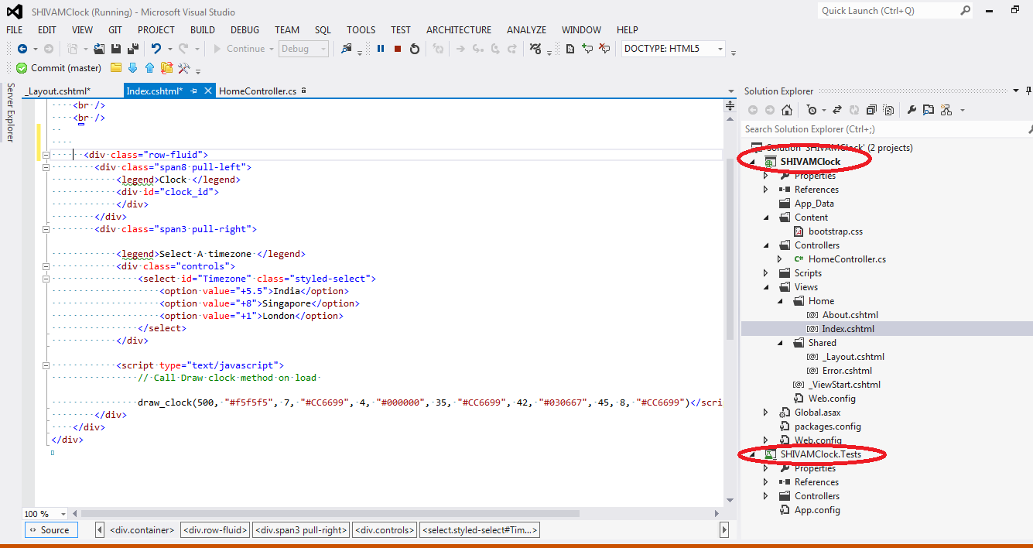

1. Main project (containing all data)
2. Unit Test project( containing test methods)